Clan-Cultural Influences on Spatial Organization in Lingnan Traditional Villages: A Case Study of Chengyanggang, Chaoshan

Ziyue Jiang, Yuan Xiong*
Faculty of Innovation and Design, City University of Macau, Macau 999078, China
Email: U25091110404@cityu.edu.mo
* Corresponding Author

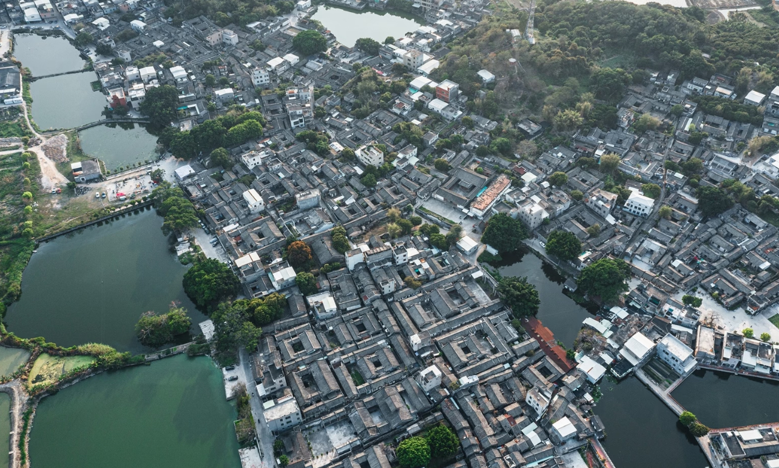
Figure 1. Chengyanggang village's rural texture

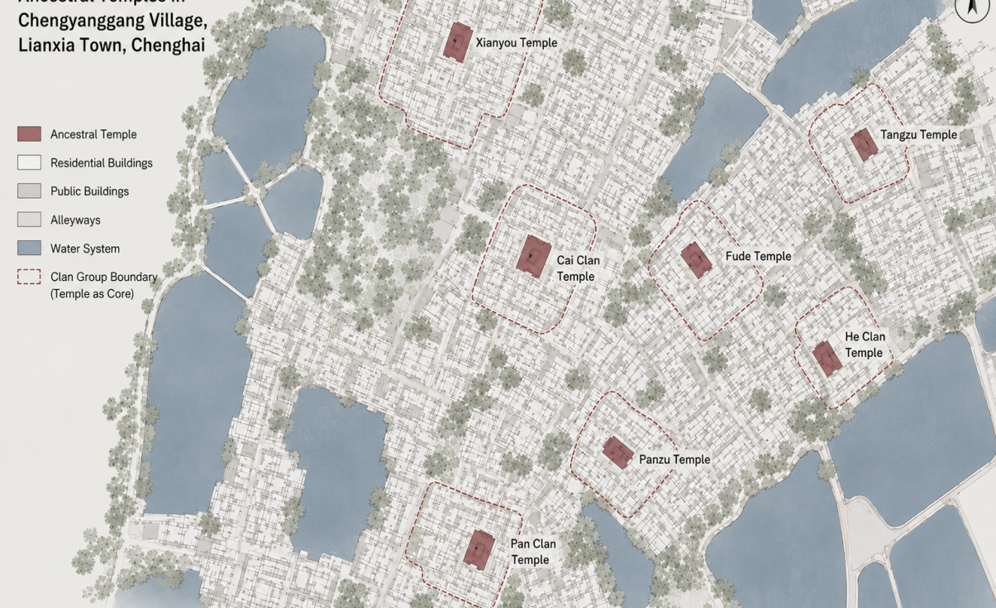
Figure 2 . Distribution map of ancestral halls in chengyanggang village

Table 1. Interview outline and data organization
Number | Participant Profile | Focus Point | Typical Answer | Key Summary | Conclusion
A1 | A local resident,  aged 78 | Venues for discussing key village affairs. | The ancestral hall is the most important place; in the past, all village matters were discussed there. | The ancestral hall serves as the central public space. | An ancestral hall possesses both a central role and a public nature.
A2 | A member of the clan, aged 72 | The main venue for ancestral worship, festivals, or public events. | Ancestral worship ceremonies, meetings, and wedding celebrations are typically held near the ancestral hall. | Clan activities are concentrated in certain areas. | Clan activities reinforce the central role of the ancestral hall.
A3 | A local resident,  aged 68 | The relationship between kinship ties and residential distance | The closer relatives all lived nearby, only as the branches multiplied did they gradually expand outward. | Blood-related settlements. | Residential distribution is influenced by clan relationships.
A4 | A elderly resident of the village, aged 75 | Whether established site selection guidance existed during past house construction. | In the past, building a house also required considering family lineage; the location wasn't chosen arbitrarily. | The hierarchical order influences site selection. | The spatial hierarchy corresponds to the clan hierarchy.
A5 | A local resident,  aged 70 | The future development direction for new housing projects. | As more people gathered behind, construction gradually expanded outward along the alley. | Expand along the alley. | The village expands along the existing structure.
A6 | A senior member of the clan, aged 82 | Space utilization during festivals such as Qingming and the Winter Solstice. | During the Qingming Festival and Winter Solstice, the ancestral hall is particularly bustling with a large crowd. | festival activities. | The event cycle enhances the utilization of public spaces.
A7 | A local resident,  aged 65 | Whether different apartment complexes share relatively concentrated residential areas. | Each household typically lives together, with their own designated area. | The branches form residential clusters. | The space exhibits a branched aggregation structure.
A8 | A local resident,  aged 74 | The Differences in the Use of Main Streets and Alleys. | The narrow alleys connect every household, while the main roads are used by everyone. | The streets and alleys are clearly graded. | The streets and alleys have a hierarchical structure.

