Evolution Characteristics of Stress Fields in Layered Surrounding Rockmass of Tunnels
Feng Li¹, Kang Qiu¹, Jiahao Ma¹, Yongbin Geng¹, Haigang Ma¹, Yinhu Guo²
¹China Railway Shanghai Engineering Bureau Group Seventh Engineering Co., Ltd., Xian, Shanxi, China
²Xi'an-Chengdu Passenger Dedicated Line Shaanxi Co., Ltd., Xi'an 710043, China
Abstract: Layered rock masses exhibit pronounced mechanical anisotropy, and bedding discontinuities can substantially alter excavation-induced stress redistribution and concentration around a tunnel, thereby increasing the likelihood of instability. In this study, a three-dimensional discrete-element numerical simulation platform was employed to investigate a tunnel excavated in layered rock with bedding dip angles of 0°, 30°, 60°, and 90°. The distributions and evolution of the vertical and horizontal stresses were examined for the four configurations. The results indicate that tunnel excavation causes marked redistribution of both the vertical and horizontal stress components. The disturbance is concentrated in the near-field region and gradually diminishes with increasing distance from the opening. Vertical compressive stress is primarily concentrated near the crown and invert, whereas horizontal compressive stress is mainly localized along the sidewalls and extends toward the arch shoulders and feet. Approximately symmetric stress patterns are obtained for bedding dip angles of 0° and 90°. By contrast, at 30° and 60°, the stress-concentration zones migrate along the bedding direction, producing a distinct asymmetry between the two sides of the tunnel. These findings provide a theoretical basis for stability assessment and support optimization in tunnels constructed in layered rock masses.
Keywords: tunnel; layered rock mass; bedding dip angle; stress redistribution; numerical simulation.

1. Introduction
With the rapid expansion of transportation infrastructure in China, an increasing number of tunnels and underground structures are being constructed at greater depths, over longer distances, and under increasingly complex geological conditions. Layered rock masses are widely distributed in western and mountainous regions, where pervasive bedding planes, joints, and fractures produce pronounced anisotropy in mechanical behaviour and failure response^{[1-2]}. Tunnel excavation disturbs the initial in-situ stress state and induces substantial stress adjustment around the opening. Once the localized stress exceeds the load-bearing capacity of the rock mass, cracking, spalling, and even large-scale instability may occur. A clear understanding of excavation-induced stress-field evolution in layered rock is therefore essential for identifying potential failure mechanisms and improving construction safety in underground engineering.
Considerable effort has been devoted to the mechanical behaviour and failure mechanisms of layered rock masses. Liu combined three-dimensional discrete-element modelling with field monitoring for the three-lane, closely spaced twin tunnels of the Wutongshan project and quantified the effects of fault dip angles of 60°, 90°, and 120° on surrounding-rock displacement^{[3]}. Chen et al. developed a three-dimensional unloading model for layered rock using an overlapping-domain continuum-discontinuum coupling scheme^{[4]}. Their work demonstrated continuous transfer of mechanical information across the coupled domains and clarified the deformation and fracture patterns induced by tunnel unloading. Using a finite-element cohesive-zone model (FEM-CZM), Meng et al investigated how bedding-plane strength, spacing, position, and orientation govern principal stresses, energy evolution, and crack development ^{[5]}. Amadei examined the macroscopic anisotropy associated with stratification and discontinuities and proposed procedures for incorporating such effects into the interpretation of in-situ stress measurements ^{[6]}. For the Taihangshan Tunnel in layered sandy slate, Miao established a PFC2D excavation model and evaluated the influences of the lateral pressure coefficient, discontinuity spacing, and discontinuity dip on tunnel stability and failure mode ^{[7]}. Zhu analysed a shield-tunnel model to characterize the loosened zone and deformation response of the surrounding rock under different bedding dip angles ^{[8]}. Gan used ABAQUS to assess the influence of bedding inclination and identified several dip-dependent failure modes, including tensile splitting, shear sliding, shear rupture across bedding planes, and splitting along bedding interfaces ^{[9]}. Liu et al. proposed a drawer-type mechanical model for inclined layered rock, together with a calculation method and identification criterion for geological bias loading, and subsequently clarified the governing factors and deformation-failure mechanism ^{[10]}. Based on the Dongfeng Road Tunnel, Wang et al. attributed the stability of horizontally layered surrounding rock to the combined effects of geological, construction, and engineering factors ^{[11]}. Zhang investigated structural loading, deformation, and deformation-control measures for the Nanzhushan high-speed railway tunnel ^{[12]}. The results showed that increasing the joint angle from 0° to 15° and 30° had little effect on the maximum vertical displacement but produced a more pronounced change in horizontal displacement.
Although previous studies have provided valuable insight into the strength characteristics, failure modes, and discontinuity-controlled behaviour of layered rock, the effect of bedding inclination on excavation-induced stress-field evolution and localized stress concentration under complex in-situ stress conditions remains insufficiently resolved. In particular, the mechanisms by which inclined bedding alters the location of stress-concentration zones and generates asymmetric stress distributions around a tunnel require further clarification. To address this issue, three-dimensional discrete-element models were established for bedding dip angles of 0°, 30°, 60°, and 90°. The vertical and horizontal stress responses were systematically compared to identify the influence of bedding geometry on stress redistribution and to provide a theoretical reference for stability evaluation and support design in layered-rock tunnels.

2. Three-Dimensional Numerical Model and Simulation Design

2.1 Model Development
A three-dimensional discrete-element model was constructed to examine how bedding dip controls the stress response of the surrounding rock during tunnel excavation under high in-situ stress. The model dimensions were 40 m × 40 m × 10 m, and four bedding configurations were considered (θ = 0°, 30°, 60°, and 90°). The outer region was discretized using a characteristic element size of 2 m, whereas the mesh around the tunnel was locally refined to 0.5 m. The tunnel adopted a straight-wall arched section with a clear width of 5 m and an overall height of 4.7 m. The crown consisted of a circular arc with a radius of 2.5 m, and the straight sidewalls were 2.2 m high. The resulting model geometry is shown in Fig. 1.
The boundary conditions are illustrated in Fig. 2. A vertical stress of 26 MPa (σ_{v}) was applied to the upper surface to represent the overburden stress, while the base was fixed in all directions. Normal displacement was constrained on the four lateral boundaries. According to the in-situ stress ratios σ_{h}/σ_{H} = 0.8 and σ_{H}/σ_{v} = 1.2, the minimum horizontal stress parallel to the tunnel axis was set to σ_{h} = 24.96 MPa, and the maximum horizontal stress perpendicular to the tunnel axis was set to σ_{H} = 31.2 MPa. The mechanical parameters of the surrounding rock mass are as follows: elastic modulus 25 GPa, cohesion 2.40 MPa, internal friction angle 35°, tensile strength 2.00 MPa, Poisson's ratio 0.30, and density 2.65 g/cm³. The normal stiffness and shear stiffness of the bedding planes are 5.8 GPa/m and 2.9 GPa/m, respectively, with an internal friction angle of 28°, and both cohesion and tensile strength equal to 0.02 MPa.
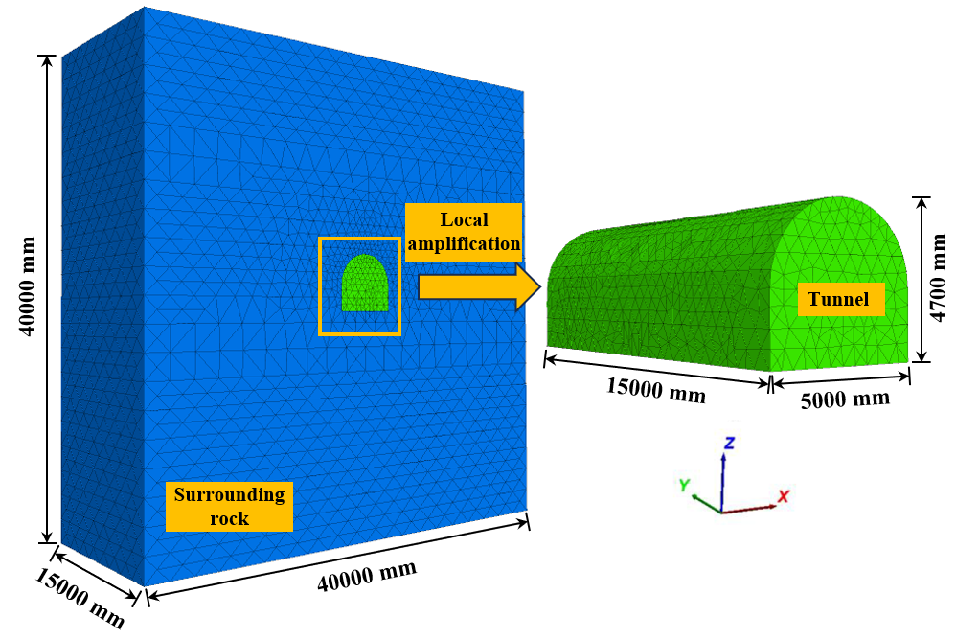 | 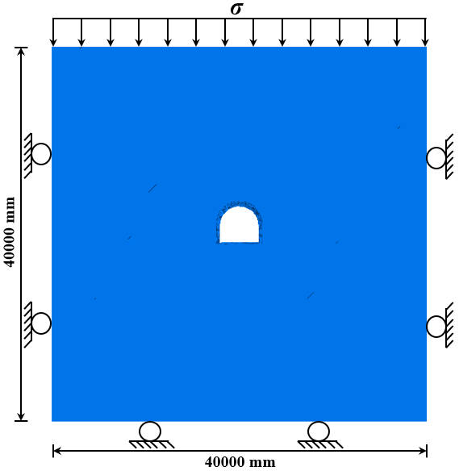
Fig. 1. Numerical model | Fig. 2. Boundary conditions

2.2 Simulation Cases
The numerical analysis focused on the excavation-induced evolution of the stress field in layered surrounding rock. The program interface was used to synchronously record the stress response across the tunnel section during the calculation. Four representative cases were defined according to the bedding dip angle (θ = 0°, 30°, 60°, and 90°) for comparative analysis, as presented in Fig. 3.
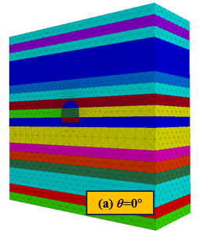 | 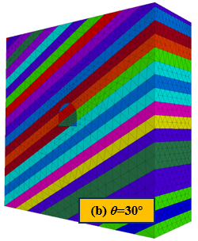 | 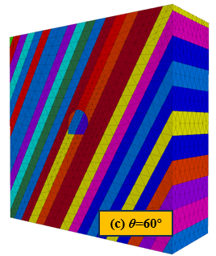 | 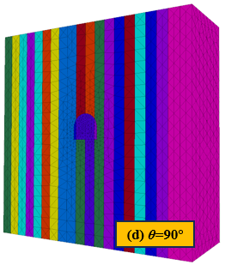
Fig. 3. Numerical simulation scheme

3. Stress-Field Response of Layered Surrounding Rock

3.1 Vertical Stress Distribution
Figure 4 presents the vertical-stress contours for the four bedding configurations. Compressive stress dominates around the excavation, and the red and orange regions denote comparatively large magnitudes of vertical compression. Excavation disrupts the initial vertical stress field and generates pronounced concentration zones near the crown and invert, whereas lower stress levels occur locally around the arch shoulders and sidewalls. The stress contours become progressively more uniform away from the opening, indicating that the vertical-stress disturbance is largely confined to the near-field region. At θ = 0°, the concentration zones above the crown and beneath the invert are regular, and the responses on the two sides of the tunnel are nearly identical. At θ = 30°, these zones shift in the bedding direction, and a left-right difference begins to emerge. A similar bedding-controlled migration persists at θ = 60°, for which the extent of the concentrated stress differs on the two sides. At θ = 90°, the high-stress regions return to the crown and invert and recover an approximately symmetric pattern. Overall, bedding inclination does not change the dominant locations of vertical stress concentration, but it substantially modifies the position and geometry of the concentration zones. Symmetric responses characterize the 0° and 90° cases, whereas the 30° and 60° cases exhibit a clear bedding-oriented offset and asymmetric stress distribution.
(a) θ = 0° | (b) θ = 30°
(c) θ = 60° | (d) θ = 90°
Fig. 4. Vertical-stress contours in the surrounding rock at different bedding dip angles (Pa)

3.2 Horizontal Stress Distribution
The horizontal-stress contours are shown in Fig. 5. Following excavation, horizontal stress is redistributed around the opening. The red and orange zones are concentrated mainly along the sidewalls and extend toward the arch shoulders and feet, while the horizontal compressive stress near the crown and invert is relatively low. As the distance from the tunnel increases, the stress field gradually approaches a uniform state, confirming that the excavation effect is concentrated close to the boundary. For θ = 0°, the high-stress zones adjacent to the two sidewalls have comparable extents and form an approximately symmetric pattern. At θ = 30°, the concentration zones are displaced along the inclined bedding; one side extends toward the arch shoulder, whereas the opposite side develops toward the arch foot. This directional offset remains evident at θ = 60°, and the positions and extents of the high-stress regions differ between the two sides. When θ = 90°, the concentration zones are again centred on the sidewalls, producing a nearly symmetric distribution.
(a) θ = 0° | (b) θ = 30°
(c) θ = 60° | (d) θ = 90°
Fig. 5. Horizontal-stress contours in the surrounding rock at different bedding dip angles (Pa)
Comparison of Figs. 4 and 5 reveals distinct concentration patterns for the two stress components. Vertical compressive stress is concentrated primarily near the crown and invert, whereas horizontal compressive stress is concentrated along the sidewalls and extends toward the arch shoulders and feet. Both components remain broadly symmetric for θ = 0° and 90°. At θ = 30° and 60°, however, the concentration zones migrate in the bedding direction, resulting in pronounced stress asymmetry across the tunnel section.

4. Conclusions
A three-dimensional discrete-element model was developed to investigate the influence of bedding dip angle on stress redistribution around a tunnel excavated in layered rock. The principal findings are summarized as follows:
(1) Tunnel excavation redistributes both the vertical and horizontal stresses in the surrounding rock. The disturbance is most pronounced close to the opening and decreases with distance. Vertical compressive stress is concentrated mainly near the crown and invert, whereas horizontal compressive stress is concentrated along the sidewalls and extends toward the arch shoulders and feet.
(2) For bedding dip angles of 0° and 90°, the vertical-stress field is approximately symmetric, and the concentration zones near the crown and invert remain relatively regular. At 30° and 60°, the vertical-stress concentration zones shift along the bedding direction, leading to unequal distributions and different concentration extents on the two sides of the tunnel.
(3) The horizontal-stress concentration zones are nearly symmetric around the two sidewalls at bedding dip angles of 0° and 90°. For the 30° and 60° cases, these zones are displaced along the bedding direction, extending toward the arch shoulder on one side and toward the arch foot on the other, which produces a marked left-right asymmetry.

Conflict of Interest
No conflict of interest was reported by all authors.

Funding
This paper is supported by the Key Project of the Science and Technology Research and Development Program of China State Railway Group Co., Ltd. (No. N2024G049) and the Enterprise commissioned projects (No. H26-050)

References
[1] Ji H, Yang S, Qi N, et al. Crack propagation behaviour and parameter optimization for tunnel blasting in layered jointed rock masses [J]. Journal of Mining Science and Technology, 2026, 11(2): 328-338. DOI: 10.19606/j.cnki.jmst.2025120.
[2] Ministry of Transport of the People's Republic of China. Statistical bulletin on the development of the transport industry in 2023 [J]. China Water Transport, 2024, (15): 31-35.
[3] Liu B. Analysis of rock mass stability in horizontally layered tunnels excavated by the full-face method under fault influence [J]. Journal of Municipal Technology, 2026, 44(2): 155-164.
[4] Chen F, Qiu Y, Yan Q, et al. Anisotropic mechanical properties of layered surrounding rock in tunnels [J]. Modern Tunnelling Technology, 2026, 63(1): 53-65. DOI: 10.13807/j.cnki.mtt.2026.01.006.
[5] Meng Y, Jing H, Yuan L, et al. Numerical investigation on the effect of bedding plane properties on mode I fracture characteristics of mudstone with the FEM-CZM method [J]. Bulletin of Engineering Geology and the Environment, 2022, 81(1): 3. DOI: 10.1007/s10064-021-02515-9.
[6] Amadei B, Pan E. Gravitational stresses in anisotropic rock masses with inclined strata [J]. International Journal of Rock Mechanics and Mining Sciences & Geomechanics Abstracts, 1992, 29(3): 225-236. DOI: 10.1016/0148-9062(92)93657-6.
[7] Miao Q. Stability analysis of a tunnel in layered rock under high horizontal stress [J]. Journal of Highway and Transportation Research and Development, 2025, 42(2): 196-206.
[8] Zhu G, Zhang F. Deformation mechanism and failure modes of shield-tunnel surrounding rock under different bedding dip angles [J]. Subgrade Engineering, 2025, (3): 219-224.
[9] Gan P. Influence of bedding-plane dip angle on the stability of surrounding rock in tunnels crossing layered strata [J]. Western China Communications Science & Technology, 2024, (11): 133-135, 169.
[10] Liu J, Fang X, Fang Q, et al. Deformation and failure mechanisms of shallow-buried tunnels in inclined layered rock and a calculation method for geological bias loads [J]. Tunnel Construction, 2024, 44(S2): 101-107.
[11] Wang X, Lv X, Liang M, et al. Deformation behaviour and progressive failure mechanism of horizontally layered surrounding rock [J]. Science & Technology Information, 2024, 22(8): 140-142.
[12] Zhang T. Deformation characteristics of a large-section high-speed railway tunnel in gently inclined layered rock [J]. Traffic Engineering and Technology for National Defence, 2023, 21(3): 22-26.

