Spatial Distribution Patterns of Traditional Villages and Their Influencing Factors in the Southeastern Shanxi Region

Wenjie Yu¹, Jichen Shen², Rong Peng¹

¹School of Urban Construction, Yangtze University, Jingzhou 434023, Hubei, China

²School of Urban Construction, Jingzhou University, Jingzhou 434020, Hubei, China

Copyright: © 2026 Author(s). This is an open-access article distributed under the terms of the Creative Commons Attribution License (CC BY 4.0), permitting distribution and reproduction in any medium, provided the original work is cited.

Abstract: The study of the overall spatial distribution of traditional villages is of great significance for a comprehensive understanding of traditional villages from the perspectives of nature, economy, society, and culture. Taking the top six batches of national level traditional villages in Southeastern Shanxi as the research object, this study quantitatively investigates the factors affecting the spatial distribution of traditional villages using methods such as nearest neighbor index, Moran index, and quantitative geography. The study explores the factors such as terrain, watershed, and transportation that affect the spatial distribution of traditional villages. The results show that: 1) the overall distribution of traditional villages in Southeastern Shanxi presents a clustered geographical spatial feature, with a distribution pattern of “dual cores and one belt”. 2) The spatial distribution of traditional villages is the result of the combined effects of terrain, water systems, economic development level, transportation network, and other factors. The natural environment is the basic factor affecting distribution, while cultural economy is the internal driving force for village development. Based on the above results analysis, it is necessary to actively explore a cluster based protection framework for the current situation of traditional village protection in Southeastern Shanxi. According to the different degrees of impact of each element on traditional villages, the connection and role between each element should be strengthened as a reference for formulating differentiated policies.
Keywords: Southeastern Shanxi; Traditional villages; Spatial distribution pattern; Influencing factors

Online publication:

1. Introduction
Traditional villages have rich material and intangible cultural heritage, and are relatively complete spatial forms created by humans to adapt to different natural environmental conditions. Their formation, distribution, evolution, and development showcase unique humanistic ecology, social development trajectory, and historical and cultural memory ^{[1]}. However, as China enters a stage of rapid urbanization, industrial civilization gradually infiltrates and devours agricultural civilization. The large number of traditional villages in Southeastern Shanxi is difficult to effectively protect and is gradually declining, and there are weak connections between villages. Therefore, in-depth investigation and analysis should be conducted on traditional villages, and a comprehensive analysis and research of villages should be carried out. This is not only conducive to exploring methods for protecting traditional villages, but also has important theoretical and practical significance. In recent years, with the increasing attention paid by the country to historical and cultural heritage and the introduction of various policies, the Ministry of Housing and Urban Rural Development and the Ministry of Finance issued the “Notice on Doing a Good Job in the Demonstration Work of Centralized Protection and Utilization of Traditional Villages in 2022”, which further reflects the need to study the protection and development of traditional villages from a holistic perspective. Traditional villages are no longer separate individuals, but are organically connected with other traditional villages as a whole ^{[2]}.
This article takes the Southeastern region of Shanxi Province, which has a strong correlation between culture and nature, as the research scope. The first six batches of national-level traditional villages are selected as the research objects, focusing on the spatial distribution characteristics and correlation analysis of traditional villages. Based on the identification of the overall spatial situation and pattern of traditional villages in Southeastern Shanxi Province, quantitative methods are applied to analyze the correlation between factors and traditional villages. The strength, types, and mechanisms of the correlation between factors and traditional villages are explored, providing a basis for the development of a comprehensive protection framework for traditional villages.

2. Research area, data and methods
2.1. Research area
The Southeastern region of Shanxi, also known as the Shangdang area, including Changzhi City and Jincheng City, is the intersection of the Han land in the Central Plains, northern ethnic groups, eastern coastal areas, and northwestern inland areas. It has diverse historical and cultural sources and obvious regional social characteristics. It is a relatively independent cultural and geographical unit within Shanxi Province. To the east is the Taihang Mountains, to the west is the Taiyue Mountains, and to the center are the Changzhi and Jincheng basins. The main terrain and landforms include basins, hills, mountains, and river valleys. The Qin River, Dan River, and Zhuozhang River that flow through them create fertile land and abundant water resources at the bottom of mountain streams; Four distinct seasons, mild climate, belonging to temperate continental climate; The suitable land and climate conditions make the two basins the core areas for urban agglomeration and agricultural development.

2.2. Research methods
The study of spatial characteristics in urban and rural planning and geography tends to construct geographic models to reveal them. Such as the nearest neighbor index, Moran index, Gini coefficient, etc ^{[3]}. Using ArcGIS spatial analysis tools and Excel, a quantitative study was conducted on the spatial distribution of traditional villages in Southeastern Shanxi, and kernel density calculations were carried out. This study explores the spatial distribution characteristics of traditional villages in Southeastern Shanxi and attempts to explore the mechanism of the evolution process of distribution space. The specific model interpretation is shown in Table 1.

Table 1. Spatial model and its geographic significance
Index | Model | Model definition | Geographical significance
Nuclear density analysis method | $$f\left(x\right)=\frac{n}{nh}\sum_{i=1}^{n}{K(\frac{x-x_{i}}{h})}$$ | ｘ_{i} represents the point position coordinates of traditional village i (i=1, 2,..., n), n represents the number of traditional villages, ｈis the search radius calculated by kernel density, and ｋrepresents the kernel function; | Characterize the degree of balance in the density of each point element within a certain range around it.
Nearest neighbor index | $$R=\frac{\begin{aligned}- \\ r_{1}\end{aligned}}{r_{E}}=\begin{aligned}- \\ r_{1}\end{aligned}÷\frac{1}{2\sqrt{\frac{m}{A}}}$$ | R represents the nearest neighbor index; r₁ represents the average actual distance between each point and its nearest neighbor; r₁ is the actual distance between each point and the nearest point; r_{E} is the theoretical nearest distance; m is the number of points; A is the area of the region; | Study the degree of proximity between traditional villages as point targets in space. When R=1, it indicates that traditional villages are randomly distributed among each other; When R>1, traditional villages tend to be evenly distributed; When R<1, traditional villages exhibit clustering characteristics.
Moran index method | $$I=Z_{i}\sum_{i=1}^{n}{W_{ij}Z_{j}}$$ | I is Moran’s index; Z_{i} and Z_{j} represent the standardized values of the observed values of the i and j spatial units, respectively; W_{ij} is the spatial weight. Divided into four categories based on clustering relationships: high high clustering (HH); High Low Agglomeration (HL); Low high agglomeration (LH); Low Low Agglomeration (LL); | Characterize the spatial correlation between a point like feature and adjacent points.

3. Spatial distribution characteristics of traditional villages in Southeastern Shanxi province
3.1. Spatial distribution types
Using the nearest neighbor index to estimate the degree of proximity of traditional villages in the Southeastern Shanxi region, analyze the distribution types of traditional villages within the geographical scope, and deconstruct the spatial characteristics and distribution patterns of traditional villages from a macro perspective. Calculate the nearest neighbor index based on the average distance between the expected nearest elements for each element, using the “Average Nearest Neighbor” function in ArcGIS 10.4. The results are as follows: r₁ = 0.396, r_{E} = 0.472; R = r₁/r_{E} = 0.83, the ratio of the actual nearest neighbor distance to the mean is R = 0.83 < 1. Therefore, according to the geographical interpretation of the “nearest neighbor index” model in Table 1, traditional villages in Southeastern Shanxi Province generally exhibit a clustered distribution at the regional macro level. In order to further verify the accuracy of its results, based on the geographical interpretation of the “coefficient of variation” model in Table 1, the coefficient of variation of the Voronoi diagram in Southeastern Shanxi was calculated. The results are as follows: the average area and standard deviation of Voronoi polygons in southwestern Shanxi are 88.93 km² and 212.33 km², respectively, and the coefficient of variation value is 238.75% > 64%, indicating that traditional villages in Southeastern Shanxi are spatially clustered, which once again confirms the conclusion drawn from the nearest neighbor index. See Figure 1.

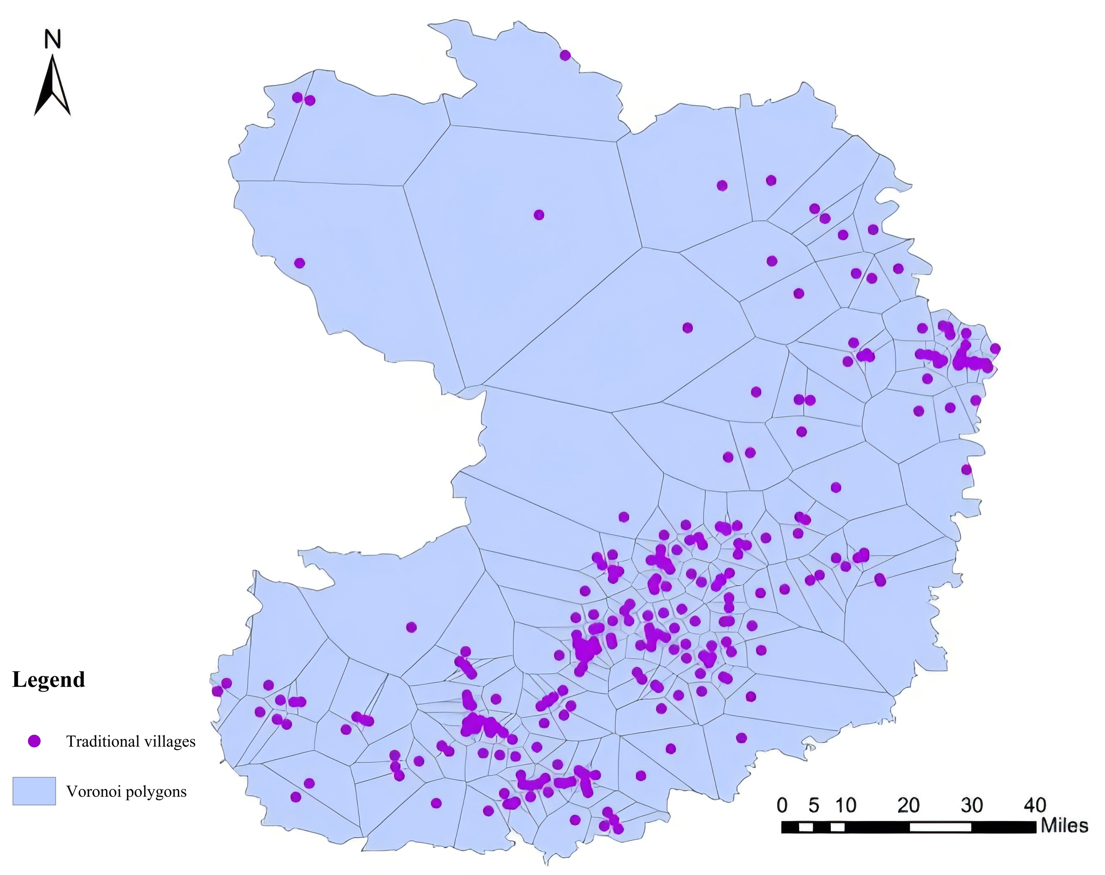
Figure 1. Voronoi polygon of traditional villages in southeastern Shanxi Province.

3.2. Spatial distribution balance
In order to analyze the spatial distribution density and balance of traditional villages in Southeastern Shanxi, ArcGIS 10.4 “Kernel Density” tool was used for kernel density analysis. From the overall spatial distribution of core density, traditional villages in Southeastern Shanxi have a higher distribution density in the Taiyue Mountain Zezhou Basin and Taihang Mountain Zhuozhang River areas, forming two obvious high concentration areas and a transitional diffusion zone, presenting an overall spatial structure of “two cores and one belt”. From different batches, the first three batches of traditional villages in Southeastern Shanxi initially clustered in the Zezhou Basin and Zhuozhang River Basin, with a small number of scattered villages in the central region; The fourth and fifth batches of traditional villages are further clustered based on the clustering areas formed in the previous three batches, consolidating and strengthening the core position of the two clustering areas; The sixth batch of traditional village core density shows a clear trend of diffusion from the core to the surrounding areas, forming a transitional diffusion zone connecting the two core clusters. See Figure 2.

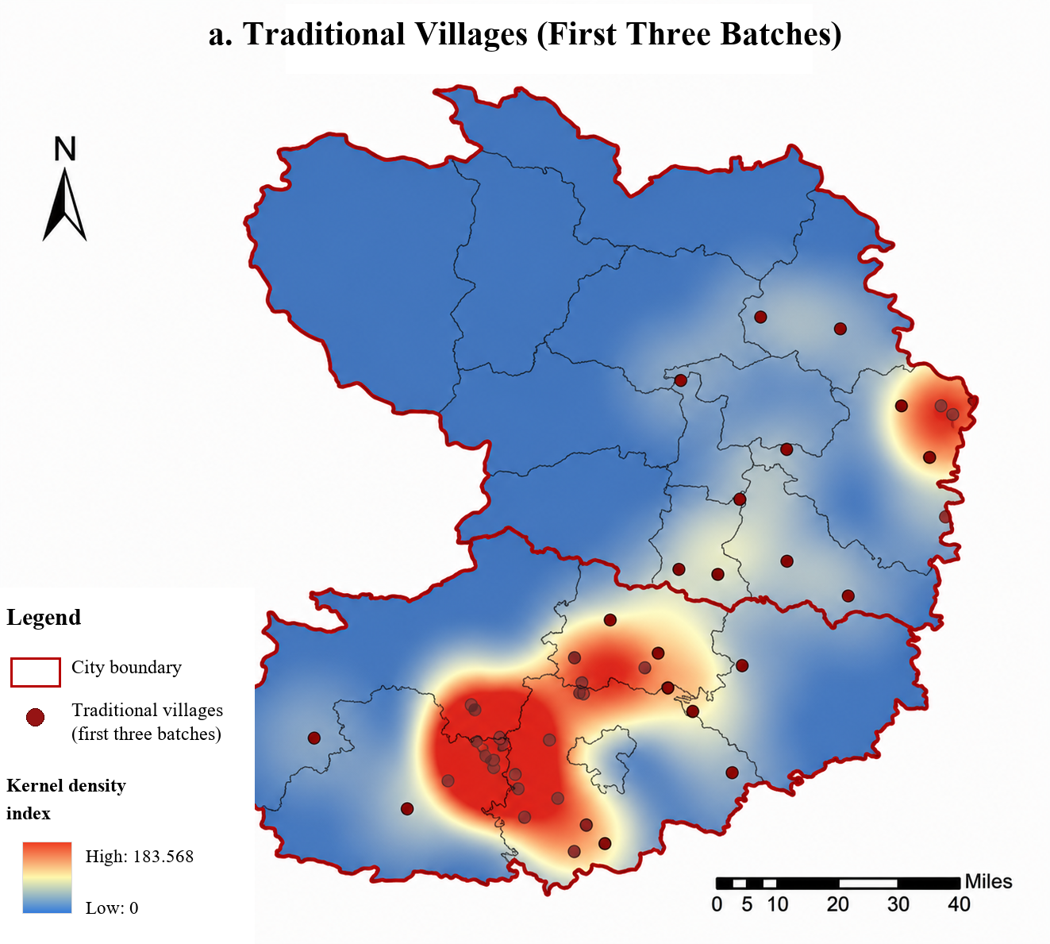 |  |  | 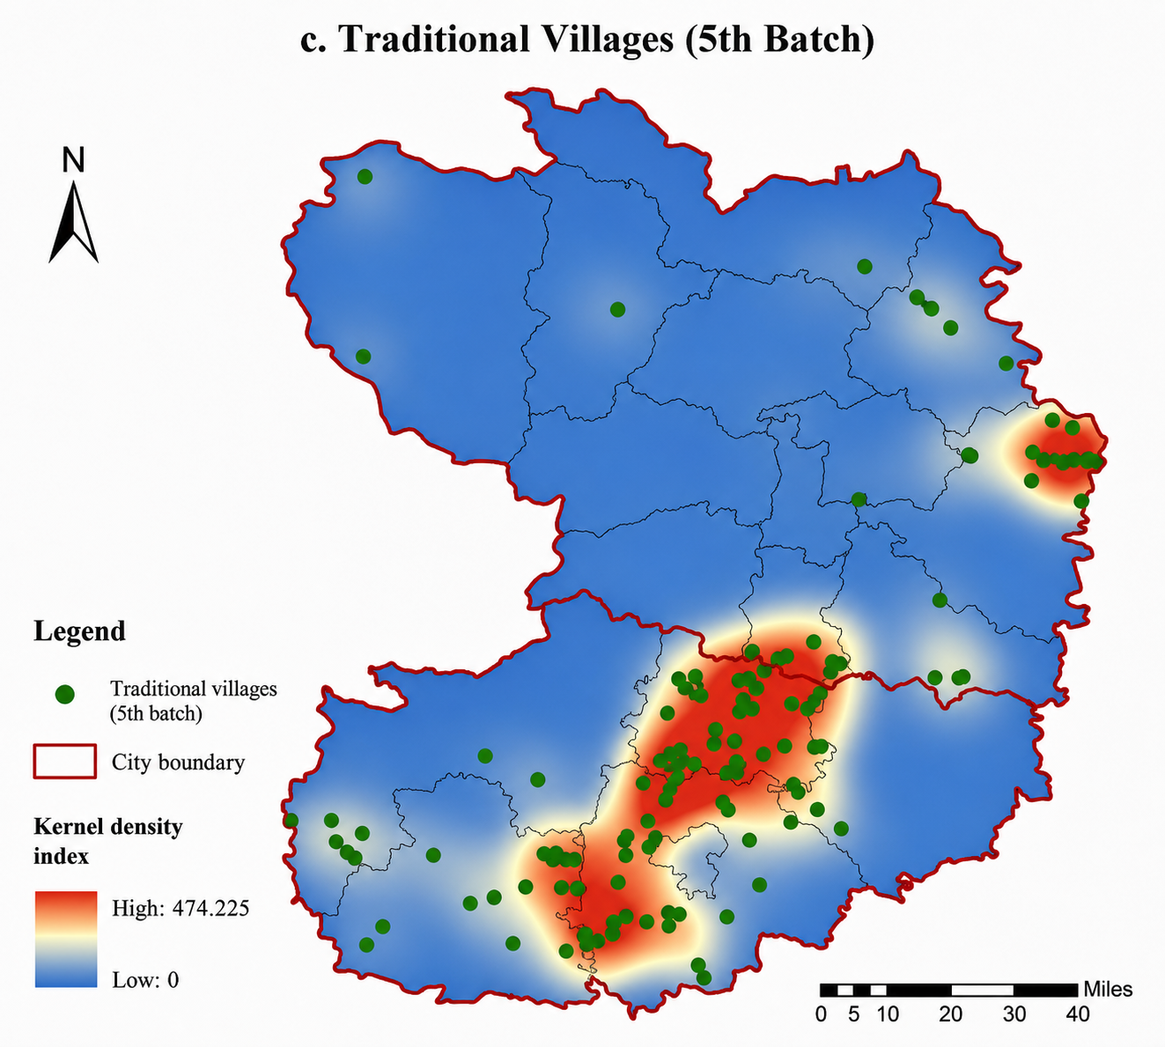
Figure 2. Distribution of nuclear density in southeastern Shanxi Province.

4. Factors influencing the spatial distribution of traditional villages
4.1. Natural environmental factors
4.1.1. Topography and geomorphology
As a fundamental element of the natural geographical environment, topography and landforms have influenced the distribution pattern and spatial structure of traditional villages. Overlay the distribution map of traditional villages in Southeastern Shanxi with the topographic map, extract the elevation information of traditional village landing points using ArcGIS 10.4 tool, and conduct spatial autocorrelation analysis of elevation using Anselin Local Moran’s I tool ^{[4]}. The results of natural discontinuity grading indicate that there are three elevation ranges, with 139 traditional villages within the range of 744–1008 m, accounting for 52.85%, and 71 traditional villages within the range of 484–783 m, accounting for 26.99%. The spatial autocorrelation analysis of elevation has generated three types of clustered villages: high high, high low, and low low. Among them, there are a total of 73 clustered villages in the low low type, accounting for 27.75%, all distributed in areas below 743m, and forming village clusters in low-altitude alluvial plains, mountains, and mid-altitude mountainous areas, which are conducive to production and life and have a high degree of consistency with the overall distribution pattern of traditional villages. There are a total of 56 villages in the high high cluster, accounting for 21.29%, with the characteristics of “high altitude, low density”. They form a relatively homogeneous village cluster in the central area, which is less compact compared to the low low cluster villages. The reason for this is that the high high cluster villages are located in complex geographical locations with steep slopes, which to some extent separates the traditional spatial distribution pattern of villages and forms relatively dispersed village clusters.
The above analysis indicates a strong correlation between terrain and traditional village distribution. In areas with low terrain and flat terrain, villages are mainly engaged in agricultural production, which is influenced by water sources, soil, climate and other conditions. Terrain and landforms are the basis for creating these conditions. Therefore, the selection of village sites attaches great importance to the examination of terrain and landforms, such as Runcheng Village and Laoshen Village, which have gradually developed into relatively dense and compact village clusters; In the Shangdang Basin, which is rich in terrain and landforms, the basin area has good agricultural production and geographical location conditions. The densely populated villages formed by the Shangdang Basin have a clustered and homogeneous distribution characteristic. See Figure 3.

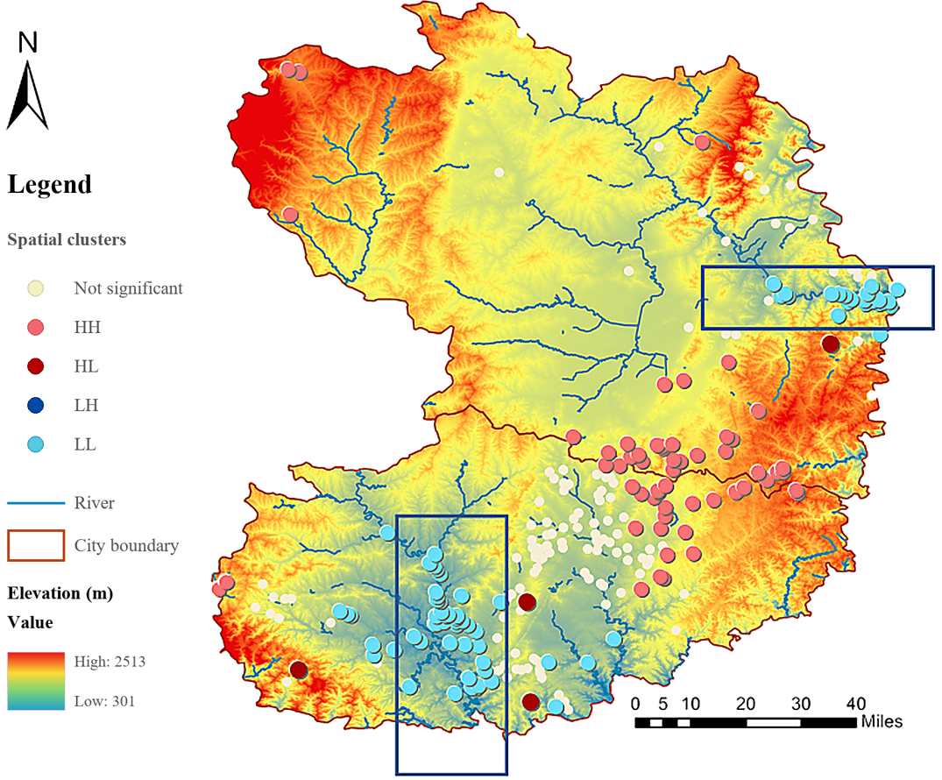
Figure 3. Autocorrelated LISA analysis of terrain and landforms.

4.1.2. Hydrology
From ancient times to the present, the vast majority of village settlements have been built on water, which not only affects the water resources and defense security of rural settlements, but also to some extent affects the site selection and development evolution of villages ^{[5]}. After multiple comparisons of data selection effects, a multi-ring buffering analysis was conducted on rivers in the Southeastern Shanxi region using circular distances of 2 km and 5 km. Within a 5 km radius of the water system, there are 190 traditional villages, accounting for 72.24%; There are 116 traditional villages within a 2 km radius of the water system, accounting for 44.10%; Village settlements have obvious characteristics of hydrophilicity and water tendency. (Figure 4 and 5)

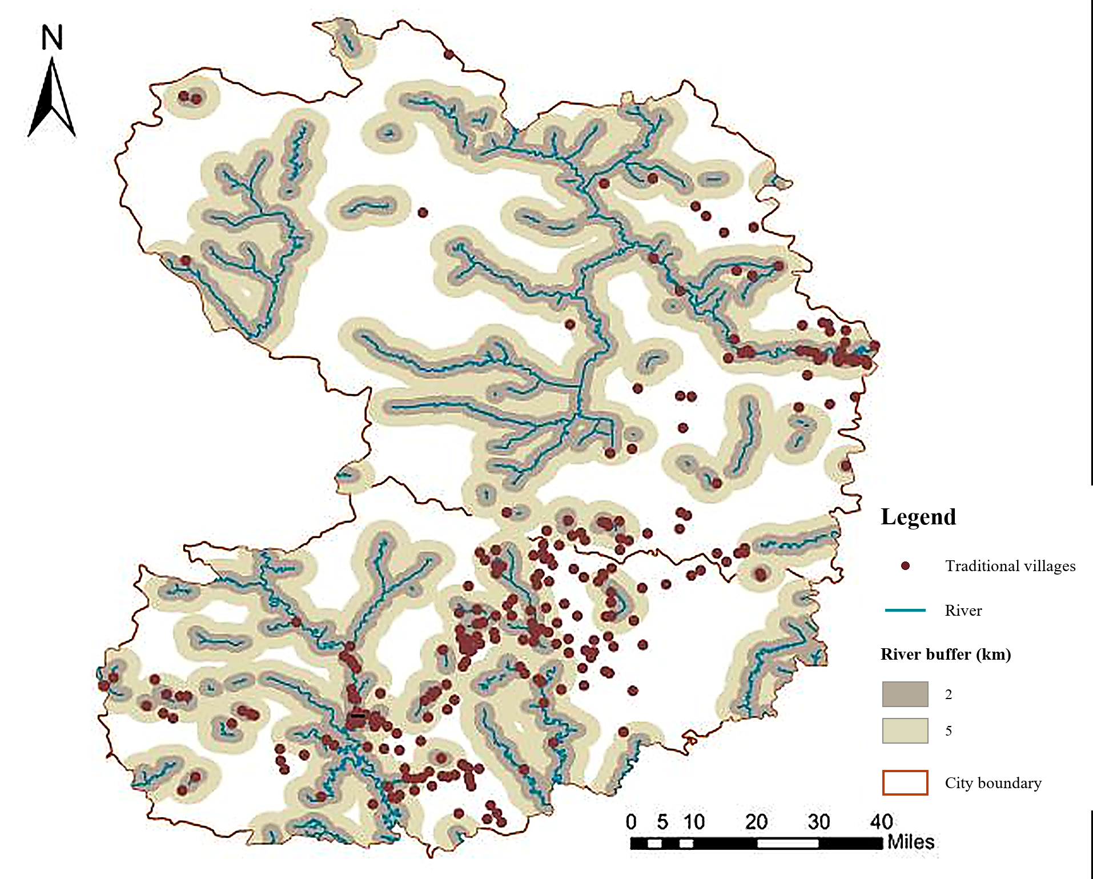 | 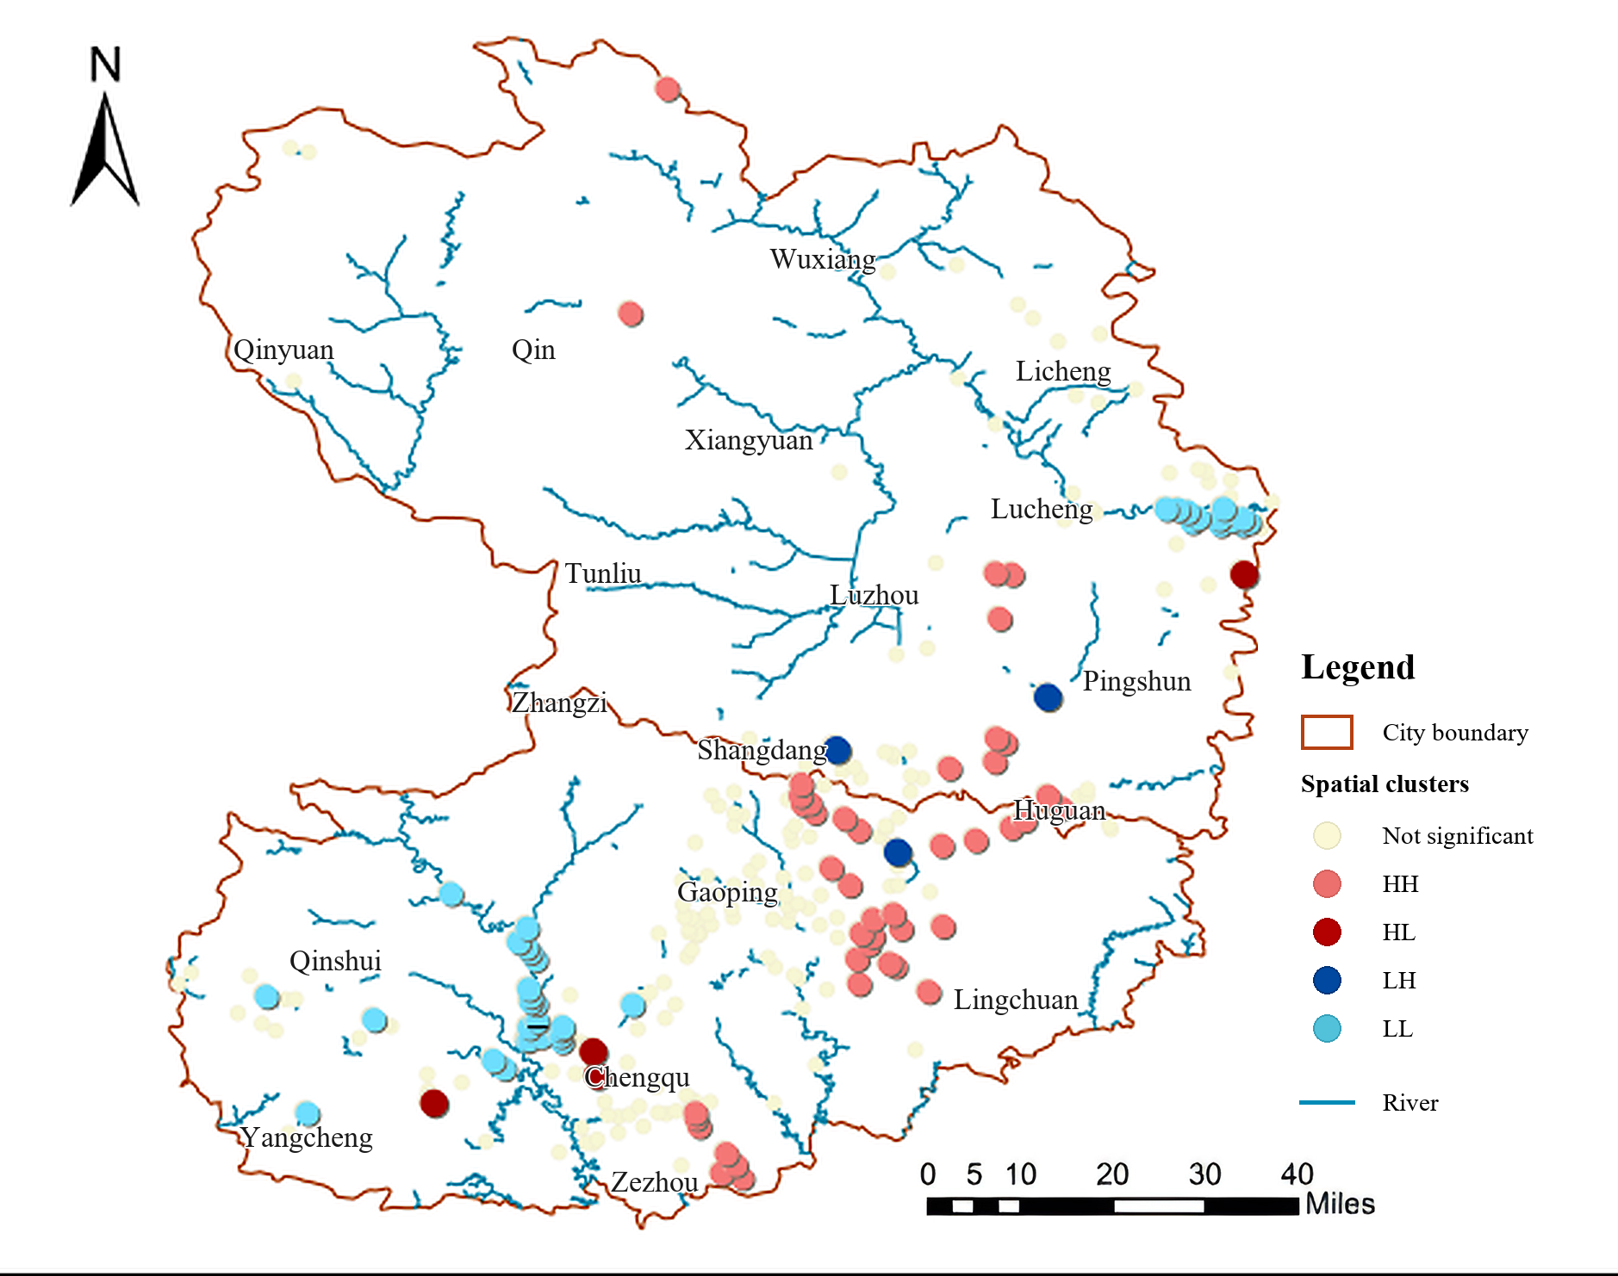
Figure 4. Analysis of multi-ring buffer in rivers | Figure 5. Autocorrelated LISA analysis of water system.

Secondly, spatial self-analysis was conducted on the water system, resulting in four types of village clustering, with a total of 37 villages classified as low low clusters, accounting for 14.07%; There are a total of 43 high type clustered villages, accounting for 16.35%; The low low cluster villages are concentrated in the Qin River and Zhuozhang River basins, while the high high cluster villages are more dispersed compared to the low low cluster villages. Although the dense part of the villages coincides with the central dense area of the distribution pattern, due to weaker correlation and interaction with the water system, the former village settlements are not as compact and tightly arranged as the low low cluster villages, further indicating that the water system is a key factor affecting the spatial distribution of traditional villages. From the perspective of spatial layout, the village clusters in both the Qinhe River Basin and the Zhuozhang River Basin have the characteristic of strip-shaped distribution along the main stream. Unlike the village clusters in the Zhuozhang River Basin, the Qinhe River Basin has a large number of river branches and a wide distribution, forming a spatial distribution pattern of small-scale aggregation around tributaries, in addition to the main stream.

4.2. Socio-economic factors
4.2.1. Transportation location
Road traffic is the material carrier for the mutual flow and interaction of various factors between urban and rural areas, playing a crucial role in the rise and fall of villages and the socio-economic development ^{[6]}. Establish a density attribute data table for various transportation arteries in the Southeastern Shanxi region in GIS, classify the road network density into natural discontinuity levels, and assign them to traditional villages in the region for spatial autocorrelation analysis. The results of spatial autocorrelation analysis show that there are a total of 73 high high type clustered villages, accounting for 27.75%, concentrated in the central part of the region, with a high degree of consistency with the village clusters formed in Gaoping City and Shangdang District. The impact of transportation on traditional village agglomeration is positively correlated. There are a total of 75 low type clustered villages, accounting for 28.51%, distributed in Qinshui, Yangcheng, and Pingshun counties with low road network density. Transportation has a negative correlation with the clustering of traditional villages. (Figure 6)

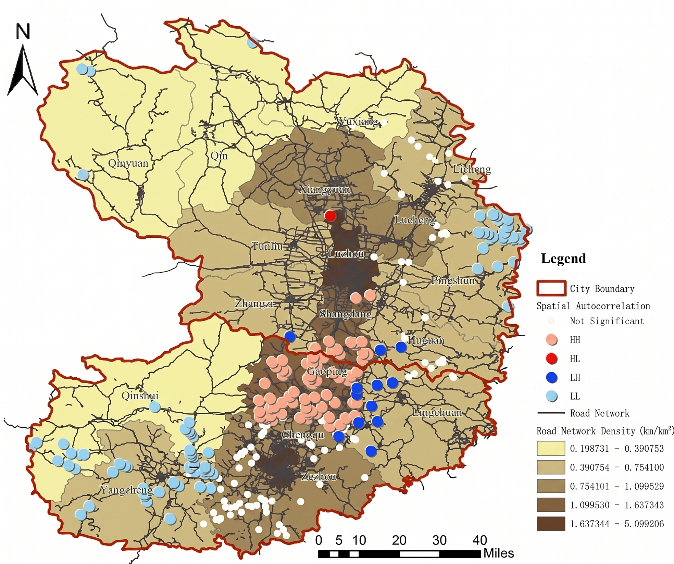
Figure 6. Autocorrelated LISA analysis of road network density.

The results indicate that there are mainly two types of village clusters, among which the formation of the central village cluster is due to the fact that there were post roads from Taiyuan to Zezhou that passed through Gaoping City and Shangdang District in the early Ming Dynasty, and became an important transportation route in Shanxi Province during the Qing Dynasty, laying a good foundation for the current dense transportation network in the central region. On the one hand, villages rely on their advantages of goods distribution and transportation hubs to grow and develop, with a higher degree of interaction and connection with the outside world, and relatively less difficulty in protection, thus creating the traditional village distribution characteristics of “high-density, high clustering” in the central region. On the other hand, the village clusters in the southwestern and eastern parts of the region are due to the low road network density and relatively poor accessibility and accessibility in the counties where they are located, resulting in an undisturbed and independent environment, thus forming the traditional village distribution characteristics of “low-density, low clustering”.

4.2.2. Per capita GDP
Integrate the gross domestic product and total population of each district and county in Southeastern Shanxi Province from the 2021 Statistical Yearbook, obtain the basic data of per capita GDP, use the natural breakpoint grading method for visualization, and overlay analysis with the overall layout of traditional villages. From the graph results, the top three counties in terms of economic development level are Qinshui County, Qinyuan County, and Xiangyuan County, with per capita GDP of 170000 yuan/person, 132000 yuan/person, and 123300 yuan/person, respectively. Among them, Qinshui County has 19 traditional villages, which are few in number and have not formed a dense high cluster of villages compared to Zezhou County. The economic development level of Pingshun County, Qin County, and Lingchuan County is relatively low, all below 30000 people per person. Among them, Pingshun County and Lingchuan County have 30 and 16 traditional villages respectively. The low low cluster villages are mainly concentrated in the Southeastern of Pingshun County. Although there are also some counties with low per capita GDP that have low low low cluster villages, their layout is relatively scattered, the density is small, and the compactness is low. (Figure 7)

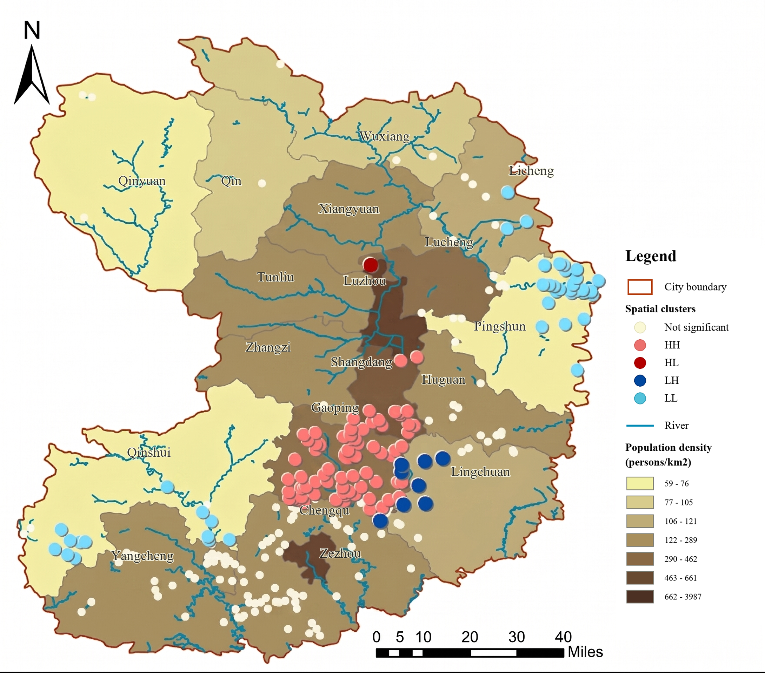
Figure 7. Autocorrelated LISA analysis of population density.

Overall, per capita GDP can indirectly reflect the level of economic development in a region and has a complex correlation with the distribution pattern of traditional villages. For example, although Zezhou County has a moderate ranking in per capita GDP, the correlation between traditional village agglomeration and factors such as water systems, topography, and transportation location is higher, and the correlation between economic development and it is weaker; The per capita GDP of Pingshun County, as an important factor, not only affects the density of road networks and the level of urban construction in the region, but also indirectly affects the distribution pattern of traditional villages.

5. Conclusion and reflection
The spatial distribution characteristics of traditional villages in Southeastern Shanxi are formed by the interaction of numerous factors, among which natural factors are the basis, and gradually social, economic, and historical cultural factors are the dominant influencing factors. The factors that affect the spatial distribution of traditional villages constitute a system of mutual interaction and influence. This article takes the first six batches of 263 traditional villages in Southeastern Shanxi as an example to analyze the overall spatial distribution pattern and influencing factors of their traditional villages. The results show that:
(1) The overall distribution of traditional villages in Southeastern Shanxi presents a clustered geographic spatial feature, with an overall distribution pattern of “dual cores and one belt”;
(2) The spatial distribution of traditional villages is the result of the combined effects of terrain, water systems, economic development level, transportation network, and other factors. Specifically, the natural environment is the fundamental element that influences the distribution pattern of traditional villages, determining their spatial structure and distribution patterns; Economic and cultural factors are endogenous factors driving the evolution and development of traditional villages.
Based on the research on the distribution characteristics and influencing factors of traditional villages in Southeastern Shanxi, there are three considerations for the protection of traditional villages in Southeastern Shanxi. Firstly, there are numerous traditional villages in Southeastern Shanxi with high cultural connections, and the overall distribution of villages presents a clustered pattern. Therefore, it is necessary to explore a cluster-based protection framework for traditional villages, integrate various resources such as culture, tourism, and infrastructure, so as to form a benign two-way flow between villages and village clusters, and drive the overall development of traditional villages in Southeastern Shanxi. Secondly, cluster development should be guided by higher-level planning and relevant planning, combined with the actual situation of the natural environment, historical and cultural circles, transportation location, and population distribution of villages in Southeastern Shanxi, to delineate contiguous protection areas and protection types, and to unify and integrate eligible villages. Thirdly, taking into account various factors that have varying degrees of impact on the location of traditional villages, differentiated strategies should be developed for the protection and development of villages based on their geographical environment characteristics, cultural features, and economic level differences. These strategies should strengthen the connections between various factors, protect and enhance the individual value of villages, and promote the overall value enhancement of traditional villages in Southeastern Shanxi.

Disclosure statement
The authors declare no conflict of interest.

References

[1] Hu Y, Chen S, Cao W, et al., 2014, Concept and Cultural Connotation of Traditional Villages. Urban Development Studies, 21(1): 10–13.

[2] Zhang H, Cai J, Xiao S, et al., 2020, Spatiotemporal Distribution and Evolution Characteristics of Traditional Villages in the Taihang Mountain Area. Urban Planning Review, 44(8): 90–97.

[3] Guan Z, Wang T, Zhi X, 2017, Spatiotemporal Pattern and Formation Mechanism of Traditional Villages in the Central Plains Economic Zone. Economic Geography, 37(9): 225–232.

[4] Liu D, Hu J, Chen J, et al., 2014, Spatial Distribution Pattern of Traditional Villages in China. Chinese Journal of Population, Resources and Environment, 24(4): 157–162.

[5] Yu L, Meng X, 2016, Extracting Spatial Distribution of Chinese Traditional Villages Based on Geographic Grid Classification. Progress in Geography, 35(11): 1388–1396.

[6] Gao N, Wu C, Bai K, et al., 2020, Spatial Differentiation and Influencing Factors of Traditional Villages in China. Journal of Shaanxi Normal University (Natural Science Edition), 48(4): 97–107.

Publisher’s note
Bio-Byword Scientific Publishing remains neutral with regard to jurisdictional claims in published maps and institutional affiliations.

