The Generative Mechanism of AIGC-Enabled Digital Revitalization of Intangible Cultural Heritage from a Cultural Memory Perspective
Guanyue Chen*
Renmin University of China, Beijing 100872, China
*Corresponding author: Guanyue Chen, 1802375478@qq.com

Copyright: © 2026 Author(s). This is an open-access article distributed under the terms of the Creative Commons Attribution License (CC BY 4.0), permitting distribution and reproduction in any medium, provided the original work is cited.

Abstract: With digital technologies increasingly embedded in systems of cultural production and dissemination, the protection of intangible cultural heritage (ICH) is shifting from static preservation toward digital expression, contextualized interpretation, and dynamic regeneration. As an intelligent content-generation technology, AIGC can reorganize ICH materials across text, images, audio, video, virtual characters, and interactive narratives. From the perspective of cultural memory, this article regards ICH as a living repository of experience, local knowledge, communal interaction, and identity. It examines persistent problems in current ICH digitization, including data-oriented display, fragmented dissemination, weakened subjectivity, and cultural distortion. The paper argues that AIGC can support the digital revitalization of ICH through five linked stages: cultural memory extraction, semantic reconstruction, multimodal translation, interactive co-creation, and value transformation. AIGC should not replace traditional transmission. Rather, through data organization, narrative reconstruction, media translation, and public participation, it can help transform preserved cultural resources into cultural memories that are understandable, experiential, and shareable. At the same time, authenticity verification, the central role of inheritors, data-source standardization, intellectual-property protection, and algorithmic-ethics governance should be built into a multi-actor collaborative process for ICH revitalization.
Keywords: Cultural memory; AIGC; Intangible cultural heritage; Digital revitalization; Generation mechanism

Online publication:

1. Introduction
Intangible cultural heritage refers to living practices, knowledge systems, aesthetic forms, and spiritual symbols created and transmitted by communities over time. It is practical, communicative, and rooted in everyday life. Against the pressures of urbanization, modernization, and changing media environments, some ICH projects now face aging inheritor communities, limited youth participation, and weak channels of dissemination. How to use digital technology for effective preservation, communication, and renewal has therefore become an important issue in the promotion of ICH.
Artificial intelligence-generated content (AIGC) is a rapidly developing mode of intelligent content production. Recent reviews show that AIGC has expanded from text generation to images, video, 3D assets, audio, and cross-modal generation, with the goal of producing new digital content in response to user intent and domain knowledge ^{[1]}. For ICH, AIGC can generate story scripts, exhibition texts, interactive Q&A, process illustrations, virtual inheritor images, and immersive experiential content based on existing materials. These functions provide new means for expressing and disseminating ICH. Cultural heritage research also notes that the use of generative AI raises questions about human agency, authorship, interpretive authority, and the future of cultural heritage ^{[2]}. When AI is used to interpret and classify cultural heritage, biased or incomplete data may produce imbalance and misinterpretation ^{[3]}.
Cultural memory theory emphasizes that culture is not merely individual knowledge or a set of symbols. It is a process of meaning that is continually recalled and reproduced through rituals, stories, media, spaces, and collective activities. ICH, as a living culture, carries the collective memory of communities, local historical experience, and shared identity. Studies on social memory and ICH protection show that ICH is not only a form of cultural diversity but also an important basis for social identity, ethical value, and cultural continuity ^{[4]}. Therefore, research on AIGC-enabled digital revitalization of ICH should move beyond a narrow view of technological application and examine how technology extracts, translates, shares, and reproduces cultural memory. On this basis, this paper takes the generative mechanism of AIGC-enabled digital revitalization of ICH from a cultural memory perspective as its topic. It asks how cultural memory explains the internal logic of digital revitalization, what generative role AIGC plays, and how a revitalization mechanism that balances authenticity, dissemination, and vitality can be constructed.

2. The generative mechanism of AIGC-enabled digital revitalization of intangible cultural heritage
2.1. Cultural memory extraction mechanism
Cultural memory extraction provides the resource foundation for AIGC-enabled digital revitalization of ICH. ICH resources need to be organized around historical sources, local legends, craft techniques, ritual scenes, oral accounts, tools and materials, movement patterns, colors, and social functions. AIGC can assist with text summarization, keyword extraction, topic identification, and knowledge-tag generation, thereby providing a basis for subsequent content generation ^{[5]}.

2.2. Semantic reconstruction mechanism
Semantic reconstruction is the process of transforming scattered ICH knowledge into understandable narratives. AIGC can generate exhibition explanations, short-video scripts, course materials, interactive Q&A, and cultural tourism guide texts. Research on the digital dissemination of ICH shows that dissemination effects are shaped by subjects, content, media, and audience feedback ^{[6]}. Therefore, semantic reconstruction aims to make cultural memory easier for the public to understand and accept.

2.3. Multimodal translation mechanism
ICH is inherently multimodal. Traditional dance involves body movements and rhythms; traditional music depends on vocal styles and melodies; and traditional handicrafts involve materials, textures, processes, and patterns. AIGC can translate ICH knowledge into images, animations, audio, video, 3D scenes, and virtual characters, enabling ICH to move from static display to dynamic experience.
Existing research on the embodied digitization of ICH indicates that digitization should focus on bodily movement, practice, and experience rather than image quality alone ^{[7]}. Multimodal translation should therefore serve the perception of cultural memory, not merely the display of visual representations.

2.4. Interactive co-creation mechanism
Living ICH gains vitality through practice and participation. AIGC can lower the threshold for public participation in ICH content creation: users can create design sketches based on traditional patterns, write short stories based on local legends, or simulate craft processes in virtual workshops.
Interactive co-creation, however, should not turn ICH into standardized or decontextualized content. Platforms should clearly identify core cultural-value elements, creative components, and content sources so that innovation is encouraged while cultural misuse is avoided.

2.5. Value transformation mechanism
AIGC-enabled digital revitalization of ICH should promote the cultural, educational, aesthetic, and economic value of ICH in contemporary society. Studies of digital twin platforms show that traditional handicrafts can be preserved and shared more concretely through digital models, scene displays, and interactive systems ^{[8]}. At the same time, ICH value can serve education, cultural tourism, cultural and creative industries, and public cultural sharing; it should not be reduced to traffic and commercial interests at the expense of cultural essence.

3. Practical paths for AIGC-enabled digital revitalization of intangible cultural heritage
AIGC-enabled digital revitalization of ICH requires a closed loop that includes resource collection, memory organization, content generation, human review, application, and feedback. The implementation process is shown in Figure 1.

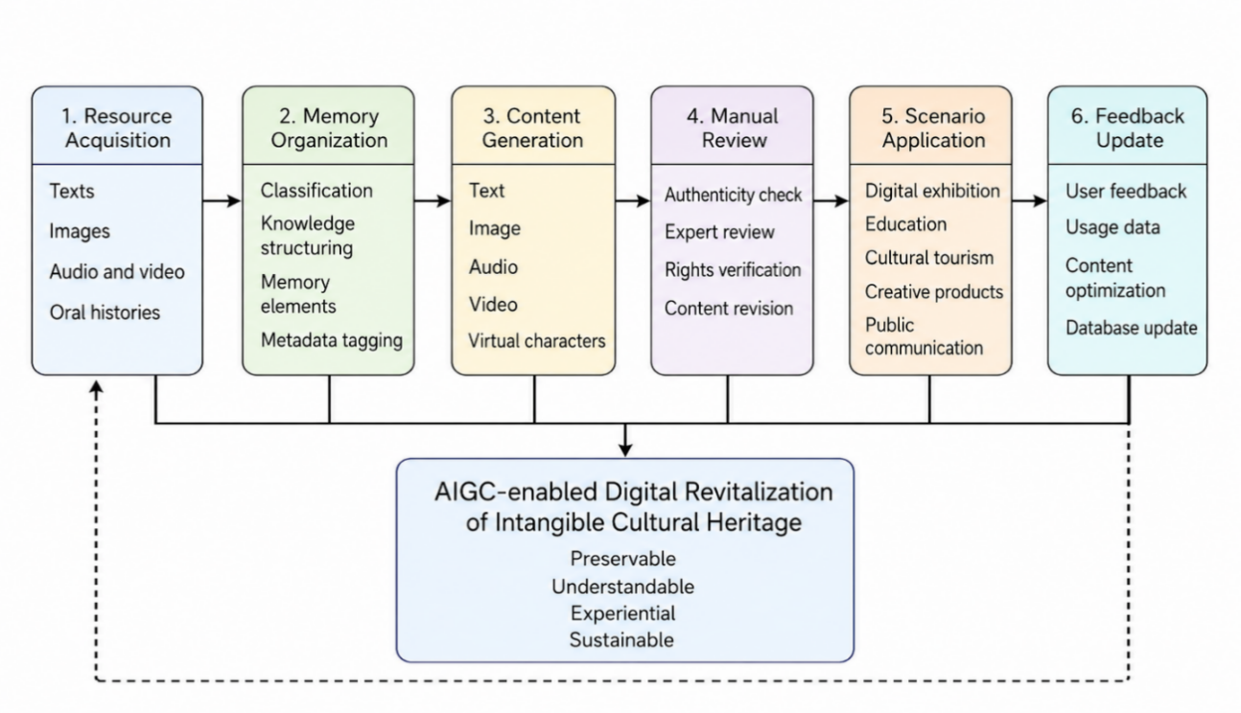
Figure 1. Practical process of AIGC-enabled digital revitalization of intangible cultural heritage

3.1. Constructing a database of intangible cultural heritage memories
The quality of AIGC outputs depends first on the quality of the underlying data. A local, structured, and sustainable cultural memory database should include project names, images, videos, inheritors’ oral histories, local historical materials, process flows, tools and materials, traditional patterns, folk customs, historical stories, common scenes, and application cases. Such a database should balance authenticity, structure, openness, and protection. Authenticity requires that all materials be traceable to sources and that important content be reviewed by inheritors or experts. Structure requires classification by project type, region, technique, cultural function, and dissemination context. Openness and protection should also be balanced by restricting access to content involving secret techniques, private portraits, commercial rights, and sensitive community information.

3.2. Constructing a multi-actor collaborative mechanism
AIGC-enabled digital revitalization of ICH should not be dominated by technical personnel alone. A collaborative ecosystem of inheritors, cultural researchers, technical staff, platform operators, and the public should be established. Inheritors provide experience, knowledge, and judgment; cultural researchers interpret historical contexts and cultural significance; technical staff create models, build platforms, and generate content; platform operators support dissemination and feedback; and users engage with ICH through interactive experiences and co-creation. Research on digital creativity in ICH crafts shows that such creativity requires coordination among cultural resources, technical tools, management, and application scenarios ^{[9–10]}. Therefore, AIGC should not be treated as a single tool, but as part of a multi-actor cultural production system.

3.3. Promoting scenario-based communication
AIGC-enabled digital revitalization of ICH can be applied in digital exhibition halls, campus education, cultural-tourism integration, cultural and creative design, and community communication. (1) In digital exhibition halls, AIGC can generate exhibition scripts, virtual explanations, interactive Q&A, and multilingual guides to make ICH exhibitions more accessible. (2) In campus education, AIGC can produce ICH courses, classroom tasks, learning Q&A, and activity plans for different age groups. Research on ICH course design shows that ICH courses and interdisciplinary workshops in the digital age can promote learning, creativity, and collaborative abilities ^{[11–12]}. (3) In cultural-tourism integration, AIGC can generate ICH experience routes, local story introductions, festival activity suggestions, and tourist-oriented cultural consumption plans, thereby supporting the dissemination of ICH through local tourism. (4) In cultural and creative design, AIGC can help restore traditional patterns, generate packaging copy, and construct product stories and brand communication, but it should not be used in ways that detach design from cultural meaning. (5) In community communication, AIGC can help organize community ICH archives, record residents’ oral histories, create local memory maps, and build online displays to strengthen community cultural heritage.

4. Risk regulation for AIGC-enabled digital revitalization of intangible cultural heritage
4.1. Preventing cultural distortion
Cultural distortion is one of the most serious risks in applying AIGC to ICH. AIGC may generate historical stories, process descriptions, or visual symbols by drawing on generalized data; once released, such content can mislead the public. Content generation should therefore be based on reliable databases and human review.

4.2. Preventing algorithmic homogenization
AIGC-generated content may converge toward similar styles, and different ICH items may be processed into a uniform “national style” or “Internet celebrity” image, thereby weakening local distinctiveness. The digital revitalization of ICH should instead highlight locality, ethnicity, and project-specific characteristics.

4.3. Protecting the rights and interests of inheritors
Inheritors are central to the living practice of ICH. If AIGC uses inheritors’ oral accounts, portraits, skill processes, or images of their work, authorization, usage scope, and revenue-distribution methods should be clearly specified to avoid a situation in which technology profits while inheritors are absent.

4.4. Clearly identifying generated content
AIGC-generated content should be clearly labeled in public cultural venues, educational materials, and commercial products. The AI-generated components and original sources should also be identified so that the public can verify the content and platforms can maintain accountability.

5. Conclusion
The cultural memory perspective provides a theoretical basis for understanding how ICH can be revitalized. ICH is not merely a cultural symbol; it is a living culture that carries collective memory, experience, ways of life, and identity. Digital revitalization uses new media to continue the cultural significance of heritage.
Through cultural memory extraction, semantic reconstruction, multimodal translation, interactive co-creation, and value transformation, AIGC can help move ICH from static memory to dynamic dissemination, from one-way display to public participation, and from resource organization to cultural reproduction. AIGC is not a cure-all. Without the participation of inheritors, cultural researchers, and ethical governance, it can easily lead to cultural distortion, homogenization, copyright disputes, and weakened subjectivity. Future work should build high-quality ICH memory resources by emphasizing authenticity, subjectivity, contextual relevance, and standardization. A collaborative process involving inheritors, researchers, technicians, platforms, and the public can support the renewal and enhancement of cultural memory in ICH.

Disclosure statement
The author declares no conflict of interest.

References
[1] Foo LG, Rahmani H, Liu J, 2025, AI-generated Content (AIGC) for Various Data Modalities: A Survey. ACM Computing Surveys, Article 243, 57(9): 1–66. https://doi.org/10.1145/3728633
[2] Spennemann DHR, 2024, Generative Artificial Intelligence, Human Agency and the Future of Cultural Heritage. Heritage, 7(7): 3597–3609. https://doi.org/10.3390/heritage7070170
[3] Foka A, Griffin G, 2024, AI, Cultural Heritage, and Bias: Some Key Queries that Arise from the Use of GenAI. Heritage, 7(11): 6125–6136. https://doi.org/10.3390/heritage7110287
[4] Kowalska S, 2024, Intangible Cultural Heritage: Social Memory and the Axiology of Protection. Muzeológia a Kultúrne Dedičstvo, 12(3): 63–75. https://doi.org/10.46284/mkd.2024.12.3.5
[5] Yu L, 2023, Digital Sustainability of Intangible Cultural Heritage: The Example of the “Wu Leno” Weaving Technique in Suzhou, China. Sustainability, 15(12): Article 9803. https://doi.org/10.3390/su15129803
[6] Li J, 2022, Grounded Theory-based Model of the Influence of Digital Communication on Handicraft Intangible Cultural Heritage. Heritage Science, 10(1): Article 126. https://doi.org/10.1186/s40494-022-00760-z
[7] Hou Y, Kenderdine S, Picca D, et al., 2022, Digitizing Intangible Cultural Heritage Embodied: State of the Art. Journal on Computing and Cultural Heritage, Article 55, 15(3): 1–20. https://doi.org/10.1145/3494837
[8] Li M, Xu S, Tang J, et al., 2024, Design and Research of Digital Twin Platform for Handicraft Intangible Cultural Heritage—Yangxin Cloth Paste. Heritage Science, 12(1): Article 43. https://doi.org/10.1186/s40494-024-01161-0
[9] Ye X, Ruan Y, Xia S, et al., 2025, Adoption of Digital Intangible Cultural Heritage: A Configurational Study Integrating UTAUT2 and Immersion Theory. Humanities and Social Sciences Communications, 12(1): Article 23. https://doi.org/10.1057/s41599-024-04222-8
[10] He Z, Wen C, 2024, Construction of Digital Creation Development Model of Intangible Cultural Heritage Crafts in China. Humanities and Social Sciences Communications, 11(1): Article 1745. https://doi.org/10.1057/s41599-024-04331-4
[11] Xia J, Yuizono T, Wang TY, et al., 2024, Intangible Cultural Heritage Course Design in the Digital Age and its Effects of Interdisciplinary Workshop. Education Sciences, 14(3): Article 325. https://doi.org/10.3390/educsci14030325
[12] Shakya M, Vagnarelli G, 2024, Creating Value from Intangible Cultural Heritage: The Role of Innovation for Sustainable Tourism and Regional Rural Development. European Journal of Cultural Management and Policy, 2024(14): Article 12057. https://doi.org/10.3389/ejcmp.2024.12057

Publisher’s note
Bio-Byword Scientific Publishing remains neutral with regard to jurisdictional claims in published maps and institutional affiliations.

