Research on the Optimization of Logistics Distribution Path of Intelligent Transportation Big Data in Dalian Based on UESTC
Jun Zhao¹, Junqing Xie²
¹Liaoning University of International Business and Economics, China
²Dalian Zhoushuizi Entry-Exit Border Inspection Station of the People’s Republic of China, Dalian, China

Copyright: © 2026 Author(s). This is an open-access article distributed under the terms of the Creative Commons Attribution License (CC BY 4.0), permitting distribution and reproduction in any medium, provided the original work is cited.

Abstract: In order to solve the problem of urban traffic congestion and long peak time, this paper combines the characteristics of dynamic traffic congestion in Dalian and the actual scene of logistics distribution in the same city, taking into account the constraints of transportation cost, equipment loss cost, intelligent construction cost, distribution timeliness, and customer satisfaction, and taking the minimization of the total cost of global distribution as the core goal, a dynamic logistics distribution path optimization model based on traffic big data is constructed. The model is fully integrated into the quantitative indicators of road congestion in various periods and regions of Dalian, and solves the defects that the traditional static path model cannot adapt to tidal traffic and dynamic congestion, and adapts the improved genetic algorithm to solve the problem.
Keywords: Distribution path; Path optimization; Big data allocation

Online publication:

1. Introduction
With the continuous advancement of the digital economy and smart city construction, smart logistics has become the core direction of modern industry development. At present, the intelligent construction of urban logistics in China is steadily advancing, but the overall intelligent level of the logistics industry in Northeast China is relatively lagging behind. There are many problems such as traditional distribution mode, solidification of path planning, waste of transportation resources, high distribution cost, and insufficient response time.
As the core port city of Northeast China and the economic window of opening to the outside world, Dalian has a perfect port logistics system and urban distribution network, and the strategic position of regional logistics is outstanding. At present, the urban logistics distribution in Dalian is still dominated by the traditional point-to-point distribution mode, relying on artificial experience to plan the path, which cannot adapt to the dynamic changes of urban tidal traffic, road section restrictions, road network congestion, etc., and the demand for intelligent logistics upgrading is extremely urgent. Based on this, this paper relies on big data technology and intelligent optimization algorithm, combined with the actual development of traffic network and logistics in Dalian, to carry out research on logistics distribution path optimization based on intelligent traffic big data, aiming at solving the lag problem of traditional distribution mode, realizing the cost reduction and efficiency increase of urban logistics, and promoting the high-quality development of regional intelligent logistics industry.

2. Summarization at home and abroad
2.1. Intelligent transportation planning
Intelligent transportation big data provides the underlying data support for logistics distribution scheduling. It can integrate multi-source information such as road conditions, GPS trajectories, bayonets, distribution orders, traffic restrictions, and meteorology, realize road dynamic perception, traffic speed prediction and congestion identification, and provide real-time road network parameters for path optimization. On the basis of this data, the academic community generally uses the vehicle routing problem with time windows (VRPTW) to describe the urban terminal distribution scenario. The NP-hard problem takes the minimum total mileage, the lowest operating cost, and the shortest delivery time as the optimization goal. At the same time, it is subject to multiple constraints such as vehicle load, customer time window, and bicycle distribution mode. In view of the complex solution requirements of VRPTW, genetic algorithm and ant colony algorithm have become the mainstream solution schemes by virtue of their strong global search ability. The genetic algorithm broadens the optimization range by evolutionary iteration, and the ant colony algorithm accelerates the convergence speed by relying on the mechanism of pheromone. The efficiency of the two algorithms is outstanding, which can adapt to the dynamic distribution optimization scenario integrating real-time traffic information, and can efficiently output the optimal distribution path scheme satisfying multiple constraints ^{[1–5]}.

2.2. The application of traffic big data in logistics distribution
This paper integrates User Equilibrium and Spatial-Temporal Correlation (UESTC) to predict urban road congestion based on vehicle trajectory big data. It is an appearance or feature of Internet development to the present stage. It requires a new processing model to have stronger decision-making power, insight discovery power, and process optimization power to adapt to massive, high-growth rate, and diversified information assets. These data, which were originally difficult to collect and use, began to be easily utilized. Through the continuous innovation of all walks of life, big data has gradually created more value for human beings. In the field of transportation, big data also has: huge data volume (Volume); variety of data types (Variety); low value density, high commercial value (Value); fast processing speed (Velocity).

3. Dalian logistics distribution and traffic situation analysis
3.1. Distribution characteristics of Dalian city
The whole region of Dalian is dominated by low hills, and the coastal plains along the Yellow Sea and Bohai Sea are narrow and long (Figure 1). The overall terrain is high in the north and low in the south, which in turn restricts the distribution of express outlets. The southern Zhongshan, Xigang, Shahekou, and southern Ganjingzi contiguous coastal plain road network is smooth; construction land is concentrated; express stations, outlets, and distribution centers are high-density along the main road; the hilly mountains such as Xiaohei Mountain and Baiyun Mountain in the central part split the urban area, and the residential areas are scattered. The network points can only be laid linearly along the valley roads and coastal corridors, and the coverage of the hinterland of the mountain is weak. The northern Wafangdian, Pulandian, and Zhuanghe are mainly mountainous villages and towns. The terrain is undulating, the road network is circuitous, and the population settlements are scattered. Only a small number of comprehensive outlets are set up in the township center, and there is a large-scale service gap in the mountainous area. The island of Changhai County is blocked by the sea area, and only the county lays out a single express station, relying on the ferry to complete the express transfer; at the same time, along the gentle coast of the Bohai Sea, it carries large distribution hubs such as postal and air express industrial parks. It is difficult to arrange large-scale express storage in hilly and mountainous areas. Finally, it forms a spatial pattern of express outlets with dense southern coastal areas, sparse northern mountainous areas, zonal agglomeration along the Yellow Sea and Bohai Sea corridors, and sparse mountain areas.

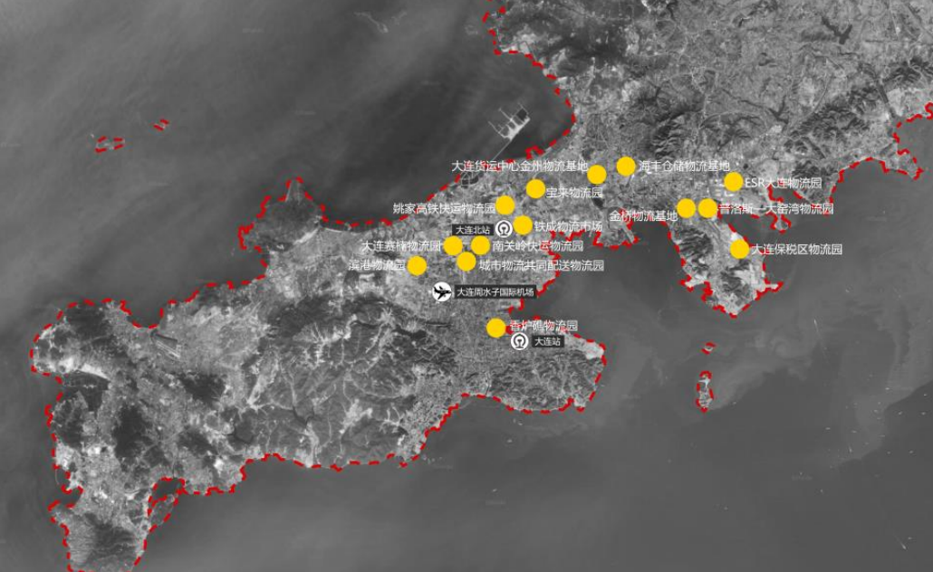
Figure 1. Distribution of distribution outlets in Dalian

3.2. Dalian smart traffic data sources
Urban traffic big data carries out multi-source fusion processing by integrating road surface monitoring data, urban operating vehicle GPS positioning data, and electronic map navigation data to generate high-precision, full-coverage dynamic real-time road conditions. In view of different logistics distribution scenarios, enterprises rely on the distribution management system to connect with the traffic big data platform to obtain information such as road traffic and real-time congestion, so as to realize the unified scheduling and distribution control of in-transit cold chain vehicles. Consumers can also use this data channel to track the dynamics of vehicles and goods in real time and submit relevant feedback. The cold chain transportation vehicle synchronously transmits the operation data such as its own location and route conditions to the distribution management system. All the business data generated by the customer, distribution vehicle, and logistics enterprise will be summarized through the urban traffic distribution management system and the traffic big data platform, and finally uploaded to the same port-public data cloud unified storage. The detailed application process of traffic big data in urban traffic logistics distribution is shown in Figure 2.

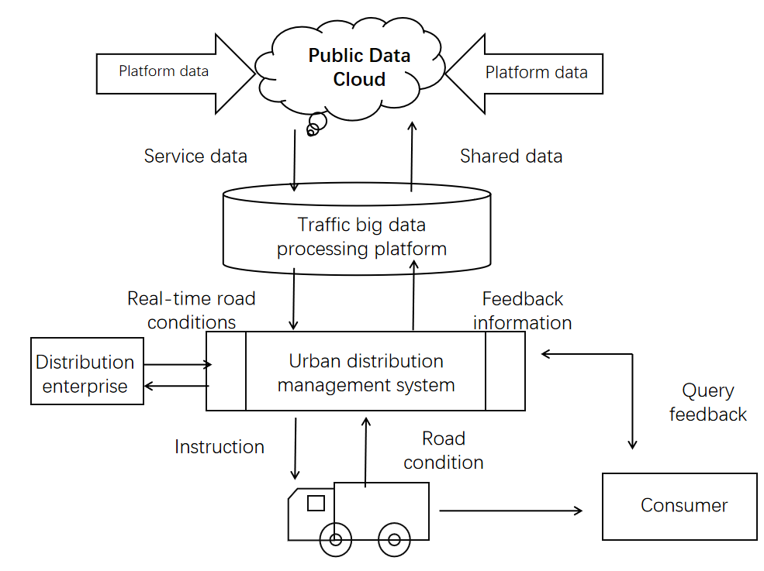
Figure 2. The application of big data in route distribution

4. Distribution path optimization model based on big data
4.1. Problem description and assumptions
4.1.1. Problem description
According to the distribution characteristics of Dalian City, the southern region has a smooth road network, the density of distribution centers is concentrated, and the distribution pressure is relatively large; the central and northern regions are sparsely populated, the distribution centers are relatively scattered, and the distribution pressure is relatively small; there are many demand points in Dalian city, including residential areas, supermarkets, convenience stores, and other distribution centers in the city. The logistics distribution center has E distribution vehicles, which provide logistics distribution services for F demand points in the urban area. In the process of vehicle distribution, starting from the distribution center, after completing the distribution tasks at all levels, it returns to the distribution center to form a distribution closed-loop. The purpose is to obtain real-time road traffic conditions through big data based on existing resources and customer needs, construct mathematical models, and use appropriate algorithms to find optimized distribution strategies.

4.1.2. Model assumptions
Before establishing the model, assume the following:
(1) The number of distribution vehicles in the distribution center is determined, and the load of each vehicle is fixed, and the customer demand does not exceed the maximum load of each vehicle;
(2) Each customer need can be met at the same time by a delivery vehicle transport;
(3) Customer delivery requirements can be fully met in the vehicle’s cruising range without refueling or charging;
(4) The congestion of the distribution section continues to be relatively stable. From the distribution decision to the distribution implementation process, the congestion of the road section remains unchanged;
(5) The time window constraint is determined, and the delivery vehicle is served within a certain time window without payment of liquidated damages, and the corresponding liquidated damages exceed the time range character;
(6) The daily loss and accidents of delivery vehicles in the distribution process are not included in the cost.

4.2. Data preprocessing
Through Baidu map, Gaode map, and other road traffic data, the traffic situation of each road section is monitored in real time, and the traffic congestion coefficient is set to feedback the real-time traffic congestion, so as to monitor the real-time traffic situation. Taking x_{kij} as the decision variable, when x_{kij} is 0, the kth vehicle passes through the road section (vi, vj), and when x_{kij} is 1, the k th vehicle fails to pass through the road section (vi, vj). At the same time, the traffic congestion coefficient of each road section (s_{i}, s_{j}) is set to r_{ij}, where at the same time node, the traffic congestion coefficient from i to j is the same as that from j to i. The value range of r_{ij} is [0,1]. Mark _{(k)} indicates whether the kth delivery vehicle is enabled.

$$\text{Mark}\text{（}\text{k}\text{）}\text{=}\left\{\begin{aligned}\sum_{\text{i}\text{=1}}^{\text{N}}{\sum_{\text{j}\text{=1}}^{\text{N}}{{\text{x}}_{\text{kij}}\text{>0}}} \\ \sum_{\text{i}\text{=1}}^{\text{N}}{\sum_{\text{j}\text{=1}}^{\text{N}}{{\text{x}}_{\text{kij}}\text{=0}}}\end{aligned}\right.$$

The closer the value is to 0, the slighter the road congestion is, and r_{ij}=0 indicates that the road is completely unblocked; the closer the value is to 1, the more serious the road condition is, and r_{ij} = 1 indicates that the road is completely congested and cannot move forward. The normal operation time of the distribution vehicle on the (s_{i}, s_{j)} road section is as follows.

$$t_{ij}=\frac{L_{ij}}{V_{0}(1-r_{ij})}$$

Where Lij denotes the distance (s_{i}, s_{j)} and $V_{0}$ denotes the average speed given by the delivery vehicle during normal driving. The dwell time (unloading time) of the delivery vehicle at $v_{i}$ point is as follows.

$$t_{i}=ug_{i}$$

Where $g_{i}$ denotes the demand of the i th customer, and u denotes the average unloading speed during the unloading process.

4.3. Mathematical model construction
The speed in the distribution process and the cost required for distribution directly affect the key factors of whether the distribution path is reasonable or not. Efficiency optimization is the basis of path planning, and it is also the standard for distribution enterprises to assess the level of distribution and market demand. It is also a key factor in enhancing the competitiveness of enterprises. Therefore, in the model construction, the time required for a fixed road section is used to represent the distribution efficiency, and the total time is determined by the normal operation time and residence time of the vehicle. In addition, the cost of distribution enterprises includes cost variables and customer satisfaction. The cost variable is expressed according to the actual situation in the urban distribution process, including the fixed cost ($C_{1}$) in the vehicle distribution process and the variable cost (C₂) in the vehicle distribution process; customer satisfaction is expressed by the penalty cost (C₃) of violating the time window of customer demand. Therefore, the cost function is as follows.

$$\text{C=}{\text{C}}_{\text{1}}\text{+}{\text{C}}_{\text{2}}\text{+}{\text{C}}_{\text{3}}\text{+}{\text{C}}_{\text{4}}$$

Among them, the fixed cost of delivery vehicles ($C_{1}$).

$${\text{C}}_{\text{1}}\text{=}\text{f}\sum_{\text{i}\text{=1}}^{\text{N}}{\text{Mark}\text{(}\text{k}\text{)}}$$

f represents the fixed cost of the delivery vehicle in the delivery process.
The variable cost of the distribution vehicle (C₂) is proportional to the mileage of the vehicle, including the fuel cost, vehicle maintenance cost, vehicle insurance cost, vehicle maintenance cost, etc.

$${\text{C}}_{\text{2}}\text{=}\sum_{\text{k}\text{=1}}^{\text{M}}{\sum_{\text{i}\text{==0}}^{\text{N}}{\sum_{\text{j}\text{=0}}^{\text{N}}{\text{h}{\text{x}}_{\text{kij}}{\text{L}}_{\text{ij}}}}}$$

Among them, h represents the cost per kilometer of the vehicle.
Distribution vehicle refrigeration energy consumption cost (C₃).
For the distribution of fresh food, refrigerated distribution vehicles are needed to ensure the quality of goods and reduce the occurrence of cargo damage. However, the distribution of refrigerated trucks requires refrigeration operations, which will generate additional refrigeration energy consumption costs. According to experience, the refrigeration cost is mainly related to the time of distribution, the number of door openings in the distribution process, and the time of door opening. Therefore, assuming that the unloading time of each point and the demand of each customer are fixed, which is a constant Q, the refrigeration cost of the refrigerated truck in the distribution process is expressed as follows.

$$C_{3}=\sum_{k=1}^{M}{\sum_{i=0}^{N}{\sum_{j=0}^{N}{b}}}x_{kij}\frac{L_{ij}}{V_{0}(1-r_{ij})}$$

Customer satisfaction demand time window penalty cost (C₄)
It is assumed that the time window of customer demand j is the best in [$o_{j},s_{j}$], and [$O_{j},S_{j}$] is the maximum tolerance time window of customer demand. The relationship is shown in Figure 1.

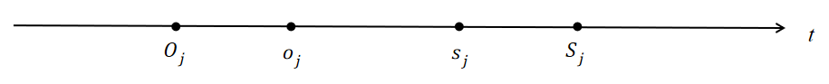
Figure 1. The relationship between the time window of customer and the maximum tolerance time window of customer demand

It can be seen from the figure that if the delivery time is $T_{j}$ between [$o_{j},s_{j}$], the penalty cost is zero; if the delivery time is $T_{j}$ between [$O_{j},o_{j}$], the penalty cost is $α_{1}$ ; if the delivery time is $T_{j}$ between [$s_{j},S_{j}$], the penalty cost is $α_{2}$; if the delivery time is $T_{j}$ outside [$O_{j},S_{j}$], the penalty cost is $\text{+∞}$.

$$C_{4}=α_{1}\sum_{j=1}^{N}{max\left\{O_{a}-T_{a},0\right\}+α_{2}\sum_{j=1}^{N}{max}}\left\{S_{a}-s_{a},0\right\}$$

Based on the congestion situation of urban real-time traffic, the distribution path with the best distribution efficiency and the smallest distribution cost is planned, and the constraints are as follows.
(1) The sum of the number of vehicles in transit does not exceed the sum of the vehicles in the enterprise distribution center (M).

$$\sum_{i=1}^{M}{\sum_{j=1}^{N}{x_{kij}≤M}}$$

(2) In the process of distribution, distribution vehicles need to start from the distribution center and return to the distribution center after completing the distribution task. (i = 0, k = 1,2,3,..., M)

$$\sum_{j=1}^{N}{x_{kij}≤1}$$
$$\sum_{j=1}^{N}{x_{kji}≤1}$$
$$\sum_{j=1}^{N}{x_{kij}=}\sum_{j=1}^{N}{x_{kji} }$$

(3) Delivery vehicles can meet all the needs of the corresponding customers every time they stop, and no additional vehicles are needed for secondary service. i, j ∈ [ 1,2,..., N ], i ≠ j

$$\sum_{k=1}^{M}{\sum_{i=0}^{N}{x_{kij}≤1}}$$
$$\sum_{k=1}^{M}{\sum_{j=0}^{N}{x_{kij}≤1}}$$

(4) The weight of each delivery task does not exceed the maximum carrying capacity (G) of a single delivery vehicle.

$$\sum_{i=0}^{N}{g_{i}\sum_{j=0}^{N}{x_{kij}≤G}}$$

gi represents the demand of the i th customer, and G represents the maximum load of each refrigerated delivery vehicle.
(5) The single maximum delivery mileage of each vehicle does not exceed the maximum endurance mileage of the vehicle. (k = 1,2,3,..., M; i ≠ j)

$$\sum_{i=1}^{M}{\sum_{j=1}^{N}{{L_{ij}x}_{kij}≤S}}$$

5. Algorithm design and simulation
5.1. Algorithm flow
In the case that the distribution center is large enough and the number of distribution vehicles is sufficient, the distribution center has M distribution vehicles and m pick-up trucks to provide logistics and distribution services for N demand points in Dalian City. R connection points are set up in the urban area to improve the efficiency of distribution and form efficient distribution services. According to real-time road congestion, existing distribution resources, selectable connection points, customer demand, demand time window, etc., a mathematical model is constructed, and the ant colony algorithm is used to quickly select the connection points. The minimum total distribution costs, such as transportation and distribution costs, cargo damage costs, refrigeration energy consumption costs, penalty costs, and fixed costs, are generated from the distribution center or the connection point until the completion of the service to the customer.

5.2. Comparative analysis of the results
According to the data released by the Dalian Municipal Postal Administration, there are currently 2737 outlets in the city, including 12 postal self-operated outlets, which are located in the station square, Nanshan, Siergou, Taoyuan, Donggang, and other branches. The brand express direct sales branch includes a total of about 50 places such as Zhongtong, Yuantong, Shunfeng, Jitu, and Yunda, about 170 community collection stations, and 30 scattered points such as convenience stores, a total of 260 places. Taking the data of postal self-operated outlets as an example, the coordinates of 12 customer groups are selected, the customer number is recorded, and the cat swarm algorithm is used to plan the optimal path (Figure 3).

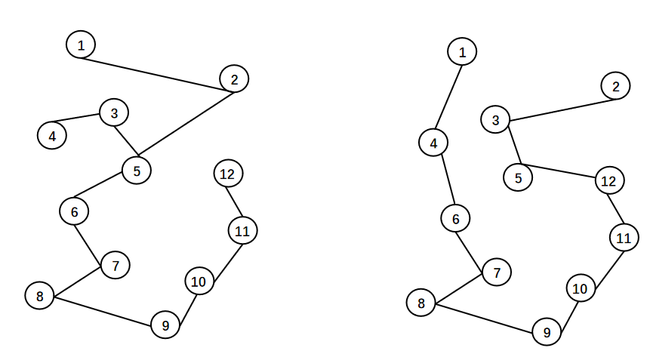
(a) Planning the pre-distribution path (b) Planning the post-distribution path
Figure 3. Comparison of distribution routes before and after graph planning

6. Conclusion
According to the relative coordinates of the geographical location of the customer’s needs, the distribution path planning model and the cat swarm algorithm are used to compare the distribution paths before and after the planning. It is found that on the basis of meeting the needs of 12 customers, the distribution distance is reduced, the distribution cost is reduced, and the waste of distribution time caused by road congestion is reduced.

Funding
2024 school-level project: Research on optimization of logistics distribution path of intelligent transportation big data in Dalian based on UESTC (Project number: 2024XJLXQN006)

Disclosure statement
The author declares no conflict of interest.

References
[1] Huang QQ, 2026, Research On Logistics Distribution Network Optimization and Lean Management Mode Innovation Driven by Big Data. Logistics Engineering and Management, 48(4): 8–11.
[2] Hu Z, 2026, Research on Cost Control of Unmanned Distribution of E-commerce Driven by Big Data. Business 2.0, 2026(9): 31–33.
[3] Zou ZY, 2025, Research on the Application of Big Data and Cloud Computing in the Optimization of E-commerce Logistics Distribution. China Storage and Transportation, 2025(8): 210–211.
[4] Shen XQ, 2024, Innovation Method of Information Model for Terminal Distribution of Logistics Enterprises in the Era of Big Data. China Storage and Transportation, 2024(11): 144–145.
[5] Yu XS, 2023, Design and Implementation of the Background System of Fresh Food Distribution Platform Based on Big Data. Henan Science and Technology, 42(15): 30–33.

Publisher’s note
Bio-Byword Scientific Publishing remains neutral with regard to jurisdictional claims in published maps and institutional affiliations.

