Research on the Construction of a Precise Teaching Model for Ideological and Political Theory Courses in Higher Vocational Colleges in the Era of Intelligence
Jing Xu, Chen Zhao*
Loudi Vocational and Technical College, Loudi 417000, Hunan, China
*Corresponding author: Chen Zhao, 563606703@qq.com

Copyright: © 2026 Author(s). This is an open-access article distributed under the terms of the Creative Commons Attribution License (CC BY 4.0), permitting distribution and reproduction in any medium, provided the original work is cited.

Abstract: Constructing an intelligent era-oriented precise teaching model for ideological and political courses in colleges and universities is conducive to achieving the organic unity of knowledge imparting and value guidance, promoting the connection between ideological leadership and intelligent learning environment, and improving the teaching effect of ideological and political courses. Based on the intelligent era, the article analyzes the connotation and significance of precise ideological and political theory course teaching from the perspective of precise ideology and politics, and proposes specific countermeasures for constructing a precise ideological and political theory course teaching system. Higher vocational colleges should establish a rich student data information database, strengthen the construction of data talent team, precisely meet the ideological and political needs of college students in the era of big data, evaluate and feedback the implementation effect of precise ideological and political education, enhance the ideological, affinity and pertinence of ideological and political courses, and cultivate more high-quality talents with both moral integrity and professional competence.
Keywords: Higher vocational colleges; Ideological and political theory courses; The intelligent era; Precision teaching model

Online publication:

1. Introduction
In today’s society, the extensive application of artificial intelligence has promoted social development and transformation, and society has entered a new stage — the intelligent era. As artificial intelligence profoundly changes people’s lifestyles and thinking habits, educational methods have also undergone profound changes. In recent years, the deep integration of artificial intelligence and education has also become a focus of national attention. To effectively promote this work, the national education department has formulated and promulgated a series of policies and regulations, aiming to guide the rational utilization of artificial intelligence in the education field, build an intelligent education system, and improve educational quality ^{[1]}.
In April 2018, the Ministry of Education released the “Action Plan for Education Informatization 2.0” to guide the development of education in the intelligent era. It specifically involved the construction of “Internet + Education,” emphasizing the utilization of information technology to do a good job in education and achieve modernized education ^{[2]}. In February 2019, the Central Committee of the Communist Party of China and the State Council issued the “China Education Modernization 2035,” emphasizing that promoting education modernization is one of the ten strategic tasks for educational reform, and highlighting the importance of accelerating educational reform in the information age ^{[3]}. The document mentioned that in order to smoothly achieve educational modernization, specific implementation paths need to be clarified, including: first, conducting overall planning based on the specific conditions of different regions and gradually promoting it region by region; second, clarifying goals and advancing step by step; third, implementing precise strategies and coordinating and promoting comprehensively; fourth, actively promoting reforms and systematically implementing. In February 2022, the Teacher Work Department of the Ministry of Education issued the “2022 Work Key Points of the Teacher Work Department of the Ministry of Education,” proposing to implement the comprehensive online teacher training plan in 2022, aiming to enhance the informatization level of teacher training, explore intelligent teacher training models, and promote the development of the teacher team by leveraging artificial intelligence. Meanwhile, in 2023, the Ideological and Political Work Department of the Ministry of Education issued the “2023 Work Key Points of the Ideological and Political Work Department of the Ministry of Education,” proposing to “further strengthen digital empowerment and improve the construction of relevant digital platforms.”
Ideological and Political Theory courses, as the key courses for implementing the fundamental task of fostering virtue and cultivating talents, should adapt to the era of intelligence and continuously innovate and develop to achieve high-quality development. The teaching of ideological and political theory courses, which serve as the main channel for ideological and political education, should also achieve innovation and development during the process of digital transformation. Therefore, discussing how artificial intelligence can empower ideological and political education in colleges and universities and effectively optimize their educational concepts, methods, and mechanisms; how artificial intelligence can assist colleges and universities in integrating educational resources, enhancing teaching and educational capabilities, and strengthening the connections among various internal links of ideological and political work; and what kind of influence artificial intelligence has on the educational space, environment, resources, carriers, paths, and methods of ideological and political education work in colleges and universities, have become important contemporary issues for ideological and political education workers in colleges and universities.

2. The proposal and development of precise ideological and political education
“The all-round development of individuals is the ultimate goal of ideological and political education.” Precise Ideological and Political Education (Precise Thought) is an innovative practice of applying the concept of precise thinking to the field of ideological and political education. It is also a practical exploration of new models of ideological and political education using big data technology ^{[4]}. It originated after 2013 and was first mentioned by then Minister of Education Chen Baosheng at the National Education Work Conference in January 2019: “We should strive to promote precise ideological and political education.” This was the first time “precise ideological and political education” appeared in a formal document. In the same year, “striving to promote precise ideological and political education” became a key point of work for the Ministry of Education. In the work key points of the Ideological and Political Department of the Ministry of Education over the years since then, “precise ideological and political education” was repeatedly mentioned ^{[5]}. Since 2015, a number of universities such as Beihang University, University of Electronic Science and Technology of China, and Peking University have successively carried out attempts and explorations of “precise ideological and political education” with the help of big data. With the passage of time, more and more universities have participated, and the application scenarios of “precise ideological and political education” have been continuously expanded.

3. Significance of constructing a precise teaching model of ideological and political theory in higher vocational colleges
First, for schools, it addresses poor pertinence and low effectiveness existing in conventional ideological‑political education. By identifying college students’ individual features and diverse developmental needs, providing tailored teaching content, selecting proper teaching methods, and evaluating educational outcomes in a timely manner, this research improves the precision, pertinence, and practicality of ideological‑political education. For ideological‑political educators, it facilitates the innovation of educational carriers and approaches and promotes the reform and development of ideological‑political education. For students, high‑quality ideological‑political education helps them form a correct outlook on the world, life and values and grow into well‑rounded talents.

4. Construction path of precise teaching model for ideological and political theory in higher vocational colleges
Figure 1 shows the construction path of the precise teaching model for ideological and political theory in higher vocational colleges.

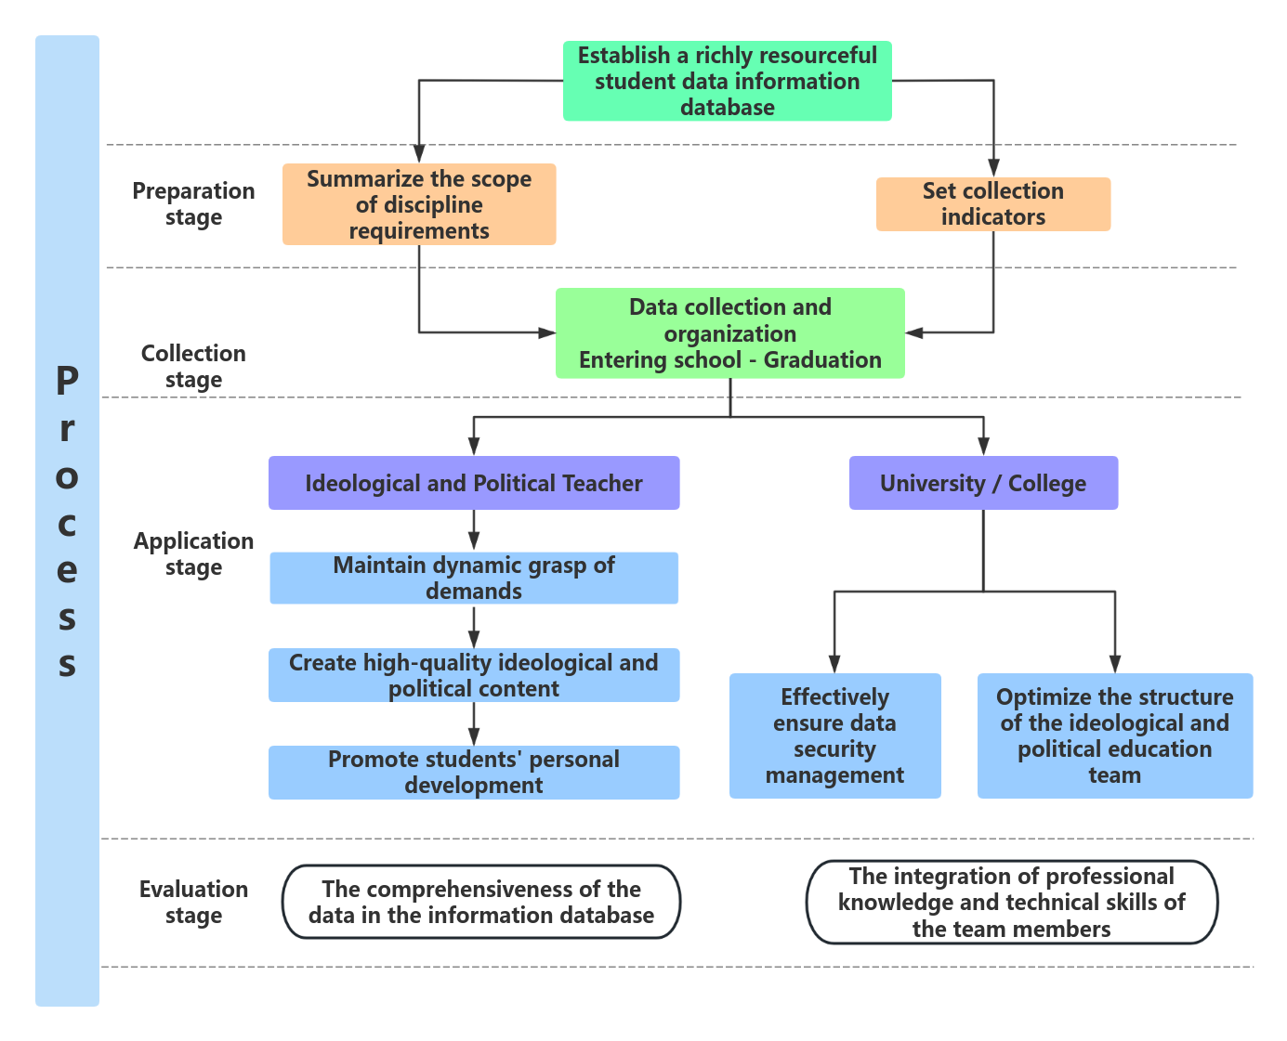
Figure 1. Construction path of precise teaching model for ideological and political theory in higher vocational colleges

4.1. Establish a rich student data information database
Student data resources are of great significance for the implementation of precise ideological and political education in universities. The establishment of the student database should be based on the basic requirements of comprehensive and multi-angle student profiling. Meanwhile, while collecting student data resources, attention should be paid to ensuring the security of the data, so that there are abundant data sources for precise analysis of student data resources (Figure 2).

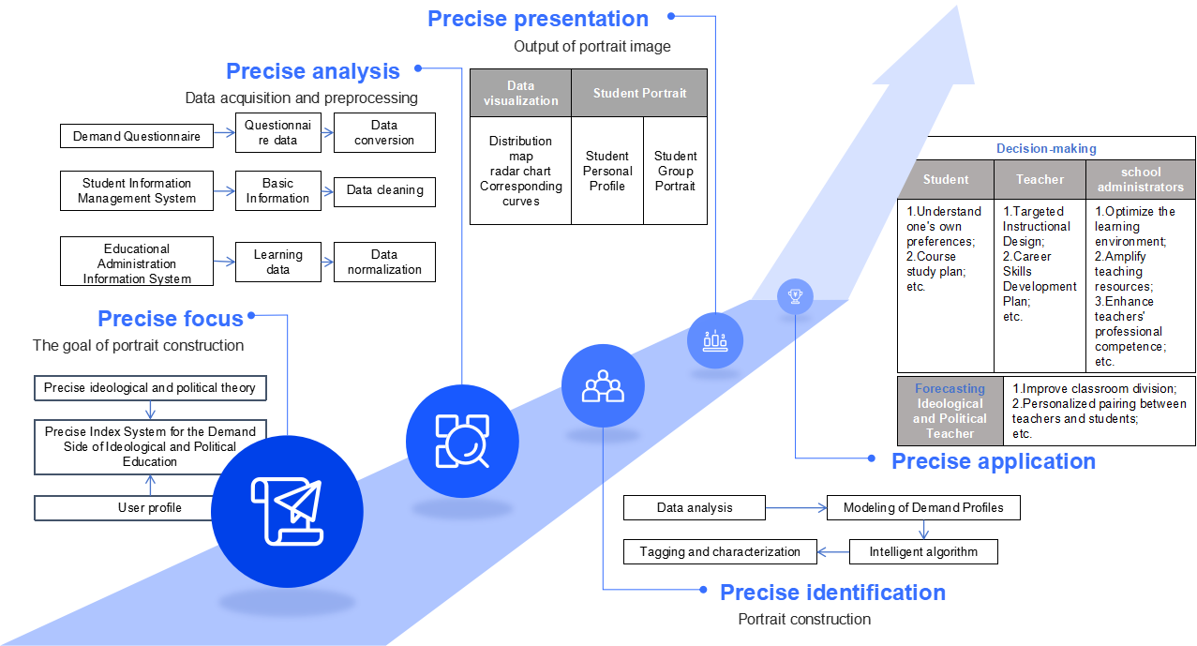
Figure 2. Acquisition path of student information database

4.2. Strengthen the construction of the data talent pool
Cultivating and establishing a team of college students dedicated to daily ideological and political education with a good understanding of the working rules of ideological and political education and familiar with big data knowledge and technology is a basic prerequisite and inherent requirement for the deep integration of the two ^{[6]}. Universities shall regularly restructure and enrich the team, improve members’ big‑data literacy and stimulate their innovation potential to tackle shortages of professionals and technical‑application difficulties. Meanwhile, educators can play a guiding role amid complicated big‑data contexts. First, front‑line staff should receive theoretical and practical training to boost data‑application capacity. Universities may organize lectures and case studies to introduce applicable modes and provide hands‑on exercises for teachers. Finally, realizing the lack of big‑data talents in ideological‑political teams, colleges ought to select and recruit specialists to build interdisciplinary research groups. In this way, the team structure can be optimized, and strengths of professional expertise and digital techniques can be complemented.

4.3. Meeting the ideological and political needs of college students in the era of big data
The implementation of precise ideological and political education should always adhere to the correct direction of ideological and political education. Analyze the individualized differences and demands of the students as the main body, provide ideological and political education supplies in a targeted and purposeful manner, and promptly evaluate and provide feedback on the effects to ensure that precise ideological and political education can be implemented efficiently ^{[7–8]}.

4.4. Evaluate and provide feedback on the implementation effect of precise ideological and political education
To evaluate and provide feedback on the implementation effect of precise ideological and political education, a standard system needs to be established to assess and provide feedback on the entire process of precise ideological and political education. A standardized evaluation‑feedback system is essential to assess the outcomes of targeted ideological‑political education. Evaluation should be integrated with students’ learning achievements. Instead of judging students only by academic scores, teachers take their comprehensive qualities and ideological tendencies into account, and examine teaching arrangements and teachers’ performance. Universities shall establish sound mechanisms for evaluation, feedback, as well as rewards and penalties. They should set assessment standards, strengthen data quality and security, and guarantee the whole‑range implementation of big‑data projects. Meanwhile, diversified incentives and a legal liability system for data‑management staff ought to be formulated ^{[8–9]}. Teachers should treat students development‑mindedly. Legally collected student information forms a database of ideological trends. By combining real‑time observation and big‑data analysis, teachers analyze students’ overall conditions. Targeted guidance based on students’ backgrounds and potentials can improve their cognition and behaviors (Figure 3).

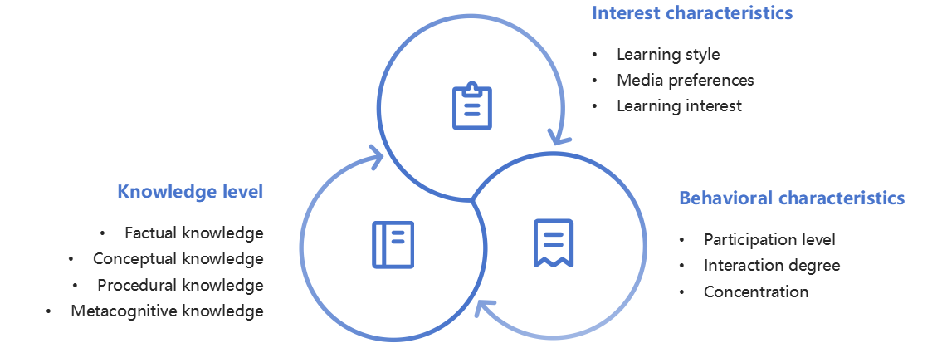
Figure 3. Diagram of the evaluation system for the effectiveness of precise implementation

5. Summary
The classroom is the main battlefield for ideological and political education. Currently, the mode of ideological and political education is undergoing various innovations ^{[10]}. Precision ideological and political education based on artificial intelligence is one of them, which plays an important role in enhancing the effectiveness of ideological and political education. However, artificial intelligence technology is a double-edged sword. Its application in the field of ideological and political education requires the participation of universities, teachers, and students. They should jointly explore effective ways for integrating artificial intelligence technology with ideological and political education teaching, providing new ideas for ideological and political education work in universities.

Funding
Loudi Vocational and Technical College 2024 education and teaching reform research project “Research on the Pathways for Enhancing the Sense of Gain in Nursing Ethics Courses for Students of Higher Vocational Nursing Programs” (LZJY24BZC15).
Loudi Vocational and Technical College 2026 Scientific Research Project “Research on the Construction and Narrative Approaches of the Discourse System for Ideological‑Political Education in Higher‑Vocational Colleges in the Digital‑Intelligent Era” (2026YK004).

Disclosure statement
The author declares no conflict of interest.

References
[1] Duong MT, Rauschecker AM, Rudie JD, et al., 2019, Artificial Intelligence for Precision Education in Radiology. The British Journal of Radiology, 92(1103): 20190389.
[2] Li H, 2025, Multicultural Data Assistance Mining Analysis for Ideological and Political Education in Smart Education Platforms using Artificial Intelligence. Wireless Net, 2025(31): 567–581.
[3] Shi Y, Wang XJ, 2021, Ideological and Political Theories Teaching in All Courses in the New Era: Core Problems and Feasible Approaches. Teaching and Research, 55(9): 91–99.
[4] Li F, Li J, 2023, The Subject Accessibility of Ideological and Political Courses for Electrical and Electronic Majors. International Journal of Computational Intelligence Systems, 2023(16): 45.
[5] Wang YJ, Gao CL, Ye XD, 2024, A Data-driven Precision Teaching Intervention Mechanism to Improve Secondary School Students’ Learning Effectiveness. Education and Information Technologies, 2024(29): 11645–11673.
[6] Song F, Quan Z, Shuang C, 2025, Research on Application Strategies of Artificial Intelligence in Intelligent Teaching of Ideological and Political Education in Higher Vocational Colleges. In Proceeding of the 2024 International Conference on Artificial Intelligence and Future Education (AIFE ‘24). Association for Computing Machinery, New York, NY, USA, 315–319.
[7] Tan AJY, Davies JL, Nicolson RI, et al., 2023, Learning Critical Thinking Skills Online: Can Precision Teaching Help? Educational Technology Research and Development, 71(3): 1275–1296.
[8] Zhang B, Velmayil V, Sivakumar V, 2023, A Deep Learning Model for Innovative Evaluation of Ideological and Political Learning. Progress in Artificial Intelligence, 2023(12): 119–131.
[9] Ping L, 2021, Evaluation Method of Teaching Effect of Ideological and Political Course in Colleges and Universities from the Perspective of Ideological and Political Education. In 2021 4th International Conference on Information Systems and Computer Aided Education (ICISCAE 2021). Association for Computing Machinery, New York, NY, USA, 1833–1838.
[10] Meng LD, Zhang T, Li Y, et al., 2024, Research on the Application of Virtual Simulation Teaching in Ideological and Political Theory Course of Colleges and Universities under VR Technology. In Proceedings of the 2024 International Conference on Intelligent Education and Computer Technology (IECT ‘24). Association for Computing Machinery, New York, NY, USA, 77–82.

Publisher’s note
Bio-Byword Scientific Publishing remains neutral with regard to jurisdictional claims in published maps and institutional affiliations.

