Exploring the AIGC Project-Based Teaching Model in 3D Graphic Design Courses from the Perspective of Cultural Inheritance
Zhiteng Zhang*
Northwest Minzu University, Lanzhou 730000, Gansu, China
*Corresponding author: Zhiteng Zhang, 394412964@qq.com

Copyright: © 2026 Author(s). This is an open-access article distributed under the terms of the Creative Commons Attribution License (CC BY 4.0), permitting distribution and reproduction in any medium, provided the original work is cited.

Abstract: To address the problems of disconnection between culture and technology, the lag in AIGC-enabled teaching, and the lack of a project-based closed loop in 3D graphic design courses, this study takes the cultural anchor principle, the technological adaptation principle, and the project-based closed-loop principle as its construction principles. It proposes an AIGC project-based teaching model and a phased tool adaptation system from the perspective of cultural inheritance, and conducts empirical verification using que ti, a traditional Chinese architectural component, as a case study. This research provides a feasible reference implementation path for the cultural empowerment of design courses and their integration with AIGC technology.
Keywords: 3D graphic design courses; AIGC; Project-based teaching; Cultural inheritance

Online publication:

1. Introduction
With the rapid development of artificial intelligence technology, AIGC has been gradually integrated into the classroom teaching of digital media design programs and has become an important means of reshaping design workflow models and creative processes. Against this backdrop, 3D graphic design, a core course for digital media design majors, is facing two critical challenges: The first is how to guide students to go beyond superficial imitation and stacking of traditional symbols, deeply understand the inherent logical connotations of cultural heritage, and complete modern context-oriented design transcreation; The second is how to effectively align course teaching with the industrial development of AIGC technology and avoid the disconnection between teaching content and actual industrial needs.

2. Current status of 3D graphic design courses
This course serves as a core requirement within the digital media design program, yet it faces several persistent problems. Its content has been slow to keep pace with developments in the field; it draws too little on resources from adjacent disciplines, and its project assignments are often out of step with the realities of industry practice. As a result, students develop technical skills that remain disconnected from any deeper cultural understanding, and the course struggles to meet the industry’s growing need for digital approaches to the preservation and dissemination of culture.

2.1. The absence of cultural-heritage anchoring
Teaching in this course tends to concentrate on the basic tools of 3D software, while paying little systematic attention to the historical development of traditional culture, the meaning of its symbols, or its underlying aesthetic systems. Students therefore grasp cultural content only at a surface level. Their design work, in turn, often amounts to little more than a straightforward reproduction of 3D forms; it rarely engages with the deeper logic of the cultural object that the model is meant to represent, and so offers no clear cultural direction for the design work that follows.

2.2. Insufficient adaptation in teaching practice
AIGC technology has already reshaped established working patterns across the digital media industry. Most institutions, however, have yet to integrate AIGC tools into their digital media curricula in any systematic way, and this has opened up a clear gap between how students are trained and what the industry actually requires ^{[1]}. The key question for this course, then, is how to use AI tools to improve teaching in core areas such as scene generation, so that students learn to fold AIGC tools into their creative process rather than treating them as an afterthought. Under conventional teaching models, design projects have often struggled to develop cultural themes in any depth, held back by high technical barriers and time-consuming workflows ^{[2]}. This observation fits closely with the way the present course currently emphasizes technical drills at the expense of cultural direction.
A second disconnect lies between project-based teaching and how such work is applied in practice. In a study of intangible heritage communication, Xu Wang argues that when technology is applied in isolation from cultural logic, cultural communication tends to fall into a trap of superficiality and mere entertainment—a view that lends theoretical weight to the problem of technology running idle in this course ^{[3]}. The themes of existing course projects dwell too heavily on practicing one technique or another and lack any real cultural orientation, leaving them mismatched with the demands of genuine application settings such as digital museum exhibitions, the digital preservation of intangible heritage, and innovation in cultural communication.

3. Constructing an AIGC project-based teaching model
3.1. Design principles and the overall framework
This study rebuilds the teaching model around three principles (cultural anchoring, technical adaptation, and a closed project loop), which address the dimensions of value orientation, technical configuration, and process organization respectively, so as to support the course’s goals in a systematic way. The principle of cultural anchoring uses a specific cultural-heritage theme as the vehicle for each project, breaking the deadlock between technical training and cultural transmission. The principle of technical adaptation follows the full 3D design pipeline—modeling, materials, rendering, and presentation—and assigns AIGC tools such as Tripo, Kaedim, and Stable Diffusion 3D across these stages in a tiered fashion, while keeping students’ creative judgment in the leading role. The “creativity” of AIGC, after all, stems from the probability distributions and statistical optimization of its training data, which leaves it with structural limits when it comes to conveying emotional resonance or cultural meaning ^{[4]}. The principle of the closed project loop takes the cultural core as its starting point and the iteration of outcomes as its endpoint, ensuring that cultural transmission is effectively carried over from understanding into practice.
The overall framework consists of four stages: introducing the cultural theme, building a technical foundation in AIGC, carrying out project tasks step by step, and refining outcomes through iteration. These stages correspond to the core competencies the course sets out to develop in students: multidimensional modeling, the translation of traditional cultural elements, and the application of AIGC tools. Feng Qiao’s action-learning method of “learning through practice and iterating through feedback supports the soundness of a framework that aims to cultivate cultural understanding and technical ability together (Figure 1) ^{[5]}.

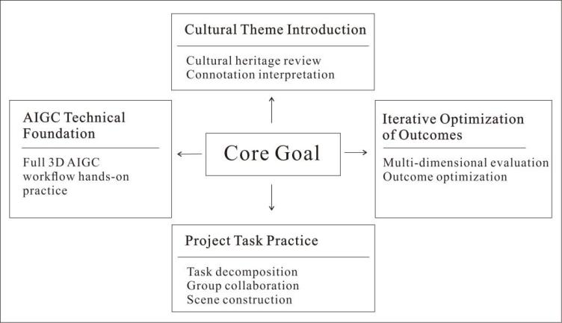
Figure 1. Overall framework of the teaching model construction

3.2. An AIGC tool-adaptation system for 3D design
The study surveys the AIGC 3D-design tools currently in common use and, from this, builds a staged tool-adaptation system mapped to the teaching stages of the course. The aim is to provide a reference for embedding these tools effectively and at the appropriate level throughout the course, as shown in Table 1.

Table 1. Comparison of major AIGC technologies and teaching adaptation

Technical Name | Core Functions | Application scenarios | Adaptation Teaching Phase | Teaching Application Point
Kaedim | Image-to-3D Modeling, Quick Basic Modeling | Initial Modeling of Cultural Symbols | Initial Modeling | Assist manual work in structural calibration
Tripo | Multimodal 3D Generation, Intelligent Editing | Multi-view Generation Technology for Reconstructing Cultural Relic Details | Basic Model Construction | Focus on calibrating the proportional standards of cultural elements
Blender AI Dream Textures | Model Detail Optimization, Intelligent Texture Mapping | Detailed Processing of Cultural Elements | Detailed Element Refinement | Assist manual work in the precise reproduction of cultural patterns
Stable Diffusion 3D | Material and Texture Generation, Atmospheric Scene Rendering | Recreation of Traditional Craft Materials | Material Reconstruction and Scene Rendering | Used for material reproduction in various craft processes
DreamFusion | Text-Driven 3D Model Generation | Creative Conceptualization of Cultural-Themed Scenes | Creative Expansion of Thematic Scenes | Enhance the leading role of human creativity

The approach to teaching these tools follows a staged progression—basic tools to establish a foundation, more advanced tools to extend it—with manual calibration running through the whole process as a connecting thread. In concrete terms, the early modeling phase uses Tripo and Kaedim to put together basic models of cultural elements quickly, lowering the technical barrier for students. The middle production phase relies mainly on Blender AI and Stable Diffusion 3D, supplemented by 3ds Max and Maya, to refine model details and restore materials. Scene construction then draws on Unreal Engine and DreamFusion to expand creative possibilities and build virtual application environments. Throughout, the capabilities and limits of each AIGC tool are made explicit, and the central role of manual refinement is emphasized, so as to preserve both the depth and the accuracy of the cultural translation.

4. Practical validation of the teaching model
To test whether the teaching model is workable and effective, this study takes the queti (sparrow brace), a key component of traditional Chinese architecture, as a case through which to put the model into practice and assess its results.

4.1. Background and teaching objectives of the project design
As a core component of traditional Chinese timber-frame architecture, the queti is at once load-bearing and decorative. Its form evolved gradually from a structural, weight-bearing element in the Han dynasty into a decorative one by the Ming and Qing periods. Its repertoire of ornamental patterns—scrolling vines, clouds, birds and flowers, auspicious beasts, and more—concentrates within it both the traditional building wisdom of “the unity of heaven and humanity” and a wealth of auspicious cultural meaning, making it an important material vehicle in the lineage of traditional Chinese architectural culture. Given the continuity of its formal evolution, the richness of its ornamental system, and the representativeness of its cultural meaning, the queti offers considerable depth for cultural translation and clear teaching value for digital preservation. It is therefore well suited to serve as the cultural anchor for validating the present teaching model.
With this choice of subject in place, the project establishes a complete project-based teaching sequence and breaks its core objectives down into three mutually supporting dimensions: cultural understanding, technical application, and practical translation (Figure 2).

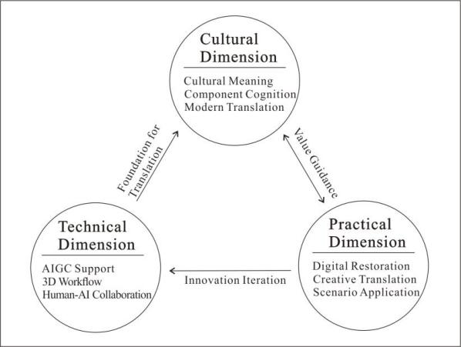
Figure 2. Dimensions of project-based teaching objectives

4.2. Design of the implementation steps
4.2.1. Organizing the cultural content
Drawing systematically on a range of sources—texts and classical records, historical images, and visual material—this step pulls together the historical origins of the queti, its regional stylistic lineages, and interpretations of what its patterns signify, and distills from these the cultural elements of the component, including its structural features, formal types, and contexts of use (Table 2). On this basis, it identifies the core cultural elements to be translated, spanning structural form, ornamentation, and materials and craftsmanship. Students are then given a systematic account of what each type of AIGC tool is for and how it works, along with hands-on training in the basic operation of these tools, which lays the technical groundwork for the stages that follow.

Table 2. Summary of structural characteristics of que ti

Function | Classification Name | Core Features | Application scenarios
Structural Load-Bearing Type | Large Que Ti | Solid wood construction, high load-bearing capacity | Temples
Structural Load-Bearing Type | Standard Que Ti | Axial symmetry | Palaces, altars and shrines
Structural and Decorative Type | Official-style Que Ti | Unilateral extension, decorative and load-bearing functions | Between large columns in a building’s interior
Structural and Decorative Type | Saddle-shaped Que Ti | Designed for narrow spaces, with a connected layout | Overhanging gate, eaves
Structural and Decorative Type | Dragon-gate Que Ti | Complex in design | Archways, Gateways, and Gate Towers
Structural and Decorative Type | Small Que Ti | Compact and minimalist design | Interior beams and joists in residential buildings
Purely Decorative Type | Decorative Floral Spandrel | Openwork carving, with graceful forms | Non-load-bearing parts of a residential living room

4.2.2. Standardizing the cultural material
AIGC tools are used to work through key information in a systematic way—structural parameters, the 6555555 of components, the density of patterns—and the result is a standardized image library of queti that provides high-quality input for the intelligent modeling to follow. Consider the queti on the gate of Miaoyin Temple in Yongdeng, Gansu Province. This component is a characteristic example of the Tibetan-Han hybrid queti form of the Ming and Qing periods: carved throughout in openwork, it depicts a dragon coursing through clouds and, together with the painted decoration of the beams, brings structural component and decorative system into harmonious unity. It is a representative sample of its regional culture, as shown in Figure 3 ^{[6]}.

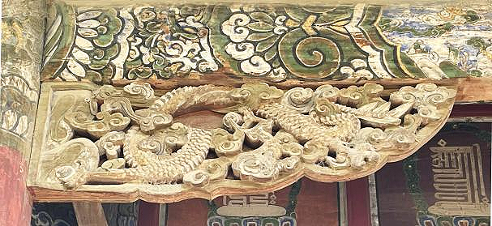
Figure 3. Que ti at the Gate of Miaoyin Temple

4.2.3. AIGC-assisted modeling and model refinement
The selected high-resolution images of the queti are imported into the Tripo.ai platform, where the architectural-component mode is selected, and high-detail parameters are set to generate an initial 3D model. Built-in functions such as “texture repair” are then used to address distortions in the patterns and breaks in the lines, calibrating the symmetry and continuity of the ornamentation (Figure 4). The initial model is imported into 3ds Max to correct errors in the topology, and students manually calibrate the key dimensions and structural proportions, correcting the cultural distortion caused by geometric deviations in the AIGC-generated model. Using the editable-polygon tools in 3ds Max, they add further detail and build a high-precision 3D model of the queti, as shown in Figure 5.

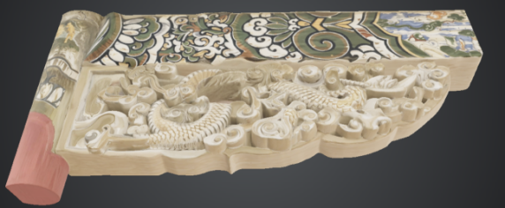
Figure 4. AI-assisted generation of bracket models

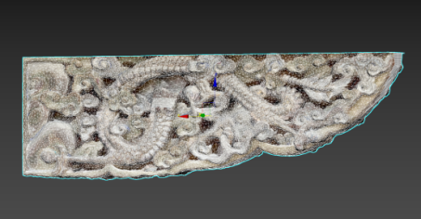
Figure 5. 3DS Max optimized model

4.2.4. Scene construction and interactive finished product output
This phase focuses on scenario-based presentation and the output of digital products based on cultural achievements. Students import refined high-precision que ti models via the Datasmith plug-in of Unreal Engine, adjust material texture and surface texture, build virtual application scenarios around the defined cultural theme, and finish interactive logic design. Executable files compatible with PCs and VR devices are ultimately generated through engine packaging functions to realize the transformation from digital assets to immersive cultural products and the practical display of cultural achievements in real application scenarios, as shown in Figure 6.

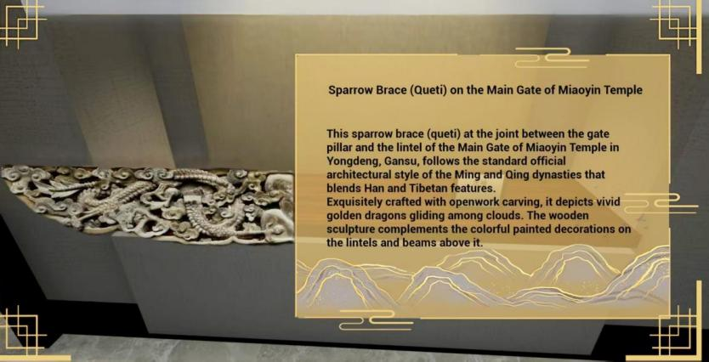
Figure 6. Interactive virtual simulation scene of que ti

4.2.5. Outcome evaluation and multi-round iterative optimization
This research adopts a diversified evaluation system combining student self-evaluation, peer evaluation, and teacher comments to comprehensively assess students’ works from four core dimensions: depth of cultural transcreation, precision of technical realization, innovative design value, and practical application value. Addressing problems exposed in evaluation, including biased cultural expression, structural faults of models, and defective interactive logic, students are guided to conduct multi-round iterative optimization so as to produce high-quality outcomes with both in-depth cultural connotations and qualified technical performance.

5. Conclusion
This study constructs an AIGC project-based teaching model from the perspective of cultural inheritance and conducts empirical verification using que ti as the case, realizing the organic integration of technical application and cultural inheritance. The phased adaptation system of AIGC tools effectively bridges the generation gap between curriculum teaching and industrial practice. Closed-loop project-based teaching serves as an effective carrier to achieve the dual training objectives of cultural understanding and technical application, thereby effectively enhancing students’ three core capabilities: three-dimensional modeling skills, cultural transcreation proficiency, and AIGC application competence.

Funding
Project: 2024 General Teaching Reform Project of Northwest Minzu University (2024YBJG-19)

Disclosure statement
The author declares no conflict of interest.

References
[1] Wang K, Chen GN, 2024, Curriculum Reform of Digital Media Art under the Background of AIGC. Shanghai Garment, 2024(6): 195–197.
[2] He SQ, Wu JJ, Qin JY, 2025, How Designers Cooperate with AI: Exploration on Teaching Mode of Design Workshop Empowered by AIGC. Art & Design Research, 2025(1): 123–129.
[3] Xu W, 2025, Research on Intangible Cultural Heritage Communication Path Empowered by AIGC. Communication and Copyright, 2025(17): 79–85.
[4] Zhang Y, 2025, Aesthetic Boundary and Value Reflection of AIGC-generated Art. Art Communication Research, 2025(5): 92–101.
[5] Feng Q, Liu ZH, 2025, Application and Practice of Action Learning in Digital Art Teaching under AIGC Background. Decoration, 2025(3): 124–127.
[6] Zhang ZT, 2025, Digital Reconstruction of Architectural Carvings in Traditional Villages of Central Longzhong Area. China Science and Technology Press, Beijing, 28.

Publisher’s note
Bio-Byword Scientific Publishing remains neutral with regard to jurisdictional claims in published maps and institutional affiliations.

