Cosplay Practices in Platform-Based Fan Communities: A Study of Embodied Labor, Gender Performance, and Community Care
Yi Ho Chen¹, Yin Sum Caspar Chan¹, Yu Tong Cheung²
¹The Hong Kong Polytechnic University Department of Applied Social Sciences, The Hong Kong Polytechnic University, Hong Kong SAR, China
²Lok Sin Tong Wong Chung Ming Secondary School, Hong Kong SAR, China

Copyright: © 2026 Author(s). This is an open-access article distributed under the terms of the Creative Commons Attribution License (CC BY 4.0), permitting distribution and reproduction in any medium, provided the original work is cited.

Abstract: As anime, games, film, and social media have become more closely intertwined, cosplay is no longer simply a leisure activity of “dressing up as a character.” It has become a layered cultural practice that involves bodily performance, fan identity, craft production, platform circulation, commercial opportunity, and community relations. This study uses a conceptual review approach and examines cosplay through four dimensions: embodied fan labor, gender performance, platform visibility, and community care. It argues that cosplay is not merely the reproduction of a character’s appearance. Rather, through costumes, makeup, poses, photography, post-production retouching, and online interaction, participants turn fictional texts into embodied works that can be viewed, evaluated, and circulated. At the same time, cross-gender cosplay and experiments with gendered style create room for expression, while observers cannot infer participants’ gender identity or orientation from characters, costumes, or bodily presentation alone. Platform circulation gives cosplay creators visibility, audience growth, and commercial possibilities, but it also intensifies algorithmic pressure, body comparison, harassment, blurred boundaries, and ongoing online labor. The article therefore approaches cosplay communities from the perspective of social policy and community governance, with attention to consent culture, minor protection, photography boundaries, digital literacy, and crisis referral pathways.
Keywords: Cosplay; Fan culture; Gender performance; Platformization; Creator economy; Community care

Online publication:

1. Introduction
For the general public, “cosplay” often means “role-playing” or wearing the costume of an anime, game, or film character at an event. This simple definition, however, understates the social and cultural complexity of cosplay. A complete cosplay usually involves character selection, costume purchase or production, wig styling, makeup design, prop making, pose training, photography appointments, venue coordination, photo post-processing, social media posting, fan interaction, and participation in offline exhibitions. Throughout this process, participants negotiate their physical condition, aesthetic preferences, economic resources, community norms, and platform rules. Previous studies have shown that cosplay can function as an embodied form of gender performance and can create a recognized performance world through collective collaboration ^{[1]}.
Yet cosplay should not be equated with a general clothing display. Research on costume-based fan practices reminds people to distinguish among character costumes, handicraft, historical context, performance motivation, and community identity ^{[2]}. This distinction provides the starting point for the present article, which understands cosplay as a platform-based fan cultural ecosystem rather than as a private hobby alone.
The connection between cosplay communities and social media platforms has deepened in recent years. Practices that once took place mainly at offline conventions, photo studios, or small interest groups are now circulated through visual platforms such as Instagram, TikTok, Bilibili, and Xiaohongshu. These platforms make it easier for cosplay works to reach unfamiliar audiences, but they also expose participants to visible competition through likes, shares, saves, follower growth, and commercial collaboration. Cosplay has therefore become not only a cultural creation, but also a form of relational and platform-based labor. This article addresses four questions: How has cosplay moved from “costume display” to embodied fan labor? How should gender performance and cross-gender cosplay be understood? How does platform circulation reshape opportunities and risks? How can communities build forms of care that do not stigmatize participants?

2. Analytical framework: Interweaving body, platform, and community
2.1. Four-dimensional analytical logic
In this article, the authors summarize current cosplay in terms of embodied fan labor, gender performance, platform visibility, and community care. Embodied fan labor refers to using costumes, makeup, props, poses, photography, and post-production to make fictional characters real life. Gender performance highlights that masculinity, femininity, androgyny, and cross-gender role-play are not proof of a participant’s personal identity. Platform visibility demonstrates how social media transforms cosplay works into rankable content that is sorted by algorithms, evaluated by audiences, and used commercially. Community care highlights the importance of establishing clear norms, cultivating consent culture, and providing practical safety mechanisms so that participation can continue.

2.2. Relationships among the dimensions
The four dimensions correspond to different core issues and governance priorities, as shown in Table 1. The value of this framework lies in its refusal to reduce cosplay to either “entertainment consumption” or an “identity declaration.” Instead, it places text, body, labor, platform, and relationships on the same analytical plane.

Table 1. Analytical dimensions of cosplay as a platform-based cultural ecosystem

Analytical dimension | Core content | Main issue | Community governance priority
Embodied fan labor | Costumes, makeup, props, photography, retouching, and interactive elements | Whose labor is visible, and whose resources are overlooked? | Respect the production process and recognize different types of participation.
Gender performance | Cross-gender role-play, style experimentation, and bodily presentation | Can personal identity be inferred from a character’s appearance? | Prevent identity-based offense and respect self-identification.
Platform visibility | Algorithmic recommendation, fan growth, and commercial collaboration | Does visibility create continuous online pressure? | Enhance digital literacy and protect creator boundaries.
Community care | Consent culture, minor protection, and crisis referral | How should communities respond to harassment and psychological risk? | Set up rules, feedback mechanisms, and support channels.

As shown in Figure 1, fictional texts provide the character sources for cosplay. Characters are then translated into figurative works through fans’ bodily labor. Once these works enter platform circulation, they generate visibility, evaluation, and commercial opportunities. Gender performance runs through character choice and bodily presentation, while community care provides boundaries, support, and buffers against risk throughout the process.

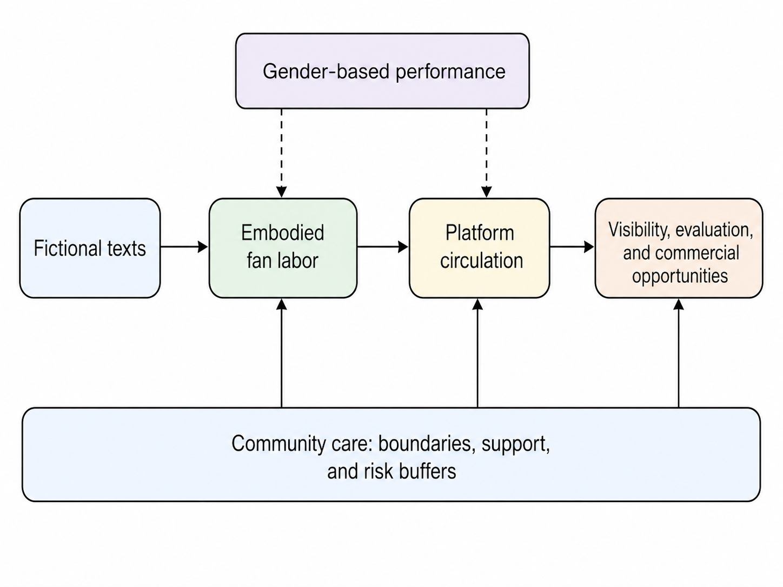
Figure 1. Analytical framework of cosplay as a platform-based cultural ecosystem

3. Embodied fan labor and differences in participation
3.1. Role translation and bodily engagement
The core of cosplay lies in the recreation of fictional characters. Participants do not simply “copy” a character into the real world; they interpret the character through their own body, skills, budget, location, and aesthetic choices. Clothing materials, wig trimming, makeup intensity, camera angles, and photo color grading all affect the final presentation of the character. In this sense, cosplay is an integrative and embodied form of fan work.

3.2. Labor complexity and resource differences
This work is complex. A participant may, at the same time, act as performer, costume maker, makeup artist, photographer, social media operator, and small-scale commercial creator. Even when no money is earned, the time, skill, emotion, and financial cost invested by participants should not be ignored. A complete work may involve expenses for fabric, wigs, props, studio rental, transportation, event tickets, and photo-editing software. After publishing, participants might also receive comments, handle private messages, collaborate, address criticisms, and delete harassing messages.
In cosplay communities, there exist evaluation criteria for authenticity and accuracy. Some viewers care about handcrafting details; some care about photo quality; others care if the temperament and emotions of the character are portrayed. This standard is not always bad, as it helps in skill learning and experience sharing, but when “accuracy” becomes absolutized, it excludes people who cannot afford to invest their money, whose bodies do not closely resemble the original character, or lack access to professional photography. Evaluations disregard the adaptive nature of cosplay — every time a fictional character inhabits a real body people must select, adjust, and re-create.

3.3. Fan well-being and community engagement
From the perspective of fans’ well-being, cosplay is not merely an exhibition. Studies of cosplay and psychological well-being have identified links among cosplay, fan identity, and offline activities. Community participation can influence individual well-being through shared activities and identity connections ^{[3]}. Broader fan studies have also found that interest-based friendships and offline social activities may mediate the relationship between fan identity and psychological well-being ^{[4]}. Healthy community evaluation should therefore look beyond the finished work and recognize learning, mutual assistance, companionship, and collaboration.

4. Boundaries between gender performance and identity inference
4.1. Character gender and performance motivation
Gender is one of the most discussed yet frequently misunderstood topics in cosplay. Many characters have highly stylized masculine, feminine, or androgynous features, and participants convey these gendered signs through clothing, poses, makeup, facial expressions, and camera language. Cross-gender cosplay is common: a female participant may play a male character, a male participant may play a female character, or any participant may choose a gender-ambiguous character.

4.2. Boundaries of identity inference
But these choices don’t always indicate who the participant actually is in their daily lives. A person might pick a character of another gender for liking the character’s personality, appreciating the character’s appearance, wanting a performance challenge, joining a group of friends, experimenting aesthetically, or exploring gender personally. There can be many reasons behind this choice that people cannot judge by just looking at photos or clothes. Research into adolescent fan identity indicates that fan identity correlates with self-concept clarity, meaning that fan activities could help understand oneself, but does not allow one as an observer to make any conclusion about the participants’ identity ^{[5]}.

4.3. Gender expression and community norms
In terms of gender performance, the importance of cosplay lies in showing how flexible gender symbols can be. Participants may magnify, soften, mix, or rearrange gendered styles. Makeup can change facial contours, clothing can reshape body lines, and poses can express strength, vulnerability, distance, or intimacy. These performances show that gender representation is not a natural or inevitable result; it is organized through symbols and interactions in a specific context.
Not every form of gendered cosplay performance is safe, however. Some participants may be ridiculed, stared at, or harassed because of their physical characteristics, gender expression, or role choice. On image-based platforms in particular, viewers may treat character photos as invitations to judge a person’s body publicly, including offensive comments about body shape, gender, age, or sexual orientation. Community norms therefore need to distinguish clearly between “evaluating the work” and “evaluating a private body.” Respecting participants’ chosen forms of address, refraining from identity inference based on appearance, and avoiding public discussion of bodies that do not fit mainstream gender expectations are basic conditions for safety in cosplay communities.

5. Platform visibility, creator labor, and commercial pressure
5.1. Platform recommendation and visibility competition
Contemporary cosplay is deeply embedded in platforms. A platform is not only a display space; it is also an infrastructure that shapes whether works are seen, recommended, forwarded, and commercialized. Character popularity, posting time, tag choice, video rhythm, cover composition, body image, and interaction frequency can all influence visibility. Research on creative labor on social media shows that creators’ pursuit of visibility affects both their production processes and labor conditions, making platform labor unstable ^{[6]}.

5.2. Creator economy and unstable labor
Platform visibility creates real opportunities for cosplay creators. They may earn income through costume commissions, photography services, makeup tutorials, livestreaming rewards, subscription content, brand collaborations, or convention invitations. For some young creators who enter cultural entrepreneurship, cosplay is no longer merely a hobby. Yet these opportunities are unstable. Research on creator platform governance shows that algorithmic visibility is not neutral; it affects creators unequally through content review, recommendation, and informal demotion ^{[7]}. Studies of content governance also remind us that platforms do not always delete content directly. Reducing recommendation and visibility can itself function as a form of governance ^{[8]}.

5.3. Opaque rules and visibility anxiety
The opacity of platform rules forces creators to rely on experience and speculation when judging what will be recommended or restricted. Research on “shadow bans” shows that when platforms deny or conceal demotion mechanisms, users struggle to understand why their content loses visibility ^{[9]}. For content involving the body, nudity, or sexualized presentation, this lack of transparency is especially likely to produce anxiety and self-censorship. Research on pole dancing and body-display content on Instagram, for example, shows how shadow bans affect user rights and content circulation ^{[10]}. In cosplay, sexy characters, swimsuit characters, adult-oriented characters, or photos that emphasize body curves may create tension between commercial opportunity and platform restriction.

5.4. Relational labor and boundary management
The creator economy requires constant approachability and a performance of authenticity. As research on the influencer economy has shown, vulnerability and authenticity can become tools for capturing attention within commercial logic. At the same time, social media work produces a “visibility paradox”: the content is visible, while the management, filtering, communication, and emotional labor behind it remain hidden. For cosplay creators, this means that comment management, private-message filtering, commission negotiation, fan expectations, photographer collaboration, and commercial boundary setting may be invisible to audiences, even though they shape the sustainability of the work.

5.5. Scenario stress matrix
Figure 2 illustrates the main pressures across different participation scenarios using a conceptual rating system. Offline activities emphasize identity expression and community interaction, photography collaborations highlight craft learning and boundary risks, short-video platforms intensify commercial opportunities and visibility pressure, and fan communities foreground the need for care.

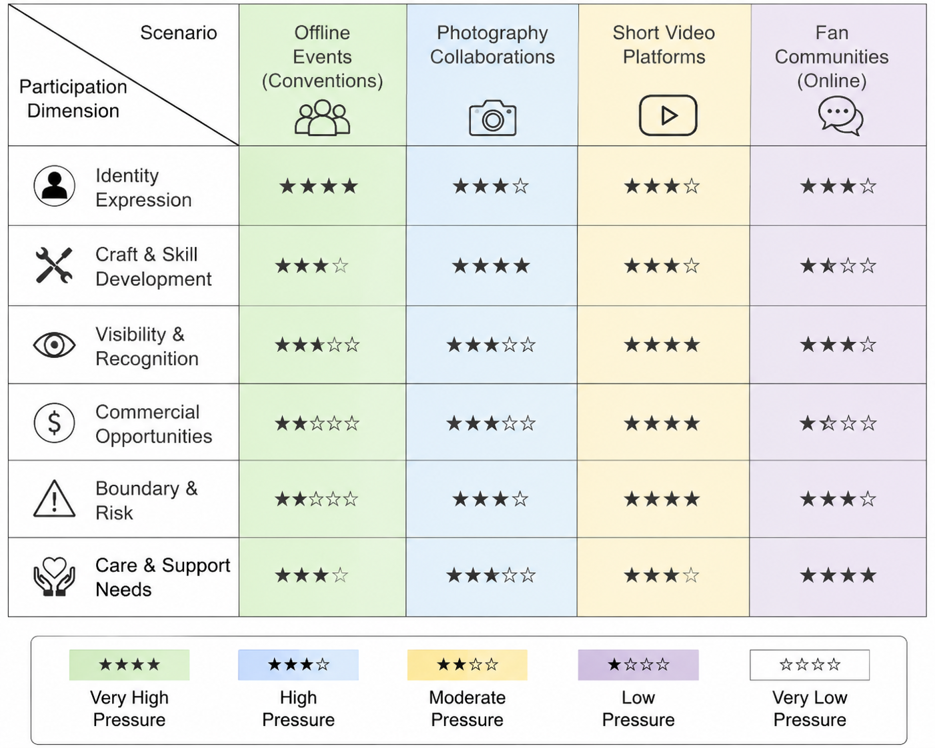
Figure 2. Conceptual matrix of participation dimensions in different cosplay scenarios

6. Community care and social policy implications
6.1. Understanding risk without stigmatization
Cosplay should not be stigmatized as risky behavior. For many participants, it offers friendship, belonging, skill learning, and emotional support. Offline events, group photoshoots, and collaborative creations allow participants to form relationships and develop a sense of self-efficacy. Recognizing the positive value of cosplay does not mean ignoring possible risks. Harassment, unauthorized photography, unauthorized reproduction, body shaming, commercial disputes, inappropriate invitations, and psychological crises can all worsen when clear rules are absent.

6.2. Body comparison and visual harassment
Image-based platforms, in particular, magnify the effects of body comparison. Studies of Instagram use and body dissatisfaction have shown how upward social comparison mediates the association between social media browsing and reduced body appreciation. Cosplay participants often compare character physique, makeup refinement, photography equipment, and editing quality. Such comparison may encourage skill development, but it may also produce body anxiety. Image-based sexual harassment and the non-consensual sharing of images are serious digital safety issues that require sustained attention. International research has examined young people’s experiences of image-based harassment through the lens of technology-facilitated sexual violence.

6.3. Institutionalizing community care
For this reason, the authors advocate viewing cosplay governance through the lens of “community care” rather than “moral panic.” Community care does not ask members to take on professional treatment roles. It asks them to build basic safety infrastructure: which behaviors require prior consent, how photo use should be authorized, how minors can participate in photography, how commercial collaborations should be agreed upon, how harassment can be reported, and how individuals can be referred to trusted adults or professional resources when signs of self-harm appear. Reviews of adolescent digital health show that the relationship between social media and mental health is not a simple one-way causality; findings vary depending on individuals, content, relationships, and platform environments. A recent umbrella review likewise suggests that social media carries both risks and opportunities, and that reducing harm requires a combination of platform governance, education, and support mechanisms.

6.4. Risk scenarios and governance recommendations
Table 2 presents basic rules for five common risk scenarios in cosplay communities: photography boundaries, minor protection, platform harassment, commercial collaboration, and psychological crisis. Rules do not suppress creativity. They reduce ambiguity so that newcomers, minors, and participants with fewer resources can judge whether a request is reasonable or crosses a boundary.

Table 2. Risk scenarios and supportive governance recommendations for cosplay communities

Risk scenario | Typical manifestation | Supportive governance recommendation
Blurred photography boundaries | Taking photos without consent, touching clothing, or requesting intimate poses. | Clearly define a “consent before filming” rule, the right to refuse, and reporting channels.
Risks involving minors | Adult-led private photoshoots, requests for adult content, or lack of guardian awareness. | Establish age-appropriate rules that require public venues and guardian awareness.
Platform harassment | Harassment via private messages, body evaluation, image theft, or account impersonation. | Use blocking, reporting, watermarking, and platform appeal mechanisms.
Commercial collaboration disputes | Unclear fees, attribution, photo usage rights, or delivery timelines. | Use simple written agreements to define payment, authorization, and cancellation rules.
Signs of psychological crisis | Hints of self-harm, severe emotional breakdowns, or withdrawal from the community after online attacks. | Set peer support boundaries and guide connections with family members, schools, or professional organizations.

7. Conclusions
This article argues that cosplay is not simply costume imitation; it connects body, text, platform, labor, and relationships. Cosplay turns fictional texts into material practices and gives fan culture an embodied, tangible, and interactive form. Through gender performance, it opens space for identity expression while also requiring observers to respect the limits of identity inference. Within platform environments, cosplay gains circulation and commercial opportunities, but it is also shaped by algorithms, aesthetic comparison, and continuous online labor. Its sustainability depends on community care mechanisms that protect safety, trust, and participation. Future research should move beyond describing cosplay as a “subcultural spectacle” or a “costume hobby” and compare differences across platforms, age groups, character types, language communities, and labor positions. Ordinary participants, professional photographers, makeup artists, costume commissioners, convention organizers, and platform content creators encounter different opportunities and risks. Interviews, participant observation, platform content analysis, and questionnaires can be combined to explore the complex relationships among identity expression, aesthetic labor, commercial collaboration, and community care. Research should avoid stigmatizing or pathologizing cosplay and should instead focus on participant agency, platform structures, and conditions of community support. Only by recognizing that creativity and risk coexist can we better understand the development of contemporary fan culture.

Disclosure statement
The authors declare no conflict of interest.

References
[1] Yang Y, 2022, The Art Worlds of Gender Performance: Cosplay, Embodiment, and the Collective Accomplishment of Gender. The Journal of Chinese Sociology, 2022(9): Article 9. https://doi.org/10.1186/s40711-022-00168-z
[2] Godwin VL, 2024, Why Costume Fandom’s Distinctions from Cosplay Matter: Costuming’s Craft, Histories, and Motivations. Transformative Works and Cultures, 2024(43): 1–22. https://doi.org/10.3983/twc.2024.2539
[3] Leshner CE, Reysen S, Plante CN, et al., 2024, Fandom Identification and In-person Activities as Mediators of the Association between Cosplay and Psychological Well-being. The Journal of Fandom Studies, 12(1): 59–76. https://doi.org/10.1386/jfs_00089_1
[4] Reysen S, Plante CN, Roberts SE, et al., 2024, Social Activities Mediate the Relation between Fandom Identification and Psychological Well-being. Leisure Sciences, 46(5): 681–701. https://doi.org/10.1080/01490400.2021.2023714
[5] Dajches L, 2022, Finding the Self through Others: Exploring Fandom, Identification, and Self-Concept Clarity among U.S. Adolescents. Journal of Children and Media, 16(1): 107–116. https://doi.org/10.1080/17482798.2021.1922474
[6] Duffy BE, Pinch A, Sannon S, et al., 2021, The Nested Precarities of Creative Labor on Social Media. Social Media + Society, 7(2): 1–12. https://doi.org/10.1177/20563051211021368
[7] Duffy BE, Meisner C, 2023, Platform Governance at the Margins: Social Media Creators’ Experiences with Algorithmic (in)visibility. Media, Culture & Society, 45(2): 285–304. https://doi.org/10.1177/01634437221111923
[8] Gillespie T, 2022, Do Not Recommend? Reduction as a Form of Content Moderation. Social Media + Society, 8(3): 1–13. https://doi.org/10.1177/20563051221117552
[9] Cotter K, 2023, “Shadowbanning is not a Thing”: Black Box Gaslighting and the Power to Independently Know and Credibly Critique Algorithms. Information, Communication & Society, 26(6): 1226–1243. https://doi.org/10.1080/1369118X.2021.1994624
[10] Are C, 2022, The Shadowban Cycle: An Autoethnography of Pole Dancing, Nudity and Censorship on Instagram. Feminist Media Studies, 22(8): 2002–2019. https://doi.org/10.1080/14680777.2021.1928259

Publisher’s note
Bio-Byword Scientific Publishing remains neutral with regard to jurisdictional claims in published maps and institutional affiliations.

