From Evidence to Justification: How Causal Attribution Shapes Public Judgments of Police Searches
Qianlin Zhou*, Richard S. John
University of Southern California, Los Angeles, CA 90089, USA
*Author to whom correspondence should be addressed.

Copyright: © 2026 Author(s). This is an open-access article distributed under the terms of the Creative Commons Attribution License (CC BY 4.0), permitting distribution and reproduction in any medium, provided the original work is cited.

Abstract: The Fourth Amendment distinguishes between reasonable suspicion and probable cause, two legal standards that authorize different levels of police intrusion. Although these standards differ in legal doctrine, both rely on subjective evaluations of evidentiary sufficiency. Drawing on attribution theory and research on heuristic judgment, this study examined how evidence type, crime-rate context, and legal standards influence public evaluations of police searches. A 2 × 2 × 2 between-subjects experiment was conducted with 299 U.S. participants. Participants were randomly assigned to read one of eight vignettes that varied evidence type (direct vs. circumstantial), crime context (high-crime vs. low-crime), and legal standard (reasonable suspicion vs. probable cause). Results indicated that evidence type was the strongest predictor of search justification, perceived guilt, and expectations of finding incriminating evidence. Crime-rate context also significantly influenced judgments, with participants expressing greater support for police searches in high-crime environments. Legal standards produced smaller but significant effects on justification and certainty judgments. No significant interaction effects were observed among the three experimental factors. These findings suggest that public evaluations of police conduct are influenced not only by legal standards but also by evidentiary and contextual information. The study contributes to understanding how psychological processes shape perceptions of evidentiary sufficiency in legal decision-making.
Keywords: Reasonable suspicion; Probable cause; Police searches; Attribution theory

Online publication:

1. Introduction
In U.S. Law, the Fourth Amendment distinguishes between “reasonable suspicion” and “probable cause,” two evidentiary thresholds that authorize different forms of police intrusion. The reasonable suspicion standard, established in Terry v. Ohio (1968), allows brief investigatory stops based on specific, articulable facts suggesting criminal activity, while probable cause, required for arrests and search warrants, demands a higher evidentiary showing ^{[1–2]}. Although these standards are formally differentiated in doctrine, neither is defined by a fixed quantitative rule. Probable cause has been described as a “practical, nontechnical conception” grounded in “the factual and practical considerations of everyday life on which reasonable and prudent men, not legal technicians, act” (Page 175) ^{[3]}. Similarly, reasonable suspicion requires no numerical threshold but instead depends on “specific articulable facts, together with rational inferences from those facts” assessed under a totality-of-the-circumstances framework (Page 238; 417) ^{[2, 4]}. Because both standards require judges to exercise judgment rather than apply fixed rules mechanically, appellate courts retain the authority to review such determinations independently, rather than simply deferring to the conclusions of lower courts ^{[5]}. As a result, the interpretation of evidentiary strength becomes central to assessing police conduct ^{[6–7]}.
Judgments of evidentiary sufficiency are not purely logical assessments of probability; they also reflect interpretive and normative evaluations of what the available evidence means ^{[8]}. Research in attribution theory suggests that individuals are sensitive to whether evidence appears causally connected to an outcome ^{[9–10]}. Direct evidence, such as eyewitness identification, provides a clearer causal pathway linking a suspect to a crime ^{[11]}. By contrast, behavioral cues or contextual indicators may be merely associative with wrongdoing, leaving greater room for interpretive flexibility ^{[12]}. This flexibility raises an important question about the role of environmental context. Legal doctrine permits consideration of whether an encounter occurs in a “high-crime area”, thereby incorporating base-rate information into assessments of suspicion ^{[13]}. However, research on heuristic judgment suggests that contextual cues can shape perceived diagnosticity, particularly when primary evidence is ambiguous ^{[14]}. Under such conditions, correlational cues may be perceived as more probative than they would be in isolation.
Despite extensive discussion of neighborhood context in both legal and psychological aspects, relatively little empirical work has examined how evidence type, crime context, and legal standards jointly influence public evaluations of police searches. In particular, it remains unclear whether lay observers meaningfully differentiate between reasonable suspicion and probable cause when evaluating a completed search and how different forms of evidence shape these judgments. Furthermore, few studies have examined the psychological mechanisms through which evidence type influences perceptions of search justification.
The present study addresses this issue using a 2 × 2 × 2 factorial design that manipulates evidence type (direct vs. circumstantial), crime context (high vs. low), and legal standard (reasonable suspicion vs. probable cause). The study predicts that evidence type, crime context, and legal standards will each independently influence public evaluations of police searches. In addition, the study examines whether the effect of evidence type on search justification operates through perceived guilt certainty and expected evidence discovery. The following questions prevail:
RQ1: Does evidence type influence perceived justification of a police search? RQ2: Does crime-rate context influence perceived justification? RQ3: Does legal standard influence perceived justification? RQ4: Does the effect of evidence type on justification operate indirectly through perceived guilt certainty and expected evidence discovery? Based on these research questions, the following hypotheses prevail: H1: Participants exposed to direct evidence will report higher justification ratings than participants exposed to circumstantial evidence. H2: Participants exposed to a high-crime context will report higher justification ratings than participants exposed to a low-crime context. H3: Participants exposed to a reasonable suspicion standard will report higher justification ratings than participants exposed to a probable cause standard. H4: Perceived guilt certainty and expected evidence discovery are expected to serve as potential mediators linking evidence type to justification judgments.

2. Literature review
2.1. The legal architecture of suspicion: Reasonable suspicion vs. probable cause
The Fourth Amendment of the U.S. Constitution governs the balance between individual privacy and public safety through two primary evidentiary thresholds (U.S. Const. amend. IV). Reasonable Suspicion (RS), established in Terry v. Ohio (1968), requires specific and articulable facts that would lead a reasonable officer to suspect criminal activity is afoot. In contrast, Probable Cause (PC) requires a higher “fair probability” of guilt to justify arrests or full searches. However, legal scholars argue that these standards are inherently “fluid” and “elastic” ^{[15]}. For the layperson, the distinction between a “reasonable” and a “probable” conclusion is often cognitively blurred.
This ambiguity may allow psychological heuristics to influence public evaluations of police decisions. Empirical evidence suggests that laypeople’s intuitive rankings of “suspiciousness” often diverge sharply from the Supreme Court’s categorical distinctions ^{[16]}. Furthermore, because precise mathematical probabilities do not define these standards, they are susceptible to “schema-consistent” interpretations, in which individuals use their prior beliefs about crime to fill in the gaps in the evidence ^{[17]}.

2.2. Causal attribution and the weight of evidence
The way people evaluate encounters with police is strongly informed by Attribution Theory, which suggests that individuals act as “naive psychologists,” continuously attempting to infer the causes behind observed behaviors ^{[9–10]}. In policing, this involves a critical distinction between causal evidence and correlational cues ^{[18]}. Causal evidence, such as a direct forensic link or physical evidence, establishes a mechanistic connection between a suspect and a specific criminal act. In contrast, many factors used to justify police stops are merely correlational or “associative,” such as a suspect’s presence in a high-crime area or an evasive demeanor. Despite their lower legal reliability, psychological research suggests that lay observers often overweigh these correlational cues ^{[19]}. This is partly due to the representativeness heuristic, in which individuals judge the likelihood of guilt based on how closely a suspect fits a stereotypical “criminal” prototype rather than on the statistical probability of crime ^{[20]}.
When evaluating a suspect’s actions (e.g., fleeing at the sight of police), the public is prone to the Fundamental Attribution Error ^{[21]}. This cognitive bias leads observers to over-attribute a suspect’s behavior to internal, dispositional factors, such as “consciousness of guilt” or criminal intent, while systematically underestimating situational explanations, such as fear of police misconduct or social pressure ^{[22]}.
Attribution theory also suggests that different forms of evidence vary in their perceived diagnostic value. Direct evidence provides a clearer causal connection between a suspect and an alleged offense, allowing observers to make stronger inferences regarding guilt and responsibility. In contrast, circumstantial evidence requires greater interpretation and may be viewed as less informative regarding a suspect’s involvement in criminal activity. As a result, individuals may perceive police actions as more justified when they are supported by direct evidence rather than circumstantial evidence. This distinction is particularly important in legal decision-making contexts, where judgments often depend on how people interpret the strength and meaning of available evidence.

2.3. Heuristics and the “high-crime neighborhood” context
A central tension in Fourth Amendment jurisprudence is the “high-crime area” designation. While the Supreme Court ruled in Illinois v. Wardlow (2000) that a location’s characteristics can be a relevant factor in an officer’s assessment of suspicion, psychological research suggests that this context profoundly distorts lay evaluations of evidence through specific cognitive shortcuts. The most pervasive bias in this context is the base-rate fallacy ^{[14]}. When individuals evaluate a police stop in a “high-crime” neighborhood, they tend to over-rely on the salient “criminal” reputation of the area while neglecting the statistical reality that the vast majority of individuals in that neighborhood are law-abiding citizens. As Slobogin (1991) noted, lay observers often allow the “denominator” of the neighborhood to dictate the “numerator” of individual suspicion, effectively lowering the evidentiary bar required for a stop to be perceived as legitimate ^{[23]}.
Neighborhoods function as powerful cognitive schemas. Research by Quillian and Pager (2001) demonstrates that perceptions of neighborhood crime are often decoupled from actual crime rates and are instead driven by social stereotypes ^{[24]}. When a neighborhood is labeled “high-crime,” it activates an “associative network” of danger and criminality in the observer’s mind. Consequently, according to the availability heuristic, examples of crime are easily recalled, leading the public to overestimate the likelihood that any given individual in that space is engaged in illicit activity ^{[20]}.
High-crime environments may therefore function as heuristic cues that independently influence judgments of police conduct. Rather than changing the legal meaning of evidence, crime context may provide additional information that shapes perceptions of risk, suspicion, and public safety ^{[14, 20]}. Research suggests that contextual crime information can activate crime-related schemas and increase the perceived diagnosticity of otherwise ambiguous cues, leading observers to draw stronger inferences regarding criminal involvement ^{[17, 24].} As a result, individuals may view police searches as more justified when they occur in high-crime settings, even when the evidentiary information remains constant ^{[13, 23]}.

3. Method
3.1. Participants
300 participants were recruited through Qualtrics, distributed by Prolific. After exclusions, the final sample included 299 participants. Inclusion criteria include: (a) fluency in English, and (b) current residence in the United States, to ensure a basic familiarity with domestic legal concepts and policing. Because this study examines legal concepts grounded in the U.S. Constitution, (c) participants are required to be U.S. citizens. (d) Participants should have a general background in legal concepts; currently enrolled in law school or holding a Juris Doctor degree will be excluded.

3.2. Design and power analysis
The data were analyzed using a 2 × 2 × 2 between-subjects ANOVA (α = .05) to examine main effects and interaction effects on perceived justification ratings. A prior power analysis confirmed that a total sample of 300 achieves sufficient power (≥ .80) to detect medium and large effect sizes.
The theoretical accounts reviewed in the preceding sections suggest that evidence type and crime context do not influence justification judgments in isolation, but rather operate through a sequence of cognitive appraisals. To formalize this evaluative process, the present study adopts a serial mediation framework grounded in Hayes’ PROCESS Model 6 ^{[25]}. This model allows for the decomposition of how situational inputs are translated into legal judgments through a structured chain of psychological inferences.
The proposed process model is illustrated in Figure 1, which depicts the serial mediational pathway linking evidence type to justification judgments via perceived guilt and expected evidence discovery.

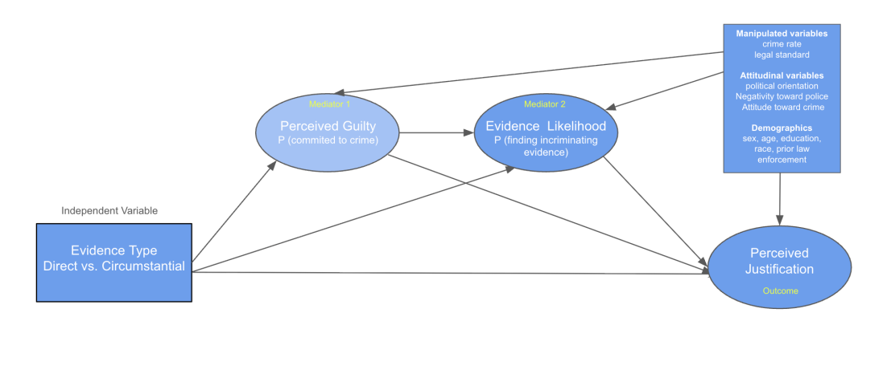
Figure 1. Process model

3.3. Materials
The primary experimental stimulus consists of eight written vignettes, each approximately 150–200 words, describing a police officer, Daniel, deciding whether to search an individual. The vignettes systematically manipulate the three independent variables and are randomly assigned to the participants. Other information, except for the manipulative variable between vignettes, is the same and controlled to eliminate possible confounding variables. For direct evidence, information is given as the officer acts on specific, causal information linking the suspect to a crime (e.g., an eyewitness report that matches security footage). Circumstantial evidence, on the other hand, the officer acts on behavioral and contextual cues with only correlational value (e.g., pacing, avoiding eye contact, no direct evidence).
In a high-crime context manipulation, the neighborhood is described as having experienced “several robberies in the past two weeks.” In a low-crime context, the neighborhood is described as one that “rarely experiences theft or robbery.” In the second paragraph, the officer’s internal deliberation is framed by one of two legal standards embedded in the text: “Based on the man’s behavior and the high-crime context, the officer considers whether he has reasonable suspicion to search the man. He decides to search the man.” or “... whether he has probable cause to search the man. He decides to search the man.”

3.4. Procedure
The study is administered online via Qualtrics. After providing electronic informed consent and a legal background check, participants are randomly assigned to one of the eight conditions and read about the corresponding vignette. They then complete the measures in the following fixed order: (1) justification rating, (2) belief certainty threshold, (3) manipulation checks, (4) exploratory covariates, and (5) demographic questionnaire. Finally, all participants receive a comprehensive debriefing statement explaining the study’s purpose, the experimental manipulations, and the legal definitions of reasonable suspicion and probable cause.

4. Result: Descriptive analysis
The final sample included 299 valid participants ranging in age from 18 to 78 years old. Participants were primarily female (53%) and male (46%), with 1% preferring not to disclose gender. The sample was predominantly White (75.3%), followed by Black or African American (16.7%), Hispanic or Latino (7.7%), Asian (7.0%), and Native American (2.3%) participants. Most participants reported relatively high educational attainment, with 35.3% holding a bachelor’s degree and 13.7% holding a graduate or professional degree. Additionally, 15.3% of participants reported prior law enforcement experience. Political orientation varied across the sample, with 43.8% identifying as conservative (scores 1–3), 24.4% identifying as moderate (score 4), and 23.5% identifying as liberal (scores 5–7). An additional 8.4% chose not to reveal.

Table 1. Intercorrelations between key case variables

Variable | 1 | 2 | 3 | 4 | 5 | 6
1. Evidence type | —
2. Crime rate context | .027 | —
3. Legal standard | .060 | .017 | —
4. Justification | .473** | .155** | .149** | —
5. Perceived guilty | .483** | .177** | .139* | .778** | —
6. Evidence finding likelihood | .371** | .204** | .088 | .759** | .854** | —
Note: N = 300. * P < .05. ** P < .01.

Pearson correlation analyses were conducted to examine the relationships among the three experimental manipulations (evidence type, crime-rate context, and legal threshold) and the primary study variables, including perceived guilt, expected evidence discovery (likelihood), and search justification. The correlation matrix is presented in Table 1.
Evidence type demonstrated the strongest associations with the primary outcome variables. Participants exposed to direct evidence reported significantly higher levels of perceived guilt, r = .483, P < .001, greater expectations that incriminating evidence would be discovered during the search, r = .371, P < .001, and stronger perceptions that the officer’s search decision was justified, r = .473, P < .001. These moderate correlations provide preliminary support for the hypothesis that evidentiary quality serves as a central determinant of legal judgments.
Crime-rate context was also significantly associated with all three evaluative outcomes, although the magnitude of these relationships was notably smaller. Participants exposed to the high-crime context reported greater perceived guilt, r = .177, P = .002, stronger expectations of evidence discovery, r = .204, P < .001, and higher levels of search justification, r = .155, P = .007. These findings suggest that contextual crime information may influence legal evaluations, but to a substantially lesser extent than evidentiary information.
Similarly, legal threshold was positively associated with perceived guilt, r = .139, P = .016, and search justification, r = .149, P = .010. However, legal threshold was not significantly associated with expectations of evidence discovery, r = .088, P = .126. This pattern suggests that legal standards may shape evaluative judgments regarding guilt and procedural legitimacy without substantially altering expectations about the likelihood of discovering additional evidence.
Strong positive associations were observed among the three psychological judgment variables. Perceived guilt was highly correlated with expectations of evidence discovery, r = .854, P < .001, indicating that participants who believed the suspect was more likely to have committed a crime were also more likely to expect incriminating evidence to be uncovered. Perceived guilt was also strongly associated with search justification, r = .778, P < .001. Likewise, expectations of evidence discovery were strongly related to search justification, r = .759, P < .001. The magnitude of these relationships is consistent with the proposed theoretical account linking guilt judgments, evidence-discovery expectations, and evaluations of investigative justification.
Importantly, the three experimental manipulations were not significantly correlated with one another (all P > .30), confirming that the random assignment procedure successfully produced independent experimental conditions. This independence reduces concerns regarding multicollinearity among the manipulated variables and supports the validity of subsequent multivariate analyses (Table 2).

Table 2. Descriptive statistics for perceptions of police priorities and transparency

Statistic | Prioritize public safety when  deciding how to  act | Provide a fast response | Prioritize the crimes most  affecting your community | Deal with everyone in the same way,  regardless of who they are | Are open and transparent about the  decisions they make | Deal effectively with violent crimes
Mean | 2.19 | 2.30 | 2.31 | 2.65 | 2.48 | 2.15
Std. Error of Mean | .055 | .053 | .059 | .082 | .079 | .062
Median | 2.00 | 2.00 | 2.00 | 2.00 | 2.00 | 2.00
Minimum | 1 | 1 | 1 | 1 | 1 | 1
Maximum | 5 | 5 | 5 | 5 | 5 | 5
Note: 1 = strongly agree, 5 = strongly disagree.

As a covariate, participants generally reported relatively positive perceptions of police engagement across all three measures (Table 3). Most participants indicated that police were “often” responsive to the local community (70.7%), maintained a visible policing presence (63.3%), and were available to individuals wishing to speak with an officer or staff member (63.7%). Mean ratings across the three items ranged from 1.77 to 1.83, suggesting overall favorable attitudes toward police-community engagement within the sample.

Table 3. Descriptive statistics for general perception on police engagement and presence

Statistic | Responsive to the local community | Providing a visible policing presence | Available to people who wish to speak to an officer or staff  member
Mean | 1.83 | 1.77 | 1.80
Std. Error of Mean | .030 | .032 | .033
Median | 2.00 | 2.00 | 2.00
Minimum | 1 | 1 | 1
Maximum | 3 | 3 | 3
Note: 1 = all the times, 3 = never.

Participants reported generally positive overall perceptions of the police across all six reverse-coded measures. Most respondents expressed strong agreement with statements reflecting favorable police performance, with “dealing effectively with violent crimes” (Mean = 2.15, SE = .062) and “prioritizing public safety when deciding how to act” (Mean = 2.19, SE = .055) showing the highest levels of endorsement (Table 4). In contrast, “dealing with everyone in the same way, regardless of who they are” received comparatively lower approval (Mean = 2.65, SE = .082). Across the six items, mean scores ranged from 2.15 to 2.65 (where lower scores indicate greater agreement), and the median remained consistently at 2.00 for all items. Overall, these results indicate generally favorable attitudes toward police performance within the sample.

Table 4. Descriptive statistics for belief of crime prevalence

Statistic | I believe that the overall crime rate in my area has  increased over the past year. | I think official  crime statistics underestimate the actual level of crime. | Media coverage makes me feel that crime is more  common than it actually is. | I believe that most residents could  become victims of crime in the next year. | I expect that serious crimes.
Mean | 2.75 | 3.21 | 3.36 | 2.45 | 2.63
Std. Error of Mean | .060 | .059 | .062 | .055 | .059
Median | 3.00 | 3.00 | 4.00 | 2.00 | 2.00
Minimum | 1 | 1 | 1 | 1 | 1
Maximum | 5 | 5 | 5 | 5 | 5
Note: 1 = strongly disagree, 5 = strongly agree.

Participants generally reported moderate to low perceptions of crime prevalence across the five measures (Figure 2). The highest level of agreement was observed for the statement “media coverage makes me feel that crime is more common than it actually is” (Mean = 3.36, SE = .062, Median = 4.00), followed by the belief that official statistics underestimate actual crime levels (Mean = 3.21, SE = .059). In contrast, participants expressed the lowest level of concern regarding personal or localized risk, with “I believe that most residents could become victims of crime in the next year” receiving the lowest agreement rating (Mean = 2.45, SE = .055, Median = 2.00). Across the five items, mean scores ranged from 2.45 to 3.36, indicating that while participants acknowledge structural and media-related influences on crime perception, their immediate concerns about local crime and personal victimization remain relatively low within the sample.

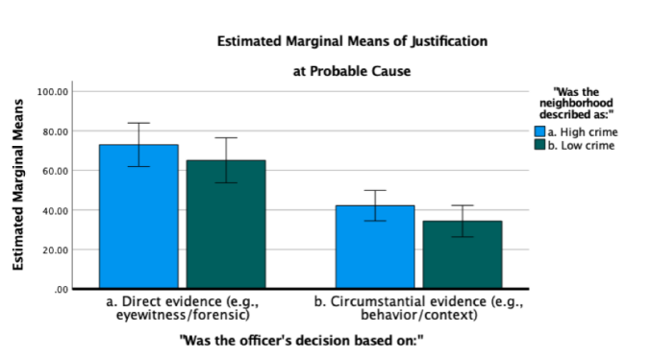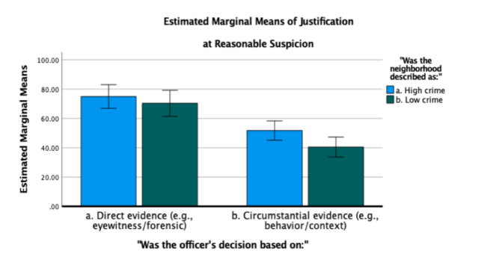
Figure 2. Justification ratings

After adjusting for these covariates, the overall model remained significant, F(15, 283) = 9.261, P < .001, explaining 32.9% of the variance in justification ratings (R² = .329) (Figure 3). Evidence type continued to exert a strong and significant effect on justification judgments, F(1, 283) = 82.988, P < .001, ηp² = .227. Crime context also showed a significant main effect, F(1, 283) = 6.386, P = .012, ηp² = .022, whereas the main effect of legal standard was marginally significant, F(1, 283) = 3.364, P = .068, ηp² = .012.
None of the two-way or three-way interaction effects reached significance (all P > .50). Among the covariates, only attitudes toward police significantly predicted justification ratings, B = -5.522, SE = 1.971, t = -2.802, P = .005. The negative coefficient indicates that participants with less favorable attitudes toward police tended to view the officer’s search decision as less justified. All other covariates, including age, gender, race, education, political orientation, prior law-enforcement experience, and crime perception, were not significant predictors (all P > .05).

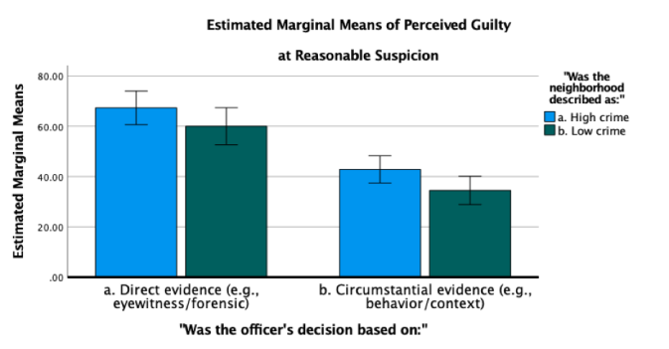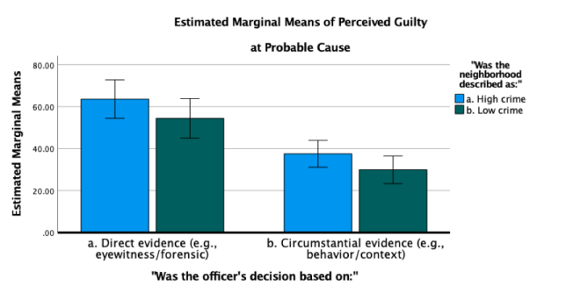
Figure 3. Perceived guilt

For the certainty that the suspect committed a crime, the overall model still was significant, F(15, 283) = 12.398, P < .001, explaining 39.7% of the variance in certainty judgments (R² = .397, Adjusted R² = .365) (Figure 4). After controlling for the covariates, a strong main effect of evidence type emerged, F(1, 283) = 93.199, P < .001, ηp² = .248. Participants in the Evidence Type 1 condition reported certainty ratings that were, on average, 24.52 points higher than those in the reference condition (B = 24.515, SE = 5.845, P < .001). A significant main effect of crime context was also observed, F(1, 283) = 9.843, P = .002, ηp² = .034, indicating that perceptions of guilt were influenced by the surrounding crime environment. The main effect of legal standard was marginally significant, F(1, 283) = 3.448, P = .064, ηp² = .012. No significant two-way or three-way interactions were found among evidence type, crime context, and legal standard (all P > .80), suggesting that these factors independently influenced certainty judgments rather than combining in a multiplicative manner.
Several covariates were significantly associated with certainty ratings. Higher levels of education predicted lower certainty that the suspect had committed a crime (B = -1.995, SE = 0.891, P = .026), whereas greater political conservatism was associated with higher certainty ratings (B = 2.047, SE = 0.671, P = .003). Positive attitudes toward police significantly predicted certainty judgments (B = -6.599, SE = 1.631, P < .001), as did belief to higher crime prevalence (B = -4.307, SE = 2.040, P = .036). Age, gender, race, and prior law-enforcement experience were not significant predictors (all P > .05). Overall, evidence type remained the strongest predictor of perceived guilt certainty even after accounting for demographic characteristics and individual differences in crime- and police-related attitudes.

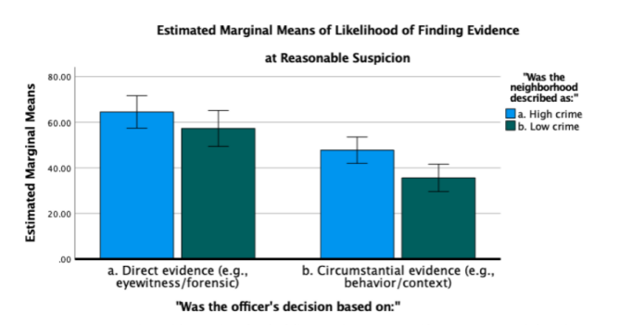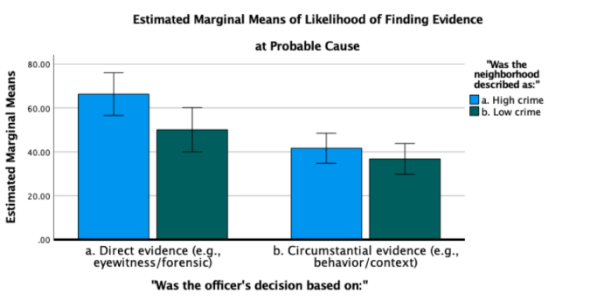
Figure 4. Likelihood of finding evidence

For the likelihood of finding evidence, the overall model was significant, F(15, 283) = 7.684, P < .001, explaining 28.9% of the variance in participants’ likelihood judgments (R² = .289, Adjusted R² = .252). After adjusting for the covariates, a significant main effect of evidence type was observed, F(1, 283) = 47.238, P < .001, ηp² = .143. Consistent with the previous dependent variables, participants in the Evidence Type 1 condition reported significantly higher expectations that incriminating evidence would be discovered than those in the reference condition (B = 13.275, SE = 6.235, P = .034). A significant main effect of crime context also emerged, F(1, 283) = 13.417, P < .001, ηp² = .045, indicating that participants expected incriminating evidence to be found more often in higher-crime environments. In contrast, legal standard did not significantly influence likelihood judgments, F(1, 283) = 0.884, P = .348, ηp² = .003. None of the two-way interactions between evidence type, crime context, and legal standard, nor the three-way interaction, reached statistical significance (all P > .14), suggesting that these factors independently influenced participants’ expectations regarding evidence discovery.
Among the covariates, political orientation significantly predicted likelihood judgments, B = 2.031, SE = 0.716, P = .005, indicating that more conservative participants tended to report greater expectations that incriminating evidence would be found. Attitudes toward police also significantly predicted likelihood ratings, B = -4.431, SE = 1.740, P = .011. However, age, gender, race, education, prior law-enforcement experience, and attitudes toward crime were not significant predictors (all P > .05). Overall, evidence type remained the strongest predictor of anticipated evidence discovery, while crime context exerted a smaller but meaningful influence even after accounting for relevant demographic and attitudinal covariates (Table 5).

Table 5. Summary of regression and experimental effects for main predictors and covariates

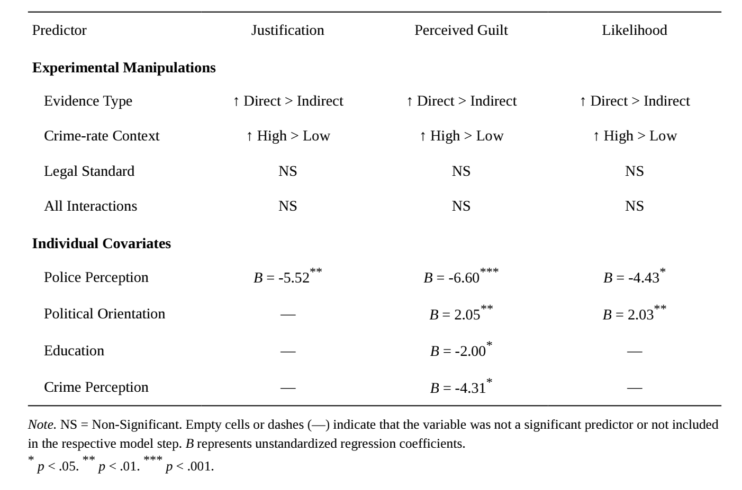

To evaluate the primary experimental manipulations, a series of three-way analyses of covariance (ANCOVAs) was conducted, simultaneously incorporating individual demographic and attitudinal variables as covariates (Table 6). Crucially, even after statistically controlling for these individual differences, the main effects of both Evidence Type and Crime Context remained highly significant across all three dependent variables (P < .001), whereas the Legal Standard manipulation and all higher-order interactions remained non-significant.
Beyond these experimental factors, several covariates emerged as systematic predictors of legal judgments. Specifically, general attitudes toward the police consistently and negatively predicted all outcomes; participants with more positive institutional trust required lower thresholds for justification (B = -5.52, P < .01) and held stronger confidence in guilt (B = -6.60, P < .001) and expected evidence discovery (B = -4.43, P < .05). Additionally, political orientation positively predicted guilt certainty (B = 2.05, P < .01) and expected evidence discovery (B = 2.03, P < .01), indicating that more conservative individuals aligned more closely with punitive outcomes. Conversely, higher education (B = -2.00, P < .05) and greater perceived crime prevalence (B = -4.31, P < .05) were associated with lower certainty regarding the suspect’s guilt. Interestingly, this effect was opposite to what might be expected from a simple punitive-orientation account. Individuals who perceived crime as more prevalent reported lower certainty that the suspect had committed a crime. This pattern suggests that while experimental framing strongly shapes immediate legal judgments, individuals’ baseline ideological and institutional trust orientations also systematically anchor their evaluations of police decision-making.

Table 6. Correlation matrix for all demographics, experimental manipulations, and perception variables

Variable | 1 | 2 | 3 | 4 | 5 | 6 | 7 | 8 | 9 | 10 | 11 | 12 | 13 | 14
1. Evidence Type | —
2. Crime-rate Context | .027 | —
3. Legal Standard | .060 | .017 | —
4. Justification | .473** | .155** | .149** | —
5. Perceived Guilty | .483** | .177** | .139* | .778** | —
6. Evidence Finding Likelihood | .371** | .204** | .088 | .759** | .854** | —
7. Crime Perception | .002 | -.069 | -.024 | -.066 | -.146* | -.118* | —
8. Police Perception | -.072 | -.013 | .049 | -.214** | -.282** | -.223** | -.042 | —
9. Education | .039 | -.028 | -.140* | -.087 | -.111 | -.073 | .097 | -.070 | —
10. Political Orientation | -.046 | -.024 | .040 | .160** | .242** | .227** | -.198** | -.316** | -.069 | —
11. Prior Law Experience | .014 | -.073 | -.024 | -.057 | -.081 | -.101 | .098 | .061 | .016 | -.094 | —
12. Age | .076 | -.035 | .001 | .106 | .094 | .140* | .066 | -.116* | .102 | .090 | .063 | —
13. Gender | -.080 | .034 | -.047 | -.103 | -.077 | -.001 | -.162** | .106 | .010 | -.104 | -.013 | .067 | —
14. Race | -.018 | -.051 | .042 | .089 | .051 | .115* | .127* | -.015 | -.083 | .171** | -.072 | .256** | -.049 | —
Note: N = 299. Diagonal dashes (—) represent the self-correlation of each variable. * P < .05. ** P < .01.

Additional correlational analyses were conducted to examine the role of crime perception. Crime perception was not significantly associated with the crime-rate manipulation, r = −.069, P = .235, indicating that participants’ preexisting beliefs about crime prevalence were largely independent of the experimental manipulation. This finding suggests that crime perception functioned as an individual-difference variable rather than as a manipulation check for the crime-rate condition.
Despite its lack of association with the experimental manipulation, crime perception was significantly related to perceived guilt, r = −.146, P = .012, and expectations of evidence discovery, r = −.118, P = .042. Participants reporting higher perceptions of crime prevalence exhibited lower certainty regarding the suspect’s guilt and lower expectations that incriminating evidence would be discovered. Crime perception, however, was not significantly associated with judgments of search justification, r = −.066, P = .257.
To examine the psychological mechanisms through which evidence type influenced evaluations of search justification, a sequential mediation model (PROCESS Model 6; Hayes, 2022) was estimated with perceived guilt as the first mediator and evidence discovery expectations as the second mediator (Figure 5). Crime-rate context, legal threshold, demographic variables, and attitudinal measures were included as covariates.

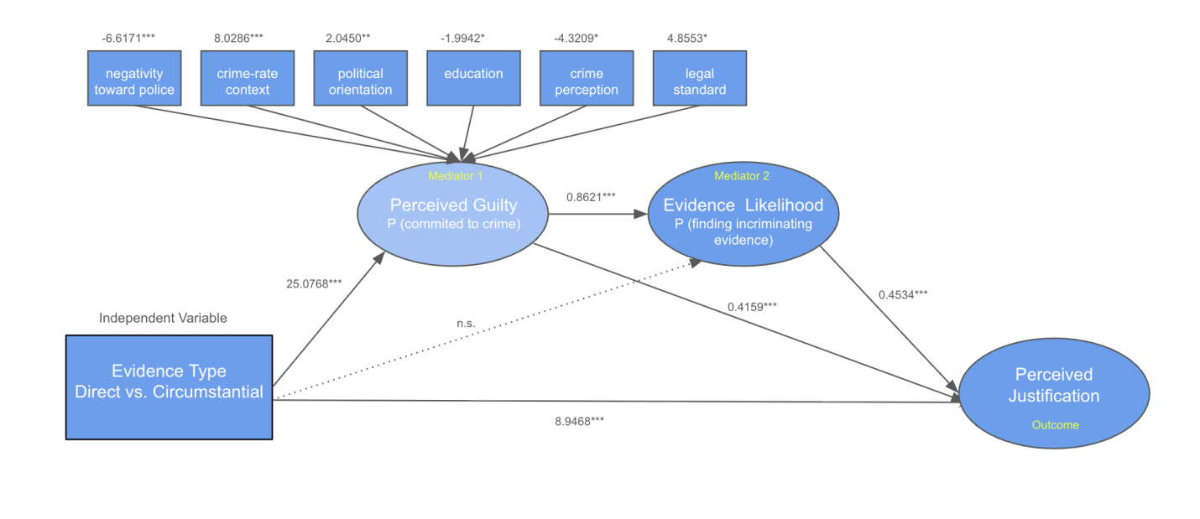
Figure 5. Hayes processing model

The model revealed a significant direct effect of evidence type on search justification, B = 8.95, SE = 2.51, t(285) = 3.56, P < .001, 95% CI [4.00, 13.89]. Participants exposed to direct evidence judged the officer’s search decision as significantly more justified than participants exposed to circumstantial evidence, even after accounting for the mediating variables. Evidence type strongly predicted perceived guilt, B = 25.08, SE = 2.51, P < .001. In turn, perceived guilt significantly predicted both evidence discovery expectations, B = 0.86, SE = 0.04, P < .001, and search justification, B = 0.42, SE = 0.09, P < .001. Evidence discovery expectations also significantly predicted search justification, B = 0.45, SE = 0.08, P < .001. Notably, evidence type did not directly predict evidence discovery expectations once perceived guilt was included in the model, B = -2.55, P = .171, suggesting that the association between evidence type and evidence discovery expectations was largely accounted for by perceived guilt.
Bootstrap analyses based on 5,000 resamples indicated a significant total indirect effect of evidence type on search justification, B = 19.08, 95% CI [14.05, 24.50]. Examination of specific indirect pathways revealed two significant mediation effects. First, evidence type exerted an indirect effect on search justification through perceived guilt alone, B = 10.43, 95% CI [4.61, 16.32]. Second, a significant sequential indirect effect emerged through perceived guilt and evidence discovery expectations, B = 9.80, 95% CI [5.76, 14.88]. In contrast, the indirect pathway through evidence discovery expectations alone was not significant, B = -1.16, 95% CI [-2.71, 0.36].
Taken together, these findings are consistent with the proposed theoretical account linking evidence type, perceived guilt, evidence discovery expectations, and search justification. Participants exposed to direct evidence reported significantly higher levels of perceived guilt (B = 25.08, SE = 2.51, P < .001), and perceived guilt was positively associated with both evidence discovery expectations (B = 0.86, SE = 0.04, P < .001) and search justification (B = 0.42, SE = 0.09, P < .001). Evidence discovery expectations were likewise positively associated with search justification (B = 0.45, SE = 0.08, P < .001). The persistence of a significant direct effect of evidence type on search justification (B = 8.95, SE = 2.51, P < .001), together with significant indirect effects, indicates partial mediation. These findings suggest that perceptions of guilt and expectations of evidence discovery may represent important evaluative processes through which evidence type is related to judgments of search justification. Because the mediators and outcome variables were measured within a single survey session, the mediation findings should be interpreted as evidence consistent with the proposed psychological mechanism rather than definitive proof of temporal causal ordering.

5. Discussion
The present study investigated how evidence type, crime context, and legal standards influence public evaluations of police search decisions. Across three dependent variables—perceived search justification, perceived guilt certainty, and expected evidence discovery—evidence type emerged as the strongest and most consistent predictor. Participants exposed to direct evidence consistently evaluated the suspect as more likely guilty, expected a greater likelihood of discovering incriminating evidence, and viewed the officer’s search decision as more justified. Furthermore, the serial mediation analysis revealed that evidence type influenced justification judgments through a sequential cognitive process in which evidence shaped guilt perceptions, guilt perceptions shaped expectations regarding additional evidence, and these expectations ultimately influenced evaluations of police conduct. These findings suggest that public evaluations of legal decisions are shaped less by formal legal standards alone and more by how individuals interpret the causal meaning of available evidence.

5.1. Evidence type as the primary driver of legal judgment
The strongest finding of the present study is that evidence type played a central role in shaping legal evaluations. Direct evidence produced substantially stronger effects than crime context or legal standards across all outcomes, indicating that individuals place particular importance on information that establishes a clear causal connection between a suspect and a criminal act. This finding is consistent with attribution theory, which proposes that individuals seek causal explanations when evaluating social events and assigning responsibility ^{[9]}. Prior research has further demonstrated that stronger causal links increase perceptions of responsibility and blameworthiness, thereby influencing legal and moral judgments ^{[26–27]}.
Importantly, the current findings extend previous research by demonstrating that causal evidence influences not only judgments of guilt but also perceptions of procedural legitimacy. Participants appeared to use evidence-based assessments of responsibility as a foundation for evaluating whether police intervention was appropriate. Consistent with procedural justice theory, evaluations of legal authority are shaped by perceptions of fairness and appropriateness rather than outcomes alone. Thus, the perceived strength of evidence may serve as a psychological bridge between information processing and normative judgments regarding the legitimacy of police searches.

5.2. Cognitive mechanisms underlying legal evaluation
The serial mediation findings provide insight into how individuals translate evidentiary information into legal judgments. Rather than directly determining whether a police search was justified, evidence type influenced evaluations through a structured inferential process. Specifically, direct evidence increased perceptions of a suspect’s guilt, which subsequently increased expectations that additional incriminating evidence would be discovered during a search. These expectations, in turn, contributed to stronger perceptions that the search was justified.
This pattern suggests that individuals may engage in a form of inferential confirmation when evaluating police decisions. Once a suspect is perceived as likely responsible for a crime, observers may become more inclined to expect the discovery of additional evidence and, consequently, view investigative actions as more reasonable and appropriate.
More broadly, the present findings indicate that legal judgments may be influenced not only by the evidence available at the time of a police decision but also by assumptions regarding what future investigation is likely to reveal. Individuals appear to construct coherent narratives that connect current evidence, inferred guilt, and anticipated evidentiary outcomes, rather than relying exclusively on objective assessments of the facts. Consequently, perceptions of search justification may reflect a broader psychological process of sense-making, in which expectations about future evidence become integrated into evaluations of procedural legitimacy.

5.3. The role of crime context in public judgment
Across the ANOVA models, the consistent pattern is that while evidence type and crime context both independently influenced legal evaluations, no significant interaction effects were observed. This suggests that participants did not integrate evidentiary and contextual information in a multiplicative or contingent manner. Instead, the effects of each factor appeared to operate in an additive fashion, with evidence type exerting a substantially stronger and more stable influence across outcomes.
The absence of interaction effects is theoretically informative. It indicates that individuals do not appear to dynamically adjust the weight of evidence based on contextual crime severity, nor do they reinterpret contextual cues in light of evidentiary strength. Rather, these factors seem to be processed in parallel but relatively independent evaluative channels. More broadly, the additive pattern observed here is consistent with research on legal judgment indicating that lay evaluations of guilt and procedural appropriateness are often dominated by salient, individuating evidence rather than contextual base-rate information. Although contextual cues such as crime rate may shift overall baseline perceptions of risk, they do not necessarily interact with diagnostic evidence in shaping final judgments. Instead, individuals appear to treat direct evidence as a privileged source of information that is relatively insensitive to contextual modulation.
This lack of interaction also has implications for how people construct legal judgments under uncertainty. Rather than engaging in fully integrated Bayesian-style updating across multiple sources of information, individuals may adopt a quasi-sequential evaluation strategy in which evidentiary information is given primary diagnostic weight, and contextual information functions as a secondary adjustment that shifts overall perception but does not alter the interpretation of core evidence.

5.4. Limited influence of legal standards on lay judgment
The present study also examined whether different legal standards influenced public evaluations. Although legal standards produced some influence on judgments of justification and guilt certainty, their effects were weaker compared with evidence-based information. Additionally, legal standards did not significantly influence expectations regarding whether incriminating evidence would be discovered.
These findings suggest that laypeople may recognize broad differences between legal concepts but do not necessarily apply formal legal reasoning when evaluating police decisions. Instead, individuals may rely on intuitive assessments of evidence strength and perceived responsibility. Because legal standards such as reasonable suspicion and probable cause require nuanced probabilistic reasoning, they may be interpreted through everyday cognitive frameworks rather than through strict legal definitions.
This finding contributes to research examining the gap between legal reasoning and public judgment. Although legal systems rely on carefully defined evidentiary thresholds, public evaluations of legal decisions may depend more heavily on psychological impressions of causality, responsibility, and risk.

5.5. Individual differences in legal evaluation
Beyond experimental manipulations, individual differences also contributed meaningfully to legal evaluations. Attitudes toward police consistently predicted judgments of search legitimacy, suggesting that broader institutional trust shapes how individuals interpret and evaluate police conduct. Participants with more favorable views of police authority were more likely to perceive searches as justified and expressed greater confidence in both guilt judgments and expectations of discovering incriminating evidence.
Political orientation also emerged as a significant predictor of some outcomes, with more conservative participants reporting higher certainty of guilt and stronger expectations that additional incriminating evidence would be found. Together, these findings indicate that legal judgments are not solely determined by situational evidence but are also systematically influenced by preexisting belief systems regarding authority, crime, and social order.
This pattern is consistent with research on motivated reasoning, which suggests that individuals interpret ambiguous information in ways that align with their prior attitudes and ideological commitments ^{[28]}. In legal contexts, such predispositions may function as interpretive frameworks that shape how evidentiary information is perceived, particularly when the available information requires subjective inference.

5.6. Practical implications
The present findings have important implications for understanding public perceptions of policing and legal decision-making. The dominant role of evidence type suggests that individuals place primary weight on diagnostic, causally informative evidence when forming legal judgments. This indicates that improving public understanding of evidentiary standards may require explicitly distinguishing between evidence that directly establishes responsibility and information that merely signals situational suspicion without identifying individual culpability.
At the same time, the observed influence of crime context suggests that environmental cues can still shape baseline perceptions of risk and police legitimacy, even when they provide limited diagnostic value regarding individual responsibility. For legal communication and public education, these findings underscore the importance of improving “evidence literacy,” or the ability to differentiate between causal, individuating evidence and broader contextual information. Without such conceptual clarity, individuals may default to intuitive judgments driven by perceived risk or situational suspicion rather than systematically evaluating the evidentiary link between a suspect and alleged wrongdoing.

6. Conclusion
The present study demonstrates that public evaluations of police searches are shaped primarily by perceptions of evidentiary strength and causal responsibility. Direct evidence influences judgments through a sequential psychological process in which individuals infer guilt, anticipate additional evidence, and evaluate investigative actions as justified. Although crime context and legal standards contribute to legal evaluations, their influence is comparatively limited. Overall, the findings reveal that public legal judgments are not determined solely by formal rules but are deeply influenced by cognitive processes involving attribution, inference, and interpretation of evidence.

Disclosure statement
The author declares no conflict of interest.

Reference
[1] Terry v. Ohio, 392 U.S. 1 (1968).
[2] Illinois v. Gates, 462 U.S. 213 (1983).
[3] Brinegar v. United States, 338 U.S. 160 (1949).
[4] United States v. Cortez, 449 U.S. 411 (1981).
[5] Ornelas v. United States, 517 U.S. 690 (1996).
[6] LaFave WR, 2012, Search and Seizure: A Treatise on the Fourth Amendment (5th ed.). Thomson Reuters/West, Minnesota.
[7] Slobogin C, 2007, Privacy at Risk: The New Government Surveillance and the Fourth Amendment. University of Chicago Press, Chicago.
[8] Crespo AM, 2020, Probable Cause Pluralism. The Yale Law Journal, 129(6): 1276–1366. https://www.yalelawjournal.org/article/probable-cause-pluralism
[9] Heider F, 1958, The Psychology of Interpersonal Relations. John Wiley & Sons, New Jersey.
[10] Kelley HH, 1973, The Processes of Causal Attribution. American Psychologist, 28(2): 107–128. https://doi.org/10.1037/h0034225
[11] Pennington N, Hastie R, 1992, Explaining the Evidence: Tests of the Story Model for Juror Decision Making. Journal of Personality and Social Psychology, 62(2): 189–206. https://doi.org/10.1037/0022-3514.62.2.189
[12] Heller KJ, 2006, The Cognitive Psychology of Circumstantial Evidence. Michigan Law Review, 105(2): 241–305. https://repository.law.umich.edu/mlr/vol105/iss2/2
[13] Illinois v. Wardlow, 528 U.S. 119 (2000).
[14] Tversky A, Kahneman D, 1973, Availability: A Heuristic for Judging Frequency and Probability. Cognitive Psychology, 5(2): 207–232. https://doi.org/10.1016/0010-0285(73)90033-9
[15] Meares TL, 2015, Programming Errors: Understanding the Constitutionality of Stop-and-frisk as a Program, not an Incident. The University of Chicago Law Review, 82(1): 159–179. https://chicagounbound.uchicago.edu/uclrev/vol82/iss1/7
[16] Palagashvili L, Goodman NP, 2023, Behavioral Public Choice and Policing in America. Behavioural Public Policy, 7(3): 432–461. https://doi.org/10.1017/bpp.2022.21
[17] Slobogin C, Schumacher JE, 1993, Reasonable Expectations of Privacy and Autonomy in Fourth Amendment Cases: An Empirical Look at “Understandings Recognized and Permitted by Society.” Duke Law Journal, 42(4): 727–775. https://doi.org/10.2307/1372830
[18] Kovera MB, Russano MB, McAuliff BD, 2002, Assessment of the Commonsense Psychology Underlying Daubert: Legal Decision Makers’ Abilities to Evaluate Expert Evidence in Hostile Work Environment Cases. Psychology, Public Policy, and Law, 8(2): 180–200. https://doi.org/10.1037/1076-8971.8.2.180
[19] Yogev T, 2024, Attribution Matters: How Causal Explanations Influence Perceptions of Dangerousness and Racial Classification. Criminal Justice and Behavior, 51(3): 312–332. https://doi.org/10.1177/00938548241307234
[20] Ask K, Granhag PA, 2005, Motivational Sources of Confirmation Bias in Criminal Investigations: The Need for Cognitive Closure. Journal of Investigative Psychology and Offender Profiling, 2(1): 43–63. https://doi.org/10.1002/jip.19
[21] Tversky A, Kahneman D, 1974, Judgment under Uncertainty: Heuristics and Biases. Science, 185(4157): 1124–1131. https://doi.org/10.1126/science.185.4157.1124
[22] Ross LD, 1977, The Intuitive Psychologist and his Shortcomings: Distortions in the Attribution Process, in Advances in Experimental Social Psychology (Vol. 10, pp. 173–220). Academic Press, New York.
[23] Goff PA, Eberhardt JL, Williams MJ, et al., 2008, Not yet Human: Implicit Knowledge, Historical Dehumanization, and Contemporary Consequences. Journal of Personality and Social Psychology, 94(2): 292–306. https://doi.org/10.1037/0022-3514.94.2.292
[24] Slobogin C, 1991, The World without a Fourth Amendment. UCLA Law Review, 39(1): 1–107.
[25] Quillian L, Pager D, 2001, Black Neighbors, Higher Crime? The Role of Racial Stereotypes in Evaluations of Neighborhood Crime. American Journal of Sociology, 107(3): 717–767. https://doi.org/10.1086/338938
[26] Hayes AF, 2022, Introduction to Mediation, Moderation, and Conditional Process Analysis: A Regression-based Approach (3rd ed.). Guilford Press, New York.
[27] Cushman F, Young L, 2011, Patterns of Moral Judgment Derive from Complexities of Causal Attribution. Cognitive Science, 35(6): 1051–1075. https://doi.org/10.1111/j.1551-6709.2011.01178.x
[28] Grinfeld S, Lagnado DA, Gerstenberg T, et al., 2020, Causal Responsibility and Robust Causation. Journal of Experimental Psychology: General, 149(10): 1940–1959. https://doi.org/10.1037/xge0000755

Publisher’s note
Bio-Byword Scientific Publishing remains neutral with regard to jurisdictional claims in published maps and institutional affiliations.

