Research on High-P Precision Match Drilling Method for Reaming Mounting Holes When Replacing Sintering Machine Sprocket Tooth Plates
Yun Ma, Zhifeng Chen, Wei Wei, Hanxiao Ma, Huan Jin
Xinjiang Institute of Engineering, Urumqi, China

Copyright: © 2026 Author(s). This is an open-access article distributed under the terms of the Creative Commons Attribution License (CC BY 4.0), permitting distribution and reproduction in any medium, provided the original work is cited.

Abstract: The operational stability and service life of sintering machines are critically dependent on the machining precision of reaming mounting holes in their sprocket tooth plates. To address the limitations of existing match-drilling techniques, this paper proposes a novel high-precision match-drilling method aimed at enhancing assembly accuracy, installation efficiency, and overall operational stability. Through a systematic analysis of current match-drilling processes, this study identifies the alignment accuracy between the reaming holes of the tooth plates and the web plates as the decisive factor in the assembly procedure. To resolve this issue, a custom-designed measuring and positioning tool, in conjunction with an innovative match-drilling workflow, is developed to form a complete reaming scheme. Experimental validation, including positioning tests on multiple tooth plates, confirms the effectiveness and repeatability of the proposed method. The results demonstrate that this approach significantly improves assembly precision and operational stability, reduces installation errors, and lowers both the failure rate and maintenance costs of sintering machines. Beyond its practical contributions, this research enriches the theoretical framework of mechanical processing and assembly, offering robust technical support for on-site applications. Moreover, the standardization of the new match-drilling process provides a comprehensive maintenance solution for routine overhauls of sintering machine sprockets and tooth plates, thereby promoting continuous innovation and advancement in related maintenance strategies.
Keywords: Sintering machine; Sprocket tooth plate; Match-drilling; High precision; Replacement

Online publication:

1. Introduction

1.1. Research background
In the metallurgical machinery industry, the performance of sintering machines is closely related to the precise fitting of all their components. As a key component of sintering machines, the machining precision of reaming mounting holes on sprocket tooth plates directly determines the overall operation stability and service life of sintering machines. In practical operation at present, sprocket tooth plates are generally replaced once every three years. The precise match drilling requirements in this replacement process are often restricted by on-site maintenance space and equipment installation precision requirements. Such restrictions increase operational complexity and may lead to misalignment of corresponding reaming mounting holes during tooth plate installation, resulting in incomplete installation of reaming bolts and further interfering with the normal operation of sintering machines. Since spare tooth plates purchased from original manufacturers are not pre-fabricated with reaming holes, on-site matched drilling and reaming between tooth plates and sprockets are required. However, due to uncontrolled precision during matched drilling of paired reaming holes, deviations occur between the two matching holes.
Although traditional match drilling technologies have been continuously improved, they still have limitations. When replacing sprocket tooth plates with traditional methods, positioning and match drilling for new pre-installed tooth plates must rely on the reaming holes on sintering sprocket web plates. Limited on-site space prevents horizontal match drilling with dedicated equipment. The conventional operation is as follows: mark corresponding positions on old tooth plates and web plates before removing the old ones; dismantle the old tooth plates, align and stack them with new tooth plates on a bench drill, and conduct match drilling on new tooth plates by taking reaming holes of worn old tooth plates as benchmarks ^{[1]}. Due to abrasion of old tooth plates, alignment errors will be generated when stacked with new plates. After match drilling is finished, misalignment between the reaming holes of tooth plates and web plates frequently appears during installation, making it impossible to mount reaming bolts. This exerts a severe negative impact on subsequent sintering machine production and operation, and may even trigger accidents such as tooth plates clamping trolley wheels ^{[2]}.
With the continuous development of measurement technology and 3D modeling simulation methods, new matched drilling schemes for reaming mounting holes demonstrate prominent advantages. Such schemes can effectively eliminate adverse impacts caused by space constraints on the premise of guaranteeing precision, and realize more accurate assembly. Research on this innovative method aims to promote theoretical progress in mechanical processing and provide more reliable technical support for practical sintering machine operation, hence possessing broad application prospects and promotion value. The implementation of scientific match drilling standards and procedures will bring more efficient solutions to relevant industries and lay a new foundation for continuous industrial innovation.

1.2. Research purpose and significance
With the continuous development of sintering machine mechanical equipment management, higher requirements are put forward for the stability of sintering machines. During the operation of sintering machines, the installation precision of sprocket tooth plates is extremely critical. Once a phase difference exists between tooth plates on both sides of the head sprocket, severe trolley deviation of sintering machines will be triggered. Therefore, the main purpose of this paper is to verify the effectiveness of the high-precision match drilling method for sprocket tooth plates during replacement, and illustrate possible errors in the assembly process through comparison of different drilling methods ^{[3]}. To overcome the limitations of existing assembly schemes for sintering machine sprocket tooth plates, this paper focuses on analyzing the positioning link in tooth plate assembly. Self-made measuring and positioning tools are developed according to practical working conditions, a complete set of match drilling procedures is formulated, and an innovative drilling scheme for reaming mounting holes is designed. When practically applied in regular sintering machine maintenance, this method is expected to significantly improve assembly precision, reduce the phase difference between tooth plates on both sides of sprockets, and lower the equipment failure rate and production cost of sintering machines. Such innovations can not only improve the working efficiency of sintering machines, but also provide valuable practical data and theoretical support for maintenance management of related sintering equipment, boosting the development and technical iteration of equipment management ^{[4]}.

2. Match drilling method

2.1. Design of the match drilling scheme
When formulating the high-precision match drilling scheme for reaming mounting holes of sintering machine sprocket tooth plates, multiple factors including on-site working environment and machining capacity of drilling equipment shall be fully considered to ensure the feasibility of this scheme in practical application. The precision of matched drilling and assembly of tooth plate reaming holes is not only related to the magnitude of phase difference between tooth plates on both sides of sintering machine sprockets, but also directly affects the service life of sprocket tooth plates ^{[5]}. The traditional method stacks old and new tooth plates together and uses reaming holes of worn old plates as benchmarks to drill new ones. During assembly, technical problems such as poor fitting between new tooth plates and sprocket web plates frequently emerge. Therefore, a brand-new machining and installation scheme with higher drilling precision must be adopted to raise the assembly accuracy of sprocket tooth plates.
Aiming at the insufficient precision of the traditional stacking match drilling technology for old and new sprocket tooth plates, this paper proposes an innovative high-precision match drilling method. First, a corresponding measuring and positioning tool is manufactured according to the specific dimensions of reaming assembly holes on sprocket web plates. Through detailed analysis of geometric features of reaming mounting holes and the on-site installation environment, a completely new match drilling and installation scheme for tooth plates is formulated ^{[6]}. With the special positioning device for match drilling of tooth plate reaming holes, the center points of reaming holes can be precisely positioned, laying a reliable foundation for subsequent tooth plate installation. The special positioning device consists of disassembly nuts, locking nuts, expansion sleeves, and taper sleeves (see Figure 1). A 10 mm-diameter drilling hole is opened at the exact center of the taper sleeve, and the expansion sleeve and taper sleeve are combined to form a positioning fixture. Before match drilling of tooth plates, install tooth plates at corresponding sprocket positions with ordinary bolts; mount expansion sleeves and taper sleeves into reaming holes of sprocket web plates, and fix the positioning device with locking nuts. At this time, the central hole of the taper sleeve is aligned with the center of the reaming hole. Construction workers then use a hand drill with a 10mm drill bit to drill a hole with a depth of about 3–5 mm at the corresponding position of the tooth plate through the central positioning hole of the taper sleeve, marking the completion of positioning drilling for tooth plate reaming holes ^{[7]}. Remove the positioning device with disassembly nuts, take down the tooth plates with positioning holes, and transfer them to a bench drill. Take the small positioning holes as benchmarks and use a 44mm match drill bit to complete reaming drilling ^{[8]}. After match drilling, install the tooth plates at corresponding positions and fasten reaming bolts, and misalignment between the reaming holes of the web plates and tooth plates will no longer occur (see Figure 2).

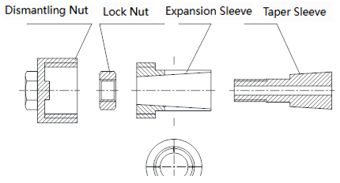
Figure 1. Component diagram of positioning device for match drilling of sintering machine sprocket tooth plate reaming mounting holes.

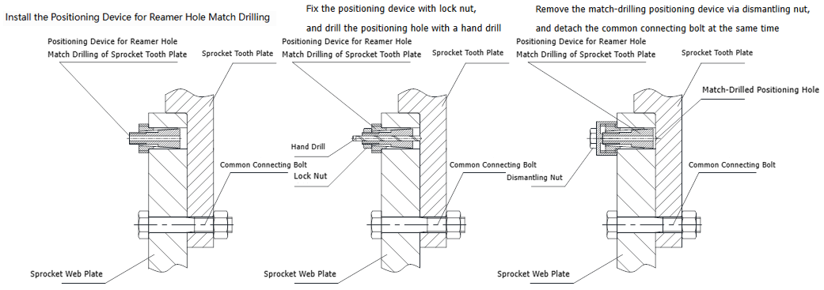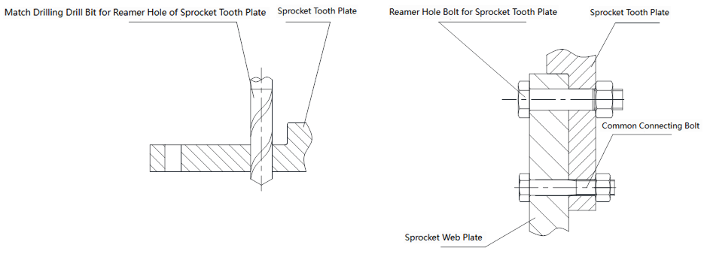
Figure 2. Match drilling flow chart of sintering machine sprocket tooth plate reaming mounting holes

It can be seen that the newly formulated high-precision match drilling method for sprocket tooth plate reaming holes is the key to solving installation precision problems of tooth plates. Through continuous improvement of tooth plate installation technology, the scheme proposed in this paper is expected to be applied in major overhauls of sintering machine sprocket tooth plates and continuously raise the installation precision of tooth plates.

3. Practical application effect

3.1. Analysis of application effect
Practical operation results after sintering machine maintenance show that after adopting the new installation method for sprocket tooth plates, the operation performance of sintering machines is obviously improved without trolley deviation. Compared with the traditional stacking match drilling technology for old and new tooth plates, the new scheme lowers both the installation difficulty of tooth plates and equipment maintenance cost. This finding is consistent with the expected viewpoints proposed before research on the new tooth plate installation scheme: the innovative match drilling method can effectively improve the operation performance of sintering machines and avoid sprocket operation failures caused by poor fitting between tooth plates and web plates.
When the same new scheme is adopted for tooth plate replacement during major overhauls of other sintering machines of the same specification, continuous improvement of the high-precision match drilling scheme for reaming holes expands its adaptability under various installation conditions. Research results indicate that high-precision matched drilling between reaming holes of web plates and tooth plates can significantly strengthen the anti-fatigue capacity of tooth plates during long-term operation. Such adaptability guarantees the safe operation of sintering machines and improves overall production efficiency.

3.2. Comparative analysis
An in-depth analysis of incomplete installation problems occurring during match drilling of sprocket tooth plate reaming holes is carried out, together with a comparative study on defects of traditional drilling techniques and advantages of the new method ^{[9]}. In traditional match drilling, old tooth plates have suffered abrasion and deformation and cannot be fully aligned with new ones. This leads to center distance errors between reaming holes of new tooth plates and web plates after drilling, making reaming bolts unable to be installed in place. Such errors further cause a phase difference between tooth plates on both sides of sprockets and trolley deviation during sintering machine operation. By comparison, the traditional installation scheme presents unsatisfactory assembly precision. Improving the match drilling accuracy of tooth plates can prevent misalignment between the reaming holes of web plates and tooth plates, thus eliminating trolley deviation failures.
The innovative match drilling scheme adopts advanced machining processes to boost assembly precision greatly. It not only solves the problem of large errors brought by stacking old and new tooth plates for drilling, but also verifies the stability and continuous production capacity of sintering machines through practical operation ^{[10]}. Research results prove that this match drilling method cuts assembly errors while drastically reducing sintering machine failure rate and trolley maintenance cost, which highly conforms to the current pursuit of high efficiency and low failure rate in equipment management. Therefore, this new method provides important technical support for the practical replacement of sintering machine sprocket tooth plates ^{[11]}.

4. Conclusion

4.1. Main research findings
Research on the high-precision match-drilling method for sintering machine sprocket tooth plate reaming holes has revealed the obvious deficiencies of traditional drilling technologies. After identifying that the drilling precision of reaming holes is the core influencing factor of tooth plate assembly, an innovative match-drilling scheme was developed, based on a self-made measuring and positioning tool. This new scheme overcomes the defects of traditional match-drilling processes and realizes more efficient and accurate positioning and drilling operations ^{[12,13]}.

4.2. Prospect for future work
Against the backdrop of rapid development of sintering machine equipment management, research on the high-precision match drilling method for sprocket tooth plate reaming holes provides important enlightenment for equipment maintenance work. The innovative drilling method proposed in this paper improves the assembly precision of tooth plates and greatly reduces the sintering machine failure rate, demonstrating wide adaptability in relevant sintering machine fields ^{[14,15]}.
Under the background of continuous technological innovation, integrating intelligent manufacturing systems with big data analysis will greatly raise the intelligence level of tooth plate match drilling processes. This can not only improve tooth plate replacement efficiency, but also provide more reliable technical support for maintenance personnel. With the advancement of artificial intelligence, more intelligent solutions will emerge for reaming hole match drilling processes, which will further optimize tooth plate assembly procedures, cut costs, and lift overall competitiveness.

Author introduction
Yun Ma, male, born in December 1980, Hui ethnicity, native of Yining City, Xinjiang; Experimentalist at Xinjiang Institute of Engineering, Master of Engineering, engaged in experimental teaching work.

Disclosure statement
The authors declare no conflict of interest.

References
[1] Zhang J, Cheng M, Gao W, et al., 2023, Practice of On-Line Repairing Sintering Machine and Grate Cooler Sprocket Tooth Plates. Shandong Metallurgy, 45(5): 77–79.
[2] Lu C, Zhang X, 2020, Welding Repair Technology for Large Sprocket Tooth Plates of Sintering Machine. Welding & Joining, 2020(12): 48–50 + 57 + 64.
[3] Li G, Wang Q, Li G, 2019, Cause Analysis and Treatment of Sintering Machine Pallet Arching. Sintering and Pelletizing, 44(4): 27–30.
[4] Jin H, 2020, Analysis and Treatment Research on Arching Phenomenon of Sintering Machine Pallets. China Equipment Engineering, 2020(17): 128–129.
[5] Wang Y, Sun H, 2015, Practice of Repairing and Installing Sintering Machine Sprocket Tooth Plates by Welding Technology. Science and Technology & Enterprise, 2015(18): 173.
[6] Deng Y, Lai Q, 2021, Analysis and Treatment of Pallet Arching Phenomenon of Chuanwei Sintering Machine. Sichuan Metallurgy, 43(3): 40–42.
[7] Fan Z, Sun Y, Dong Y, 2012, Single Tooth Plate Machining of Sintering Machine Sprocket Device. Modern Economic Information, 2012(3): 265.
[8] Yu H, 2018, Brief Analysis on Machining of Sprocket Body and Tooth Plates of 550 m² Belt Sintering Machine. China Equipment Engineering, 2018(8): 157–159.
[9] Wang P, Xue Y, Xu R, 2020, Improvement of Construction Scheme for Replacing Head Sprocket of 200 m² Sintering Machine. Shanxi Metallurgy, 43(1): 70–72.
[10] Li G, Guan X, 2019, Application of Sprocket Speed Regulation System in High Temperature Fan of Rotary Kiln. Angang Technology, 2019(5): 43–45.
[11] Hou B, Li J, Gao L, et al., 2021, Identification Method of Fastener Failure Based on Rail Vibration Response Under Pulse Excitation. Engineering Mechanics, 38(2): 122–133.
[12] Chen G, Li H, Wang X, et al., 2021, Analysis of Influence of Measurement Error on Wellbore Trajectory Uncertainty. Coal Technology, 40(4): 54–56.
[13] Wang Z, Si L, Wei D, et al., 2024, Key Technologies of Fully Autonomous Drilling System for Coal Mine Anti-Impact Drilling Robots. Journal of China Coal Society, 49(2): 1240.
[14] Xu H, Yao D, Sun Z, 2025, Application and Research of Oxygen-Enriched Ignition Combustion Technology for Sintering Machine in Nanjing Iron and Steel Co., Ltd. NISCO Science, Technology and Management, 2025(3): 30–32.
[15] Shi D, 2025, Application of “Electrostatic Precipitator + Baghouse” Dust Removal Technology in Dust Treatment at Sintering Machine Discharge End and Finished Product Area. Modern Industrial Economy and Informationization, 15(5): 137–138.

Publisher’s note
Bio-Byword Scientific Publishing remains neutral with regard to jurisdictional claims in published maps and institutional affiliations.

