The Application of an Intelligent Automatic Control System for Wastewater Treatment Containers

Fengliang Tan, Yulin Zheng*
School of Intelligent Manufacturing, Guangzhou Huali College, Guangzhou, China
*Author to whom correspondence should be addressed.

Copyright: © 2026 Author(s). This is an open-access article distributed under the terms of the Creative Commons Attribution License (CC BY 4.0), permitting distribution and reproduction in any medium, provided the original work is cited.

Abstract: The sewage treatment system is completed by an upper computer, PLC, and an electric control actuator. The carrier is a container, which is flexible. According to the characteristics of decentralized domestic sewage, we intend to make use of our own advantages in container design and manufacturing, and integrate advanced biological sewage treatment technology into intelligent monitoring technology, such as wind, light, electricity, energy-saving storage technology, container modularization technology, mobile integration technology, etc., to realize the technical subversion of the traditional sewage treatment industry, and upgrade the traditional high-energy, large-scale and centralized sewage treatment mode to a low-carbon, intelligent and decentralized micro-ecological water circulation mode. By designing a new system and a new mode of use and service, the environmental protection industry can be greatly upgraded and eventually industrialized.
Keywords: Wastewater treatment; Intelligent; Intelligent monitoring technology; Container

Online publication:

- Introduction to the current situation of wastewater treatment
For example, China has issued certain discharge standards in accordance with relevant provisions of the “Marine Environmental Protection Law of the People’s Republic of China”, thereby strengthening the anti-pollution and environmental protection conventions ^{[1]}. Issues regarding the treatment of wastewater, oily waste, and dirty water on ships continue to emerge, leading to increasingly stringent technical standards for sewage treatment equipment. Relevant regulations clearly state that oil pollution treatment devices must not only separate heavy and light oils but also efficiently treat oily wastewater containing surfactants. Currently, although the discharge standard for oily mixed water remains below 15 mg/L, many countries have raised it to a stricter level of less than 5 mg/L ^{[2]}.
Based on research into the current status of rural wastewater discharge and considering the characteristics of rural living conditions, a micro-powered containerized domestic wastewater treatment system has been designed to collect and treat rural domestic wastewater through a moderately centralized approach. Additionally, the containerized unit facilitates integrated design and modular functionality, enabling automated operation, unmanned monitoring, and simple operation—making it well-suited to the basic conditions of rural areas in China ^{[3]}.
The application of automation technology has improved the control efficiency of wastewater treatment processes, contributing to urban environmental improvement. However, existing electrical control systems in wastewater treatment still suffer from complex structures and relatively poor automation performance, failing to meet the demands of modern social development ^{[4]}.
As standards for wastewater treatment continue to rise and application scenarios become increasingly diverse, the demand for wastewater treatment solutions is growing rapidly. Consequently, the market for mobile containerized wastewater treatment systems is expanding, with higher requirements for automation and intelligence. This places greater demands on the control systems and electrical controls.

- This wastewater treatment system
The treatment process selected by the intelligent micro-ecological water circulation system is an advanced technology specially designed for domestic wastewater treatment, which has the advantages of simple operation, convenient maintenance and management, good treatment effect, etc. According to the conventional treatment capacity, users can choose according to actual needs, and run different treatment systems in series or parallel to meet the treatment requirements of unconventional specifications. Because we use containers as carriers, the intelligent micro-ecological water circulation system can complete the installation of boxes, equipment, and pipelines in the factory, and can realize batch production. The products can be commissioned after being transported to the user’s site and connected with water and electricity, which is convenient for installation and transportation and greatly shortens the construction period. The intelligent micro-ecological water circulation system is also equipped with an intelligent automatic control system and a remote monitoring and control service system to realize the automatic operation and “unattended“ of the treatment system, and online monitoring through networking. Once there is a problem, our technicians can immediately find it and adjust the process parameters in time by remote operation or informing users to ensure the normal operation of the system.

  - Composition of the wastewater treatment system
This part consists of an industrial computer, main control PLC, actuator, and various sensors. The core is the intelligent control of the master PLC and the remote operation platform, which is completed by professional application software. The software program adopts the clock cycle scanning working mode and has high working reliability. The industrial computer has an intelligent control function, which can perform intelligent automatic analysis and realize multiple control by using time, dissolved oxygen, and sludge concentration. Set the time to avoid the peak of electricity consumption as much as possible; Set the upper and lower limits of dissolved oxygen to ensure the process; Set the sludge concentration index of the reaction tank, and control the reflux pump and surplus sludge pump in real time to ensure the best amount of activated sludge in the reaction tank, so as to reduce energy consumption.
Currently popular control systems use conductivity sensors and frequency inverters to communicate with PLCs via RS485 expansion modules ^{[5]}.

2.1.1. The technical route of the project mainly includes three parts: product research and development process, production process, and product circuit control programming and program debugging
(a) Product development process
(b) First of all, due to the different requirements of users, local environmental departments and national environmental laws and regulations, it is necessary to choose the appropriate treatment process in combination with the requirements of inlet water quality, outlet water standard and use, for example, restaurant wastewater needs to be treated by oil separation first, hotel wastewater should focus on nitrogen and phosphorus removal, and reclaimed water reuse has higher requirements for outlet water. Secondly, the selected wastewater process can be realized through the structural design of container box, which can realize the function of treatment unit (such as sedimentation tank) and meet the installation requirements of related equipment and pipelines; The action of each pipeline in the box body is controlled by the circuit, and all electromagnetic valves, electric valves, ball valves, etc. are given signals by the central signal processor of the system to perform specified actions. Users can control the on-off of each circuit through the editing program, and then control the on-off action of the pipeline, thus completing wastewater treatment. Finally, the products need to meet the transportation requirements, be waterproof, windproof, and structurally stable.
(c) Process flow of circuit design and system debugging. According to the circuit design process, the flow chart of specific product debugging operation principle is shown in Figure 1.

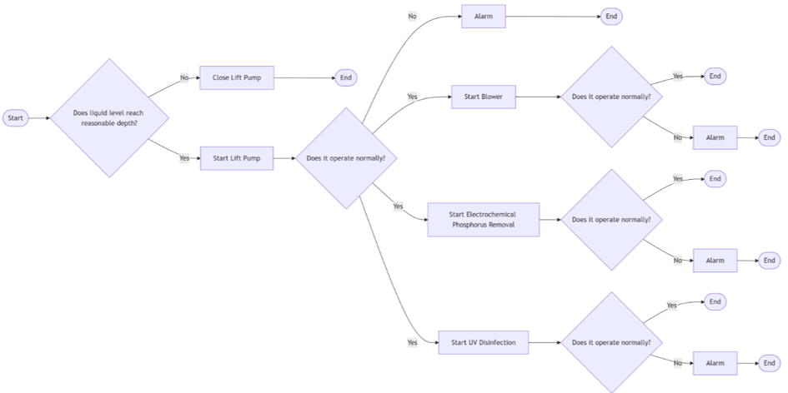
Figure 1. Flow chart of product debugging and operation principle.

2.1.2. Debugging the man-machine interface of the system
Input state parameters and monitor the process. The main screen shows the touch screen switches of each fan, solenoid valve, electric valve, and pump, and the monitoring process shows the feedback parameters of each fan, such as frequency and electromagnetic flowmeter.

2.1.3. Output status reading
System status monitoring feedback. It can monitor whether the equipment works normally online in real time, and it can also be set if remote monitoring is needed.

2.1.4. Input and output writing
The input and output wiring diagram of the PLC is shown in Figure 2. During program debugging, diodes can be used to replace KM1–KM7 for analog display. It is worth noting that in practical circuits, protective measures such as overload and overcurrent should also be set according to the size of the load.
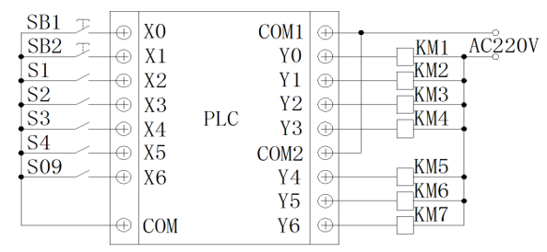
Figure 2. PLC input and output wiring diagram.

2.1.5. Program debugging
The debugging program for extracting a wastewater tank from a series of batches. According to the technological process and control requirements, the state transition diagram of the wastewater treatment controller can be drawn.

- Conclusion
The new generation wastewater treatment system uses industrial Ethernet technology to combine the upper computer, the PLC controlled by the whole machine and the container as the transport carrier to form a fully enclosed synchronous control system of real-time communication, which not only improves the performance index of the wastewater treatment system, but also has the function of remote monitoring, which raises the automation, intelligent control level and real-time remote monitoring and detection level of the wastewater treatment system to a new height, and also breaks through the traditional container as the carrier of the wastewater treatment system, making the new generation wastewater treatment system have the characteristics of subversive mobility. Since the 21st century, the Internet business has developed rapidly, mobile phones have become increasingly popular as Internet terminal devices, and various types of application apps in software have also become widely popular. PLC manufacturers also keep up with the situation in time to develop the corresponding mobile app debugging software. It makes remote debugging equipment more convenient and faster, and is no longer limited to notebook computer debugging. Developers can set corresponding parameters according to their own needs and specific conditions; At the same time, the mobile phone interface can also reflect the operation of various components in the wastewater treatment system, as shown in the following figure. For example, the state of a fan shown in the figure is: stop in place, and if necessary, just click “turn on in place“. Really achieve one-button control and debugging with one hand. Master Teacher Studio is generated.

Acknowledgments
Fund Project: A Study on the Construction of a Big Data-Driven Teaching Quality Monitoring and Early Warning System, 2026 Guangdong Private Higher Education Research Project. Thank you.

Author contributions
J.X. conceived the idea of the study. P.P. performed the experiments. X.O. analyzed the data and wrote the paper.

Funding
The 2019 Ministry of Education industry-university cooperation collaborative education project “Research on the Construction of Economics and Management Professional Data Analysis Laboratory” (Project No.: 201902077020)

Disclosure statement
The authors declare no conflict of interest.

References
[1] Zhang S, 2022, Design of Modern Ship Bilge Sewage Discharge and Trea. Ship Engineering, 44(12): 36–42.
[2] Zheng Q, Guo S, 2021, Design Scheme for a Ship Residual Oil Evaporation and Water Removal Device. Navigation, 2021(5): 35–38.
[3] Shen S, Li H, Yin C, et al., 2018, Design and Application of 30 m³/d Micro-Power Container for Rural Domestic Sewage Treatment. Technology Innovation and Application, 2018(15): 175–176.
[4] Shi M, 2023, Design of Sewage Treatment Process Control System Based on PLC. Electronic Technique, 52(11): 246–247.
[5] Ren T, Li Z, Ren X, 2026, Research and Development of the Electrical Control System for Mobile Wastewater Treatment and Recycling Equipment. China Nuclear Power, 2026(2): 210–215.

Publisher’s note
Bio-Byword Scientific Publishing remains neutral with regard to jurisdictional claims in published maps and institutional affiliations.

