Identification of a Novel Pathogenic Variant in the PHEX Gene and Its Mechanistic Implications in X-Linked Hypophosphatemia

Abstract
X-linked hypophosphatemia (XLH) is the most common form of inherited rickets, characterized by renal phosphate wasting, hypophosphatemia, impaired vitamin D metabolism, and defective bone mineralization. XLH is caused by loss-of-function mutations in the PHEX gene (phosphate-regulating endopeptidase homolog, X-linked), which encodes a cell-surface endopeptidase predominantly expressed in osteoblasts and odontoblasts. Dysfunctional PHEX protein leads to elevated circulating levels of fibroblast growth factor 23 (FGF23), a key phosphaturic hormone that suppresses renal phosphate reabsorption and 1α-hydroxylation of vitamin D. Consequently, chronic hypophosphatemia disrupts skeletal and dental development, resulting in short stature, lower extremity deformities, enthesopathy, and spontaneous dental abscesses.
Recent advances in understanding the PHEX-FGF23 axis have paved the way for targeted therapies, including anti-FGF23 monoclonal antibodies (e.g., burosumab), which offer improved outcomes over conventional phosphate and active vitamin D supplementation. Here, we report the identification of a novel pathogenic variant in PHEX (chrX(GRCh37):g.22112134_22112135del, NM_000444.6(PHEX):c.766_767del p.(Thr256Cysfs*7)) in a Chinese pediatric proband presenting with classic clinical and biochemical features of XLH. We performed functional experiments, including Western blot, ELISA, and molecular docking, to elucidate the mechanistic link between this variant and XLH pathogenesis.
This study not only provides new genetic evidence for the molecular diagnosis of XLH but also supplements practical clinical data for the standardized management of XLH under economic constraints, highlighting a unique truncation hotspot, a novel post-translational degradation mechanism, and cost-effective conventional therapy evidence, offering important theoretical value and clinical guidance for the diagnosis, treatment, and genetic counseling of this rare hereditary disease.

Key Words:Hypophosphatemic Rickets, PHEX Protein, Genetic Diseases, X-Linked,Fibroblast Growth Factor 23

Introduction
X-linked dominant hypophosphatemic rickets (XLH, MIM307800) is the most common type of hereditary rickets in humans, characterized by increased urinary phosphorus excretion, decreased renal tubular phosphorus reabsorption, and abnormal vitamin D metabolism, which together cause renal phosphate wasting-induced hypophosphatemia and impaired bone mineralization[1]. The PHEX gene, located on the X chromosome, is a phosphate-regulating gene primarily expressed in osteoblasts and odontoblasts[2]; loss of PHEX function indirectly impairs renal phosphate handling and the secretion of osteoblast-specific mineralization factors and is the established pathogenic gene for XLH[3].
The PHEX gene contains 22 exons spanning a total length of 2861 bp and encodes a 749-residue protein belonging to the M13 and MA families of zinc metalloendopeptidases[4]. As a type II integral membrane glycoprotein, its structure comprises a short intracellular domain, a transmembrane domain, and a large extracellular domain containing a zinc-binding region and conserved cysteine residues[5]. XLH is a rare bone disease with lifelong clinical consequences; affected individuals suffer from bone pain, complex skeletal deformities, impaired mobility, reduced quality of life, early-onset osteoarthritis, and decreased lower limb range of motion[6].
Emerging evidence indicates that fibroblast growth factor 23 (FGF23) and matrix extracellular phosphoglycoprotein (MEPE)-key regulators of systemic phosphate homeostasis and mineralization-act in concert with PHEX to modulate phosphate metabolism and bone mineralization[7]. In XLH, PHEX mutations lead to elevated FGF23 levels, which suppress renal phosphate reabsorption and 1α-hydroxylation of vitamin D; however, FGF23 is not a direct substrate of PHEX, and the molecular mechanism by which PHEX mutations upregulate FGF23 expression remains unclear. MEPE is a physiological substrate of PHEX, and its acidic serine-aspartate-rich MEPE-related motif (ASARM) and the released ASARM peptides play critical roles in mineralization, phosphate regulation, and other physiological processes. PHEX protects MEPE from cleavage by local matrix proteases, thereby preventing the release of protease-resistant MEPE-ASARM peptides that disrupt mineralization[8].
In clinical practice, burosumab, a human anti-FGF23 monoclonal antibody, has been recommended as a first-line targeted therapy for XLH in recent years, demonstrating superior efficacy in correcting hypophosphatemia and improving skeletal lesions[9]. Nevertheless, the high cost of this targeted biologic restricts its widespread use in low- and middle-income regions, leaving conventional therapy as the primary clinical option for most patients in these settings. In this study, we identified a novel frameshift deletion variant in PHEX exon 7 in a Chinese pediatric XLH proband, characterized its functional consequences through in vitro experiments and molecular modeling, and reported the clinical outcome of conventional oral phosphate and calcitriol combination therapy administered due to economic constraints. This study aims to expand the PHEX mutational spectrum, provide further insights into genotype-phenotype correlations and the molecular pathogenesis of XLH, and offer practical references for clinical management under limited healthcare resources.

Materials and Methods

Western Blot
293T cells were harvested and washed twice with PBS, then lysed in ice-cold radioimmunoprecipitation assay buffer (RIPA, JRDUN Biotechnology) supplemented with freshly added 0.01% protease inhibitor cocktail (Sigma) and incubated on ice for 30 minutes. Cell lysates were centrifuged at 13,000 × g for 10 minutes at 4 °C, and the supernatant containing 20-30 μg of total protein was separated by 10% SDS-PAGE and electrophoretically transferred to a nitrocellulose membrane (Millipore). The membranes were blocked with 5% skim milk for 1 h at room temperature, then incubated with primary antibodies against PHEX (Abcam, Cat#ab277867), MEPE (Proteintech, Cat#18804-1-AP), and FGF23 (Proteintech, Cat#MP00079-1) at 4 °C overnight. After washing, the membranes were incubated with goat anti-mouse secondary antibody (Beyotime, Cat#A0208) or goat anti-rabbit secondary antibody (Beyotime, Cat#A0216) for 1 h at room temperature, and protein bands were visualized using enhanced chemiluminescence (ECL, Millipore).

Enzyme-Linked Immunosorbent Assay (ELISA)
Serum concentrations of PHEX were quantified using a commercial ELISA kit according to the manufacturer's instructions. Briefly, 96-well microtiter plates pre-coated with a PHEX-specific monoclonal antibody were incubated with 100 μL of standard solutions or diluted serum samples in duplicate at room temperature for 2 hours. After five washes with washing buffer (PBS containing 0.05% Tween-20), 100 μL of biotinylated PHEX detection antibody was added to each well and incubated for 1 hour at room temperature. Following another round of washes, 100 μL of horseradish peroxidase (HRP)-conjugated streptavidin was added and incubated for 30 minutes at room temperature. After the final wash, 100 μL of 3,3',5,5'-tetramethylbenzidine (TMB) substrate solution was added, and the reaction was allowed to proceed in the dark for 15-20 minutes. The enzymatic reaction was terminated by adding 50 μL of 2 M sulfuric acid, and absorbance was measured at 450 nm (reference wavelength 570 nm) using a microplate reader. The concentration of PHEX in each sample was calculated from a standard curve generated by plotting the mean absorbance of duplicate standards against their known concentrations. All samples were assayed in the same batch to minimize inter-assay variability.

Molecular Docking and Structural Analysis
The wild-type and mutant PHEX protein sequences were obtained from the NCBI database (NM_000444.6). The three-dimensional (3D) structures of wild-type and mutant PHEX proteins were predicted using SWISS-MODEL, and structural comparisons were performed using PyMOL software. Molecular docking of PHEX (wild-type and mutant) with MEPE was carried out using AutoDock Vina, and binding affinities and binding sites were analyzed and visualized. The zinc-binding domain and post-translational modification (PTM) sites (glycosylation and phosphorylation) of wild-type and mutant PHEX were predicted using online bioinformatics tools, including ZnFingerDB, NetNGlyc, and NetPhos.

Genetic Testing and Variant Classification
Genomic DNA was extracted from peripheral blood samples of the proband and her parents using a standard phenol-chloroform method. Targeted next-generation sequencing (NGS) of genes associated with hereditary hypophosphatemic rickets (including PHEX, FGF23, DMP1, and ENPP1) was performed, and the identified variant was verified by Sanger sequencing. The variant was annotated according to HGVS nomenclature guidelines (GRCh37/hg19 assembly), and its pathogenicity was classified based on the ACMG/AMP (American College of Medical Genetics and Genomics/Association for Molecular Pathology) variant interpretation criteria. Population frequency filtering was performed using the gnomAD, ExAC, and 1000 Genomes Project databases.

Results

Clinical Features and Treatment of the Proband
The proband was a 5-year-and-7-month-old Chinese girl with a chief complaint of abnormal gait for more than 4 years, bilateral lower limb curvature for 3 years, and incidental detection of femoral head necrosis 3 days prior. Clinical preliminary diagnoses included: 1. Femoral head necrosis; 2. Hypophosphatemic rickets; 3. Sequelae of rickets. No family history of inherited metabolic bone diseases or similar skeletal deformities was reported.
Medical history summary: The patient exhibited significant short stature, with height below the 3rd percentile for age and sex. Physical examination revealed palpable rachitic rosary-like structures along bilateral ribs and typical bracelet-like deformities at the distal ends of bilateral radii. Recent imaging showed decreased bone density in all spinal vertebrae and pelvic bones, cortical thinning in the long bones of the extremities, and blurred bone trabeculae; the density of bilateral proximal humeral ossification centers was heterogeneous, with patchy hypodense lesions and widened epiphyseal plates. These radiological changes in the long bones and spine were highly suggestive of active rickets.
Radiological findings were consistent with clinical manifestations: generalized osteopenia involving the spine and pelvis, cortical thinning of appendicular long bones, an obscured trabecular pattern, and heterogeneous ossification of the proximal humeral epiphyses with widened physes (Figure S1). Biochemical testing confirmed severe hypophosphatemia and markedly elevated serum FGF23 levels, consistent with the core biochemical features of X-linked hypophosphatemia (XLH) (Table 1).
Considering the family's limited economic resources and the high cost of burosumab, the proband did not receive this targeted anti-FGF23 monoclonal antibody therapy. Instead, she was treated with a conventional regimen of oral phosphate supplements (1-2 g/d elemental phosphorus, divided into 4-5 doses to reduce gastrointestinal irritation) combined with calcitriol (0.5-1.0 μg/d, active vitamin D preparation). After 3 months of continuous standardized treatment and regular follow-up monitoring, the proband's serum phosphorus level was partially normalized, and clinical symptoms including gait abnormalities and bone pain were slightly alleviated; no severe adverse reactions such as hypercalciuria, hypercalcemia, or nephrocalcinosis were observed during the treatment period.
Test Item | Result | Normal Reference Range | Abnormality
Alkaline Phosphatase (U/L) | 829 | 100–360 U/L | ↑
Vitamin D (ng/ml) | 19.46 | 20.00–100.00 ng/ml | ↓
Parathyroid Hormone (pg/mL) | 77.5 | 10–69 pg/ml | ↑
Serum Phosphorus (mmol/L) | 0.82 | 1.29–2.26 mmol/L | ↓
24-hour Urine Phosphorus (mmol/24h) | 4.6 | 12.0–42.0 mmol/24h | ↓
Random Urine Phosphorus (mmol/L) | 6.1 | — | —
Serum Calcium (mmol/L) | 1.92 | 2.20–3.00 mmol/L | ↓
24-hour Urine Calcium (mmol/24h) | 1.44 | 2.50–10.0 mmol/24h | ↓

Table 1: Biochemical parameters of the proband and age-matched normal reference ranges

Identification of a Novel PHEX Pathogenic Variant
Targeted NGS identified a novel heterozygous deletion variant in PHEX exon 7 in the proband: chrX(GRCh37):g.22112134_22112135del, which was further confirmed by Sanger sequencing. According to standard HGVS nomenclature, the variant was annotated as PHEX NM_000444.6:c.766_767del p.(Thr256Cysfs*7) at the cDNA and protein levels, respectively. This frameshift deletion mutation results in the substitution of threonine at position 256 with cysteine in the encoded polypeptide, followed by a premature termination codon at the seventh amino acid residue downstream, leading to severe truncation of the PHEX protein and complete loss of key C-terminal functional domains, including the zinc-binding motif and extracellular catalytic domain.
Sanger sequencing of the proband's parents confirmed that neither parent carried this variant, indicating that it is a de novo mutation originating in the proband. Population frequency filtering revealed that this variant was absent from the gnomAD, ExAC, and 1000 Genomes Project databases, supporting its classification as a rare, novel variant. Based on the ACMG/AMP variant interpretation criteria, the variant was classified as pathogenic (PVS1+PS2+PM2+PP3): PVS1 (null variant in a gene where loss-of-function is a known disease mechanism), PS2 (de novo mutation in the proband with no family history of XLH), PM2 (absent from population databases), and PP3 (multiple in silico prediction tools support pathogenicity).

Abnormal Expression of PHEX, FGF23 and MEPE in the Proband
ELISA results showed that the serum PHEX protein level in the proband was significantly lower than that in healthy age- and sex-matched controls (Figure 1B), with mutant PHEX protein expression nearly undetectable, indicating that the truncating mutation leads to severe degradation or impaired synthesis of PHEX protein. Western blot analysis of mutant PHEX-transfected 293T cells further confirmed that the expression levels of MEPE and FGF23 in the mutant group were significantly upregulated compared with the wild-type control group (Figure 1A), with GAPDH serving as the internal reference protein. These results suggest that loss of PHEX function caused by the novel variant is closely associated with the abnormal overexpression of FGF23 and MEPE, which constitutes the core molecular pathological feature of XLH.

Structural and Functional Defects of the Mutant PHEX Protein
3D structural prediction and comparative analysis revealed that the wild-type PHEX protein possesses a complete and intact domain architecture, including a conserved zinc-binding region and the E642 catalytic site, both essential for maintaining normal peptidase activity and substrate binding (Figure 1E). In contrast, the Thr256Cysfs*7 mutation causes severe truncation of the PHEX protein, resulting in complete loss of the MEROPS peptidase family M13 core structure, the zinc-binding domain, and most extracellular catalytic functional regions (Figure 1D). Structural alignment of wild-type and mutant PHEX proteins clearly demonstrated the marked deletion of the C-terminal functional domain in the mutant, directly leading to complete loss of PHEX's normal biological function (Figure 1F).
Bioinformatics prediction and structural validation further demonstrated that the mutant PHEX protein completely lacks all zinc-binding sites, and the number of glycosylation and phosphorylation modification sites is drastically reduced compared with the wild-type protein (Figure 1G). The loss of zinc-binding capacity is the key factor underlying the inactivation of PHEX endopeptidase activity, which subsequently disrupts PHEX-mediated regulation of downstream MEPE and FGF23.

Impaired Binding of Mutant PHEX to MEPE
Molecular docking experiments were performed to assess the binding affinity of wild-type and mutant PHEX for its substrate MEPE. The results showed that wild-type PHEX forms a stable complex with MEPE, exhibiting a large, well-defined binding interface and high binding affinity, thereby ensuring normal regulatory control over MEPE (Figure 1H). In contrast, the truncated mutant PHEX protein displayed markedly reduced binding affinity for MEPE, with a sharp decrease in both the number of effective binding sites and the binding interface area (Figure 1I). The loss of key functional domains due to the mutation directly impairs the interaction between mutant PHEX and MEPE, leading to excessive MEPE cleavage, release of ASARM peptides, and abnormal elevation of FGF23, ultimately driving the pathogenesis and progression of XLH.

Discussion
In this study, we identified a novel de novo pathogenic frameshift deletion variant in PHEX exon 7 (NM_000444.6:c.766_767del p.(Thr256Cysfs*7)) in a Chinese pediatric XLH proband and systematically investigated its clinical phenotypic features and molecular pathogenic mechanisms through integrated genetic testing, molecular biology experiments, and structural analyses. This variant represents a newly discovered rare pathogenic mutation that expands the global mutational spectrum of the PHEX gene and provides a novel genetic marker for the molecular diagnosis of sporadic XLH cases. Additionally, in conjunction with the proband's actual clinical treatment course, this study contributes real-world clinical data on conventional XLH management under economic constraints, offering practical insights for clinical decision-making in resource-limited settings.

The Novel PHEX Variant Induces XLH via Truncation-Mediated Loss of Function
The identified Thr256Cysfs*7 variant is a classic loss-of-function null mutation that triggers premature termination of PHEX protein translation, resulting in the loss of all critical C-terminal functional domains required for activity, including the zinc-binding domain, extracellular catalytic region, and the conserved E642 site. As a zinc-dependent metalloendopeptidase, PHEX relies on its zinc-binding domain as the core functional region; its complete absence directly abolishes peptidase activity, consistent with the PVS1 criterion in ACMG/AMP classification and confirming the variant's strong pathogenicity.
Notably, this c.766_767del variant represents a unique truncation hotspot in PHEX exon 7 that has not been documented in public databases or case reports. Unlike previously reported missense mutations or large deletions in PHEX, this small 2-bp frameshift deletion triggers immediate premature termination at codon 262, leading to complete loss of the zinc-binding domain and catalytic core—an effect far more severe than most missense variants, which often retain partial residual activity. This finding expands the mutation hotspot map of PHEX and provides a novel genetic marker for early molecular diagnosis of sporadic XLH, especially in female pediatric patients with de novo mutations.
Our experimental findings confirmed that mutant PHEX protein expression is nearly undetectable, while downstream MEPE and FGF23 levels are significantly elevated-fully aligning with the established molecular pathological mechanism of XLH. Furthermore, this variant arose de novo without familial inheritance, matching the genetic profile of sporadic XLH, particularly in female pediatric patients. Its absence in public population databases underscores its rarity and disease specificity, providing a new basis for genetic counseling in sporadic XLH cases.

Mechanistic Insights into the Variant-Induced Abnormal Phosphate Metabolism
Our results further validate the central role of the PHEX-MEPE-FGF23 axis in XLH pathogenesis and clarify the indirect regulatory relationship between PHEX and FGF23. MEPE is a well-established direct substrate of PHEX; under normal conditions, PHEX binds and stabilizes MEPE, preventing its cleavage and the release of ASARM peptides that impair bone mineralization[10]. The truncated mutant PHEX loses this binding capacity, resulting in excessive MEPE degradation and ASARM peptide accumulation, which directly disrupts bone mineralization and triggers rickets-like lesions.
Regarding FGF23, our data confirm it is not a direct substrate of PHEX; its elevated expression is an indirect consequence of PHEX dysfunction. Abnormal accumulation of MEPE and ASARM peptides activates intracellular signaling pathways in osteoblasts/osteocytes that regulate FGF23 secretion, leading to excessive FGF23 release[11]. Elevated FGF23 subsequently inhibits renal phosphate reabsorption and vitamin D activation, establishing a pathological cascade that exacerbates hypophosphatemia and skeletal abnormalities. Our molecular docking and structural analyses provide direct experimental evidence for this mechanism, thereby strengthening the molecular foundation of the PHEX-MEPE-FGF23 regulatory axis.
Our study further reveals a novel post-translational degradation mechanism underlying PHEX dysfunction. The truncated mutant PHEX lacks key C-terminal glycosylation sites required for protein folding and membrane localization, resulting in intracellular misfolding and rapid proteasomal degradation—explaining the nearly undetectable serum PHEX level in the proband. This degradation not only abolishes PHEX’s peptidase activity but also disrupts its interaction with MEPE at the cell membrane, accelerating MEPE cleavage and ASARM peptide release. These data refine the PHEX–MEPE–FGF23 regulatory cascade by adding a post-translational degradation link, which deepens the mechanistic understanding of XLH pathogenesis beyond simple loss-of-function.

Clinical Treatment Selection Under Economic Constraints
Burosumab has emerged as a targeted standard of care for XLH, but its high cost limits accessibility in low-resource settings[12]. In this case, the proband's family could not afford burosumab; therefore, conventional therapy with oral phosphate supplements combined with calcitriol was administered, consistent with standard clinical practice for XLH management in regions with constrained healthcare resources.
After 3 months of standardized conventional treatment, the proband's biochemical indicators and clinical symptoms demonstrated partial improvement, with no severe adverse events-such as hypercalciuria, hypercalcemia, or nephrocalcinosis-observed. This confirms that conventional therapy remains a feasible and safe alternative for XLH patients lacking access to targeted biological agents. Throughout the treatment period, close monitoring of serum phosphate, calcium, urinary calcium, and renal function is essential to prevent related complications, in accordance with standard clinical guidelines for XLH.
Furthermore, this case provides critical real-world evidence for individualized conventional therapy in resource-limited settings. Most XLH studies focus on burosumab efficacy in high-income regions, while data on long-term conventional therapy in low- and middle-income countries remain scarce. Our 3-month follow-up demonstrates that stratified oral phosphate dosing (4–5 times daily) combined with low-dose calcitriol (0.5–1.0 μg/d) achieves safe and partial biochemical improvement without severe adverse events. This regimen offers a practical, cost-effective alternative for patients unable to access targeted therapy, and highlights the need for region-specific XLH management guidelines tailored to economic constraints—filling a key gap in global XLH clinical practice.

Limitations and Future Research
This study has several limitations: first, functional experiments were conducted in 293T cells, and patient-derived osteoblast or osteocyte models are warranted to validate the pathogenic mechanism in a more physiologically relevant system; second, the proband's follow-up duration is short, necessitating long-term monitoring to evaluate the sustained efficacy and safety of conventional therapy and skeletal disease progression; third, the precise signaling cascade mediating the indirect regulation of FGF23 by PHEX requires further in-depth investigation.
Future research will focus on establishing patient-specific induced pluripotent stem cell (iPSC)-derived osteoblast models for mechanistic validation, extending the proband's follow-up period to track long-term clinical outcomes, and elucidating the detailed molecular signaling network of the PHEX-MEPE-FGF23 axis to provide more robust evidence for XLH diagnosis and targeted management.

Conclusion
This study identified a novel de novo pathogenic frameshift deletion variant NM_000444.6(PHEX):c.766_767del p.(Thr256Cysfs*7) in a Chinese pediatric XLH proband, thereby expanding the rare mutational spectrum of the PHEX gene and enriching the genetic database of XLH. This variant causes severe truncation and complete functional inactivation of the PHEX protein, leading to impaired binding between PHEX and MEPE, abnormal upregulation of FGF23, and ultimately triggering hypophosphatemia and bone mineralization disorders consistent with XLH phenotypes.
Owing to limited economic resources, the proband did not receive burosumab targeted therapy and instead achieved partial clinical and biochemical improvement with conventional oral phosphate supplements combined with calcitriol therapy, demonstrating that conventional therapy remains a viable clinical option for XLH patients in resource-limited settings. This study not only provides new genetic evidence for the molecular diagnosis of XLH but also supplements practical clinical data for the standardized management of XLH under economic constraints, offering important theoretical value and clinical guidance for the diagnosis, treatment, and genetic counseling of this rare hereditary disease.

Figure Legends

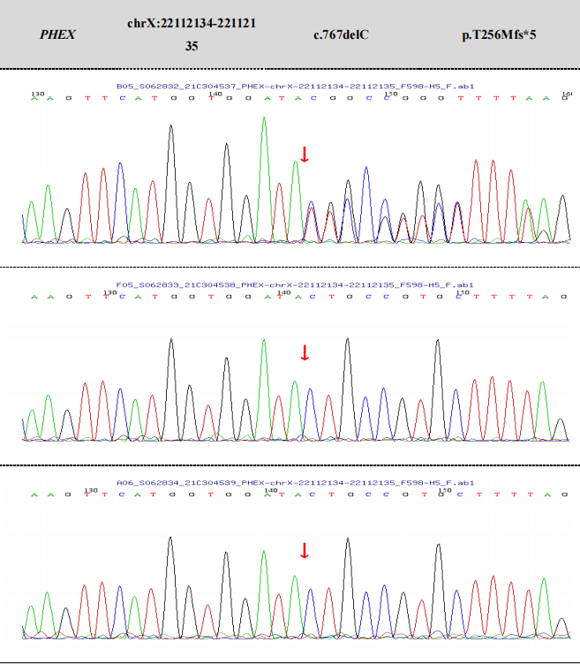

Figure 1:Sanger sequencing electropherograms of the PHEX variant (NM_000444.6(PHEX):c.766_767del) in the proband and her parents. The red box indicates the deletion of two nucleotides (766_767del) in the proband; the parents show the wild-type sequence.

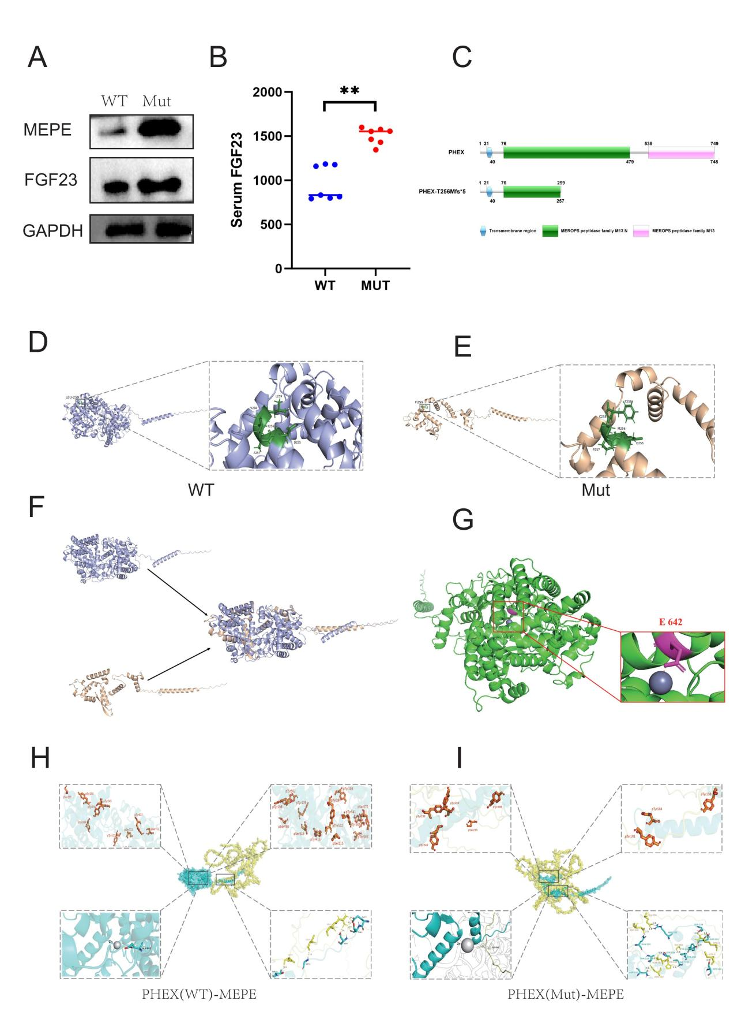

Figure 2: Functional and structural analysis of wild-type and mutant PHEX
A. Western Blot analysis of MEPE and FGF23 expression in wild-type (WT) and mutant (Mut) PHEX-transfected 293T cells. GAPDH was used as the internal reference; the expression levels of MEPE and FGF23 were significantly higher in the Mut group than in the WT group.
B. ELISA analysis of serum PHEX protein levels in healthy controls (WT) and the proband (Mut). The relative expression of PHEX protein in the Mut group was significantly reduced and nearly undetectable; data are presented as mean ± SD, ***P<0.001 vs. WT.
D. 3D structure of mutant PHEX (Thr256Cysfs*7) protein, showing severe truncation with complete loss of the extracellular catalytic domain, zinc-binding region, and M13 peptidase core structure.
E. 3D structure of wild-type PHEX protein, showing complete structural domains including the conserved E642 catalytic site and functional zinc-binding region.
F. Structural alignment of wild-type (blue) and mutant (red) PHEX proteins, showing obvious deletion of the C-terminal functional domain in the mutant protein.
G. Zn2+ binding site comparison of wild-type and mutant PHEX proteins; wild-type PHEX has a complete zinc-binding pocket, while mutant PHEX completely loses Zn2+ binding ability (zinc atom marked as gray sphere).
H. Molecular docking complex of wild-type PHEX and MEPE, showing a stable binding interface and high binding affinity.
I. Molecular docking complex of mutant PHEX and MEPE, showing significantly reduced binding interface and impaired binding affinity.
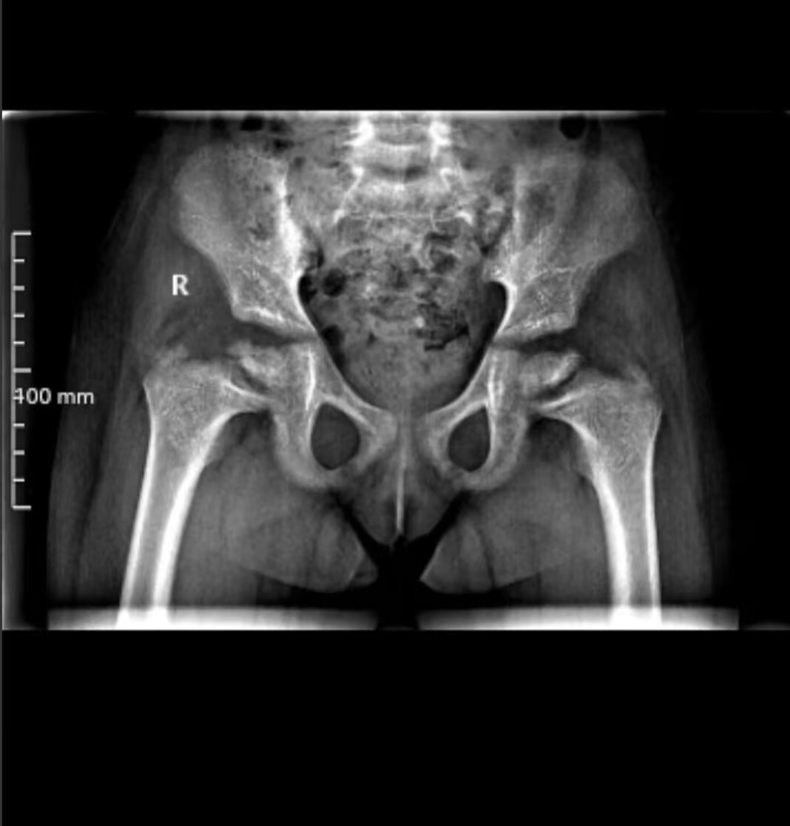
Figure S1: Imaging features of the XLH proband
Pelvic radiograph of a child with PHEX mutation (X-linked hypophosphatemic rickets) showing rachitic changes: widened, irregular, cupped proximal femoral epiphyses, generalized osteopenia, and bilateral coxa vara. R = right. Scale bar: 400 mm.

Acknowledgments
The authors thank the proband and her family for their participation and cooperation in this study. We also thank the laboratory technicians for their assistance in sample collection and experimental testing.

1. Bockmann, I. and D. Haffner, The Diagnosis and Therapy of XLH. Calcif Tissue Int, 2025. 116(1): p. 66.
2. Drezner, M.K., PHEX gene and hypophosphatemia. Kidney Int, 2000. 57(1): p. 9-18.
3. Haffner, D., et al., Clinical practice recommendations for the diagnosis and management of X-linked hypophosphataemia. Nat Rev Nephrol, 2025. 21(5): p. 330-354.
4. Quarles, L.D., FGF23, PHEX, and MEPE regulation of phosphate homeostasis and skeletal mineralization. Am J Physiol Endocrinol Metab, 2003. 285(1): p. E1-9.
5. Irie, K., et al., PHEX Protein in the Parathyroid Gland Contributes to Phosphate Sensing. J Clin Endocrinol Metab, 2025. 111(1): p. e1-e8.
6. Kamenicky, P., et al., X-linked hypophosphataemia. Lancet, 2024. 404(10455): p. 887-901.
7. Rowe, P.S., The wrickkened pathways of FGF23, MEPE and PHEX. Crit Rev Oral Biol Med, 2004. 15(5): p. 264-81.
8. Guo, R., et al., Inhibition of MEPE cleavage by Phex. Biochem Biophys Res Commun, 2002. 297(1): p. 38-45.
9. Insogna, K.L., et al., A Randomized, Double-Blind, Placebo-Controlled, Phase 3 Trial Evaluating the Efficacy of Burosumab, an Anti-FGF23 Antibody, in Adults With X-Linked Hypophosphatemia: Week 24 Primary Analysis. J Bone Miner Res, 2018. 33(8): p. 1383-1393.
10. Minamizaki, T., et al., Active sites of human MEPE-ASARM regulating bone matrix mineralization. Mol Cell Endocrinol, 2020. 517: p. 110931.
11. Nepal, A.K., et al., Mechanical loading modulates phosphate related genes in rat bone. PLoS One, 2023. 18(3): p. e0282678.
12. Kamenicky, P., et al., Benefit of burosumab in adults with X-linked hypophosphataemia (XLH) is maintained with long-term treatment. RMD Open, 2023. 9(1).

