Research Hotspots and Development Trends of Reablement From 1999 to 2025: A bibliometric analysis
Abstract
Aims
This study aims to explore the current research status, hotspots, and emerging trends of reablement and provide references for further research in this field.
Methods
English-language literature related to reablement was retrieved from the Web of Science Core Collection database, covering the period from January 1, 1999 to October 20, 2025. The software CiteSpace and VOSviewer were used to conduct visual bibliometric analyses of eligible publications, including annual publication output, countries, authors, institutions, cited references, and keywords.
Results
A total of 276 publications were included. Overall, the number of publications showed an increasing trend over time. The United States contributed the largest number of publications, followed by Australia and Norway, and Resnick was the most productive author. The top five keywords by frequency were “older adults”, “reablement”, “intervention”, “people”, and “physical activity”. Intervention studies and qualitative studies were the main research types, with application-focused research hotspots primarily concentrated on improving physical activity among service recipients.
Conclusions
Research on reablement has attracted increasing attention. Future studies should focus on conducting high-quality empirical research to identify optimal intervention strategies, as well as sensitive assessment tools and outcome indicators. In addition, researchers are encouraged to draw on existing experiences to actively promote home-based reablement services and explore the development of reablement models tailored to national contexts.
Keywords
Reablement; Older adults; Bibliometric analysis; Function-focused care; Restorative care; self-supporting care
Iintroduction
According to the World Health Organization, the proportion of the global older population is continuously increasing and is expected to reach 1.4 billion by 2030, accounting for one sixth of the world’s total population. By 2050, the number of older adults is projected to double to 2.1 billion ^{[1]}. The rapid population aging trend has made health-related issues among older adults increasingly prominent. Maintaining physical function in older adults and reducing the care-giving burden on families and society have become key research priorities in the field of healthy aging ^{[2]}.
Reablement is a person-centred and holistic care approach that aims to enhance individuals’ physical and psychological functioning, maintain or improve independence in activities of daily living (ADL), and reduce the need for long-term care ^{[3]}. In different countries, reablement is also referred to as function-focused care (FFC), restorative care, and self-supporting care. Although the terminology varies, these approaches share similar core principles, focusing on identifying individuals’ potential abilities, encouraging self-care practices, and improving independence in daily living. Therefore, in this study, these care approaches are collectively referred to as reablement.
At present, reablement has been widely implemented in countries such as the United States ^{[4]}, the United Kingdom ^{[5]}, Japan ^{[6]}, South Korea ^{[7]}, the Netherlands ^{[8]}, and Australia ^{[9]}. Evidence suggests that reablement can effectively improve depression, cognitive function, social participation, grip strength, ADL performance, and quality of life among service recipients ^{[10–12]}. These benefits not only enhance individuals’ independence in daily living but also alleviate caregiving burdens on families and society.
Bibliometric analysis is a commonly used method for evaluating the quantity and quality of academic literature and can help rapidly identify research hotspots and development trends within a field. Although reablement research has attracted increasing attention from scholars, no bibliometric analysis has yet systematically examined the literature in this field. Therefore, this study adopts bibliometric methods to retrieve, organize, and visually analyze English-language literature related to reablement, with the aim of exploring the current research status, hotspots, and development trends of reablement and providing references for future research in this area.
Methods
Data collection
The Web of Science Core Collection (WoSCC) was used as the data source in this study. WoSCC is the oldest, most widely used and authoritative database in the world, providing professional raw data to bibliometric partners. A topic search strategy was applied as follows: TS (reablement) OR TS (re-ablement) OR TS (“restorative care”) OR TS (“restorative home care”) OR TS (“function-focus*”) OR TS (“reactivation care”) OR TS (“self-support*”). As the first publication related to reablement was published in 1999 ^{[13]}, the search period was set from January 1, 1999 to October 24, 2025. “TS” indicates topic search, which includes the title, abstract, and keywords of publications.
Literature screening
The inclusion criteria for this study were as follows: (1) research topic focused on reablement; (2) publication types included original research articles and reviews. The exclusion criteria were: (1) conference abstracts, commentaries, and news reports; (2) non-English publications; (3) articles with unavailable full texts. The processes of literature inclusion and exclusion were independently conducted by two researchers through reading titles and abstracts. Any disagreements were resolved through discussion with a third researcher. A total of 10,872 English-language publications were initially retrieved. After screening according to the inclusion and exclusion criteria, 276 publications were finally included. Fig. 1 shows the flowchart of the research selection for reablement.
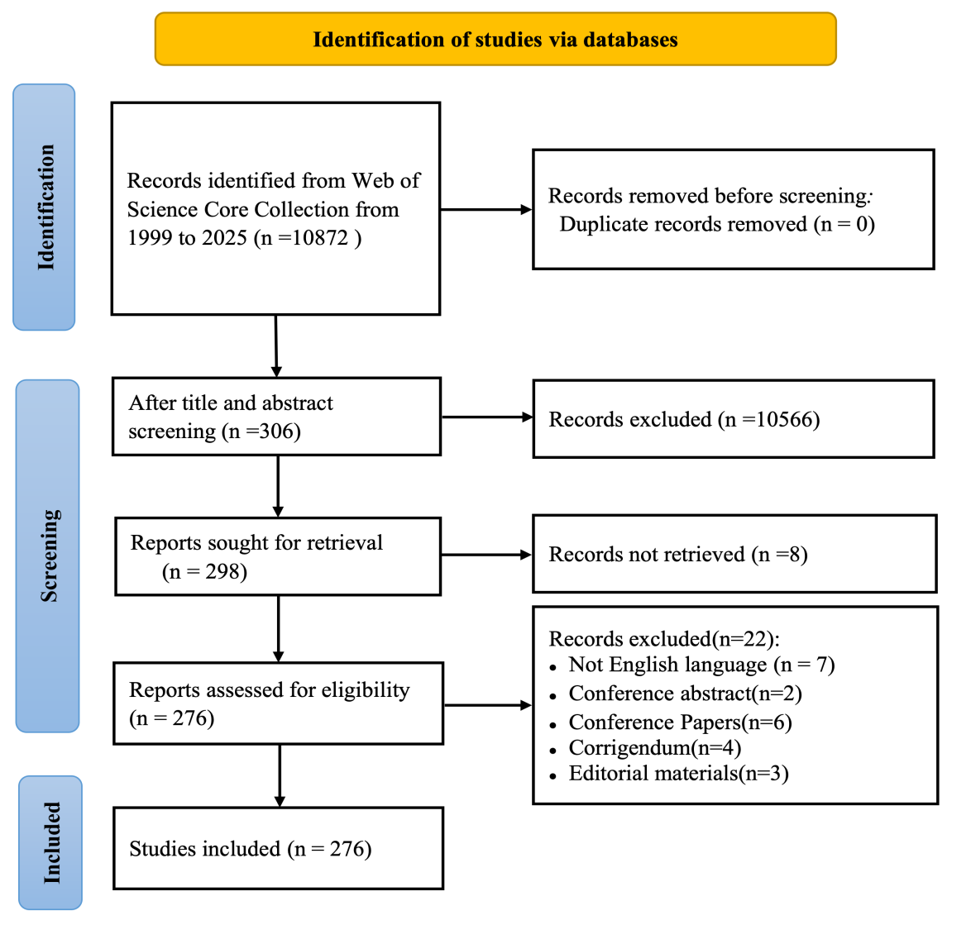
Fig. 1. Flow diagram of study selection.
Data analysis
Software CiteSpace v6.4.1 and VOSviewer v1.6.20 were used for data analysis and visualization of countries, institutions, authors, and keywords. CiteSpace was mainly applied for keyword clustering, burst detection, and time-zone evolution analysis, while VOSviewer was used for co-occurrence analysis of countries, institutions, authors, and keywords. The parameter settings for CiteSpace were as follows: the time span was set from January 1999 to October 2025, with a time slice of one year; the threshold was set to Top 50; the g-index was set to 25; the pruning methods included “pathfinder” and “pruning sliced networks”. Node types included authors, countries, institutions, and keywords, with other parameters set to default values. Extracted keywords were cleaned and standardized. Specifically, “re-ablement”, “function-focused care”, “function focused care”, “restorative care” and “self-supporting care” were unified as “reablement”; “RCT” was standardized as “randomized controlled trial”; “older people” was unified as “older adults”. Words with no substantive meaning (“study”, “research”) were removed.
Results
Publication outputs and trend
Overall, the number of publications related to reablement showed an upward trend. From 1999 to 2018, the annual publication output increased slowly, followed by a marked rise between 2019 and 2022. The number of publications peaked in 2021, with 29 articles. After a slight decline in 2023, the publication output continued to increase. Detailed trends are shown in Figure 2.
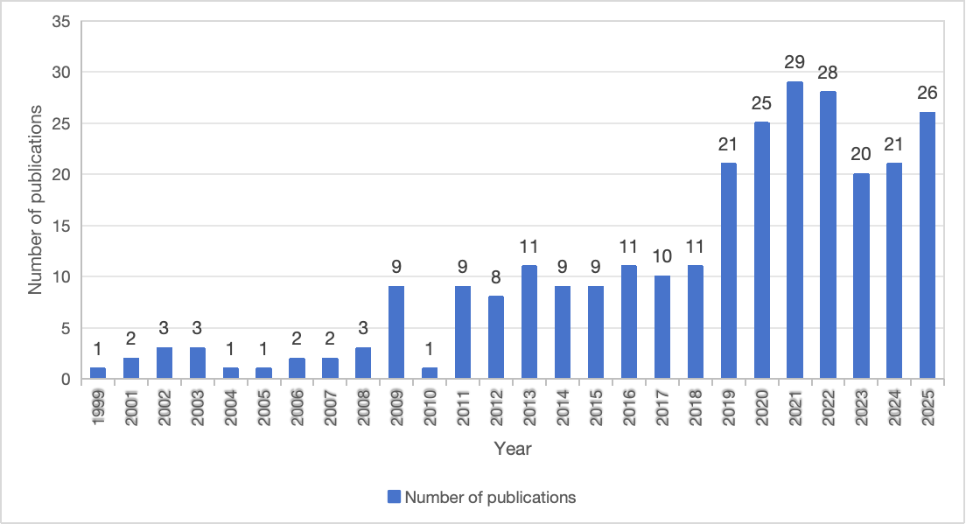
Fig. 2. The number and trend in annual publications on reablement research from 1999 to 2025.
Author analysis
A total of 771 authors and 5,267 co-cited authors were identified in this research field. Table 1 presents the top 10 authors ranked by publication output and co-citation frequency. Resnick was the most productive author, with 57 publications, followed by Galik (n=42) and Boltz (n=33). In terms of co-citation frequency, Resnick ranked first with 1,368 citations, followed by Galik (n=933) and Boltz (n=577). Notably, Resnick, Galik, and Boltz were not only highly productive authors but also among the most frequently cited authors in the field.
Table 1. Top 10 authors ranked by publication output and co-citation frequency.
Rank | First Author | Country | Publications | Co-cited author | Country | Citation frequency
1 | Resnick, Barbara | United States | 57 | Resnick, Barbara | United States | 1368
2 | Galik, Elizabeth | United States | 42 | Galik, Elizabeth | United States | 933
3 | Boltz, Marie | United States | 33 | Boltz, Marie | United States | 577
4 | Metzelthin, Silke F | Netherlands | 17 | Forland, Oddvar | Norway | 412
5 | Zhu, shijun | United States | 15 | Zimmerman, Sheryl | United States | 375
6 | Clemson, Lindy | Australia | 14 | Pretzer-aboff, Ingrid | United States | 327
7 | Forland, Oddvar | Norway | 12 | Tuntland, Hanne | Norway | 306
8 | Tuntland, Hanne | Norway | 12 | Gruber-baldini, Ann L | United States | 292
9 | Kuzmik, Ashley | United States | 12 | Lewin, Gill | Australia | 208
10 | Zimmerman,Sheryl | United States | 10 | Clemson, Lindy | Australia | 206
Country and institution analysis
The included publications originated from 74 countries. The top five countries by publication output were the United States (n=89), Australia (n=52), Norway (n=48 ), the Netherlands (n=29), and the United Kingdom (n=22). The top five institutions were the University of Maryland, United States (n=63), Pennsylvania State University, United States (n=25), Maastricht University, the Netherlands (n=20), the University of Sydney, Australia (n=17), and the University of North Carolina, United States (n=13). Using VOSviewer, collaboration networks among countries and institutions were analyzed. The strength of collaboration was represented by total link strength (TLS). The top five countries by TLS were Australia, Norway, the Netherlands, the United States, the United Kingdom and Canada (tied for fifth). The top five institutions by TLS were the University of Maryland, United States; the University of Sydney, Australia; Maastricht University, the Netherlands; Curtin University, Australia; and Pennsylvania State University, United States.
Keywords analysis
High-frequency keywords analysis
Keyword frequency reflects the level of research attention, while centrality indicates a keyword’s influence or importance within the research network. Based on high-frequency keywords, current research hotspots in reablement can be categorized into five main aspects. First, in terms of research populations, “older adults” had the highest frequency, indicating that this group is the primary focus of reablement research. “Dementia” showed the highest centrality, suggesting its pivotal role within the research network. Second, regarding research content, “reablement” had the highest frequency, followed by “physical activity” and “rehabilitation”. Third, in terms of research types, “intervention” appeared most frequently, followed by qualitative studies focusing on “experiences” and “randomized controlled trials”. “Intervention” also demonstrated relatively high centrality. Fourth, concerning outcome measures, “reliability” had the highest frequency, followed by “health”, “validity”, and “quality of life”. Among these, “health” showed relatively high centrality. Fifth, regarding research settings, “home care” appeared with relatively high frequency. Detailed information is presented in Table 2.
Table 2. Top 20 keywords by frequency in research on reablement.
Rank | Keywords | Times | Centrality | Rank | Keywords | Times | Centrality
1 | Older adults | 105 | 0.07 | 11 | Activities of daily living | 27 | 0.12
2 | Reablement | 86 | 0.08 | 12 | Dementia | 27 | 0.18
3 | Intervention | 68 | 0.16 | 13 | Long-term care | 26 | 0.10
4 | People | 61 | 0.15 | 14 | Validity | 25 | 0.05
5 | Physical activity | 43 | 0.02 | 15 | Quality of life | 20 | 0.01
6 | Home care | 37 | 0.07 | 16 | Residents | 19 | 0.04
7 | Reliability | 32 | 0.08 | 17 | Experiences | 19 | 0.06
8 | Health | 31 | 0.17 | 18 | Randomized controlled trial | 18 | 0.04
9 | Care | 30 | 0.12 | 19 | Impact | 17 | 0.01
10 | Rehabilitation | 30 | 0.07 | 20 | Disability | 15 | 0.07
Keywords clustering analysis
Keyword clustering groups similar or related research topics and reflects focal issues within a research field. Using the Log-Likelihood Ratio (LLR) algorithm, keywords were clustered, with a larger number of keywords within a cluster corresponding to a smaller cluster label value. Cluster 0 represents the largest cluster. The results showed a modularity value (Q) of 0.4809, indicating a significant clustering structure (Q > 0.3), and a silhouette value (S) of 0.7888, suggesting a high level of reliability for the clustering results (S > 0.7). Detailed results are shown in Table 3. A total of eight clusters related to reablement research were identified: reablement, nursing home, home care, community care, acute care, exercise, active aging, and comprehensive geriatric assessment.
Table 3. Clustering visualization of research on reablement.
Rank | Cluster | Keywords
#0 | reablement | physical activity; assisted living; long term care; aged care
#1 | nursing home | outcome expectations; self-efficacy; agitation; assistants
#2 | home care | community; goal-setting; carers; dementia
#3 | community care | cognitive rehabilitation; occupation; social support; disability
#4 | acute care | functional recovery; family engagement; reablement; hospitalized older adult
#5 | exercise | restorative home care services; aging; burden; health behavior/symptom focus
#6 | active aging | occupational therapy; economic evaluation; aging in place; care work
#7 | comprehensive geriatric assessment | older adults; discharge from hospital; patient expectation; follow up
Keywords burst analysis
Burst keywords refer to terms that show a sharp increase in frequency over a short period and can indicate emerging research trends and frontiers. The top 25 keywords with the strongest burst strength reflected changes in reablement research from 1999 to 2025. As shown in Figure 3, the five keywords with the strongest burst strength were “quality of life”, “dementia”, “home”, “reablement”, and “mobility”. Burst keywords emerging in the most recent year included “quality of life”, “nursing home”, “home care”, and “health”.
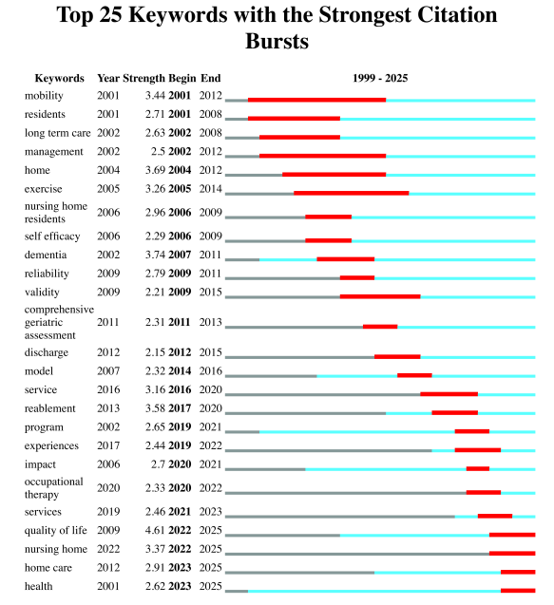
Fig. 3. Top 25 keywords with the strongest burst detection in reablement research.
Keywords time-zone visualization
From 1999 to 2004, research primarily focused on “older adults”, “intervention”, “health”, and “dementia”, reflecting attention to health status and intervention strategies for older populations. Between 2005 and 2010, research hotspots gradually shifted toward “reablement”, “physical activity”, and “rehabilitation”. Outcome-related keywords such as “reliability”, “validity”, and “quality of life” began to emerge, with research settings mainly concentrated in “nursing homes”. From 2011 to 2016, keywords such as “home care”, “social care”, and “home independence program” indicated increasing interest in individualized reablement care models and self-care capacity. Keywords including “activities of daily living”, “barriers”, and “falls” reflected the core research content of reablement. Between 2017 and 2025, research themes shifted toward “community care”, “care work”, and “occupational therapy”, emphasizing the scientific basis, professionalization, and innovative service models of reablement. As shown in Figure 4, node size represents keyword frequency, and node color indicates the year of first appearance.
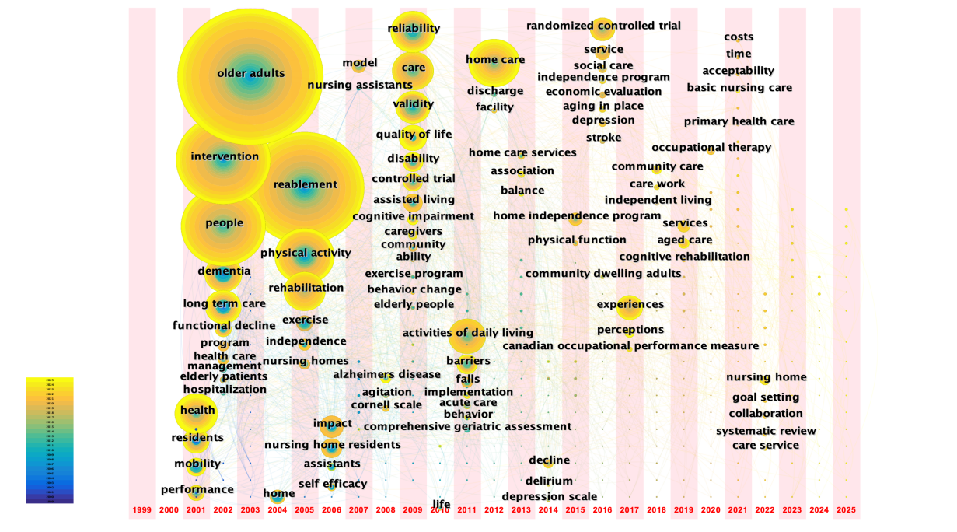
Fig. 4. Time-zone map of keywords in reablement research.
Discussion
Publication output, countries, and institutions in reablement research
Publications from the most recent six years accounted for 53.99% of the total number of reablement-related articles, indicating that reablement research has entered a phase of rapid development. In terms of country distribution, the top five countries contributed 240 publications, accounting for 86.95% of the total output, suggesting an uneven geographical distribution of research in this field. The United States ranked first in publication output, which may largely be attributed to strong governmental support. For example, projects led by the University of Maryland and funded by the National Institute on Aging (NIA), such as FFC-AC-EIT(Function Focused Care for Acute Care), have provided substantial data support for reablement research ^{[14]}. Australia and Norway ranked second and third, respectively, with similar publication outputs. This may be explained by policy and financial support from their governments. In Australia, an independent aged care assessment system has been established to ensure service quality, separating provider accreditation and service quality evaluation from service delivery. In Norway, the Norwegian Occupational Therapy Association launched the “Reablement in Norway” program, in which multidisciplinary teams composed of physiotherapists, occupational therapists, nurses, and nursing assistants provide structured reablement services to older adults with functional decline, while also promoting the program among health authorities and clinicians at various levels ^{[15–16]}. The Netherlands ranked fourth in publication output, which may be related to the Living Lab in Ageing and Long-Term Care jointly initiated by Maastricht University and a nursing home in 1998 ^{[17]}. In addition, the United Kingdom has implemented reablement for over 20 years and has accumulated substantial theoretical and practical experience, resulting in a relatively high number of publications ^{[16]}.
From the perspective of collaboration networks, Australia, Norway, and the Netherlands demonstrated a stronger emphasis on international academic collaboration. Institutions such as the University of Maryland (United States), the University of Sydney (Australia), and Maastricht University (Netherlands) played prominent roles in international cooperation. Such cross-national collaboration may accelerate the sharing of theoretical and practical knowledge, contributing to these countries’ leading positions in reablement research. Therefore, researchers in other countries are encouraged to strengthen resource integration and international collaboration, draw on advanced experiences, and explore the development of region-specific reablement strategies and operational guidelines.
Research hotspots in reablement
The frequent appearance of the keyword “older adults”, together with the high frequency and centrality of “people” and “dementia”, indicates that current reablement research primarily focuses on older populations, particularly individuals with dementia. To alleviate caregiving burdens on families and society, researchers have attempted to maximize older adults’ functional capacities through reablement and improve their independence in daily living. Empirical evidence has demonstrated that reablement can improve ADL performance, mobility, and quality of life among older adults ^{[18–19]}. Keyword analysis also highlights people with dementia as a key target group for reablement. Jeon ^{[20]} suggested that although neurological, psychological, and social impairments associated with dementia may limit daily activities and experiences, individuals with dementia are still capable of living meaningful lives. Currently, Australia is implementing the I-HARP program, which incorporates cognitive rehabilitation, cognitive and physical function assessment, and person-centered dementia care into standard reablement services to address the specific needs of people with dementia. This program aims to improve independence, mobility, quality of life, depression, and caregiver burden ^{[21]}.Regarding evidence for cognitive rehabilitation, only one systematic review ^{[22]} has concluded its effectiveness for individuals with mild dementia. However, findings from the I-HARP program suggest that when combined with other multidisciplinary interventions, cognitive rehabilitation may also be beneficial for individuals with moderate dementia. In addition, Claire ^{[23]} developed a reablement practice manual for service providers caring for people with dementia, systematically outlining intervention procedures and contents related to occupational therapy, cognitive interventions, fall prevention, and communication strategies. Although stroke was not identified as a prominent research focus based on keyword analysis, Chiu ^{[24]} demonstrated that a six-week home-based reablement program for individuals with stroke improved motor function, ADL and instrumental ADL (IADL), mood, and memory. Compared with traditional rehabilitation, home-based reablement reduced medical costs by 15% and decreased the need for caregiving staff. Therefore, it is recommended to develop family-based reablement models and strengthen collaboration among communities, primary healthcare institutions, and families to provide effective services for individuals with stroke, dementia, and other conditions.
“Physical activity (PA)” and “activities of daily living (ADL) ”were identified as high-frequency keywords, “exercise” formed Cluster #5, and “mobility” showed burst activity between 2001 and 2012. PA generally includes ADL, household activities, leisure activities, and structured exercise, indicating that current research hotspots mainly focus on improving physical activity among service recipients. Consequently, ADL training and physical function exercise constitute the core components of reablement ^{[25]}. ADL training is typically delivered by occupational therapists or registered nurses and involves repeated practice of personal care, eating, and other daily activities within everyday contexts, encouraging individuals to complete activities independently or partially independently. Physical function exercise is usually provided by physiotherapists and includes training in strength, balance, endurance, and fine motor skills ^{[26]}. However, a systematic review ^{[27]} reported that most reablement intervention studies did not clearly describe specific PA-related strategies or intervention intensity, resulting in limited evidence regarding how reablement influences PA. Future research should conduct high-quality empirical studies to explore the feasibility, effectiveness, and influencing factors of PA interventions within reablement programs.
Based on high-frequency keywords, keyword clustering, and burst analyzes, experiences and intervention were identified as major research hotspots in reablement. This may be attributed to the person-centered nature of reablement, which aims to support individuals in doing what they want and need to do. As a result, researchers often comprehensively explore participation experiences from the perspectives of service recipients, caregivers, and service providers. In addition to qualitative research, intervention studies constitute another major research focus. Current intervention studies on reablement cover diverse populations, settings, and intervention components. However, Cochrane reviewers ^{[28]} have indicated that high-quality evidence confirming the effectiveness of reablement remains insufficient. The keywords time-zone analysis showed that before 2012, reablement interventions were mainly conducted in institutional care settings, whereas in recent years, they have gradually shifted toward home- or community-based settings. This shift may be explained by increasing population aging and rising life expectancy, which have placed substantial pressure on healthcare and welfare systems. Home- or community-based care, characterized by lower costs, ease of implementation, and greater flexibility, has therefore attracted increasing attention. Currently, only a limited number of national-level home-based reablement programs are in operation, such as the Home Independence Program (HIP) in Australia, the I-MANAGE community reablement program in the Netherlands, and the ASSIST program in Sweden. Experiences from these programs suggest that with policy support, financial investment, and multidisciplinary collaboration, home-based reablement can effectively reduce healthcare burdens and improve independence and quality of life among service recipients, providing valuable references for other countries seeking to develop home- or community- based reablement programs.
Conclusions
This study employed VOSviewer and CiteSpace to conduct a visualized bibliometric analysis of the literature on reablement, presenting the current research landscape, hotspots, and development trends in this field. The analysis of research patterns and evolutionary characteristics provides multidimensional references for researchers and policymakers. At present, reablement research is still evolving. Future studies are recommended to conduct more high-quality empirical research to identify optimal intervention strategies, as well as sensitive assessment tools and outcome indicators. In addition, the active promotion of home-based reablement services is encouraged to further support independence and quality of life among service recipients.
Limitations
This study has several limitations. Due to language restrictions and the limitations of data analysis tools, only English-language publications from the Web of Science Core Collection were included, which may have influenced the results. Future studies could incorporate literature from other databases, such as Scopus and PubMed, and conduct cross-national comparative analyzes to explore reablement models suitable for different national contexts, thereby providing stronger evidence for policy formulation and service implementation.
References
- World Health Organization: Ageing and health. [EB/OL]. (2025)[2025-12-20].
https://www.who.int/zh/news-room/fact-sheets/detail/ageing-and-health
- Fu Jingjing, Hong Yan, Liu Siqi, et al. Global research on the social health of community-dwelling elderly over the past decade: a visual analysis [J]. Chinese Journal of Clinical Healthcare, 2022, 25(3): 415-420.
- Metzelthin SF, Rostgaard T, Parsons M, et al. Development of an internationally accepted definition of reablement: a Delphi study. Ageing and Society. 2020;42(3):703-718. doi:10.1017/s0144686x20000999
- Resnick B, Galik E. Using function-focused care to increase physical activity among older adults. Annu Rev Nurs Res. 2013;31:175-208. doi:10.1891/0739-6686.31.175
- Cunliffe AL, Gladman JR, Husbands SL, et al. Sooner and healthier: a randomised controlled trial and interview study of an early discharge rehabilitation service for older people. Age Ageing. 2004;33(3):246-252. doi:10.1093/ageing/afh076
- Hattori S, Yoshida T, Okumura Y, et al. Effects of Reablement on the Independence of Community-Dwelling Older Adults with Mild Disability: A Randomized Controlled Trial. Int J Environ Res Public Health. 2019;16(20):3954. Published 2019 Oct 17. doi:10.3390/ijerph16203954
- Jung D, Lee H, Lee M. Function-focused care programme for older people in Korean long-term care facilities. Int J Older People Nurs. 2020;15(1):e12277. doi:10.1111/opn.12277
- Smeets RGM, Kempen GIJM, Zijlstra GAR, et al. Experiences of home-care workers with the 'Stay Active at Home' programme targeting reablement of community-living older adults: An exploratory study. Health Soc Care Community. 2020;28(1):291-299. doi:10.1111/hsc.12863
- Lewin G, Vandermeulen S. A non-randomised controlled trial of the Home Independence Program (HIP): an Australian restorative programme for older home-care clients. Health Soc Care Community. 2010;18(1):91-99. doi:10.1111/j.1365-2524.2009.00878.x
- Assander S, Bergström A, Eriksson C, et al. ASSIST: a reablement program for older adults in Sweden - a feasibility study. BMC Geriatr. 2022;22(1):618. Published 2022 Jul 26. doi:10.1186/s12877-022-03185-2
- Resnick B, Galik E, Gruber-Baldini AL, et al. Implementing a restorative care philosophy of care in assisted living: pilot testing of Res-Care-AL. J Am Acad Nurse Pract. 2009;21(2):123-133. doi:10.1111/j.1745-7599.2008.00394.x
- Galik EM, Resnick B, Gruber-Baldini A, et al. Pilot testing of the restorative care intervention for the cognitively impaired. J Am Med Dir Assoc. 2008;9(7):516-522. doi:10.1016/j.jamda.2008.04.013
- K. Suggs, Catherine B. Messick, Mau P. RESTORATIVE (GERIATRIC SUBACUTE) CARE: THE EDUCATIONAL COMPONENT. Educational Gerontology. 1999;25(3):211-219. doi:10.1080/036012799267837
- Resnick B, Boltz M, Galik E, et al. Implementation of Function Focused Care for Acute Care Using the Evidence Integration Triangle. J Am Geriatr Soc. 2025;73(5):1388-1397. doi:10.1111/jgs.19334
- Guadaña J, Oyeneyin B, Moe CF, et al. Publication Trends in Reablement - A Scoping Review. J Multidiscip Healthc. 2023;16:1641-1660. Published 2023 Jun 13. doi:10.2147/JMDH.S407802
- Rostgaard T, Parsons J, Tuntland H, eds. Reablement in Long-Term Care for Older People: International Perspectives and Future Directions. Policy Press; 2023.
- Buma LE, Vluggen S, Mouchaers I, et al. Feasibility of a Reablement Programme in Community Care in the Netherlands; A Qualitative Study. Int J Integr Care. 2025;25(3):27. Published 2025 Sep 10. doi:10.5334/ijic.9005
- Bennett C, Allen F, Hodge S, et al. An investigation of Reablement or restorative homecare interventions and outcome effects: A systematic review of randomised control trials. Health Soc Care Community. 2022;30(6):e6586-e6600. doi:10.1111/hsc.14108
- Mugica-Errazquin I, Irazusta J, Kortajarena M, et al. Maintaining daily living activities in older adults: The impact of a functional exercise program in long-term nursing homes. A single-group pre-post intervention. Geriatr Nurs. 2024;60:215-224. doi:10.1016/j.gerinurse.2024.09.003
- Jeon YH, Clemson L, Naismith SL, et al. Improving the social health of community-dwelling older people living with dementia through a reablement program. Int Psychogeriatr. 2018;30(6):915-920. doi:10.1017/S1041610217001533
- Jeon YH, Simpson JM, Low LF, et al. A pragmatic randomised controlled trial (RCT) and realist evaluation of the interdisciplinary home-bAsed Reablement program (I-HARP) for improving functional independence of community dwelling older people with dementia: an effectiveness-implementation hybrid design. BMC Geriatr. 2019;19(1):199. Published 2019 Jul 29. doi:10.1186/s12877-019-1216-x
- Bahar-Fuchs A, Clare L, Woods B. Cognitive training and cognitive rehabilitation for mild to moderate Alzheimer's disease and vascular dementia. Cochrane Database Syst Rev. 2013;2013(6):CD003260. Published 2013 Jun 5. doi:10.1002/14651858.CD003260.pub2
- O'Connor CMC, Gresham M, Poulos RG, et al. Translating reablement research for dementia practice: development of a handbook using implementation science. Disabil Rehabil. 2022;44(8):1524-1536. doi:10.1080/09638288.2020.1797910
- Chiu EC, Chi FC, Chen PT. Investigation of the home-reablement program on rehabilitation outcomes for people with stroke: A pilot study. Medicine (Baltimore). 2021;100(26):e26515. doi:10.1097/MD.0000000000026515
- Buma LE, Vluggen S, Zwakhalen S, et al. Effects on clients' daily functioning and common features of reablement interventions: a systematic literature review. Eur J Ageing. 2022;19(4):903-929. Published 2022 May 3. doi:10.1007/s10433-022-00693-3
- Mouchaers I, Verbeek H, Kempen GIJM, et al. Development and content of a community-based reablement programme (I-MANAGE): a co-creation study. BMJ Open. 2023;13(8):e070890. Published 2023 Aug 30. doi:10.1136/bmjopen-2022-070890
- Mjøsund HL, Moe CF, Burton E, et al. Integration of Physical Activity in Reablement for Community Dwelling Older Adults: A Systematic Scoping Review. J Multidiscip Healthc. 2020;13:1291-1315. Published 2020 Oct 29. doi:10.2147/JMDH.S270247
- Cochrane A, Furlong M, McGilloway S, et al. Time-limited home-care reablement services for maintaining and improving the functional independence of older adults. Cochrane Database Syst Rev. 2016;10(10):CD010825. Published 2016 Oct 11. doi:10.1002/14651858.CD010825.pub2
Conflict of Interest
No conflict of interest was reported by all authors.
Funding
None.
Author information
Hongxi Jin 1, Xiaoyun Yu 2, Ying Qian ¹*, Keying Yang ¹, Minghui Ren ¹, Yifan Qin ¹
Contributions
All authors read and approved the final version of the manuscript. HJ started the idea and designed the methodology, as well as manuscript writing; XY did the data analysis and graphics and data interpretation; YQ was responsible for reviewing the manuscript; KY, MR and YQ helped in developing the methodology and enriched the discussion.
Corresponding author
Correspondence to Ying Qian.
Email: qianying06@163.com
Ethics declarations
Not applicable.

School of Public Health and Nursing, Hangzhou Normal University, Hangzhou, China
Jinhua No. 1 Secondary Vocational School, Jinhua, China

