First-line Treatment for Wound Healing of Tophi Ulceration in a Patient with Gout and Type 2 Diabetes: A Case Report
Ning Xu, Yadong Lin, Jiaqi Dong, Aimin Li*
Rheumatology Department, Qingdao No.5 People’s Hospital, Qingdao 266002, Shandong, China
*Author to whom correspondence should be addressed.

Copyright: © 2026 Author(s). This is an open-access article distributed under the terms of the Creative Commons Attribution License (CC BY 4.0), permitting distribution and reproduction in any medium, provided the original work is cited.

Abstract: Background: Tophi ulceration with infection and refractory wound healing remains a clinical challenge, particularly in patients with concurrent diabetes. Interleukin-1β (IL-1β) is a central mediator of gouty inflammation; targeted IL-1 inhibition may rapidly suppress inflammation and facilitate tissue repair. Case Presentation: This study reported the case of a 27-year-old male with a 6-year history of gouty arthritis, multiple tophi, infected left foot ulceration, and type 2 diabetes. Despite conventional anti-infective therapy, glycemic control, and local wound care, the ulcer showed limited improvement. Following a single subcutaneous injection of firsekibart (200 mg), wound exudate decreased rapidly, granulation tissue developed satisfactorily, and the ulcer healed progressively. At the 4-month follow-up, complete wound closure was achieved without recurrence or adverse events. Conclusion: Firsekibart demonstrated favorable anti-inflammatory and wound-healing effects in a patient with tophi ulceration complicated by diabetes, suggesting its potential as a therapeutic option for refractory cases. Prospective studies are warranted to confirm these findings.
Keywords: Gout; Tophi ulceration; Wound healing; IL-1 inhibitor; Firsekibart; Type 2 diabetes

Online publication:

1. Introduction
Gout is a prevalent inflammatory arthropathy caused by the deposition of monosodium urate (MSU) crystals in and around joints. Hyperuricemia, defined as a serum urate concentration ≥0.42 mmol/L (7 mg/dL), is the principal risk factor for gout development. Clinically, gout manifests as episodic acute flares of severe pain, swelling, and erythema, driven by an innate immune response to deposited MSU crystals ^{[1]}.
If left untreated, acute gouty flares typically resolve spontaneously within 7–14 days, followed by an asymptomatic intercritical period. However, in patients with persistent hyperuricemia, recurrent flares may progress to chronic gouty arthritis, joint structural damage, and the formation of tophi—subcutaneous deposits of MSU crystals surrounded by granulomatous inflammation ^{[2,3]}. Tophi can ulcerate through the skin, leading to persistent drainage, secondary infection, and chronic non-healing wounds that significantly impair limb function and quality of life ^{[4]}.
The coexistence of gout and diabetes mellitus poses a particular clinical challenge. Epidemiological studies indicate that approximately 12.2–26.9% of gout patients have comorbid diabetes, and this proportion reaches 26% among hospitalized gout patients ^{[5,6]}. The pathophysiological interplay is bidirectional: hyperuricemia impairs pancreatic β-cell function and exacerbates insulin resistance, while diabetic nephropathy reduces uric acid excretion, further elevating gout risk. Moreover, diabetic foot ulceration, a severe complication of diabetes, affects up to 8.1% of patients over 50 years of age, with a 5-year post-amputation mortality rate of 40% ^{[7,8]}.
Tophi ulceration with non-healing wounds is driven by persistent MSU crystal-induced inflammation, tissue destruction, secondary infection, and metabolic derangement. Conventional anti-inflammatory, urate-lowering, and antimicrobial therapies often yield suboptimal outcomes in these complex cases.
Interleukin-1β (IL-1β) is a pivotal pro-inflammatory cytokine in the gouty inflammatory cascade, mediating acute flares, chronic granuloma formation, and tissue injury ^{[9,10]}. Firsekibart is a fully humanized monoclonal antibody targeting IL-1β that rapidly and sustainably suppresses MSU crystal-induced inflammation. Its efficacy in acute gout flares has been demonstrated in phase III clinical trials ^{[11]}. However, data on its use in tophi ulceration and wound healing remain limited.
Herein, we present a case of tophi ulceration with infection in a young patient with longstanding gout and type 2 diabetes, in whom the addition of firsekibart to a comprehensive treatment regimen resulted in rapid wound healing. We discuss the potential mechanisms and clinical implications of this approach.

2. Case presentation

2.1. Patient history
A 27-year-old male was admitted to the Department of Rheumatology, Qingdao Hospital of Integrated Traditional Chinese and Western Medicine on August 6, 2025, with a chief complaint of recurrent polyarticular swelling and pain for over 6 years, and acute swelling and pain of the left first metatarsophalangeal (MTP) joint for 4 days.
The patient first developed left first MTP joint swelling and pain more than 6 years prior, with a serum urate level exceeding 700 μmol/L at an outside hospital, but did not receive systematic treatment. Over the preceding 2 years, he experienced approximately 10 flares annually involving the left hand, right elbow, and other joints. Each flare affected a single joint and was self-managed with colchicine and nonsteroidal anti-inflammatory drugs (NSAIDs), with gradual symptom resolution.
Four days before admission, the left first MTP joint became acutely swollen, warm, erythematous, and painful, with impaired mobility. Self-treatment with colchicine, etoricoxib, and diclofenac sodium sustained-release tablets provided inadequate relief. The overlying skin appeared dark red with white chalky-like fluid drainage. The patient then presented to our hospital for integrated Chinese and Western medicine treatment. He reported fatigue and recurrent polyarticular pain. There was no history of hypertension, coronary artery disease, diabetes mellitus in the family, or tobacco and alcohol use.

2.2. Clinical findings
On admission, physical examination revealed erythema, warmth, swelling, and tenderness of the left first MTP joint, with a wound measuring approximately 4 cm × 5 cm draining white chalky-like material. Local skin temperature was elevated. Tophi were visible on the left fifth finger and the extensor surface of the right elbow. Vital signs were as follows: temperature 36.7 ℃, pulse 78 beats/min, respiratory rate 19 breaths/min, blood pressure 138/88 mmHg. The left first MTP joint was swollen with positive tenderness, and chalky-like exudate was observed from the wound.

2.3. Laboratory and imaging investigations
Key laboratory findings included: serum urate 556.40 μmol/L (elevated), C-reactive protein (CRP) 65.06 mg/L (elevated), fasting blood glucose 11.4 mmol/L (elevated), and glycated hemoglobin (HbA1c) 10.10% (elevated). Wound culture yielded Staphylococcus aureus.
Left foot ultrasonography demonstrated a “double contour sign” at the first MTP joint, synovial thickening, and tophaceous deposits. Doppler imaging revealed increased vascularity within the thickened synovium. Magnetic resonance imaging (MRI) confirmed gouty arthritis with multiple tophi and a small joint effusion (Figure 1).
Additional findings included mild-to-moderate hepatic steatosis and roughened intima-media of both lower extremity arteries on Doppler examination (Figure 2).

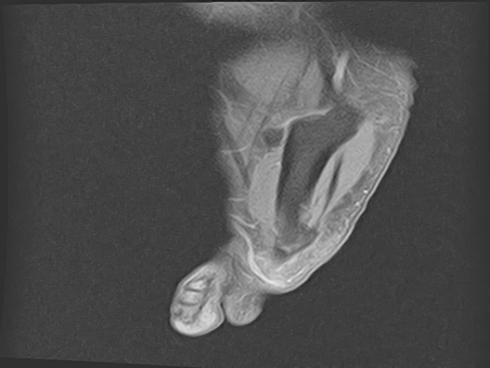  A | 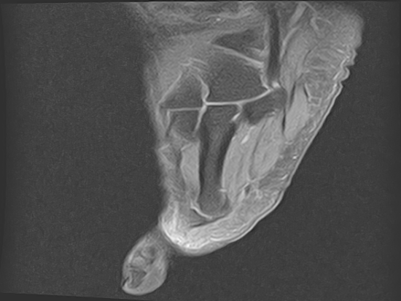  B
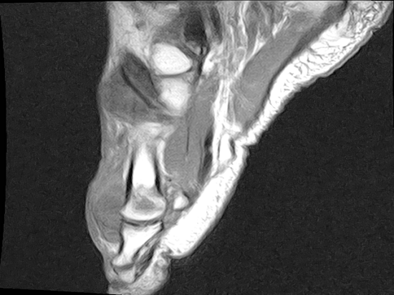  C | 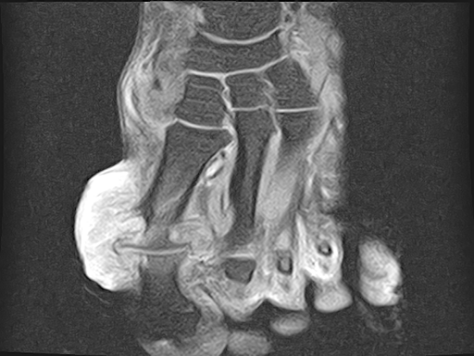  D
Figure 1. Magnetic resonance imaging (MRI) of the left foot. (A) Coronal T1-weighted fat-suppressed image showing multiple periarticular tophaceous deposits (arrows) around the first MTP joint with slightly prolonged T1 signal. (B) Sagittal T1-weighted fat-suppressed image demonstrating tophaceous deposits along the dorsal aspect of the first MTP joint. (C) Axial T2-weighted image revealing minimal joint effusion (arrowhead). (D) Coronal T2-weighted image showing preserved joint alignment with minimal periarticular soft tissue changes. Findings are consistent with gouty arthritis and multiple tophi.

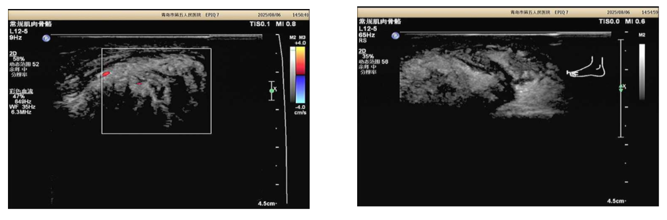
Figure 2. Ultrasonography of the left foot. (A) Mixed echogenicity measuring approximately 8 × 2.8 cm at the first MTP joint with indistinct margins and increased Doppler vascularity. (B) Arc-shaped hyperechoic deposits on the cartilage surface (“double contour sign”), synovial thickening up to 9.5 mm with irregular projections, and multiple punctate hyperechoic foci consistent with tophaceous material.

2.4. Diagnosis
2.4.1. Western medicine diagnoses
(1) Foot skin infection;
(2) Gouty arthritis with tophi, confirmed according to the 2015 American College of Rheumatology/European League Against Rheumatism (ACR/EULAR) gout classification criteria (score: 22 points; see Table 1);
(3) Type 2 diabetes mellitus with suboptimal glycemic control.

Table 1. ACR/EULAR 2015 Gout Classification Criteria and Scoring for the Present Case
Domain | Finding | Score
Entry criterion (required) | Yes | –
Sufficient criterion: MSU crystals | Not assessed | –
Clinical domain
Pattern of joint involvement | Monoarthritis (1st MTP) | 0
Characteristics of episode | Erythema, tenderness, immobility | 5
Time course | Monoarticular, ≤14 days | 2
Tophi | Present (left 5th finger, right elbow) | 4
Laboratory domain
Serum urate | 556.40 μmol/L | 4
MSU crystal confirmation | Not aspirated | 0
Imaging domain
Double contour sign on ultrasound | Present | 4
Gout-related erosion on imaging | Not present | 0
Total score |  | 22

2.4.2. Traditional Chinese medicine diagnosis
Gout (damp-heat obstruction pattern).

2.5. Treatment course
2.5.1. Initial management
Dexamethasone was administered for 3 days for anti-inflammatory effect, with limited improvement. Given the patient’s elevated blood glucose, corticosteroids were discontinued. Wound culture revealed Staphylococcus aureus, and levofloxacin was initiated for anti-infection therapy. Glycemic control was achieved with saxagliptin/metformin plus acarbose. Loxoprofen sodium was administered for analgesia. Concurrently, traditional Chinese medicine therapy for clearing heat, resolving dampness, and promoting blood circulation was applied.

2.5.2. Targeted therapy
On August 20, 2025, firsekibart 200 mg was administered as a single subcutaneous injection to block the IL-1β inflammatory pathway.

2.5.3. Local wound care
Daily dressing changes were performed, combined with ozone intra-articular injection under local anesthesia, needle-knife lysis, and external application of recombinant bovine basic fibroblast growth factor (rb-bFGF) to promote wound repair.

2.6. Treatment outcome
Following firsekibart administration, joint pain resolved rapidly, wound exudate from the left first MTP joint ceased, and infection was controlled. At discharge, the wound had reduced to approximately 2 cm × 2 cm with a depth of 0.5 cm. Tophaceous material was progressively cleared, with no erythema or exudate, and healthy granulation tissue was evident. After discharge, the patient continued regular dressing changes, topical bovine basic fibroblast growth factor gel, glycemic control, and urate-lowering therapy.
At the 1-month follow-up, the wound showed progressive healing with a CRP of 0.95 mg/L (normal range ≤ 4 mg/L). At the 4-month follow-up, complete wound closure was achieved with no evidence of recurrence or adverse events. (Figure 3)

Figure 3. Clinical photograph of the left foot showing the tophi ulceration wound at the first MTP joint with white chalky-like exudate and surrounding erythema at presentation.

3. Discussion
Tophi and chronic gouty arthritis, although occasionally observed early in the disease course, are typically manifestations of longstanding inadequately controlled hyperuricemia. Subcutaneous tophi present as firm nodules beneath translucent skin that may drain chalky-white material, often with overlying telangiectasia, and favor characteristic locations including joints, ears, olecranon bursae, digital pads, and tendons such as the Achilles tendon ^{[4]}. Their size ranges from barely palpable to large confluent masses. Although usually painless, tophi may restrict joint mobility, cause disfigurement, and impair daily function. Patients with tophaceous gout frequently develop joint deformity and structural damage ^{[12]}.

3.1. Pathological mechanisms of non-healing tophi ulceration
Three principal factors contribute to impaired wound healing in tophi ulceration:
First, ulcerated tophi drain white viscous material composed primarily of MSU crystals, which perpetuate IL-1β-driven chronic inflammation and recurrent tissue injury ^{[12]}. Second, ulceration predisposes to secondary bacterial infection, compounding tissue necrosis ^{[13,14]}. Third, in patients with concurrent diabetes, poor glycemic control impairs microcirculation and tissue repair capacity ^{[15,16]}. These factors create a self-reinforcing cycle that conventional therapy often fails to interrupt.

3.2. IL-1β-mediated pathways in impaired wound healing
IL-1β is a central cytokine linking inflammation to impaired wound healing, particularly in the context of diabetes. Multiple pathways are involved:

3.2.1. Macrophage phenotypic dysregulation
Hyperglycemia induces sustained IL-1β expression, which maintains macrophages in a pro-inflammatory M1 phenotype and inhibits their transition to the wound-healing M2 phenotype. This disrupts the pro-inflammatory/anti-inflammatory balance, perpetuating a cycle of amplified inflammation that blocks normal wound closure ^{[17]}. Mirza et al. demonstrated that local blockade of IL-1β with neutralizing antibodies in diabetic mouse wounds promoted macrophage phenotype switching from M1 to M2, increased wound growth factor levels, and significantly improved healing ^{[17]}.

3.2.2. Inflammatory signaling and extracellular matrix disruption
IL-1β activates the p38 MAPK pathway, altering extracellular matrix (ECM) remodeling protein levels, suppressing cell proliferation and migration, and directly delaying wound closure. Concurrently, IL-1β disrupts the IL-1β/soluble IL-1 receptor antagonist (sIL-1Ra) balance, impairing the PI3K/Akt repair pathway and reducing chemokine and growth factor expression ^{[8]}. Yan et al. showed that diabetes specifically suppresses wound-induced sIL-1Ra expression, leading to an imbalanced IL-1β/sIL-1Ra ratio, delayed epithelial healing, increased apoptosis, impaired PI3K-Akt signaling, reduced neutrophil and NK cell infiltration, and defective sensory nerve reinnervation. Topical recombinant IL-1Ra (anakinra) significantly reversed these pathological changes ^{[9]}.

3.2.3. Synergistic impairment of repair pathways
A recent review by Erna et al. ^{[10]} elucidated the roles of peroxisome proliferator-activated receptor γ (PPARγ), IL-1β blockers, and transforming growth factor-β1 (TGF-β1) in diabetic wound healing. PPARγ suppresses inflammation and promotes tissue repair, but its function is compromised under diabetic conditions. Persistent IL-1β signaling delays macrophage M1-to-M2 transition, while dysregulated TGF-β1 disrupts collagen synthesis and ECM remodeling, contributing to fibrosis or delayed healing. PPARγ agonists (e.g., rosiglitazone), IL-1β blockers (e.g., anakinra, canakinumab), and TGF-β1 modulators represent promising therapeutic strategies ^{[10]}.

3.3. Firsekibart: Mechanism of Action and Clinical Implications
Four IL-1 inhibitors are currently approved globally (anakinra, rilonacept, canakinumab, and firsekibart). In China, only firsekibart is approved for the indication of acute gout flares.
As a fully humanized IL-1β monoclonal antibody, firsekibart selectively binds and neutralizes IL-1β, blocking the inflammatory cascade at its source, a mechanism fundamentally distinct from conventional agents that act on downstream inflammatory mediators. A pivotal phase III clinical trial ^{[11]} demonstrated that a single dose of firsekibart achieved rapid onset of action and reduced the risk of gout recurrence by 90% at 3 months and 87% at 6 months.
In the present case, firsekibart achieved rapid inflammatory control by precisely blocking IL-1β, suppressing the crystal-induced inflammatory storm, and reducing erythema, pain, and exudate, thereby creating a stable environment for wound repair ^{[10]}. Additionally, systemic inflammation reduction may improve insulin sensitivity, synergizing with glycemic control measures to further support granulation tissue growth and wound healing.
To our knowledge, this is the first reported case of firsekibart promoting wound healing in a gout patient with comorbid diabetes. Our patient presented with multiple adverse prognostic factors, young age, long disease duration, multiple tophi, infected ulceration, and concurrent diabetes. On the basis of conventional anti-infective, glycemic, and local wound care, a single dose of firsekibart achieved rapid inflammatory suppression, cessation of exudate, and progressive wound healing without exacerbating infection, with a favorable safety profile.
This case carries several clinical implications:
First, for complex cases of tophi ulceration with infection or diabetes, IL-1 inhibitors such as firsekibart may serve as a breakthrough therapeutic strategy.
Second, an integrated approach combining systemic targeted anti-inflammatory therapy, local wound repair, and metabolic control may optimize outcomes.
Third, firsekibart’s rapid onset, favorable tolerability, and extended half-life make it particularly suitable for patients requiring rapid and sustained inflammatory control to salvage wounds in the setting of comorbid diabetes.

3.4. Limitations
This report is limited by its single-case observational design. The findings require validation through prospective, controlled studies with larger sample sizes.

4. Conclusion
Firsekibart rapidly suppressed local inflammation at the site of tophi ulceration and promoted wound healing in a patient with gout and comorbid type 2 diabetes. The favorable efficacy and safety profile observed in this case support the consideration of firsekibart as a therapeutic option for refractory tophi ulceration. High-quality prospective controlled trials are warranted further to evaluate its clinical utility in this challenging patient population.

Disclosure statement
The authors declare no conflict of interest.

References
[1] Xiao L, Huang C, Chen W, et al., 2026, Expert Consensus on Surgical Management of Gouty Arthritis/Tophi. Chinese Journal of Traditional Medical Traumatology & Orthopedics, 34(2): 1–11.
[2] Chazova I, Zhernakova Y, Kisliak O, et al., 2019, Consensus on Patients with Hyperuricemia and High Cardiovascular Risk Treatment. Systemic Hypertension, 16(4): 8–21.
[3] Jiang J, Zhang T, Liu Y, et al., 2023, Prevalence of Diabetes in Patients with Hyperuricemia and Gout: A Systematic Review and Meta-analysis. Current Diabetes Reports, 23(6): 103–117.
[4] Pan A, Teng G, Yuan J, et al., 2016, Bidirectional Association Between Diabetes and Gout: The Singapore Chinese Health Study. Scientific Reports, 6: 25766.
[5] Chinese Burn Association, Yangtze River Delta Integrated Diabetic Foot Alliance, 2025, Practical Guideline on the Prevention and Management of Diabetic Foot in China (I). Chinese Journal of Burns and Wounds, 41(11): 1029–1049.
[6] Kim Y, Lee H, Ryu J, et al., 2018, Sarcopenia Increases the Risk for Mortality in Patients Who Undergo Amputation for Diabetic Foot. Journal of Foot and Ankle Research, 11: 32.
[7] Narang R, Dalbeth N, 2020, Pathophysiology of Gout. Seminars in Nephrology, 40(6): 550–563.
[8] Erna R, Kartasasmita A, Boesoirie S, et al., 2025, Role of PPARγ, IL-1β Blockers, and TGF-β1 in Diabetic Wound Healing. Journal of Wound Management and Research,21(2): 58–66.
[9] Xue Y, Chu T, Hu J, et al., 2025, Firsekibart Versus Compound Betamethasone in Acute Gout Patients: A Randomized Phase 3 Trial. Innovation (Camb), 6(8): 101015.
[10] Dalbeth N, Gosling A, Gaffo A, et al., 2021, Gout. Lancet, 397(10287): 1843–1855.
[11] Yoo J, 2025, Gouty Tophus Mimicking Calcific Tendinitis of the Supraspinatus: A Case Report. Journal of Orthopaedic Science Research, 6(3):1–5.
[12] Lai B, Pang Z, 2022, Sepsis Complicated with Secondary Hemophagocytic Syndrome Induced by Giant Gouty Tophi Rupture. World Journal of Clinical Cases, 10(23): 8224–8231.
[13] Chinese Diabetes Society, 2025, Chinese Guidelines for the Prevention and Treatment of Type 2 Diabetes Mellitus (2024 Edition). Chinese Journal of Diabetes Mellitus, 17(1): 16–139.
[14] Mayrovitz H, Aoki K, 2025, Microcirculation in Wound Healing. In: Tuma R, et al., Handbook of Microcirculation. Springer.
[15] Mirza R, Fang M, Ennis W, et al., 2013, Blocking Interleukin-1β Induces a Healing-Associated Wound Macrophage Phenotype and Improves Healing in Type 2 Diabetes. Diabetes, 62(7): 2579–2587.
[16] Dai J, Shen J, Chai Y, et al., 2021, IL-1β Impaired Diabetic Wound Healing by Regulating MMP-2 and MMP-9 Through the p38 Pathway. Mediators of Inflammation, 2021: 6645766.
[17] Yan C, Gao N, Sun H, et al., 2016, Targeting Imbalance Between IL-1β and IL-1 Receptor Antagonist Ameliorates Delayed Epithelium Wound Healing in Diabetic Mouse Corneas. American Journal of Pathology, 186(6): 1466–1480.

Publisher’s note
Bio-Byword Scientific Publishing remains neutral with regard to jurisdictional claims in published maps and institutional affiliations.

