The Alienation of Emotional Labor and the Reconstruction of Dual-dimensional Incentives in Rural Areas under the Long-term Care Insurance System—Qualitative Study Based on Rural Doctors in Guilin City
Wenhui Cheng¹, Peiwen Li¹, Rongxiao Feng¹, Peiying Jiang ¹, Chaoqun Liu¹, Longying Liao¹, Juncheng Fang¹, Lingmi Zhou²*, Yang Zhao¹*
¹School of Humanities and Management, Guilin Medical University, Guilin 541199, Guangxi Zhuang Autonomous Region, China
²School of Public Health, Guilin Medical University, Guilin 541199, Guangxi Zhuang Autonomous Region, China
*Corresponding authors: Yang Zhao, 10036244@qq.com; Lingmi Zhou, lm_zhou@foxmail.com

Copyright: © 2026 Author(s). This is an open-access article distributed under the terms of the Creative Commons Attribution License (CC BY 4.0), permitting distribution and reproduction in any medium, provided the original work is cited.

Abstract: As China’s long-term care insurance (LTCI) system expands into rural areas, village doctors in aging mountainous cities like Guilin will become core providers of home care. Although Guilin has not formally implemented LTCI, emotional labor is already a key variable in rural “quasi-long-term care”. This study employs an interpretative sequential mixed method: a word frequency analysis of 249 policy documents from 29 pilot cities nationwide, combined with in-depth interviews with village doctors in Guilin to simulate future LTCI scenarios. The study finds a significant policy bias toward “strong control and neglect of emotional support,” with emotional and incentive terms accounting for less than 0.1% of texts. Under administrative and social network pressures, village doctors use “quasi-kinship” strategies to compensate for care resource shortages. However, the current mechanism treats emotional labor as an unpaid obligation, leading to dignity erosion and emotional exhaustion. We propose a dual-dimensional incentive scheme (“emotional points + care difficulty coefficient”) to incorporate trust-building costs and emotional value into the payment system, shifting LTCI from “payment based on quantity” to “payment based on quality” to stabilize the rural doctor team.
Keywords: Rural doctors; Long-term care insurance; Emotional labor alienation; Dual-dimensional incentives

Online publication:

1. Introduction
With population aging and rural hollowing in China, establishing a three-level rural elderly care network has entered a practical stage ^{[1–3]}. Consequently, village doctors, as “last mile” care providers, will be systematically included in the LTCI payment system.
However, rural care fundamentally differs from urban institutional care. Based on Fei Xiaotong’s “differential order”, rural care relies heavily on emotion and trust. Guilin, a typical aging city in a karst mountainous region, exhibits these core LTCI characteristics through the “quasi-long-term care services” (disability management, home visits, end-of-life care) currently provided by village doctors. A word frequency analysis of 249 policy documents from 29 national pilot cities shows that hard indicators like “service” and “management” dominate, while “emotion” and “incentives” account for less than 0.1%, indicating a clear institutional neglect of emotional value (Figure 1). Directly transplanting this structural bias to rural areas conflicts with rural “quasi-kinship” logic.
Existing LTCI research focuses on fund sustainability, institutional design, and caregiver professionalization, but neglects the operational mechanisms and motivational restructuring of emotional labor in rural contexts ^{[4]}. Village doctors must regulate emotional expressions to meet organizational expectations, impacting their burnout and job satisfaction ^{[5–8]}. This study uses an interpretive sequential mixed approach across six villages in Guilin to reveal the alienation mechanisms and real dilemmas of village doctors’ emotional labor under LTCI expansion.


Figure 1. Word cloud for long-term care insurance policy analysis.

2. Data sources and research methods
2.1. Frequency analysis of policy texts
This study has conducted a full-sample quantitative analysis of 249 valid policy texts (Implementation Measures and supporting documents) from all 29 national pilot cities. Texts were cleaned, segmented, and analyzed using NVivo 15.0 to determine the frequency and weighted percentage of core keywords, establishing the macro policy context.

2.2. Interviewees and research field
Using a prospective simulation strategy, we selected Taiping Village and Ertang Village under Guilin’s jurisdiction to capture geographical and resource heterogeneity. Following theoretical sampling, we conducted in-depth interviews with village doctors varying in gender, age, and practicing years to capture the multiple tensions of rural LTCI expansion.

2.3. Data collection and analysis
Semi-structured interviews (average 80 minutes) explored service scenarios, emotional experiences, burnout, and incentive demands. Clinic assessment records and contract ledgers were collected for triangulation. Following constructivist grounded theory, we utilized open, axial, and selective three-level coding to model the emotional labor mechanism.

3. Data analysis
3.1. Policy text characteristics
Word frequency analysis (Table 1) confirms an administrative and standardized supply orientation in current LTCI designs, while vocabulary regarding positive incentives, providers’ subjective experiences, and rural conditions is extremely scarce, establishing a structural bias that overemphasizes material indicators over emotional value.

Table 1. Word frequency statistics of the national LTCI policy texts
Word | Length | Counts | Weighted percentage (%) | Similar words
Service | 2 | 12272 | 3.49 | Help, Assistance, Treatment,  Service, Supply
Care | 2 | 11917 | 3.41 | Care
Institution | 2 | 10354 | 2.97 | Institution
Management | 2 | 8037 | 1.93 | Handle, Manipulate, Strategy,  Process, Management,  Supervision, Transaction,  Operation, Competition,  Control, Trading, Guide,  Dominance, Guidance,  Organization
Assessment | 2 | 6784 | 1.89 | Assessment, Evaluation,  Appraisal
Long-term | 2 | 6208 | 1.78 | Long-term
Insurance | 2 | 5863 | 1.68 | Insurance
Personnel | 2 | 5053 | 1.45 | Personnel
Medical | 2 | 4209 | 1.21 | Medical
Regulation | 2 | 4855 | 1.17 | Standard, Regulation,  Specification,  Standard size, Level
Designated | 2 | 4011 | 1.15 | Designated
Work | 2 | 5210 | 1.1 | Operation, Location, Policy,  Post, Work, Function, Labor,  Trouble, Fatigue, Usage,  Industry, Operation, Profession, Responsibility
Guarantee | 2 | 3858 | 1.1 | Guarantee
Incentive | 2 | 358 | 0.07 | Stimulate, Inspire, Incentive, Move, Support
Rural | 2 | 105 | 0.03 | Rural
Extreme poverty | 2 | 91 | 0.03 | Extreme Poverty
Family affection | 2 | 66 | 0.02 | Family Affection
Psychological | 2 | 68 | 0.02 | Psychological
Special Fund | 2 | 63 | 0.02 | Special Fund
Assistance | 2 | 21 | 0.01 | Assistance
Reward | 2 | 32 | 0.01 | Reward
Emotion | 2 | 15 | 0.00 | Feel, Emotion, Mood

3.2. The operational mechanism and alienation of village doctors’ emotional labor
Based on three-level coding (Table 2), this study has constructed an emotional labor mechanism model for Guilin’s village doctors under simulated LTCI contexts (Figure 2), revealing that emotional labor has become a strained survival strategy facing serious alienation.

Table 2. Summary of village doctor interviews
Coding level | Focus content
Open coding | 1. Institutional Pressure: “Going to the countryside for follow-up visits”, “Entry into the system”, “Being subservient to others for cooperation”.  2. Economic Hardship: “Not settling accounts for six months, having to pay for medicine out of pocket”, “Sharply reduced income (monthly income of over 10,000 to 20,000 is ineffective)”, “Public health subsidies are deducted at every level”.  3. Dignity Ruin: “Being subservient to others for cooperation”, “Not even knowing if team members are male or female”, “Sitting in the office with legs crossed, thinking about tasks”.  4. Trust Barriers: “Villagers avoid and do not cooperate”, “Non-locals are not trusted”.  5. Efficacy Deprivation: “Drug use restrictions”, “Patient attrition”, “Feeling sorry for patients”.  6. Formalism: “Taking photos and uploading”, “Falsifying medical examination photos”, “Deductions in performance evaluations”.
Spindle encoding | 1. Public health formalism: Taking photos, filling out forms, and entering data into the system consume service time.  2. Double squeeze of system and personal relationships: Tension between administrative tasks (follow-up visits) and villagers’ cooperation.  3. Dignity erosion and emotional exhaustion: Forced to “humble themselves” for income and performance evaluations, leading to damage to professional self-esteem.  4. Deprivation of medical efficacy: Medication restrictions result in “a skilled cook cannot cook without rice”, leading to guilt for not being able to cure patients.  5. High cost of building trust: Outside or young village doctors need to expend extra emotional labor to break down the barriers of the “differential order” system.
Selective coding | “Institutional constraints (delayed medication or assessment or funding) → survival pressure (sharply reduced income or cash flow disruption) → alienation of emotional labor (erosion of dignity or performative cooperation) → weakened care effectiveness (patient attrition or inadequate medical care)”. In this vicious cycle, if long-term care insurance cannot provide effective emotional value returns and medical empowerment, village doctors will be unable to shoulder the heavy responsibility of future rural disability care.

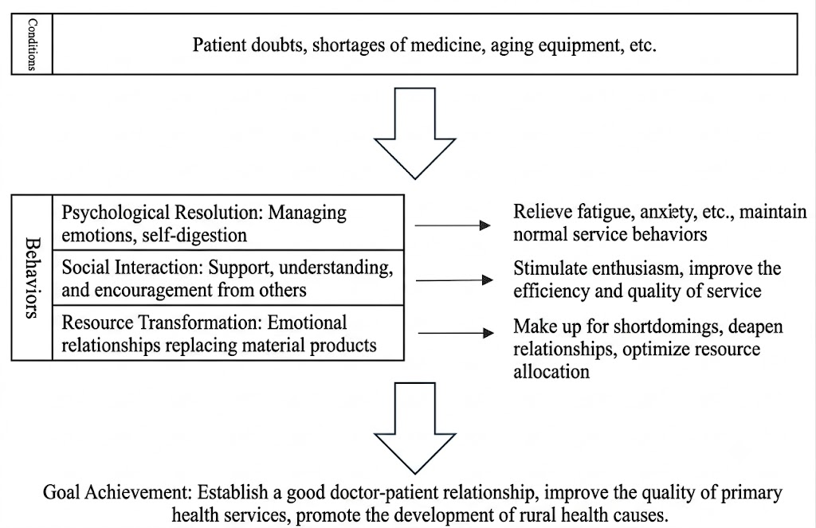
Figure 2. Mechanism model of emotional labor of rural doctors.

3.2.1. Labor alienation under institutional pressure
Open coding concepts like “rural follow-up visits” and “humbly seeking cooperation” reveal severe dual pressures. The current public health system enforces digital formalism (“taking photos and uploading”), prioritizing documentation over care effectiveness. As Doc1 stated, to meet performance targets, doctors must “humbly” beg for villagers’ cooperation, creating a stark contrast between rigid data management and field realities. Furthermore, terminal isolation—such as “not knowing upper-level team members” (Doc1)—distorts sincere “quasi-kinship” care into a submissive “performative labor”, severely eroding professional dignity.

3.2.2. Efficacy deprivation caused by resource scarcity and cash flow disruption
Coding exposed a grim reality of drug use restrictions and delayed funding. Under zero-markup policies, village doctors face sharp income reductions. Delayed public health allocations create a cash flow crisis where doctors “subsidize drug purchases out of pocket for six months” (Doc1). This intertwining of medical efficacy deprivation and economic anxiety undermines professional fulfillment. When resource limitations prevent effective treatment, doctors suffer from self-blame and emotional exhaustion (Doc2).

3.2.3. The hidden costs and vicious cycle of building trust in rural areas
In Guilin’s karst mountainous regions, village doctors must expend high emotional labor to navigate the trust barriers of the “differential order”, especially if they are young or non-local. When this emotional investment lacks institutional compensation and medical efficacy remains low, a vicious cycle emerges: administrative tasks encroach on service time → emotional labor distorts into performative cooperation → dignity erosion and exhaustion occur → care efficacy weakens, leading to patient attrition.

4. Discussion
A profound tension exists between the “rigid” characteristics of national LTCI policies (high management, low emotion) and the “flexible” governance (high emotion, quasi-kinship) required in rural Guilin. To prevent institutional stagnation and a “last-mile” disconnect during rural LTCI expansion, we propose five reconstruction paths:

4.1. Constructing an “emotional points” system
Quantify soft indicators, such as improvements in patients’ emotional states and family satisfaction with psychological support and link them directly to economic returns to restore professional dignity.

4.2. Restoring medical efficacy
Grant village doctors greater clinical discretion in medication use for common complications in disabled elderly individuals, allowing the use of essential special drugs after proper registration.

4.3. Implementing differentiated difficulty coefficients
Introduce a “care difficulty coefficient” to provide targeted subsidies to caregivers facing high trust-building costs due to identity or complex geographical locations.

4.4. Establishing instant settlement channels
Separate LTCI service fees from traditional public health fund allocations. Implement monthly settlements and temporary drug cost advance mechanisms to protect clinic cash flow.

4.5. Stripping away administrative formalism
Decouple LTCI service assessments from complex public health indicators, reducing excessive reliance on trace management and photo uploads to maximize direct care time.

5. Conclusion
Through mixed-method analysis, this study reveals an inherent flaw in current LTCI frameworks: overemphasizing material administration while neglecting the emotional labor that serves as the implicit capital of rural care systems. The proposed “emotional points + care difficulty coefficient” incentive mechanism fills the institutional gap in quantifying emotional value, providing a pre-adaptive design reference for expanding LTCI coverage in Guilin and western rural China.

Funding
2026 Guangxi Social Sciences Think Tank General Project (“Summary of Guangxi Long-Term Care Insurance Pilot Experience and System Optimization Research” (Project No.: zkybkt2026073); 2023 Undergraduate Innovation Training Project “Retaining People with ‘Affection’: A Study on the Emotional Labor of Rural Family Doctors” (Project No.: S20231061183)

Disclosure statement
The authors declare no conflict of interest.

References
[1] Ministry of Civil Affairs of the People’s Republic of China, 2025, Reply to Proposal No. 5173 of the Third Session of the 14th National People’s Congress.
[2] The State Council Information Office of the People’s Republic of China, 2025, The Three-Tiered Elderly Care Service Network at the County, Township, and Village Levels Will Be Basically Completed by 2029 and Further Improved by 2035—Steady Safeguard for Older People’s Needs for Elderly Care Services. People’s Daily.
[3] Shandong Provincial Medical Security Bureau, 2026, Reply to Proposal No. 13040652 of the Fourth Session of the 13th Shandong Provincial Committee of the Chinese People’s Political Consultative Conference: On Addressing the Shortcomings in Rural Elderly Care Services.
[4] Su Y, 2022, Professional Emotional Labor from the Perspective of Jurisdiction. Chinese Social Science Evaluation, 2022(3).
[5] Hochschild A, 1983, The Managed Heart: Commercialization of Human Feeling, University of California Press.
[6] Wang A, Tang C, Zhou L, et al., 2023, How Surface Acting Affects Turnover Intention Among Family Doctors in Rural China: The Mediating Role of Emotional Exhaustion and the Moderating Role of Occupational Commitment. Human Resources for Health, 21(1): 3.
[7] Gu L, Tian B, Xin Y, et al., 2022, Patient Perception of Doctor Communication Skills and Patient Trust in Rural Primary Health Care: The Mediating Role of Health Service Quality. BMC Primary Care, 23(1): 255.
[8] Chen W, Feng Y, Fang J, et al., 2020, Effect of Trust in Primary Care Physicians on Patient Satisfaction: A Cross-Sectional Study Among Patients with Hypertension in Rural China. BMC Family Practice, 21(1): 196.

Publisher’s note
Bio-Byword Scientific Publishing remains neutral with regard to jurisdictional claims in published maps and institutional affiliations.

