One Case of Undifferentiated Embryonal Tumor of Adult Liver
Dingfeng Liu, Chao Jiang, Xiaohui Wang
The First Affiliated Hospital of Hunan Normal University (Hunan Provincial People’s Hospital), Changsha 415005, Hunan, China

Copyright: © 2026 Author(s). This is an open-access article distributed under the terms of the Creative Commons Attribution License (CC BY 4.0), permitting distribution and reproduction in any medium, provided the original work is cited.

Abstract: Undifferentiated embryonal sarcoma of the liver (UESL) is rare in adults, and its clinical manifestations, laboratory tests, and imaging findings lack specificity. Diagnosis relies on pathological diagnosis. This article reports a 55-year-old male patient with UESL who was admitted to the hospital due to right upper abdominal pain for 3 months. He had no history of chronic hepatitis or cirrhosis, and the tumor marker was only elevated CA-125. CT showed a huge cystic solid exogenous mass in the right lobe of the liver. The patient underwent right hemihepatectomy due to tumor rupture and bleeding. Postoperative pathology confirmed UESL, and genetic testing revealed FGFR2 amplification and TP53 mutation. This disease needs to be differentiated from hepatocellular carcinoma and liver abscess. Surgical resection is the preferred treatment, and postoperative combined chemotherapy can effectively improve prognosis.
Keywords: Adult undifferentiated embryonal liver tumors; Case report; Hepatic cystic solid mass

Online publication:

1. Introduction
Undifferentiated embryonal sarcoma of the liver (UESL) is the third most common liver malignancy in children, accounting for approximately 9–15% of liver tumors in children and extremely rare in adults. According to literature records, there were fewer than 90 cases of undifferentiated embryonal sarcoma of the adult liver reported globally between 1973 and 2019 ^{[1,2]}. The clinical manifestations, laboratory tests, and imaging examinations of UESL do not have specificity, and pathological examination is necessary for a definitive diagnosis ^{[3,4]}. Currently, surgical resection is the most effective treatment method, and postoperative combination chemotherapy or adjuvant therapy can significantly prolong the survival of patients ^{[5,6]}. This study reports a confirmed adult patient with UESL and summarizes the relevant clinical data and differentiation points as follows.

2. Case data
The patient is a 55-year-old male who was hospitalized for “right upper abdominal pain for over 3 months”. His clinical manifestation is paroxysmal upper right abdominal distension and pain, without symptoms such as fever, chills, jaundice, nausea, and vomiting; Physical examination revealed deep tenderness in the upper right abdomen, with an enlarged liver palpable below the xiphoid process. There was percussion pain in the liver area, but no other positive signs were observed. The laboratory test results showed that hemoglobin was 89 g/L, albumin was 31.20 g/L, globulin was 17.30 g/L, and carbohydrate antigen was 187.12 U/ml. The levels of aspartate aminotransferase, alanine aminotransferase, bilirubin, and other tumor markers were normal (See Table 1). Enhanced CT scan of the upper abdomen shows a huge exogenous, multilocular cystic solid mixed density mass in the right lobe of the liver (see Figure 1). In order to clarify the diagnosis, liver biopsy was performed, and the pathological diagnosis was considered “malignant spindle cell mesenchymal tumor”. Due to tumor rupture and bleeding, an open right hemihepatectomy was performed. During the operation, a soft and tofu-like mass with a diameter of approximately 25cm was observed to adhere to the diaphragm (see Figure 2). Postoperative routine pathological examination combined with immunohistochemistry confirmed the diagnosis of undifferentiated embryonal sarcoma of the liver (Figure 3 and Figure 4). After postoperative genetic testing, FGFR2 amplification and TP53 mutation were found. Based on the results of the genetic testing, the next step of treatment was carried out. (See Figure 5).

Table 1. Laboratory tests
Inspection items | Case 1
Hb, g/L | 89
WBC, 10⁹/L | 4.20
PLT, 10⁹/L | 309
AST, U/L | 15.5
ALT, U/L | 23.7
GGT, U/L | 47.7
TBIL, umol/L | 13.11
ALB, g/L | 31.20
PT, s | 11
CRE, umol/L | 59.7
CEA, ng/ml | 1.88
AFP, ng/ml | 3.74
CA-199, u/ml | 2.79
CA-125,u/ml | 187.12
HCV Antibody | Negative
HBsAg | Negative

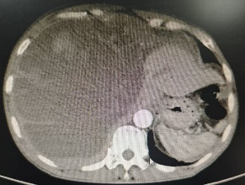
Figure 1. CT shows a huge cystic solid mass in the right lobe of the liver.

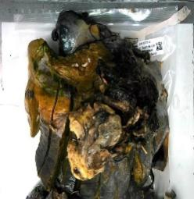
Figure 2. Surgical resection of tumor specimen.


Figure 3. HE staining shows visible mitosis, with tumor giant cells visible.

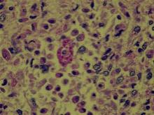
Figure 4. Special Stained PAS (+) and D-PAD (+).

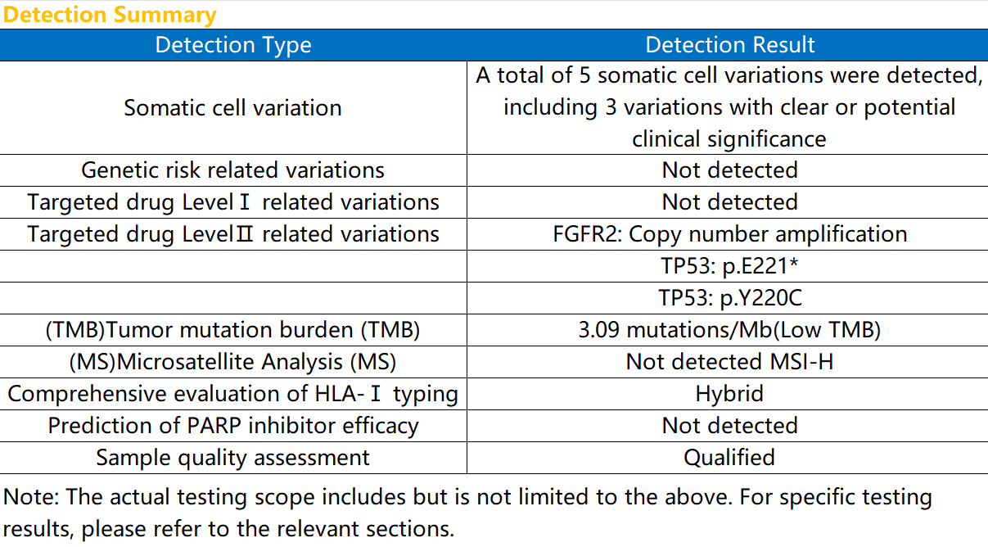

Figure 5. Genetic testing results.

3. Discussion
The clinical manifestations of UESL are atypical, often manifested as abdominal pain, fatigue, nausea, vomiting, weight loss, etc; Tumor markers (AFP, CA199, CEA, etc.) are usually negative ^{[7]}; Ultrasound often presents as a large solid echo accompanied by many small, irregular hypoechoes ^{[8]}. CT often presents as a large cystic-solid mass in the liver, with clear boundaries, uneven density, and internal septa ^{[9]}. Histologically, UESL shows solid/irregular tumor structures. The high cell size, necrosis, high mitotic index, frequent atypical mitosis, and apoptotic bodies of highly polymorphic tumor cells are important microscopic features of this tumor. Cytologically, UESL is rich in spindle-shaped or star-shaped cells, with blurred boundaries and inconspicuous nucleoli. Multinucleated giant cells, abnormal cell nuclei, and eosinophilic transparent spheres are important diagnostic clues for UESL. Immunohistochemical studies do not have specificity for the histogenesis of UESL; There are currently no individual biomarkers that can diagnose this cancer ^{[10]}. UESL needs to be differentiated from hepatocellular carcinoma ^{[11]}. Typical hepatocellular carcinoma is more common in high-risk populations with a history of hepatitis and cirrhosis. Clinical manifestations include liver pain, nausea and vomiting, fatigue, weight loss, etc. Tumor markers such as alpha-fetoprotein and abnormal prothrombin are usually elevated, and enhanced CT or MRI often show a “fast in, fast out” characteristic ^{[12]}. This case has no history of hepatitis or cirrhosis, and its clinical manifestations are similar to hepatocellular carcinoma. The tumor marker CA125 is elevated, AFP and abnormal prothrombin are normal, and the imaging manifestation is an exogenous, multilocular cystic solid mixed density mass, which is different from typical hepatocellular carcinoma. Although UESL is common in children with liver malignancies and does not have typical clinical features, for adult patients with negative indicators of hepatitis and cirrhosis, normal AFP tumor markers, and no relevant medical history, in the case of positive immune markers, imaging examination reveals a huge cystic solid mass in the liver with multiple septa, with or without bleeding foci, and dynamic enhancement of the cyst wall, septa, and solid parts showing gradual delayed enhancement. When considering conventional liver malignancies, the possibility of rare adult UESL should not be ruled out ^{[13]}.
UESL should be differentiated from liver abscesses ^{[14]}. Liver abscesses often have a history of diabetes. The clinical manifestations are right upper abdominal pain with fever and chills, and the liver area percussion pain is positive; Laboratory tests showed elevated white blood cells and CRP levels, as well as abnormal liver function; On CT, it often appears as a circular low-density lesion with unclear boundaries. During enhancement, there may be enhancement of the lesion’s internal septum and small abscess walls, and there may be patchy weak enhancement areas around the abscess walls. In this case, there were no obvious systemic inflammatory manifestations such as fever and chills. White blood cells and CRP were not high, transaminase and bilirubin were not high, and CT findings were significantly different from abscesses.
Surgical resection is the main treatment for UESL, and postoperative combined adjuvant chemotherapy can significantly improve median survival ^{[15,16]}. For unresectable, refractory, and recurrent UESL, liver transplantation is an effective and safe alternative treatment option ^{[13,16]}. Although the survival rate and duration of patients with UESL have been low and short in the past, with the continuous improvement of modern multimodal treatment methods, the 5-year overall survival rate of some UESL patients is higher than 70%, and some patients can even be cured ^{[17]}. Therefore, accurately distinguishing UESL from other liver malignancies is of great significance for clinical decision-making and patient survival prognosis.

4. Conclusion
The clinical incidence rate of UESL is extremely low, and its clinical manifestations, imaging, and tumor markers lack typical characteristics, which can easily be misdiagnosed as other liver space-occupying lesions. For liver cystic solid masses with no history of hepatitis, normal AFP, but elevated CA125, caution should be taken against this disease. The core treatment plan for complete surgical resection, combined with personalized comprehensive interventions such as chemotherapy and targeted therapy based on genetic testing results, can effectively improve the long-term survival of patients.

Disclosure statement
The authors declare no conflict of interest.

References
[1] Pu T, Chen J, Guo Q, et al., 2021, Surgical Diagnosis and Treatment of Adult Huge Undifferentiated Embryonal Sarcoma of the Liver. Zhonghua Wai Ke Za Zhi, 59: 848–853.
[2] Gerson G, Valença J, Cavalcante J, et al., 2019, Undifferentiated Embryonal Sarcoma of the Liver in Elderly: Case Report and Review of the Literature. Indian Journal of Pathology and Microbiology, 62: 129–131.
[3] Zhang C, Jia C, Xu C, et al., 2020, Undifferentiated Embryonal Sarcoma of the Liver: Clinical Characteristics and Outcomes. World Journal of Clinical Cases, 8: 4763–4767.
[4] Putra J, Ornvold K, 2015, Undifferentiated Embryonal Sarcoma of the Liver: A Concise Review. Archives of Pathology & Laboratory Medicine, 139(2): 269–273.
[5] Ziogas I, Zamora I, Lovvorn H, et al., 2021, Undifferentiated Embryonal Sarcoma of the Liver in Children Versus Adults: A National Cancer Database Analysis. Cancers (Basel), 13(12): 2918.
[6] Cao W, Qiu B, 2012, A Case of Undifferentiated Embryonal Sarcoma of the Adult Liver and Literature Analysis. Chinese Journal of Clinical Physicians (Electronic Edition), 6(17): 5360–5361.
[7] Wu M, Yu K, Shu J, 2020, One Case of Undifferentiated Embryonal Sarcoma of the Adult Liver. Chinese Journal of Modern Medicine, 22(12): 80–81.
[8] Xu X, Luo B, 2013, Ultrasound Findings of Undifferentiated Embryonal Sarcoma in Adult Liver: A Case Report. Chinese Medical Imaging Technology, 29(8): 1408.
[9] Qiu G, Liao W, Wen Z, et al., 2021, Imaging Manifestations of Undifferentiated Embryonal Sarcoma in Adult Liver. CT Theory and Applications, 30: 114–123.
[10] Martins-Filho S, Putra J, 2020, Hepatic Mesenchymal Hamartoma and Undifferentiated Embryonal Sarcoma of the Liver: A Pathologic Review. Hepatic Oncology, 7(2): Hep19.
[11] Liu S, Yang Y, Li B, 2025, Misdiagnosed as Hepatocellular Carcinoma in One Case of Undifferentiated Embryonal Sarcoma of the Adult Liver. Chinese Journal of CT and MRI, 23(9): 209–211.
[12] Department of Medical Administration, National Health Commission of the People's Republic of China, 2024, Diagnosis and Treatment Guidelines for Primary Liver Cancer (2024 Edition). Liver Cancer Electronic Journal, 11: 1–26.
[13] Lin W, Wu K, Chen C, et al., 2024, Treatment of Undifferentiated Embryonal Sarcoma of the Liver in Children. Cancers (Basel), 16(5): 897.
[14] Lou J, Li G, Lv J, et al., 2026, One Case of Undifferentiated Embryonal Sarcoma of the Liver Misdiagnosed as Liver Abscess and Literature Review. Chinese Journal of CT and MRI, 24: 199–201.
[15] Lenze F, Birkfellner T, Lenz P, et al., 2008, Undifferentiated Embryonal Sarcoma of the Liver in Adults. Cancer, 112: 2274–2282.
[16] Wu Z, Wei Y, Cai Z, et al., 2020, Long-Term Survival Outcomes of Undifferentiated Embryonal Sarcoma of the Liver: A Pooled Analysis of 308 Patients. ANZ Journal of Surgery, 90: 1615–1620.
[17] Capozza M, Ruggiero A, Maurizi P, et al., 2019, Undifferentiated Embryonal Sarcoma of the Liver (UESL) in Adolescents: An Unexpected Diagnosis. Journal of Pediatric Hematology/Oncology, 41: e132–e134.

Publisher’s note
Bio-Byword Scientific Publishing remains neutral with regard to jurisdictional claims in published maps and institutional affiliations

