Bibliometric Analysis of the Effect of Orofacial Myofunctional Training on Postoperative Mouth Breathing in Children with OSA
Weini Hu¹*, Huali Li¹, Shaohua Li¹, Yiming Yuan²
¹Department of Nursing, Zhongshan Hospital of Traditional Chinese Medicine, Zhongshan 528401, Guangdong, China
²Department of Pharmacy, Zhongshan Hospital of Traditional Chinese Medicine, Zhongshan 528401, Guangdong, China
*Corresponding author: Weini Hu, 260765304@qq.com

Copyright: © 2026 Author(s). This is an open-access article distributed under the terms of the Creative Commons Attribution License (CC BY 4.0), permitting distribution and reproduction in any medium, provided the original work is cited.

Abstract: Objective: To conduct a bibliometric and visualized analysis on studies related to the application of orofacial myofunctional therapy (OMT) in the context of improving habitual mouth breathing after adenotonsillectomy in children with obstructive sleep apnea (OSA). This analysis will be done using the BERTopic method. Methods: From the China National Knowledge Infrastructure (CNKI) database, we searched for relevant articles. These articles were used as the study objects. The Sentence-BERT model was employed for text encoding, and then dimensionality reduction was done using UMAP, and clustering was done with HDBSCAN. Topic keywords were extracted via class-based term frequency-inverse document frequency (c-TF-IDF). Then, thematic structure was analyzed with intertopic distance maps, similarity heatmaps, document distribution maps, and hierarchical clustering maps. BERTopic is a topic modeling technique that employs transformer embeddings and c-TF-IDF to derive interpretable topics from text data. Results: The related studies mainly have two research lines. The first was a diagnostic and therapeutic line focusing on sleep-disordered breathing, perioperative management, and minimally invasive techniques. The second one was a functional rehabilitation line focused on OMT, orofacial functional assessment, and morphological and functional improvement. Current studies mainly focus on adenotonsillectomy and technical optimization, but OMT is an adjunctive intervention, which has a certain research basis for improving postoperative mouth breathing, sleep quality, and orofacial function in children with OSA. Conclusion: OMT holds potential clinical value as an essential adjunctive approach for enhancing postoperative habitual mouth breathing and promoting orofacial functional reconstruction. Future studies need to further evaluate its long-term efficacy and standardized application to promote an integrated diagnostic and therapeutic model of “surgical treatment plus functional rehabilitation”.
Keywords: BERTopic; Orofacial myofunctional therapy; Obstructive sleep apnea; Pediatric adenotonsillectomy; Habitual mouth breathing; Bibliometric analysis

Online publication:

1. Introduction
Pediatric obstructive sleep apnea (OSA) is a common sleep-disordered breathing disease, which can trigger intermittent hypoxia, sleep architecture disturbance, and abnormal ventilation function, and exert adverse impacts on children’s growth and development, cognitive behavior, and quality of life ^{[1]}. Hypertrophy of adenoids and tonsils is a key anatomical basis for pediatric OSA, and adenoid and/or tonsillectomy remains an important therapeutic measure for moderate to severe pediatric OSA ^{[2,3]}. Nevertheless, some children still suffer from residual OSA, habitual mouth breathing, and imbalance of orofacial myofunctional function after surgery. With the continuous advancement of minimally invasive technologies such as low-temperature plasma, an increasing number of studies have focused on surgical procedure optimization, perioperative management and complication control, which have improved the surgical treatment system for pediatric OSA.
Orofacial myofunctional therapy (OMT) is a rehabilitation method targeting the functions of the lip, tongue, cheek, soft palate, and related orofacial muscle groups. It can correct tongue position, lip closure ability, nasal breathing habits and swallowing patterns, thereby promoting the reconstruction of orofacial function ^{[4,5]}. Existing studies have indicated that OMT can be used as an auxiliary intervention for pediatric OSA, with potential benefits in elevating sleep quality, improving life quality, enhancing upper airway function, and correcting mouth breathing habits ^{[6,7]}. Therefore, systematically sorting out the research status of OMT in postoperative rehabilitation of children with OSA is of great significance for optimizing postoperative management.
In recent years, natural language processing methods represented by BERTopic have provided new technical approaches for bibliometric analysis of medical literature. Integrating transformer semantic embedding, cluster analysis, and c-TF-IDF keyword extraction, BERTopic can generate interpretable text topics, which are applicable to visual analysis of research hotspots and knowledge structures ^{[8–10]}. In this study, the BERTopic topic model was adopted to mine topics from literature concerning the application of OMT in improving habitual mouth breathing after adenotonsillectomy in children, aiming to clarify research hotspots, thematic structures, and potential deficiencies in this field, and offer references for constructing a comprehensive intervention model of “surgical radical resection plus functional rehabilitation”.

2. Research methods

2.1. Research process
This study adopted a systematic text mining method, and the whole process included the following key steps: raw literature collection, text preprocessing, semantic vector encoding, dimensionality reduction, unsupervised cluster analysis, and thematic feature extraction. Particularly, considering the unique characteristics of medical literature, a professional retrieval strategy was formulated to guarantee data quality.

2.2. Literature retrieval strategy
(“orofacial myofunctional training” OR “oral muscle training” OR “oral myofunctional therapy” OR “orofacial muscle training”) ^{[11–18]}
AND (“obstructive sleep apnea” OR “OSA” OR “sleep-disordered breathing”)
AND (“children” OR “pediatrics”)
AND (“adenoidectomy” OR “tonsillectomy” OR “adenotonsillectomy” OR “AT surgery”)
AND (“mouth breathing” OR “habitual mouth breathing” OR “mouth breathing habit”)
A total of 707 articles were retrieved from the CNKI database and included in this study by adopting combined professional medical retrieval formulas.

2.3. Semantic vector generation: Text representation based on sentence-BERT
To obtain deep semantic features of texts, the Sentence-BERT (SBERT) model was used for text encoding in this study. As an improved version of the BERT architecture optimized specifically for sentence-level semantic representation, this model can generate 768-dimensional semantic embedding vectors. Compared with traditional word vector methods, SBERT can more effectively capture contextual semantic information of texts.

2.4. Dimensionality reduction: Nonlinear dimensionality reduction via UMAP algorithm
To address the challenges of visualization and computational efficiency in high-dimensional semantic space, the Uniform Manifold Approximation and Projection (UMAP) algorithm was applied for nonlinear dimensionality reduction. Based on manifold learning theory, this algorithm can reduce 768-dimensional semantic vectors to a 5–10-dimensional space suitable for subsequent cluster analysis without altering the topological structure of the original high-dimensional space, greatly improving processing efficiency.

2.5. Thematic clustering: Density-adaptive clustering via HDBSCAN
In the dimensionality-reduced semantic space, the Hierarchical Density-Based Spatial Clustering (HDBSCAN) algorithm was used for unsupervised clustering. Based on hierarchical density clustering theory, this method has the following advantages:
(1) It can automatically determine the optimal number of clusters;
(2) It can effectively identify clusters with different densities;
(3) It can process noisy data. These features make it particularly suitable for text topic discovery tasks.

2.6. Thematic characterization: c-TF-IDF keyword extraction algorithm
To construct interpretable representations of topics, the class-based TF-IDF (c-TF-IDF) algorithm was adopted to extract thematic keywords. This method improves upon traditional TF-IDF in the following aspects:
(1) It takes documents within each class as the calculation unit;
(2) It fully considers the distribution of documents across different classes;
(3) It improves cross-class comparability through normalization. The final output keyword sets can well reflect the core semantic features of each topic.

3. Analysis results

3.1. Topic distribution
Three key topics were selected in this study, which correspond to different clinical decision-making stages and together form a complete logical chain ranging from pathological characterization to therapeutic intervention (See Figure 1).

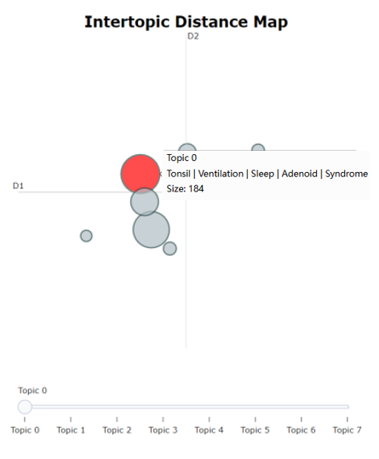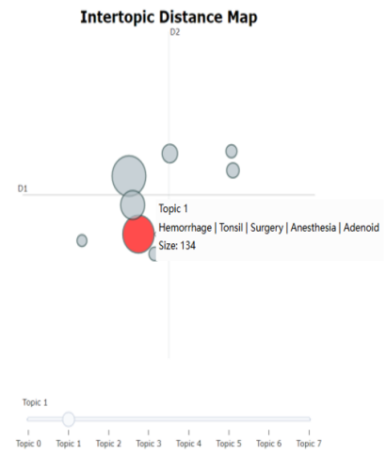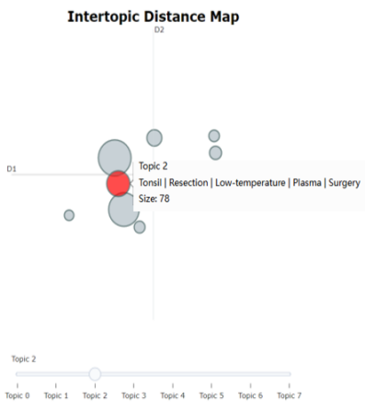
Figure 1. Intertopic distance map.

3.1.1. Topic 0: Clinical manifestations of sleep-disordered breathing (fundamental basis)

This topic node has a size of 154 and is located on the left side of the core cluster, indicating that the background of the corpus is represented by this node. High-frequency keywords (“tonsil”, “ventilation”, “sleep”, “syndrome”) reveal that academic discussions mainly revolve around the pathological manifestations of pediatric obstructive sleep apnea hypopnea syndrome (OSAHS) and the ventilatory dysfunction it induces, forming the logical starting point for subsequent therapeutic research.

3.1.2. Topic 1: Perioperative management and surgical intervention (treatment path)

This topic (Size: 134) is closely adjacent to Topic 0 in the semantic space. Its keywords (“bleeding”, “surgery”, “anesthesia”) show that the research focus transitions from disease diagnosis to surgical treatment and perioperative risk management naturally. This spatial adjacency indicates that adenotonsillectomy (T&A) and the control of its complications are key concerns in this field.

3.1.3. Topic 2: Application and optimization of minimally invasive techniques (in-depth research)

As a detailed branch of Topic 1 (Size: 78), this topic focuses on the highly aggregated keywords “resection”, “low temperature” and “plasma”. It demonstrates that this cluster specifically explores the concrete application of low-temperature plasma ablation technology in surgery, reflecting the shift from macroscopic therapeutic schemes to microscopic operational technical optimization.

Spatially, the three topics form a linear evolutionary chain of Topic 0 → Topic 1 → Topic 2 (See Figure 1). This layout objectively reveals the research context of “symptom diagnosis – surgical intervention – technical refinement” in this field, and also reflects the academic orientation that scholars have been committed to improving children’s postoperative quality of life through minimally invasive technologies after establishing clinical diagnostic criteria for OSAHS.

3.2. Similarity heatmap
To further quantify the strength of semantic correlation between different topics, a topic similarity matrix was constructed (Similarity Matrix, see Figure 2). The color depth in the matrix reflects the overlap degree of c-TF-IDF features between topics; the closer the color is to dark blue, the higher the similarity of vocabulary distribution between the two topics and the tighter their semantic connection.

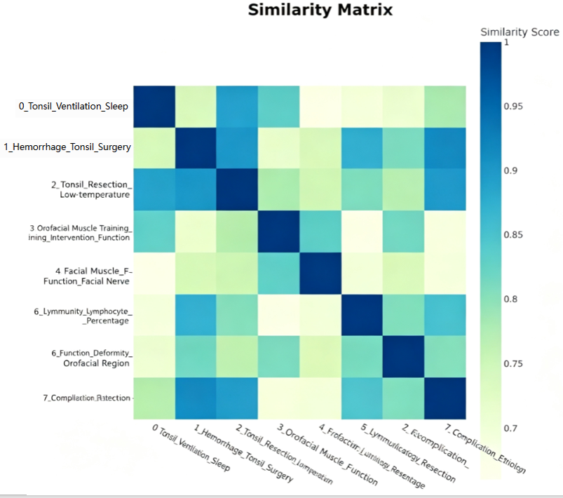
Figure 2. Topic heatmap.

The similarity matrix intuitively verifies the clinical logical chain shown by the spatial layout above. Topic 0 (sleep-disordered breathing), Topic 1 (perioperative management), and Topic 2 (minimally invasive techniques) achieve extremely high similarity scores, with dark blue cells in the matrix (similarity > 0.90).
The internal logic reflects a strong coupling relationship among “disease manifestations–treatment–technology”. Although they differ in spatial distribution and thus present separation, at the underlying semantic level, discussions on the diagnostic description of adenotonsillar hypertrophy are closely linked to therapeutic means such as surgical resection and low-temperature plasma, jointly forming the core discourse system of this field.
Topic 4 (orofacial muscle function) and Topic 6 (function/deformity) show relatively high similarity (light blue area), which conforms to clinical medical logic: the assessment of orofacial muscle function is often associated with the diagnosis of facial developmental deformities, jointly constructing a functional evaluation system covering pre-operation and post-operation. Topic 7 (complications) and Topic 1 (surgery) have high similarity, indicating that discussions on complications mainly center on surgical procedures and serve as a natural extension of surgical risk assessment. In this matrix, Topic 5 (immune indicators) is relatively independent (light color), which suggests that discussions on immunological indicators such as lymphocyte percentage are highly specialized and weakly connected with conventional clinical surgical narratives.

3.3. Document visualization
The UMAP dimensionality reduction algorithm was used to analyze the semantic attribution of individual documents in the corpus and explore micro differences among topics, based on which a document scatter distribution map was drawn (Documents and Topics, Figure 3).

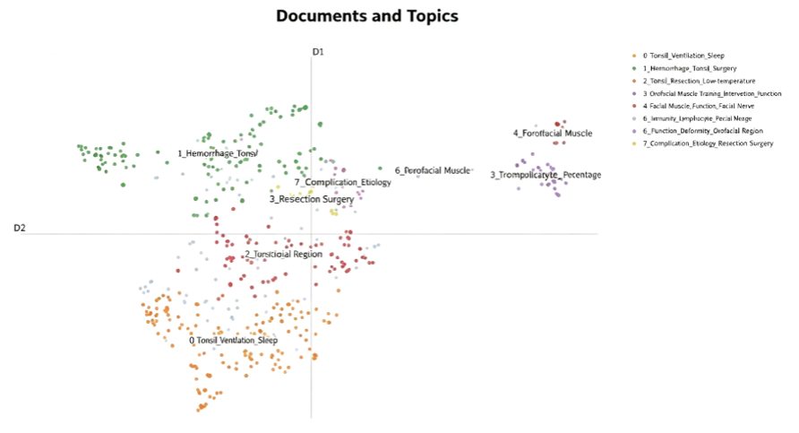
Figure 3. Document and topic distribution map.

Each point on the map projects high-dimensional text vectors onto a two-dimensional plane, representing an independent literature or text fragment, and the color of each point corresponds to its affiliated topic category.
Orange nodes (Topic 0), green nodes (Topic 1), and red nodes (Topic 2) in the lower left quadrant are densely distributed, forming an obvious “core semantic cluster”. This phenomenon indicates that the core focus of current bibliometric research is highly concentrated on adenotonsillar hypertrophy and its surgical treatment.
Topic 0 (sleep-disordered breathing) presents an extensive underlying distribution, while Topic 1 (perioperative management) and Topic 2 (minimally invasive techniques) are closely connected. This spatial overlap confirms the integrated characteristic of “diagnosis-surgery” in clinical practice: discussions on surgical complications (Topic 1) and technical details (Topic 2) are all associated with the basic pathological diagnosis (Topic 0).Independence of Orofacial Myofunctional Training (Topic 3): The purple nodes representing Topic 3 (orofacial myofunctional training) in the upper right quadrant show obvious outlier characteristics, with a large spatial distance from the core surgical cluster in the lower left corner.
Marginal distribution of functional assessment and complications: Topics 4, 5, 6 and 7 are distributed in marginal areas.

3.4. Keyword extraction
Keywords with the highest c-TF-IDF weights under each topic were extracted (See Figure 4). The weight of word frequency directly indicates the salience of the vocabulary in the document set of a specific topic, as well as the hidden semantic focus.
Core Pathology and Surgical Topics (Topic 0, 1, 2): The foundation of clinical treatment. The keywords of these three topics highly overlap with basic medical terms such as “tonsil”, “adenoid” and “surgery”, constituting the absolute core of the literature corpus.
Functional Training and Rehabilitation Topics (Topic 3, 4): Exploration of non-surgical interventions. The keywords of these two topics differ greatly from the first three, with distinct “function-oriented” characteristics.
Chapters 5 and 7 elaborate on complications and their mechanisms, respectively: Chapter 5 focuses on morphological aspects, while Chapter 7 centers on upper airway function assessment.

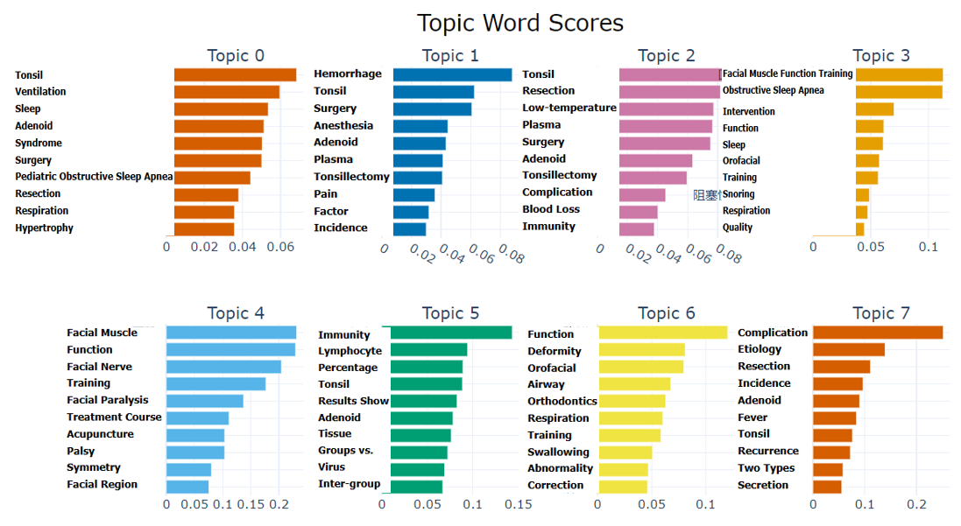
Figure 4. Topic word scores.

3.5. Hierarchical structure
An agglomerative hierarchical clustering algorithm was adopted to construct a topic dendrogram (See Figure 5). The vertical axis (Y-axis) of the dendrogram measures the semantic distance when different topic clusters merge; the longer the horizontal line, the greater the difference in underlying vocabulary distribution between the two topics, and vice versa.

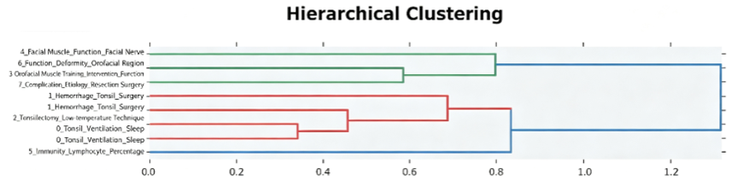

Figure 5. Hierarchical clustering dendrogram.

The most critical bifurcation at the top of the tree divides the 8 topics into two major academic camps:

Red Camp (Surgery and Pathology Main Line): Including Topics 0, 1, 2, 5, 7. It covers all surgical-related discussions starting from “adenotonsillar hypertrophy”, extending to “surgical operation”, “complications,” and “immune mechanisms”. This indicates that the main framework of current literature is constructed based on the classic clinical medical logic of “disease – surgery – outcome”.

Blue Camp (Function and Rehabilitation Main Line): Including Topics 3, 4, 6. It consists of rehabilitation medical discussions centered on “orofacial myofunctional function”. This division intuitively demonstrates that the traditional surgical path of otorhinolaryngology and the emerging functional rehabilitation training path remain two relatively independent systems in academic classification.

Further refinement of the clustering structure within the Red Camp shows an obvious progressive hierarchical relationship:

Surgical Implementation Layer (Topic 1 and Topic 2): These two topics merge at the bottom (distance = 0.35), the shortest distance among all topics. This proves that “perioperative management” (Topic 1) and “application of minimally invasive techniques” (Topic 2) are regarded as highly integrated concepts in academic contexts, jointly forming the specific implementation layer of surgical intervention.

Clinical Pathological Layer (Topic 0): At a distance of approximately 0.65, Topic 0 (sleep-disordered breathing) merges with the above surgical combination. This shows that “disease manifestations” serve as the prerequisite for surgical intervention, forming a closed loop of “etiology–treatment” logically.

In-depth Mechanism and Risk Layer (Topic 5 and Topic 7): Topic 5 (immune indicators) and Topic 7 (attribution of complications) eventually merge into the red main line, yet they combine with other nodes only at a long distance. This reveals that research on “immune changes” and “in-depth analysis of complications” possesses certain independence in research methodologies and focuses, representing advanced, refined research directions of surgical treatment.

Consensus within the Blue Camp: The three internal topics (Topics 3, 4, 6) merge rapidly at a short distance, which indicates that academia has formed a unified academic discourse consensus on rehabilitation objectives including orofacial myofunctional training, facial deformity correction, and nerve function remodeling, jointly constructing the functional rehabilitation main line for improving postoperative quality of life.

4. Discussion
Adopting the BERTopic topic model, this study conducted systematic bibliometric and visual analysis on literature concerning the application of orofacial myofunctional therapy (OMT) in ameliorating habitual mouth breathing after adenotonsillectomy in children. By constructing an automated analysis workflow of “semantic vector – dimensionality reduction clustering – keyword extraction” combined with multi-dimensional visual means, this study revealed the research status, knowledge structure, and evolutionary logic of this field.
Spatially, the three core topics form a linear evolutionary chain of Topic 0 → Topic 1 → Topic 2. This layout objectively presents the research context of “symptom diagnosis–surgical intervention–technical refinement” in this field, and also reflects the academic orientation that scholars have continuously optimized minimally invasive technologies to improve children’s postoperative quality of life after establishing clinical diagnostic criteria for OSAHS.
Analysis of the inter-topic similarity matrix demonstrates this distribution characteristic, which precisely reflects the specific value of this research: as a non-surgical or auxiliary intervention, orofacial myofunctional therapy differs semantically from traditional “surgical radical resection”. Moreover, it is strongly correlated with “orofacial muscle function”, indicating that this training method mainly remodels the orofacial muscle system in clinical application, serving as an important bridge connecting preoperative assessment and postoperative rehabilitation.
Potential deficiencies in interdisciplinary integration: Hierarchical clustering analysis (dendrogram) further quantifies the degree of separation between disciplines. The top-level bifurcation of the Red Camp (surgery/pathology) and Blue Camp (function/rehabilitation) indicates great disparities in their methodologies and research objects. At present, no research framework integrating “surgical resection” and “functional training” has been formed, leading to a common clinical tendency of only focusing on “lesion resection” while ignoring “functional reconstruction”.

5. Conclusions and prospects
Through visual analysis based on the BERTopic model, this study clearly delineates the research landscape of the field of pediatric sleep-disordered breathing treatment. The conclusions show that adenotonsillectomy (T&A) is regarded as the fundamental treatment by current academia, with mature technical research focusing on minimally invasive approaches. Nevertheless, as an important measure to correct postoperative habitual mouth breathing and improve facial development, orofacial myofunctional therapy (OMT) has gained rising academic attention yet remains marginalized, lacking in-depth intersection with the mainstream surgical research.
Future research should break the existing disciplinary barriers and build an integrated diagnosis and treatment model of “surgical radical resection plus functional rehabilitation”. Specifically, evidence-based medical research on the long-term efficacy of postoperative OMT, improvement of craniofacial growth and development, and elevation of quality of life should be strengthened, so as to transform this marginal auxiliary intervention into an indispensable component of core therapeutic protocols, ultimately shifting treatment from simple anatomical structural repair to comprehensive reconstruction of physiological functions.

Funding
Scientific Research Project of Zhongshan Municipal Health Bureau: Research on the Application of Orofacial Myofunctional Training in Improving Habitual Mouth Breathing after Adenotonsillectomy in Children with Obstructive Sleep Apnea (Project No.: 2023A020396)

Disclosure statement
The authors declare no conflict of interest.

References
[1] Ni X, 2020, Chinese Guidelines for the Diagnosis and Treatment of Childhood Obstructive Sleep Apnea (2020). Chinese Journal of Evidence-Based Medicine, 20(8): 883–900.
[2] Locci C, Cenere C, Sotgiu G, et al., 2023, Adenotonsillectomy in Children with Obstructive Sleep Apnea Syndrome: Clinical and Functional Outcomes. Journal of Clinical Medicine, 12(18): 13.
[3] Schechter M, Pulmonology S, 2002, Diagnosis and Management of Childhood Obstructive Sleep Apnea Syndrome. Pediatrics, 110(6): 1255–1257.
[4] Li Y, Ren W, 2021, Analysis of the Application Effect of Simplified Orofacial Myofunctional Training After Adenotonsillectomy in Children. Journal of Bengbu Medical College, 46(8): 1126–1130.
[5] Zang Y, Lou Y, Li J, et al., 2022, Application of Orofacial Myofunctional Training Combined with Myofunctional Appliance in Postoperative Rehabilitation of Children with OSA. Journal of Clinical Otorhinolaryngology Head and Neck Surgery, 36(6): 457–462.
[6] Li D, Liang H, 2021, Research Progress of Orofacial Myofunctional Therapy for Obstructive Sleep Apnea. Journal of Shandong University of Otorhinolaryngology and Ophthalmology, 35(4): 108–114.
[7] Reimers N, Gurevych I, 2019, Sentence-BERT: Sentence Embeddings Using Siamese BERT-Networks. ArXiv: 1908.10084.
[8] Grootendorst M, 2022, BERTopic: Neural Topic Modeling with a Class-Based TF-IDF Procedure. ArXiv: 2203.05794.
[9] Xu Z, Duan J, Zhan L, 2026, Topic Mining and Quantitative Evaluation of China's Policy Texts on Realizing the Value of Ecological Products: Based on BERTopic Topic Model. Resources Development & Market, 42(3): 329–340.
[10] Luo D, Zeng L, Huang H, 2025, Application Effect of Orofacial Myofunctional Training Combined with Adenoidectomy in Children with OSA. Medical Innovation of China, 22(29): 15–19.
[11] Zhou J, Zhao R, Liu J, 2025, Effect of Orofacial Myofunctional Training Combined with Myofunctional Appliance on Habitual Mouth Breathing After Adenotonsillectomy in Children with OSA. Clinical Research and Practice, 10(24): 33–37.
[12] Chen Q, Chen A, Sheng L, 2024, Application Effect of Simplified Orofacial Myofunctional Training Combined with Myofunctional Appliance in Children After Adenotonsillectomy. Medical Theory and Practice, 37(21): 3764–3767.
[13] Liu Y, 2024, Research on the Application of Orofacial Myofunctional Training in Postoperative Rehabilitation of Children with Obstructive Sleep Apnea, thesis, Chongqing Medical University.
[14] Li K, 2024, Study on Orofacial Myofunctional Training for Persistent Mouth Breathing After Adenoidectomy in Children, thesis, Dalian Medical University.
[15] Gao J, Zhou Q, Tang B, 2023, Effect of Simplified Orofacial Myofunctional Training on Changes of Upper Airway Structure in Children with Obstructive Sleep Apnea with Apnea Hypopnea Index ≥5 After Adenoidectomy and/or Tonsillectomy. Internal Medicine, 18(5): 509–512.
[16] Zhao Y, Yang D, 2023, Application Effect of Orofacial Myofunctional Training in Children After Adenoid and Tonsil Surgery for OSA. Huaxia Medicine, 36(3): 144–148.
[17] Wang S, Zhang L, Xu L, 2021, Research Progress of Oral Treatment for Pediatric Obstructive Sleep Apnea Syndrome. Academic Journal of Chinese PLA Medical School, 42(1): 104–108.
[18] Xiong J, 2015, Clinical Research on Oral Appliance Therapy for Obstructive Sleep Apnea Hypopnea Syndrome (OSAHS), thesis, Sanming Hospital Affiliated to Fujian University of Traditional Chinese Medicine.

Publisher’s note
Bio-Byword Scientific Publishing remains neutral with regard to jurisdictional claims in published maps and institutional affiliations

