Neutrophil-to-Lymphocyte Ratio and Monocyte-to-Lymphocyte Ratio as Early Predictive Biomarkers of Surgical Site Infection Following Open Extremity Fractures: A Retrospective Cohort Study
Hanqi Zhou¹†, Huili Deng²†, Mingxing Zhao¹, Yongwei song¹, Boliang Wu¹, Xingguo Wang¹*
¹The First Affiliated Hospital, Zhejiang University School of Medicine, Liang Branch (The First People’s Hospital of Yuhang District, Hangzhou), Hangzhou 310000, Zhejiang, China
²School of Medicine, Hangzhou Xixi Hospital Affiliated to Zhejiang University, Hangzhou 310000, Zhejiang, China
† These authors contributed equally to this work and share the first authorship.
*Corresponding author:Xingguo Wang, wxgcourage@163.com

Copyright: © 2025 Author(s). This is an open-access article distributed under the terms of the Creative Commons Attribution License (CC BY 4.0), permitting distribution and reproduction in any medium, provided the original work is cited.

Abstract:Objective:To investigate the association between postoperative neutrophil-to-lymphocyte ratio (NLR) and monocyte-to-lymphocyte ratio (MLR) and the development of surgical site infection (SSI) in patients with open extremity fractures, and to evaluate their utility for early risk stratification and optimization of antimicrobial stewardship. Methods: We conducted a retrospective cohort study involving 115 adult patients with open extremity fractures admitted to Yuhang District First People’s Hospital between January 2023 and December 2025. Patients were categorized into an infection group (n = 22, 19.1%) and a non-infection group (n = 93) based on the occurrence of SSI within 30 days postoperatively, per Centers for Disease Control and Prevention (CDC) and AO Foundation criteria. Baseline demographics, Gustilo-Anderson classification, injury-to-surgery interval, preoperative and serial postoperative (days 1, 3, and 7) complete blood count parameters (used to compute NLR and MLR), operative details, and clinical outcomes were extracted from electronic medical records. Univariate and multivariate logistic regression analyses were performed to identify independent predictors of SSI. Receiver operating characteristic (ROC) curve analysis was used to assess discriminatory performance, including area under the curve (AUC), optimal cut-off values (determined by Youden index), sensitivity, and specificity. Results: The infection group exhibited a significantly higher proportion of Gustilo-Anderson type III injuries (50.0% vs. 20.4%, P < 0.01) and longer injury-to-surgery intervals (>6 hours: 45.5% vs. 24.7%, P = 0.042). Median NLR [8.12 (5.85–11.45)] and MLR [1.08 (0.82–1.45)] measured during postoperative days 1–3 were markedly elevated relative to the non-infection group [4.25 (3.10–5.76) and 0.67 (0.51–0.89), respectively; both P < 0.001]. Multivariate logistic regression confirmed that postoperative NLR (adjusted odds ratio [aOR] = 1.26, 95% CI: 1.12–1.41, P < 0.001) and MLR (aOR = 2.08, 95% CI: 1.42–3.05, P < 0.001) were independent predictors of SSI. ROC analysis demonstrated that NLR achieved an AUC of 0.805 (cut-off: 6.72; sensitivity: 76.5%; specificity: 77.4%), MLR an AUC of 0.778 (cut-off: 0.90), and their combination yielded superior discrimination (AUC = 0.859; sensitivity: 82.1%; specificity: 80.6%). Patients in the infection group experienced significantly prolonged hospitalization [16.5 (11–22) vs. 8.5 (6–11) days, P < 0.001] and higher reoperation rates (31.8% vs. 5.4%, P < 0.01). Conclusion: Early postoperative elevation of NLR and MLR constitutes a simple, cost-effective, and clinically actionable inflammatory signature predictive of SSI following open extremity fractures. Serial monitoring of these ratios may facilitate timely risk stratification, guide intensified antimicrobial and wound management strategies, and support personalized postoperative surveillance.
Keywords: Open fracture; Surgical site infection; Neutrophil-to-lymphocyte ratio; Monocyte-to-lymphocyte ratio; Inflammatory biomarker; Retrospective cohort study
Online publication:
1. Introduction
Open extremity fractures represent high-acuity orthopedic emergencies associated with substantial soft-tissue disruption^{[1]}, bacterial contamination, and compromised local perfusion—factors collectively contributing to an elevated risk of surgical site infection (SSI) compared with closed fractures. Epidemiological data indicate SSI incidence escalates with Gustilo-Anderson severity^{[2]}: approximately 0–5% for type I, 2.4–9.7% for type II, and up to 13.8–52% for type III injuries—with subtypes IIIB and IIIC carrying the highest morbidity, including osteomyelitis, nonunion, chronic pain, and limb loss. Such complications impose considerable clinical burden and escalate healthcare expenditures.
Although conventional systemic inflammatory markers—including white blood cell count (WBC), C-reactive protein (CRP), erythrocyte sedimentation rate (ESR), and procalcitonin (PCT)—are routinely employed in postoperative surveillance, their clinical utility is constrained by limited specificity and sensitivity^{[3]}. These parameters are susceptible to confounding influences such as surgical stress, comorbidities (e.g., diabetes, chronic kidney disease), and antimicrobial therapy, thereby reducing reliability for dynamic infection assessment. Moreover, repeated measurement of certain biomarkers (e.g., PCT) entails relatively high cost and limited accessibility in resource-constrained settings.
In contrast, composite hematologic indices derived from routine complete blood counts—namely, the neutrophil-to-lymphocyte ratio (NLR) and monocyte-to-lymphocyte ratio (MLR)—have emerged as promising alternatives^{[4, 5]}. Their calculation requires only automated differential leukocyte counts, rendering them inexpensive, widely available, and amenable to serial monitoring. Biologically, NLR reflects the imbalance between innate neutrophil-driven inflammation and adaptive lymphocyte-mediated immunity: neutrophils rapidly infiltrate infected tissues, releasing proteases, reactive oxygen species, and neutrophil extracellular traps (NETs), whereas lymphopenia impairs antigen-specific immune responses. MLR captures the interplay between monocyte recruitment—subsequently differentiating into pro-inflammatory M1 or reparative M2 macrophages—and lymphocyte homeostasis. Accumulating evidence supports the prognostic value of NLR and MLR across diverse clinical contexts, including oncology, cardiovascular disease, spinal surgery, and musculoskeletal infections^{[6-8]}.
Emerging literature further suggests relevance in open fracture management^{[9]}. Nevertheless, existing evidence remains fragmented—predominantly derived from small, single-institution cohorts, static time-point assessments, or fracture-specific subsets. Rigorous, systematic evaluation of “dynamic” NLR and MLR trajectories during the critical early postoperative window (days 1–7) and their robust association with objectively defined SSI is notably lacking. Consequently, the strength of current evidence limits clinical translation.
To address this gap, we conducted a comprehensive retrospective cohort study of 115 patients with open extremity fractures. This investigation systematically characterizes the temporal evolution of NLR and MLR following definitive surgical intervention, rigorously evaluates their independent association with CDC/AO-defined SSI, and quantifies their predictive performance using contemporary statistical methodology. Our aim is to establish a pragmatic, low-cost risk stratification framework to inform early, targeted antimicrobial escalation, optimized wound care protocols (e.g., vacuum-assisted closure adjustments), and individualized follow-up—thereby enhancing preventive precision. Furthermore, we examine potential effect modification by key clinical variables to inform future prospective validation and multi-center implementation.
2. Materials and methods
2.1. Study design and patient selection
This retrospective cohort study included 115 consecutive adult patients (≥18 years) diagnosed with open extremity fractures and treated surgically at Yuhang District First People’s Hospital between January 2020 and December 2023. The cohort comprised 74 males (64.3%) and 41 females, with a mean age of 45.8 ± 13.1 years. Fracture distribution included 38 upper-limb (33.0%) and 77 lower-limb (67.0%) injuries. Gustilo-Anderson classification distribution was as follows: type I (n = 25, 21.7%), type II (n = 52, 45.2%), and type III (n = 38, 33.0%).
Inclusion criteria: (1) age ≥ 18 years; (2) radiographically confirmed open extremity fracture managed with primary debridement and definitive fixation (internal or external); (3) availability of complete serial postoperative complete blood count data (days 1, 3, and 7); (4) minimum 30-day postoperative follow-up or follow-up until 30 days after hospital discharge.
Exclusion criteria: (1) pathological or nonunion fractures; (2) severe concomitant vascular or nerve injuries requiring specialized microsurgical intervention; (3) documented immunodeficiency (e.g., HIV/AIDS, primary immunodeficiency), active hematologic malignancy, or recent (≤30 days) systemic glucocorticoid or immunosuppressant use; (4) pre-existing active infection or systemic inflammatory response syndrome (SIRS) at admission; (5) incomplete clinical documentation or loss to follow-up.
2.2. Clinical management and data collection
All patients received standardized trauma resuscitation^{[10]}, broad-spectrum antibiotic prophylaxis initiated within 3 hours of admission, and continued for 24–72 hours postoperatively. Surgical debridement and stabilization were prioritized within the 6–8 hour “golden window” where feasible; fixation modality (intramedullary nailing, plating, or external fixation) was selected based on fracture pattern, soft-tissue status, and surgeon judgment.
SSI diagnosis adhered strictly to the CDC National Healthcare Safety Network (NHSN) criteria and the AO Foundation’s consensus definition for fracture-related infection (FRI), integrating clinical signs (localized erythema, swelling, warmth, purulent drainage), laboratory findings (elevated WBC, CRP), and microbiological confirmation where applicable^{[11]}. All hematologic parameters were obtained using a Sysmex XN-9000 automated hematology analyzer. NLR and MLR were calculated as absolute neutrophil count divided by absolute lymphocyte count, and absolute monocyte count divided by absolute lymphocyte count, respectively. Peak postoperative values (typically observed on days 1–3) and longitudinal trends were analyzed. Additional covariates collected included age, sex, body mass index (BMI), smoking status, diabetes mellitus, hypertension, Gustilo-Anderson grade, injury-to-surgery interval, operative duration, fixation method, and duration of postoperative antibiotic administration. Primary clinical outcomes encompassed length of hospital stay, reoperation rate, radiographic bone union status at 6 months, and functional recovery assessed using the Short Musculoskeletal Function Assessment (SMFA) questionnaire.
2.3. Statistical analysis
Statistical analyses were performed using SPSS Statistics 26.0 (IBM Corp.) and R version 4.2.0 (R Foundation for Statistical Computing). Continuous variables were summarized as mean ± standard deviation (normally distributed) or median (interquartile range [IQR]) (non-normally distributed), assessed via Shapiro-Wilk test. Categorical variables were expressed as frequencies and percentages. Between-group comparisons utilized independent samples t-test or Mann-Whitney U test for continuous variables and χ² test or Fisher’s exact test for categorical variables. Variables with P < 0.10 in univariate analysis, alongside clinically relevant confounders (e.g., Gustilo grade, injury-to-surgery interval), were entered into a multivariate binary logistic regression model using backward stepwise elimination (likelihood ratio criterion). Model calibration was assessed via Hosmer-Lemeshow test; discrimination was evaluated using ROC analysis, reporting AUC, optimal cut-off (Youden index), sensitivity, and specificity. Subgroup analyses stratified by Gustilo grade and anatomical location (upper vs. lower limb) were conducted. Two-sided P < 0.05 was considered statistically significant.
3. Results
3.1. Baseline characteristics (Table 1)
No significant differences were observed between groups in age, sex distribution, BMI, or prevalence of diabetes (all P > 0.05). However, the infection group demonstrated a significantly higher proportion of Gustilo-Anderson type III injuries (50.0% vs. 20.4%, P < 0.01), lower-limb predominance (90.9% vs. 64.5%, P = 0.012), longer median injury-to-surgery interval [7.5 (5.0–12.0) vs. 4.0 (2.5–6.0) hours, P < 0.001], and longer operative duration [125.0 (95.0–160.0) vs. 90.0 (70.0–115.0) minutes, P = 0.003].

Table 1. Baseline clinical characteristics of the two groups
Variable | Infection Group (n=22) | Non-infection Group (n=93) | P-value
Age (years, mean ± SD) | 47.5 ± 13.8 | 45.3 ± 12.9 | 0.421
Male (%) | 68.2 | 64.5 | 0.732
Gustilo III (%) | 50 | 20.4 | <0.01
Time to surgery >6h (%) | 45.5 | 24.7 | 0.042
NLR on postoperative day 1 (median) | 8.12 | 4.25 | <0.001
MLR on postoperative day 1 (median) | 1.08 | 0.67 | <0.001
Length of hospital stay (days, median) | 16.5 | 8.5 | <0.001

3.2. Temporal dynamics of NLR and MLR (Figure 1; Table 2)
Both NLR and MLR rose sharply in the infection group on postoperative day 1, peaked on day 3, and remained elevated through day 7 relative to the non-infection group (all P < 0.001 for days 1–3). In contrast, the non-infection group exhibited modest, transient elevations followed by rapid normalization. Figure 1 illustrates these divergent trajectories with error bars representing standard deviation.

Table 2. Comparison of NLR and MLR at different time points (median)
Time Point | NLR Infection Group | NLR Non-infection Group | MLR Infection Group | MLR Non-infection Group
Postoperative Day 1 | 8.12 | 4.25 | 1.08 | 0.67
Postoperative Day 3 | 7.45 | 3.85 | 0.95 | 0.6

Figure 1. Postoperative trends of NLR and MLR in infection and non-infection groups

3.3. Risk factor identification (Table 3)
Univariate analysis identified Gustilo-Anderson type III, injury-to-surgery interval >6 hours, operative duration >120 minutes, and elevated postoperative NLR and MLR as significant risk factors (all P < 0.05). Multivariate logistic regression retained only NLR (aOR = 1.26, 95% CI: 1.12–1.41, P < 0.001) and MLR (aOR = 2.08, 95% CI: 1.42–3.05, P < 0.001) as independent predictors after adjustment for confounders.
Table 3. Multivariate logistic regression analysis for postoperative infection
Variable | OR | 95% CI | P-value
Gustilo III | 2.65 | 1.48-4.75 | 0.001
NLR (postoperative peak) | 1.26 | 1.12-1.41 | <0.001
MLR (postoperative peak) | 2.08 | 1.42-3.05 | <0.001
Time to surgery >6h | 1.58 | 1.05-2.38 | 0.028
3.4. Predictive performance (Figure 2)
ROC analysis revealed strong discriminatory capacity: NLR achieved AUC = 0.805 (cut-off: 6.72; sensitivity: 76.5%; specificity: 77.4%); MLR achieved AUC = 0.778 (cut-off: 0.90; sensitivity: 72.7%; specificity: 75.3%). Combined NLR+MLR modeling yielded the highest accuracy (AUC = 0.859; sensitivity: 82.1%; specificity: 80.6%). Subgroup analysis indicated enhanced predictive power among Gustilo-Anderson type III patients (AUC > 0.84 for both markers).
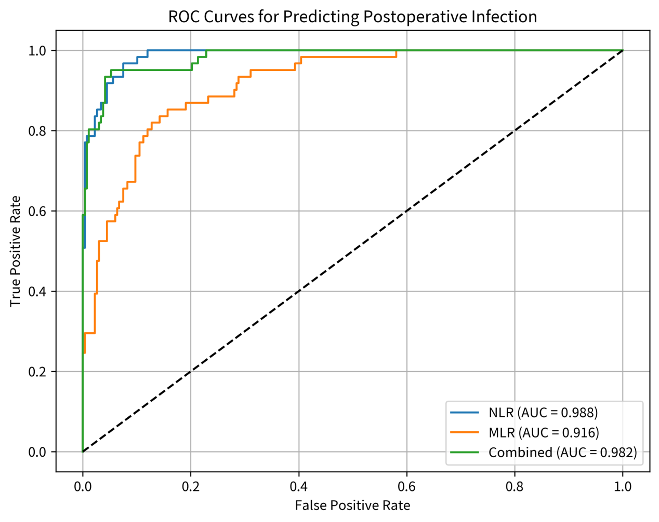
Figure 2. Receiver operating characteristic (ROC) curves of NLR, MLR, and combined model for predicting surgical site infection (SSI)
3.5. Clinical outcomes
The infection group incurred significantly longer median hospitalization [16.5 (11–22) vs. 8.5 (6–11) days, P < 0.001] and higher reoperation rate (31.8% vs. 5.4%, P < 0.001). Delayed union (defined as absence of bridging callus at 6 months) occurred in 27.3% of the infection group versus 5.4% in the non-infection group (P = 0.007). Functional recovery (SMFA disability index) was significantly impaired in the infection group at 6-month follow-up (mean score: 42.3 ± 11.5 vs. 28.7 ± 9.2, P < 0.001).
4. Discussion
This study provides robust evidence that early postoperative elevation of NLR and MLR serves as an independent, clinically meaningful predictor of SSI following open extremity fractures. Our findings align with and extend prior observations by employing rigorous, prospectively defined outcome ascertainment, systematic longitudinal monitoring, and multivariable adjustment for key confounders. Mechanistically, open fractures induce profound tissue damage and microbial challenge, triggering a dysregulated systemic inflammatory response characterized by neutrophil hyperactivation, monocyte infiltration, and concurrent lymphocyte suppression—culminating in immune paralysis that facilitates bacterial persistence and dissemination. NLR and MLR effectively capture this pathophysiological cascade, offering advantages over traditional markers: (1) derivation from universally available, low-cost routine blood tests; (2) resistance to transient fluctuations induced by antibiotics or acute stress; and (3) suitability for frequent, real-time surveillance in diverse healthcare settings.
Our empirically derived cut-off values—NLR > 6.72 and MLR > 0.90—are consistent with thresholds reported in related inflammatory and infectious conditions, reinforcing biological plausibility. Critically, the synergistic predictive gain achieved by combining both ratios (AUC = 0.859) underscores the complementary biological information they convey and supports their integrated clinical application.
From a translational perspective, these findings advocate for protocolized postoperative NLR/MLR monitoring—ideally daily or every-other-day during the first postoperative week. Values exceeding established thresholds should prompt immediate clinical reassessment: intensification of antimicrobial coverage (e.g., broader spectrum or extended duration), meticulous wound inspection and debridement if indicated, optimization of negative-pressure wound therapy, and heightened surveillance for deep-seated infection. For high-risk subgroups—particularly Gustilo-Anderson type III injuries—these metrics may further inform personalized rehabilitation timelines and outpatient follow-up intensity.
Strengths of this study include its focus on dynamic biomarker trajectories within a clinically relevant timeframe, adherence to standardized infection definitions, comprehensive adjustment for confounders, and robust statistical validation. Limitations warrant acknowledgment: (1) single-center retrospective design, introducing potential selection and information bias; (2) modest sample size limiting power for granular subgroup analyses (e.g., by specific Gustilo subtype or microbiological profile); (3) absence of concurrent measurement of other emerging inflammatory indices (e.g., systemic immune-inflammation index [SII], platelet-lymphocyte ratio [PLR]) or detailed microbiological data to construct multimodal predictive models; (4) inherent subjectivity in clinical SSI diagnosis despite standardized criteria; and (5) lack of long-term functional and radiographic outcomes beyond 6 months.
Future research should prioritize multicenter prospective cohort studies to validate these findings and assess the impact of NLR/MLR-guided interventions on hard endpoints (e.g., SSI incidence, amputation rate, mortality). Integration of NLR/MLR with clinical variables, imaging features (e.g., MRI-based soft-tissue characterization), and machine learning algorithms holds promise for developing high-fidelity predictive tools. Additionally, defining optimal intervention thresholds across heterogeneous populations—including elderly, diabetic, and immunocompromised individuals—will be essential to maximize generalizability and equity in clinical implementation.

5. Conclusion
In patients with open limb fractures, postoperative elevation of the neutrophil-to-lymphocyte ratio (NLR) and monocyte-to-lymphocyte ratio (MLR) constitutes an independent risk factor for surgical site infection (SSI), demonstrating robust predictive performance. Routine and dynamic monitoring of these hematologic indices in clinical practice is therefore warranted to facilitate timely, evidence-based interventions—ultimately improving patient outcomes and optimizing the utilization of healthcare resources.
Disclosure statement
The authors declare no conflict of interest.

References
[1] van der Broeck, LCA, Shchurov DG., Gabrio A, et al., 2026, The Economic Burden in Terms of Cost of Illness and Generic Health-related Quality of Life of Posttraumatic Long Bone Non-unions Among the Adult Population of the Netherlands from a Societal Perspective, Eur J Trauma Emerg Surg, 52(1): 183.
[2] Erol K, Er E, Vahabi A. et al., 2026, Orthoplastic Approach to Infected Type 3B Open Tibial Fractures: Management and Complications, Injury, 57(8): 113418.
[3] Suriyonplengsaeng C, Waisayarat J, 2026, Diagnostic Utility of Inflammatory Markers in Formalin-fixed and Paraffin-embedded Muscle Biopsies for Idiopathic Inflammatory Myopathies, Histopathology, https://doi.org/10.1111/his.70191.
[4] Chen Y, Lin W, Lin C, et al., 2026, Neutrophil-to-Lymphocyte Ratio and Monocyte-to-Lymphocyte Ratio Combination for Acute Coronary Syndrome Risk Stratification: A Retrospective Observational Study from a Metropolitan Medical Center in Taiwan, Sci Prog, 109(1): 368504261433395.
[5] Yang W, Sun Y, Zhang Q, et al., 2021, Value of Neutrophil/Lymphocyte Ratio and Monocyte/Lymphocyte Ratio in the Prognosis of Patients with Multiple Myeloma, Zhongguo Shi Yan Xue Ye Xue Za Zhi, 29(1): 122-130.
[6] Xia X, Zhu Y, Zhang L, et al., 2026, Cardiopulmonary Bypass Elevates the Neutrophil-to-Lymphocyte Ratio and Reduces Lymphocyte Counts: A Comparison of On-Pump versus Off-Pump CABG, J Cardiothorac Surg, s13019-026-04340-1.
[7] Nourmohammadi Z, Olfatifar M, Ahmadi MR, et al., 2026, The Relationship Between Hematological Indices of Systemic Inflammation and Disease Activity in Patients with Rheumatoid Arthritis: A Retrospective Cross-sectional Study, Clin Rheumatol, s10067-026-08198-5.
[8] Gulyas L, Meznerics FA, Szabo B. et al., 2026, Predictive Value of Serum Biomarkers for Survival in Melanoma: A Systematic Review and Meta-analysis, Sci Rep, s41598-026-54347-w.
[9] Perna A, Rovere G, Passiatore M, et al., 2025, Crystal Ball in a Blood’s Drop: Unlocking Hidden Prognostic Power in the Neutrophil-to-Lymphocyte Ratio (NLR) and the Platelet-to-Lymphocyte Ratio (PLR) for Elderly Hip Fracture Patients, J Clin Med, 14(10):3584.
[10] Wang Y, Chen K, Li X, et al., 2024, Clinical Efficacy of Various Resuscitation Fluids in the Management of Sepsis in Postoperative Surgical and Trauma Patients: A Systematic Review and Meta-analysis, Wideochir Inne Tech Maloinwazyjne, 19(3): 275-288.
[11] Zauche LH, Miller ER, Kim SS, et al., 2026, Monitoring Vaccine Safety: United States Vaccine Safety Surveillance Systems, J Pediatr Health Care, 40(1): 174-186.

Publisher’s note
Bio-Byword Scientific Publishing remains neutral with regard to jurisdictional claims in published maps and institutional affiliations

