Empowering Pre-service Chemistry Teachers: A Cognitive Scaffolding Approach to Mohr’s Salt Synthesis for Systemic Professional Development
Yunxia Qu*, Ruihan Mei, Huilin Li, Jinhui Lai, Siru Lin
School of Chemistry and Chemical Engineering, Lingnan Normal University, Zhanjiang, Guangdong, China
*Author to whom correspondence should be addressed.

Copyright: © 2026 Author(s). This is an open-access article distributed under the terms of the Creative Commons Attribution License (CC BY 4.0), permitting distribution and reproduction in any medium, provided the original work is cited.

Abstract: Traditional chemistry experiment teaching often follows a linear and programmed narrative approach, with students mechanically repeating the experimental process, which is extremely detrimental to the career and cognitive development of chemistry education students. This study explores measures to bridge the gap between theory and practice by reconstructing the classic preparation experiment of ferrous ammonium sulfate (Morel salt) through micro-engineering zoning. This teaching reform is aimed at the freshmen of the 2024 freshman chemistry teacher training program in the second semester, who are transitioning from passive exam-oriented learning to professional teaching thinking and have received another semester of basic experimental training. By implementing the micro engineering teaching reform of the “six zone cognitive scaffold matrix”, we have replaced the standard linear operation instruction with an interlocking reasoning framework. The reform involved 90 students majoring in chemistry education, and the results showed that the experimental group using cognitive scaffolds performed well in explaining complex chemical mechanisms, such as the thermodynamic stability of products and the kinetic mechanisms preventing oxidation, while maintaining basic experimental skills. The systematic training of students through this method not only enhances their proficiency in experimental operations, but also cultivates the necessary “subject teaching knowledge” (PCK) for future educators.
Keywords: STEM education; Pedagogical transformation; Cognitive apprenticeship; Mohr’s salt preparation; Systems thinking

Online publication:

1. Introduction
In traditional chemistry laboratory teaching in many universities, students behave more like “assembly line operators” rather than “exploratory learners”. They meticulously follow the standard linear operation in textbooks with simple and mechanical experimental parameters under the guidance of teachers, but avoid deep cognitive investment ^{[1]}. This issue is particularly prominent among first-year students majoring in chemistry education. These students are in a “transitional state”: they have learned relevant basic theoretical knowledge from inorganic chemistry courses, but lack practical experience in dealing with multiple variables in real chemistry experiments.
Taking the classic inorganic preparation experiment of synthesizing Mohr’s salt from scrap iron as an example, this experiment is not simply a mixture of two single salt solutions. It requires precise regulation of the oxidation state of iron and the solubility of various salts. When students observe that the product turns brownish yellow or fails to crystallize as expected, they often lack systematic engineering thinking to consider the experiment as a whole, so they lack diagnostic tools and find it difficult to attribute the failure to improper pH regulation, excessive heating during oxidation or evaporation stages, etc. It is crucial for cultivating future high school chemistry teachers to enable students to ‘see’ these micro-level failures and attributions. Modern engineering education also requires the cultivation of this ‘systems thinking,’ where learners view the laboratory as a dynamic environment rather than a static set of formulas ^{[2]}. To address these issues, this study proposes a “micro engineering” framework aimed at transforming students’ identities into active “cognitive agents” - individuals who not only know how to conduct chemical experiments, but also understand how chemical knowledge is constructed and validated, viewing experiments as a micro engineering, a holistic system ^{[3]} (Figure 1). Developing this initiative in the first year is very important, as it not only lays the foundation for students to conduct exploratory science teaching in middle school in the future, but also lays a solid thinking foundation for other chemistry experiments in the later stage.

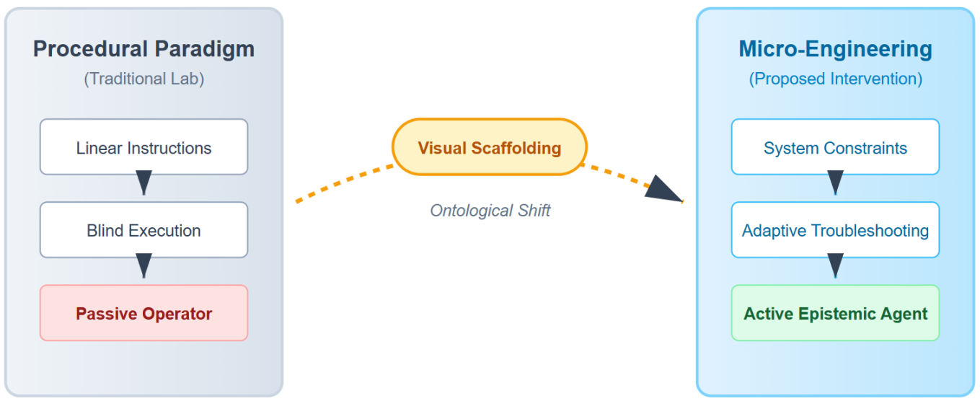
Figure 1. The Epistemological Paradigm Shift: From Passive Procedure-Follower to Active Epistemic Agent in the Chemistry Laboratory.

2. Theoretical framework and intervention design
The methodology of this study is not simply a concept of “scaffolding”, but rather a scaffolding based on a “distributed cognition” model ^{[4]}. In the high-pressure environment of the laboratory, students often prioritize completing experimental tasks while ensuring personal safety, rather than systematically designing and completing an experimental operation based on theoretical knowledge of chemistry, resulting in “cognitive overload” ^{[5]}. For freshmen who are independently conducting experiments for the first time, simply completing a large number of basic operations such as titration, heating, filtration, and monitoring is overwhelming. They cannot consider the connections between each step of the operation and the theoretical principles behind it. To address this issue, we applied Vygotsky’s “zone of proximal development” theory ^{[6]} and created a visual mediation tool: the six-zone cognitive scaffolding matrix (Figure 2).

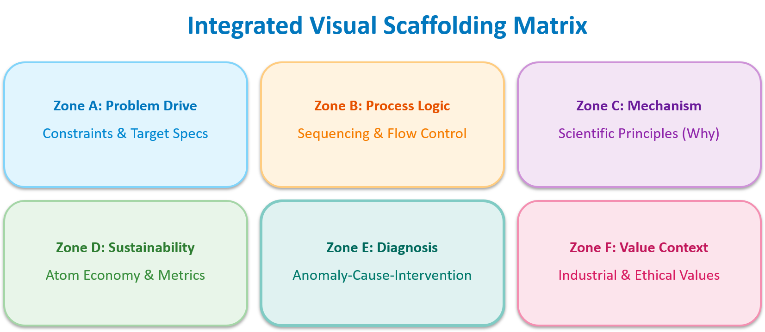
Figure 2. Six-Zone Cognitive Scaffolding Matrix for the Preparation of Mohr’s Salt from Scrap Iron.

The design of this matrix not only serves as an organizational tool, but also as a manifestation of the “cognitive apprenticeship” model ^{[7]}. This model urges students to externalize their own thinking process, and can be adjusted and customized according to different experiments. For example, in the experiment of preparing Moir’ salts, we designed and implemented the following operational points around the difficulties and key points in the synthesis process:
(1) The connection between operational logic and mechanistic logic: When the experimental textbook specifies the addition of excess iron, the scaffold matrix (B and C regions) further explores: “Why must iron powder be excessive? Can excess iron powder suppress the generation of Fe³⁺ through normalization reaction?” Thus, the operation is directly linked to the Nernst equation and redox stability.
(2) Environmental Responsibility Awareness: Zone D (Sustainability) requires students to calculate the “E-factor” of using scrap iron compared to pure iron powder, in order to transform waste management tasks into a green chemistry lesson.
(3) Diagnostic prediction: Zone E (diagnosis) is the area where students conduct hypothesis deduction and anomaly diagnosis before and after hands-on operation. For example, they can predict how the anhydrous or hydrolyzed products generated during the evaporation concentration stage will disrupt the crystal morphology and affect the purity of the product if the evaporation temperature exceeds the thermodynamic stability range of the product.
This micro-engineering teaching paradigm fundamentally changes the organizational structure of the classroom: teachers shift from “answer providers” to “reasoning facilitators”, while students independently derive answers and explanations based on theoretical frameworks - this is precisely the cognitive transformation that we hope chemistry teacher trainees can personally experience. Table 1 outlines the methodological distinctions.

Table 1. Methodological comparison of instructional designs
Dimension | Control Group (Procedural) | Experimental Group (Micro-Engineering)
Instructional Medium | Linear text-based manual | Multi-zone visual matrix (Figure 2)
Cognitive Focus | Task fidelity and completion | System thinking & mechanism mapping
Anomaly Resolution | Instructor-dependent | Autonomous diagnosis via Zone E
Learner Identity | Passive instruction follower | Active epistemic agent

3. Methodology
We conducted one semester of teaching reform research on 90 chemistry teacher education students from the 2024 cohort in the second semester of college. This semester, there were a total of 14 experiments in inorganic chemistry laboratory courses. We chose this specific group because they are in the process of transitioning from “learning to seek knowledge” to “learning to teach”. The control group (N = 45) used the traditional teaching mode, while the experimental group (N = 45) used the six-zone cognitive scaffolding matrix mode for teaching.
The core project of this teaching reform is to use industrial scrap iron to synthesize Mohr’s salt, because this experiment not only involves basic operations such as dissolution, filtration, evaporation, and pH adjustment, but also the metal ions of the product Mohr’s salt are easily oxidized during the operation process, requiring full protection to avoid oxidation of ferrous ions. Students must first use sodium carbonate (Na₂CO₃) to remove oil and impurities from the scrap iron, carefully control its reaction with sulfuric acid (H₂SO₄), and also consider the amount of reactants used. In addition, the addition method and concentration of ammonium sulfate (NH₄)₂SO₄), as well as the time and temperature of evaporation and concentration, need to be considered.
Purity was checked via KSCN qualitative tests and redox titration, while “soft skills” like diagnostic reasoning were measured through analytical reports and interviews.

4. Results and analysis
The data showed a fascinating trend: “technical parity” but “cognitive divergence.” As seen in Table 2, both groups achieved high purity levels (p > 0.05), proving the matrix is as safe as a traditional manual. However, the experimental group’s ability to explain “why” things happened was significantly higher.

Table 2. Statistical analysis of learning outcomes
Assessment Metric(1–10 Scale) | Control Group(Mean ± SD) | Exp. Group(Mean ± SD) | P-value
Product Purity (Technical) | 8.12 ± 0.6 | 8.35 ± 0.5 | 0.082 (ns)
Atom Economy Comprehension | 5.30 ± 1.2 | 7.90 ± 0.8 | < 0.01 *
Quality Metrics | 5.00 ± 1.4 | 8.50 ± 0.7 | < 0.01 *
Diagnostic Reasoning | 5.25 ± 1.5 | 8.85 ± 0.9 | < 0.01 *
System Thinking Capacity | 4.80 ± 1.3 | 8.55 ± 1.1 | < 0.01 *
Note: * ns = not significant. denotes a highly significant difference (p < 0.01). Assessed via double-blind scoring.

After a semester of research and observation, it was found that the most significant difference between the experimental group and the control group was reflected in the diagnosis of experimental abnormalities. In the control group, when the solution of ferrous sulfate (FeSO₄) becomes too acidic, or crystals precipitate in the form of small powders rather than clear monoclinic prisms, students usually ask questions and wait for the teacher to solve the problem. They are trapped in a linear process of operational steps, without systematically considering the reasons from an engineering perspective, let alone having corresponding improvement measures.
Students in the experimental group will engage in “collaborative diagnosis” when encountering experimental abnormalities or confusion. I once observed a group of students discussing details such as the dosage, concentration, and addition method of ammonium sulfate. They consulted the C region (mechanism) and inferred the need to add saturated solution based on the formation conditions and synthesis principles of double salts. This is precisely the hallmark of a future teacher: being able to diagnose students’ experimental errors through chemical theory, rather than just guessing. The experimental group scored 36.00% higher in diagnostic reasoning, which strongly demonstrates the enormous potential of visual scaffolds in cultivating cognitive agency (Figure 3).

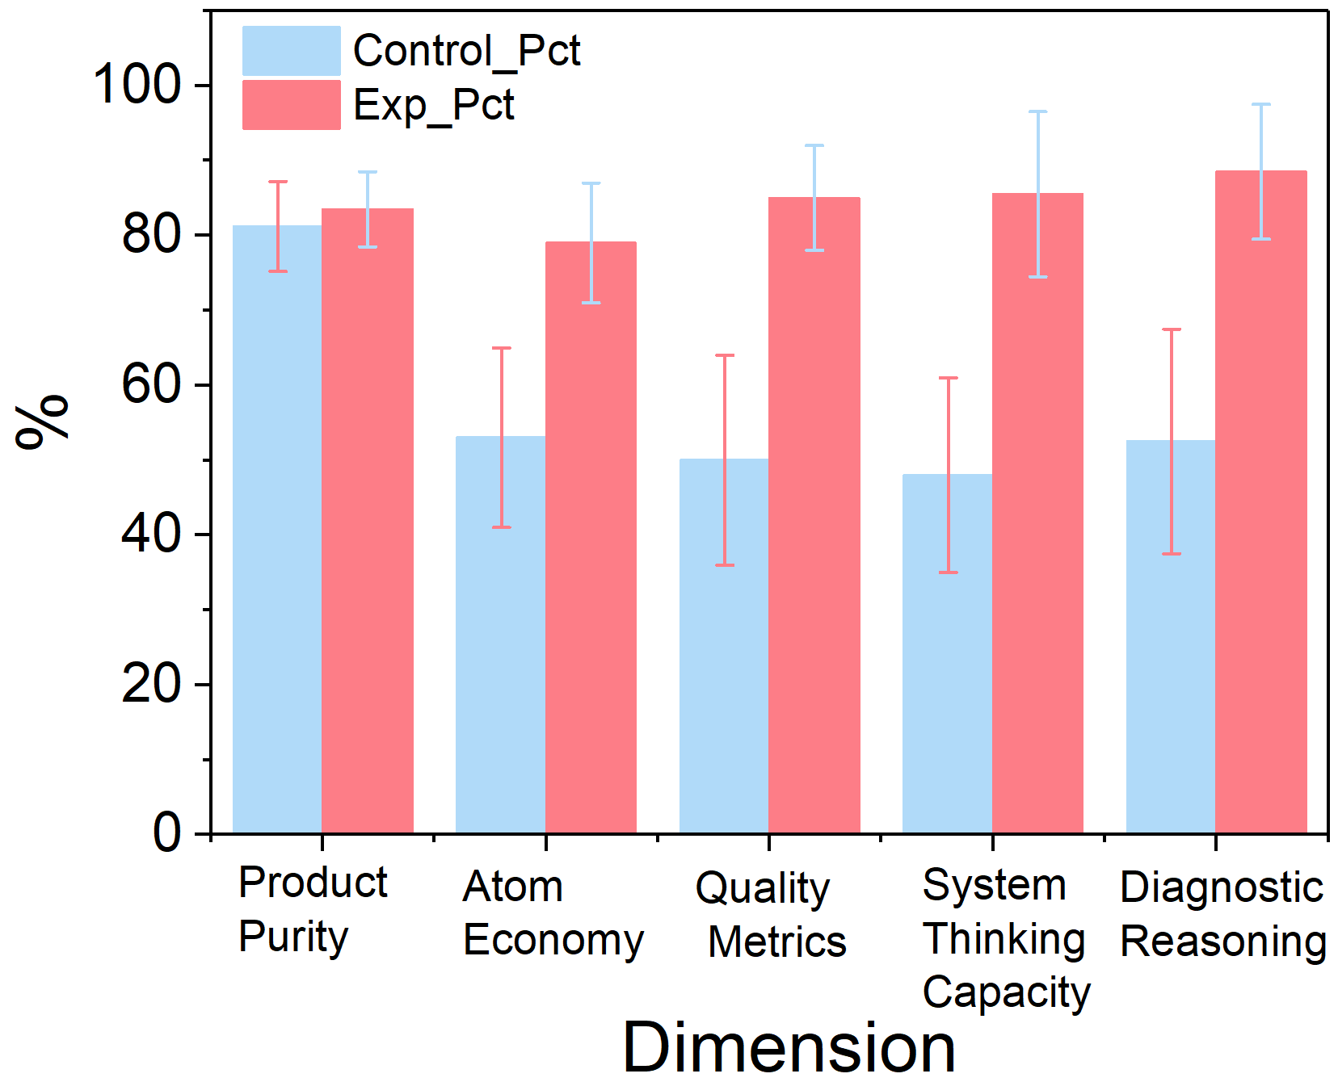
Figure 3. Comparative Performance Radar Chart.

5. Discussion
The success of this teaching reform lies in its reconstruction of the “cognitive division of labor” in the laboratory. By explicitly mapping the synthesis of Mohr’s salt, we shift students’ focus from the “macro level” (dissolution, heating, solution mixing, etc.) to the “micro level” (ion behavior, phase equilibrium, etc.) and “metacognitive level” (problem solving, anomaly attribution, etc.). This is particularly important and crucial for chemistry teacher trainees who will explain these concepts to others in the future ^{[8]}.
The “micro engineering” paradigm allows these freshmen to view experiments as small-scale chemical systems composed of interrelated variables such as temperature, pH, concentration, and purity. When they understand that the stability of the(NH₄)₂Fe(SO₄)₂ complex is what makes it a better titrant than FeSO₄, they are not just memorizing facts; they are building a professional knowledge base. As Stroupe (2023) notes, creating a classroom where students are “knowledge-producers” requires the teacher to have first experienced that role themselves ^{[9]}. Our scaffolding matrix provides that experience early in their career.
While some students initially found the matrix more “mentally taxing” than a simple list of steps, this “productive struggle” is essential for deep learning. By the end of the semester, these pre-service teachers were not just better at making Mohr’s salt; they were better at thinking like chemists and educators.

6. Conclusion
This study indicates that by using a six-zone cognitive scaffold matrix in the preparation of Mohr’s salts, we provide chemistry teacher trainees with a tool to bridge the gap between abstract theory and practical operation, enabling them to undergo systematic micro-engineering chemistry experiments in their first year of solid foundation. The transition from passive ‘scheme executors’ to active ‘cognitive agents’ is crucial for the development of these students who will step onto the podium in the future. By anchoring experiments on systems thinking and diagnostic reasoning, future high school chemistry teachers will not only possess proficiency in experimental operation techniques, but also become deep thinkers who can inspire the next generation of scientists.

Funding
2026 Smart Course Development and Construction Project of the College of Chemistry and Chemical Engineering, Lingnan Normal University (Project No.: ZHKC2609); College Students’ Entrepreneurship Training Program of Lingnan Normal University (Project No.: X202610579037, X202610579034 & X202610579039)

Disclosure statement
The authors declare no conflict of interest.

References
[1] Hofstein A, Lunetta VN, 2004, The Laboratory in Science Education: Foundations for the Twenty-First Century. Science Education, 88(1): 28–54.
[2] Mahaffy PG, Krief A, Hopf H, et al., 2018, Reorienting Chemistry Education Through Systems Thinking. Nature Reviews Chemistry, 2(4): 1–3.
[3] Stroupe D, 2014, Examining Classroom Science Practice Communities: How Teachers and Students Negotiate Epistemic Agency. Science Education, 98(3): 487–516.
[4] Pea RD, 2004, The Social and Technological Dimensions of Scaffolding and Related Theoretical Concepts for Learning, Education, and Human Activity. Journal of the Learning Sciences, 13(3): 423–451.
[5] Kirschner PA, Sweller J, Clark RE, 2006, Why Minimal Guidance During Instruction Does Not Work: An Analysis of the Failure of Constructivist, Discovery, Problem-Based, Experiential, and Inquiry-Based Teaching. Educational Psychologist, 41(2): 75–86.
[6] Vygotsky LS, 1978, Mind in Society: The Development of Higher Psychological Processes. Harvard University Press, Massachusetts.
[7] Collins A, Brown JS, Newman SE, 1991, Cognitive Apprenticeship: Teaching the Crafts of Reading, Writing, and Mathematics. In: Resnick LB (Ed.), Knowing, Learning, and Instruction: Essays in Honor of Robert Glaser, 453–494.
[8] Talanquer V, 2022, Fostering Mechanistic Reasoning in Chemistry: A Critical Priority. Journal of Chemical Education, 99(1): 12–19.
[9] Stroupe D, 2023, Growing and Sustaining Student-Centered Science Classrooms. Harvard Education Press, Massachusetts.

Publisher’s note
Bio-Byword Scientific Publishing remains neutral with regard to jurisdictional claims in published maps and institutional affiliations.

