Intercultural Competence, Perceived Support and Digital Literacy of Pre-service Teachers: A Model Based on Self-Determination Theory
Yinrui Zhang*
Guangdong University of Foreign Studies, Guangzhou, Guangdong, China
*Author to whom correspondence should be addressed.

Copyright: © 2026 Author(s). This is an open-access article distributed under the terms of the Creative Commons Attribution License (CC BY 4.0), permitting distribution and reproduction in any medium, provided the original work is cited.

Abstract: With the digitalization of education, pre-service teachers will need to enhance their intercultural communicative competence (IC) and digital literacy (DL) to take part in all sorts of various and technology-based learning environments. According to the theory of self-determination, this paper examines how IC, perceived support and the three types of basic psychological needs for autonomy, competence and relatedness are related to the three factors of DL. Multigroup Structural Equation Modeling was used to analyze the questionnaire data of the 250 pre-service teachers in South China. Based on the above analysis, it is found that IC positively correlates with all three types of psychological needs, and in turn, these needs are related to different parts of DL. Competence is closely related to how well one has learned the new technologies. Based on the above results, the application of self-determination theory to the intersection of intercultural and digital competence has been expanded, and the motivation for pre-service teachers’ development of digital literacy has been revealed. Therefore, the teacher training program should include cross-cultural learning to support the inclusiveness and diversity of digital education.
Keywords: Digital literacy; Intercultural competence; Self-determination theory; Pre-service teachers; Gender differences

Online publication:

1. Introduction
Intercultural competence (IC) is the ability of a person to communicate and behave appropriately in different cultures with openness, cultural self-awareness, relevant knowledge, interpretation skills and adaptive behaviour ^{[1]}. Pre-service teachers should be aware of IC in their communication with people from different countries and cultures, create inclusive classes, take into account all perspectives in teaching, and avoid culturally discriminatory ways of teaching.
Need to build a DL. DL does not only run the company. Ng has proposed three types of concepts: the ability to use digital tools, the ability to evaluate and create digital information, and the ability to participate in the online world safely, ethically and cooperatively ^{[2]}. Therefore, pre-service teachers should be equipped with digital literacy that can integrate technological knowledge, critical thinking and responsible use of communication.
IC and DL intersect because the digital world is also an intercultural space ^{[3]}, according to the above empirical studies. Digital storytelling and intercultural project work have been used to foster cultural reflection, multimodal communication and digital literacy at the same time ^{[4]}.
However, the present data are not uniform. Most studies have investigated the role of digital participation in people’s learning about foreign cultures. Less is known about the connection between IC and DL. Shonfeld found that a high IC was associated with lower technological anxiety among education students, but technological anxiety is not the same as multidimensional DL ^{[5]}.
Self-determination theory is a system of classification for this reason. Autonomy, competence and relatedness all need to be met for students to be interested in learning and development according to SDT ^{[6]}. Technology learning support has been found to promote DL to some extent by meeting the needs mentioned above ^{[7]}, and both autonomous and relational motivation have also been associated with the DL of university students. Based on the above evidence, this paper will determine whether IC is independently associated with the satisfaction of fundamental psychological needs for pre-service teachers and whether these needs are related to the three aspects of technicality, cognition and socio-emotional development (DL).

2. Literature review
2.1. Intercultural competence
IC is the ability to communicate and behave appropriately in intercultural situations. Deardorff’s process model is based on respect, openness and curiosity; at the level of interpretation resources, there is cultural self-awareness and knowledge, and the necessary skills include listening, analysis, connection and adaptation. Reasons for this may be personality defects, etc.
IC is professional for pre-service teachers because the classrooms have different languages, identities, ways of communication, educational expectations and social backgrounds. Teachers with strong IC can learn from all directions; they have studied a lot, adjusted their language appropriately, and help others speak out politely. Students in the digital education environment need to know the cultural references and reasons behind a work, and they should also develop other types of emotional connections beyond non-verbal signals.

2.2. Digital literacy
DL refers to the application of digital technology with full knowledge and responsibility, not just the operational skills of devices. Ng is divided into three. Technical DL is to use digital technology to solve basic technological problems. Cognitive DL is to find, evaluate, integrate and create knowledge. Social-emotional DL is about safe, ethical, respectful and cooperative participation in the digital world.
They are separate but related. Technical access is not an indication of cognition, so there is a high risk of being deceived by false information; without social-emotional awareness, one may not know that the communication is harmful or alienating. A three-dimensional system is relatively convenient for teacher training; that is to say, new teachers will need to use technology, manage resources, design teaching activities, communicate effectively, guide students in the responsible use of the Internet, etc.

2.3. Empirical relationship between intercultural competence and digital literacy
Most research on the connection between IC and DL has been carried out in the digital world. Resta and Laferrière believe that digital equity and intercultural education are related, and although technology can promote the spread of cross-cultural communication, digital exclusion will reduce people’s contact with and understanding of other cultures.
The projects have shown that both kinds of abilities can be developed at the same time through learning activities. Galante used cross-cultural observation in his writing and also filmed, edited and presented a work of digital storytelling. Komalasari has organized various interdisciplinary city-story projects to gather students from all over the world and create numerous different stories together [8]. Although the above research has confirmed pedagogical integration, it has not determined whether IC predicts DL or if DL predicts IC.
There is still no evidence of the other way. Shonfeld found that IC and cultural sensitivity are negatively correlated with the level of technological anxiety among education students. Therefore, it can be concluded that an open attitude towards cultural differences is positively related to the willingness to learn new technologies. Reduced anxiety is not the same as technical, cognitive and social-emotional development. Therefore, it needs to be verified experimentally that there is a link between IC and the multi-dimensional DL.

2.4. Self-determination theory and the proposed mechanism
SDT is based on the idea that people need to feel autonomous, competent and loved to be motivated ^{[9]}. Autonomy is one’s will and freedom, and it also includes one’s sense of self-worth, the ability to take care of oneself daily, etc. These requirements are in line with the characteristics of digital learning; that is to say, students need to make choices, adapt to new tools, solve problems and communicate in the form of media.
Studies have shown that the satisfaction of needs is related to DL. Chiu found that technology helps with learning, and in this case, it may be affected by all sorts of factors at the level of basic needs. Research has shown that people believe the support they receive in daily life helps them study better on their own.

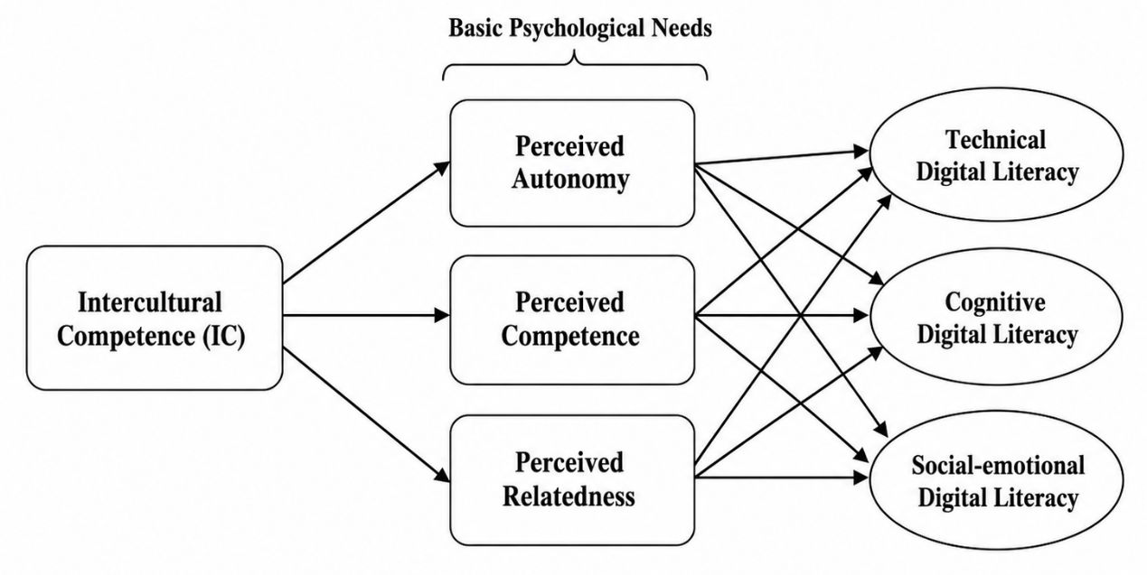
Figure 1. Theoretical framework.

IC should be treated as a resource for a person independently. Be more open-minded, adopt the other person’s viewpoint, be less afraid of the unknown, be flexible, etc., in online communication. These abilities can help us do better in new environments, give us a sense of connection when talking with people from all walks of life, and motivate us to study on our own initiative more readily. There is no direct evidence to support the above paths yet; thus, they should be regarded as hypotheses rather than confirmed reasons. The foundation of this paper is shown in Figure 1.

2.5. Hypothesis
(1) H1a-H1c. The three stages of autonomy, competence and relatedness are the three levels of intercultural competence in digital learning.
(2) H2a-H2c. Perceived support is positively related to autonomy, competence and relatedness in digital learning.
(3) H3a-H3c. Autonomy is positively correlated with the level of technical, cognitive and social-emotional digital literacy.
(4) H4a-H4c. Competence is positively associated with the technical, cognitive and social-emotional digital literacy of people.
(5) H5a-H5c. Relatability is positively associated with the three kinds of digital literacy.

3. Method
3.1. Participants
The objects of this study are the students of a four-year college in South China who are about to begin their third year of university. A safe electronic questionnaire will be sent to the students. A total of 276 questionnaires were distributed first, and after strict cleaning of the data to eliminate missing, careless or fixed answers, finally 250 sets of valid data from respondents were obtained with an actual response rate of 90.58%. In the validated sample, the proportion of men was 54.8% and that of women was 45.2%.

3.2.1. Intercultural competence (IC)
To determine the starting level of IC for the participants, a tool was created in this paper based on the valid scales of Chen et al. ^{[10]}. All 10 items in the measurement tool are 5-point Likert scales. Based on the current sample, it was found that the scale has good internal consistency and reliability, with a Cronbach’s alpha of 0.956. A typical item of this scale is that one can feel the difference between oneself and other cultures.

3.2.2. Digital literacy (DL)
According to the model put forward by Ng, the levels of digital literacy will be used for this instrument. The 14 instruments are divided into three sub-dimensions: cognition, technology and social-emotional learning; the first is used in this paper. The general shape of the whole instrument in this study was relatively good, and its Cronbach’s alpha was 0.872.

3.2.3. Basic psychological needs (BPN)
To study the psychological needs of the target group, a new scale was constructed in this paper based on the reliable scale by Chiu and others. The six items of measurement are divided into the three dimensions of autonomy, competence and relatedness in the study of digital learning. All of the answers were at the top of the 5-point Likert scale, and the internal consistency for the research was good (Cronbach’s α = 0.762). A basic sample item focusing on the realization of competence is: “I think I am quite good at learning with digital tools”.

3.3. Data collection procedure
Data will be collected anonymously by way of electronic informed consent, and to address the problem of common method bias, item randomization will be employed.

3.4. Data analysis
Empirical Data in SPSS and AMOS (Version 26.0). To explore both the measurement and structure of SEM at the same time, MLE was used for SEM estimation. To confirm that the above framework is in good agreement with the empirical data, the indices of absolute fit, relative fit and parsimony were selected.

4. Results
4.1. Model fit assessment
First of all, to determine whether a structural equation model (SEM) is suitable for the analysis of empirical data, it was first verified that the overall model fit is reasonable. As shown in Table 1, the new model fits all the above categories well. The absolute fit indices are good, and RMSEA = 0.076 and GFI = 0.904. All of the comparison fit indices are greater than 0.9, so there is a good structural fit. Finally, the parsimonious fit indices (PGFI = 0.612, PNFI = 0.675, PCFI = 0.709) are relatively small; that is to say, the theoretical framework is simple but still meets the criteria for model fitting and explains a certain proportion of the variance. Therefore, we can proceed to the next stage of path analysis.

Table 1. Model fit indices and criteria
Fit Indices |  | Criteria and Cutoff Values | Model Fit Indices
Absolute Fit Indices | $${\text{χ}}^{\text{2}}\text{∕}\text{ⅆ}\text{f}$$ | <2（Strict），<5（Acceptable） | 2.426
Absolute Fit Indices | GFI | >0.900 | 0.904
Absolute Fit Indices | AGFI | >0.900 | 0.858
Absolute Fit Indices | RMR | <0.050 | 0.087
Absolute Fit Indices | RMSEA | <0.050 | 0.076
Comparative Fit Indices | NFI | >0.900 | 0.881
Comparative Fit Indices | IFI | >0.900 | 0.926
Comparative Fit Indices | CFI | >0.900 | 0.925
Comparative Fit Indices | TLI | >0.900 | 0.903
Parsimonious | PGFI | >0.500 | 0.612
Parsimonious | PNFI | >0.500 | 0.675
Parsimonious | PCFI | >0.500 | 0.709

4.2. Path analysis and hypothesis testing
Based on the above reasonable conclusions, path analysis will be employed to explore the precise structure of the whole. Table 2 is as follows, and these are the standardized estimates ($\beta$), standard errors (S.E.), and critical ratios (C.R.). According to the analysis method of modern educational research, the above results can be divided into two stages: the generation of psychological “nutrients” and the driving forces for various dimensions of digital literacy.
As shown in Table 2, IC is a strong predictor of the three basic psychological needs (all β values are between 0.731 and 0.740, and all p values are less than 0.001).
Second, it was found that people were satisfied in terms of psychological needs, and as a result, the development of technical, cognitive, and socio-emotional aspects of digital literacy (DL) has also increased. At that time, the particular reasons for each factor were revealed.
Technically speaking, it was found that perceived competence was the main reason (β = 0.500, p < 0.001), followed by autonomy (β = 0.316, p < 0.001) and relatedness (β = 0.199, i = 0.008). As shown by the top rank, basic digital literacy has a goal; most teachers will be willing to learn the necessary tools based on their own wishes.

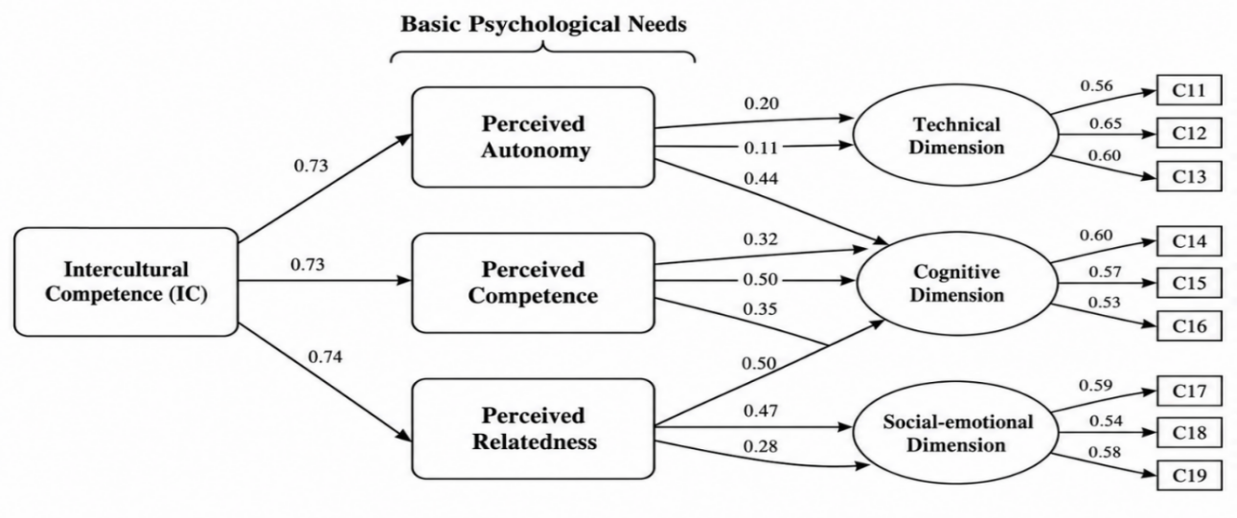
Figure 2. The SEM results.

The other reasons mentioned are that people have a high degree of self-determination ($\beta = 0.497$, p < 0.001) and believe that they can meet the challenge ($\beta = 0.465$, p < 0.001). Therefore, it is proposed that pre-service teachers should be able to make their own choices in order to maximize digital critical thinking and resource integration. Note that the path from perceived relatedness to the cognitive dimension was not significant (β = 0.113, p = 0.131); therefore, cognitive literacy is an independent reflective process and not a social-emotional one. In terms of the social-emotional aspect, the main factor was perceived relatedness (β = 0.445, p < 0.001), and autonomy (β = 0.346, p < 0.001) and competence (β = 0.279, p < 0.001) were also significant. Therefore, it can be concluded that active participation and collaborative empathy in virtual cross-cultural environments originate from one’s sense of belonging to society before entering the field of teaching, and the structure of the results is shown in Figure 2 above.

Table 2. Path fitting results for males
Path | Estimate | S.E. | C.R. | P
Perceived Autonomy<--Intercultural Competence | 0.712 | 0.086 | 9.322 | <0.001
Perceived Relatedness<--Intercultural Competence | 0.749 | 0.089 | 10.153 | <0.001
Perceived Competence<--Intercultural Competence | 0.690 | 0.097 | 8.989 | <0.001
Technical Dimension<--Perceived Relatedness | 0.126 | 0.075 | 1.184 | 0.236
Cognitive Dimension<--Perceived Relatedness | 0.077 | 0.077 | 0.724 | 0.469
Social-emotional Dimension<--Perceived Relatedness | 0.559 | 0.098 | 5.158 | <0.001
Technical Dimension<--Perceived Autonomy | 0.295 | 0.074 | 2.628 | 0.009
Cognitive Dimension<--Perceived Autonomy | 0.478 | 0.074 | 4.358 | <0.001
Social-emotional Dimension<--Perceived Autonomy | 0.324 | 0.089 | 3.107 | 0.002
Technical Dimension<--Perceived Competence | 0.508 | 0.074 | 4.323 | <0.001
Cognitive Dimension<--Perceived Competence | 0.489 | 0.067 | 4.668 | <0.001
Social-emotional Dimension<--Perceived Competence | 0.144 | 0.079 | 1.473 | 0.141

5. Discussion
5.1. Bridging the disciplinary gap: IC as a psychological catalyst
The assumption that IC and DL belong to different training domains has long shaped teacher education curricula, but the current data are not so simple. IC was a strong indicator of all three basic psychological needs (β = 0.731-0.740, p < 0.001), and it has not been one of the mechanisms emphasized by programme designers that the disposition fostered in intercultural learning - such as tolerance for ambiguity, flexibility in perspective and communication adaptability - is closely related to the internal resources that can support learners’ sense of agency, efficacy and belonging in the digital environment ^{[11]}. A teacher who has been accustomed to dealing with cultural differences tends to think that an unfamiliar platform or a technically flawed online class is a problem that needs to be resolved rather than an indication to withdraw. Due to all the close contact and interaction in the region, a certain sense of power and self-efficacy may have developed among the people. Cultural inclusiveness, as shown in this reading, is not an addition to teaching but rather the foundation that drives the will to learn online.

5.2. Psychological nourishment in the digital era: General mechanisms
The paths of the estimates are all around perceived competence as the main reason for technical digital literacy (β = 0.500, p < 0.001), and autonomy is ranked second (β = 0.316, p < 0.001). Technical proficiency seems to be linked with a sense of competence, and pre-service teachers are motivated to master the platform-level skills they believe they can acquire independently. The path coefficient of perceived relatedness on cognitive digital literacy was non-significant (β = 0.113, p = 0.131) and is consistent with theory. Cognitive Literacy - Location, Evaluation and Synthesis of Digital Information - is a person’s independent critical thinking ability and does not involve society.
This difference may be the characteristics of information evaluation itself; that is to say, the learner needs to withdraw from the social consensus and not be pulled further in by it, and the risk of an “echo chamber” increases precisely when relatedness has too much weight in epistemic reasoning. Social-emotional DL, on the other hand, is based on the concept of perceived relatedness ($\beta = 0.445$, p < 0.001), and this idea of essential relation fits well with the nature of responsible online behaviour, ethical communication and cooperation across different cultures.

6. Conclusion and implications
Based on the above results, the teacher education program needs to be improved in terms of how it connects cross-cultural learning with digital skill development. Give the pre-service teachers a choice of meaningful cross-cultural tasks and digital tools, provide them with scaffolded support to solve technical problems, and they will be more motivated by the path model in terms of autonomous motivation for cognitive and technical literacy. Organize all kinds of activities that can have students from different cultural backgrounds interact frequently, such as joint online projects, to cultivate a sense of belonging for the model of connected social-emotional digital literacy.
There are still some deficiencies in the current research. The sample is from pre-service teachers in a single area of South China, so the results may not be applicable to other institutions and educational cultures; To test the generality of the pattern, replication should be conducted with participants from various places and different types of institutions. The use of only self-report questionnaires, and all at a single time, may be subject to various response biases; therefore, in addition to this tool, one could also carry out interviews or observe the classroom.
This is a cross-sectional study, so it can only determine whether the hypothesis of association exists; it is impossible to track the joint development of intelligence and digital literacy in pre-service teachers over time. A long-term study of the same group of students over several semesters can help us determine whether the initial gains in intercultural competence lead to or occur at the same time as improvements in digital literacy, and whether the motivation pathway observed here is still valid given that both the changes in the technological environment and demands for teacher training in terms of curriculum are constantly changing.

Disclosure statement
The author declares no conflict of interest.

References
[1] Deardorff DK, 2006, Identification and Assessment of Intercultural Competence as a Student Outcome of Internationalization. Journal of Studies in International Education, 10(3): 241–266.
[2] Ng W, 2012, Can We Teach Digital Natives Digital Literacy? Computers & Education, 59(3): 1065–1078.
[3] Resta P, Laferrière T, 2015, Digital Equity and Intercultural Education. Education and Information Technologies, 20: 743–756.
[4] Galante A, 2015, Developing EAL Learners’ Intercultural Sensitivity Through a Digital Literacy Project. TESL Canada Journal, 32(1): 53–66.
[5] Ang S, Van Dyne L, Koh C, Ng KY, Templer KJ, Tay C, Chandrasekar NA, 2007, Cultural Intelligence: Its Measurement and Effects on Cultural Judgment and Decision Making, Cultural Adaptation and Task Performance. Management and Organization Review, 3(3): 335–371.
[7] Shonfeld M, Yazbak Abu Ahmad M, Cohen Liverant R, et al., 2025, Reducing Technological Anxiety Through Intercultural Competence. Technology, Knowledge and Learning. 2025.
[8] Chiu TKF, Sun JC-Y, Ismailov M, 2022, Investigating the Relationship of Technology Learning Support to Digital Literacy from the Perspective of Self-Determination Theory. Educational Psychology, 42(10): 1263–1282.
[9] Komalasari A, 2021, Developing 21st Century Education and Digital Literacy Skills Through Intercultural City Stories Project: Multimodal Narratives About Urban Cultures. PIONEER: Journal of Language and Literature, 13(1): 1–15.
[10] Ryan RM, Deci EL, 2000, Self-Determination Theory and the Facilitation of Intrinsic Motivation, Social Development, and Well-Being. American Psychologist, 55(1): 68–78.
[11] Chen G-M, Starosta WJ, 2000, The Development and Validation of the Intercultural Sensitivity Scale. Human Communication, 3: 1–15.
[12] Earley PC, Ang S, 2003, Cultural Intelligence: Individual Interactions Across Cultures. Stanford University Press, California.

Publisher’s note
Bio-Byword Scientific Publishing remains neutral with regard to jurisdictional claims in published maps and institutional affiliations.

