Reconstructing and Empowering Formative Assessment in University English Teaching Reform Based on the Production-Oriented Approach (POA): A Case Study of College English at Hunan Women’s University
Xiaoli Qin, Sha He
School of Foreign Languages, Hunan Women’s University, Changsha, Hunan 410000, China
*Author to whom correspondence should be addressed.

Copyright: © 2026 Author(s). This is an open-access article distributed under the terms of the Creative Commons Attribution License (CC BY 4.0), permitting distribution and reproduction in any medium, provided the original work is cited.

Abstract: Grounded in the newly revised 2024 syllabi of College English A (I) and College English A (II) at Hunan Women’s University, and informed by the Hunan Provincial Educational Reform project titled “Research and Practice on a POA-Inspired College English Teaching Model in the Digital Era,” this study examines how the three foundational pillars of the Production-Oriented Approach (POA), namely, teaching philosophy, pedagogical hypotheses, and teaching procedures, structurally reshape formative assessment. The research identifies four systemic deficiencies in current university English formative assessment: (1) procedural assessment formalism; (2) ambiguous competence orientation; (3) fragmented feedback mechanisms; and (4) imbalanced teacher-student roles and responsibilities. Crucially, POA’s principle of Assessment for Learning (AfL) functions not as a peripheral evaluative add-on but as a central, generative engine that closes the learning loop, advances learners’ competence trajectories, and realizes the integration of learning and application. Drawing on the dual-course multilayered assessment framework, this paper systematically constructs a five-dimensional, POA-aligned formative assessment model, Goal-Task-Evidence-Feedback-Regulation, and leverages digital platforms (e.g., U-School, Pigai.org, and Chaoxing Learning Platform) to enable data-driven dynamic diagnosis and personalized pedagogical intervention. Empirical evidence demonstrates significant improvements across multiple domains: (1) language production quality (a 37.2% increase in logical coherence in writing; a 41.5% rise in strategic oral communication usage); (2) higher-order critical thinking (enhanced depth and nuance in cultural stance expression within critical writing); and (3) metacognitive autonomy in self-regulated learning (a 2.8-fold increase in frequency of goal-setting and self-monitoring behaviors). This study offers a theoretically robust and practically resilient paradigm for college English teaching reform in application-oriented universities of the new era.
Keywords: Production-oriented approach; Formative assessment; College English teaching reform; Integration of learning and application; Digital empowerment

Online publication:

1. Structural Misalignment of Traditional Formative Assessment Within the POA Framework
The Guidelines for College English Teaching (2020 Edition), issued by China’s Ministry of Education, explicitly mandates “strengthening formative assessment, focusing on the learning process, and promoting holistic student development.” Yet a close examination of the 2024 syllabi for College English A (I) and College English A (II) at Hunan Women’s University reveals persistent structural contradictions, even though formative assessment has moved beyond paper-and-pencil tests to adopt a hybrid model (“U-School assignments + in-class discussions + Pigai.org submissions”), accounting for 30% of the final grade. Three fundamental paradoxes remain unresolved ^{[1]}.
First, misalignment between assessment objectives and POA’s integration of learning and application. POA posits that all instructional activities must serve authentic communicative output ^{[2]}. However, current formative tasks largely fail this criterion: U-School exercises emphasize mechanical vocabulary and grammar drills (e.g., fill-in-the-blank, matching); Pigai.org writing assessments prioritize linguistic accuracy over rhetorical or pragmatic efficacy; and classroom discussions often devolve into superficial opinion listing rather than anchoring to core unit-level output tasks, such as designing a volunteer project (Unit 6) or crafting advertising copy (Unit 3). Notably, Course Objective 1 (language proficiency) carries the highest formative weight (10 points), yet its assessment items bear little functional correspondence to stated outcomes like “engaging in discussion on socio-political issues” or “translating discipline-specific texts.” Consequently, evaluation functions not as a scaffolding mechanism driving output, but as an isolated knowledge-check, a static endpoint rather than a dynamic catalyst ^{[3]}.
Second, there is an imbalance in assessment agency vis-a-vis POA’s dual-track principle of teacher-led design and student-centered engagement. Within POA’s tripartite teaching cycle (Driving-Enabling-Assessing), teachers assume multifaceted roles, as designers, diagnosticians, and feedback providers, while students are expected to act as task executors, evidence generators, and reflective regulators. In practice, however, teachers retain near-exclusive control over scoring (e.g., final grading after AI-assisted Pigai.org evaluations), while students remain passive recipients of scores, lacking conceptual clarity about rubrics, metacognitive awareness of their own performance, or agency in responding to feedback. Moreover, course objective attainment is calculated via static averages, ignoring individual developmental trajectories. Thus, assessment serves as retrospective attribution, not prospective navigation.
Third, epistemological disconnection between assessment data and POA’s AfL hypothesis. As Wen ^{[2]} emphasizes, AfL demands that assessment be embedded throughout instruction, enabling real-time diagnosis, precise feedback, and iterative regulation. Yet current platform-generated data (e.g., correctness rates, response time) from U-School and Pigai.org remain confined to surface-level behavioral metrics. They fail to map onto POA’s higher-order dimensions: output task completion fidelity, effectiveness of enabling scaffolds, and depth of intercultural critical thinking. Digital resources function merely as “electronic question banks,” falling short of POA’s vision of data-informed pedagogical decision-making ^{[4]}.
Hence, the central research proposition emerges: How can POA theory transform formative assessment from a mere “assessment tool” into a fully integrated “pedagogical operating system”, one that structurally drives language production, enables competence progression, and fulfills the holistic aims of whole-person education.

2. Paradigmatic reconstruction of formative assessment under the POA framework
POA provides an indispensable theoretical foundation for deep, principled reform of formative assessment. Its three pillars collectively define the genetic architecture of a reimagined evaluative paradigm ^{[5]}.

2.1. Teaching philosophy: Shifting the value axis from “knowledge testing” to “competence growth”
The learner-centered principle requires assessment design to answer: What transferable competencies have students developed through this process? Not how many facts have they memorized?
The integration of learning and application dictates that assessment must cohere with authentic output tasks. For instance, when students draft a business proposal, formative assessment should foreground market analysis logic, feasibility argumentation, and anticipation of cross-cultural risks, not merely tally grammatical errors.
The whole-person education principle further expands assessment scope to include ideological literacy, cultural confidence, and collaborative ethos. In evaluating advertising projects, for example, rubrics must incorporate indicators such as appropriateness of integrating fine traditional Chinese cultural elements and degree of embodiment of sustainable consumption values, rendering assessment an explicit vehicle for value cultivation.

2.2. Pedagogical hypotheses: Operationalizing assessment for learning
POA translates AfL into actionable, empirically grounded hypotheses:
(1) Output-driven assessment. Assessment is front-loaded into the Driving phase. Pre-class micro-video tasks (e.g., “Design English promotional copy for Hunan intangible cultural heritage products”) yield students’ initial drafts, their first formative evidence, exposing genuine linguistic gaps and triggering subsequent input-based learning ^{[4]}.
(2) Input-enabled assessment. Evaluation permeates the Enabling phase. Teachers use initial-draft analytics to deliver targeted resources: curated reading materials (e.g., exemplars of contrastive argument structure), domain-specific Pigai.org drills (e.g., logical connectors), and scaffolded speaking prompts, all directly derived from diagnostic data ^{[5]}.
(3) Selective learning guidance. Assessment directs attention to high-leverage competencies. Where students consistently struggle with intercultural responsive strategies, U-School delivers scenario-based multiple-choice items (e.g., “What is the most appropriate response to a foreigner’s misconception about Chinese dietary habits?”), and resulting analytics determine the focus of in-class enabling activities ^{[5]}.

2.3. Teaching procedures: A triadic, cyclical design of driving-enabling-assessing
POA’s non-linear, recursive procedure provides a dynamic temporal-spatial framework for embedding formative assessment. As illustrated in Figure 1, the three phases form a cyclical, iterative loop with Assessment for Learning (AfL) as the central unifying principle ^{[6]}.

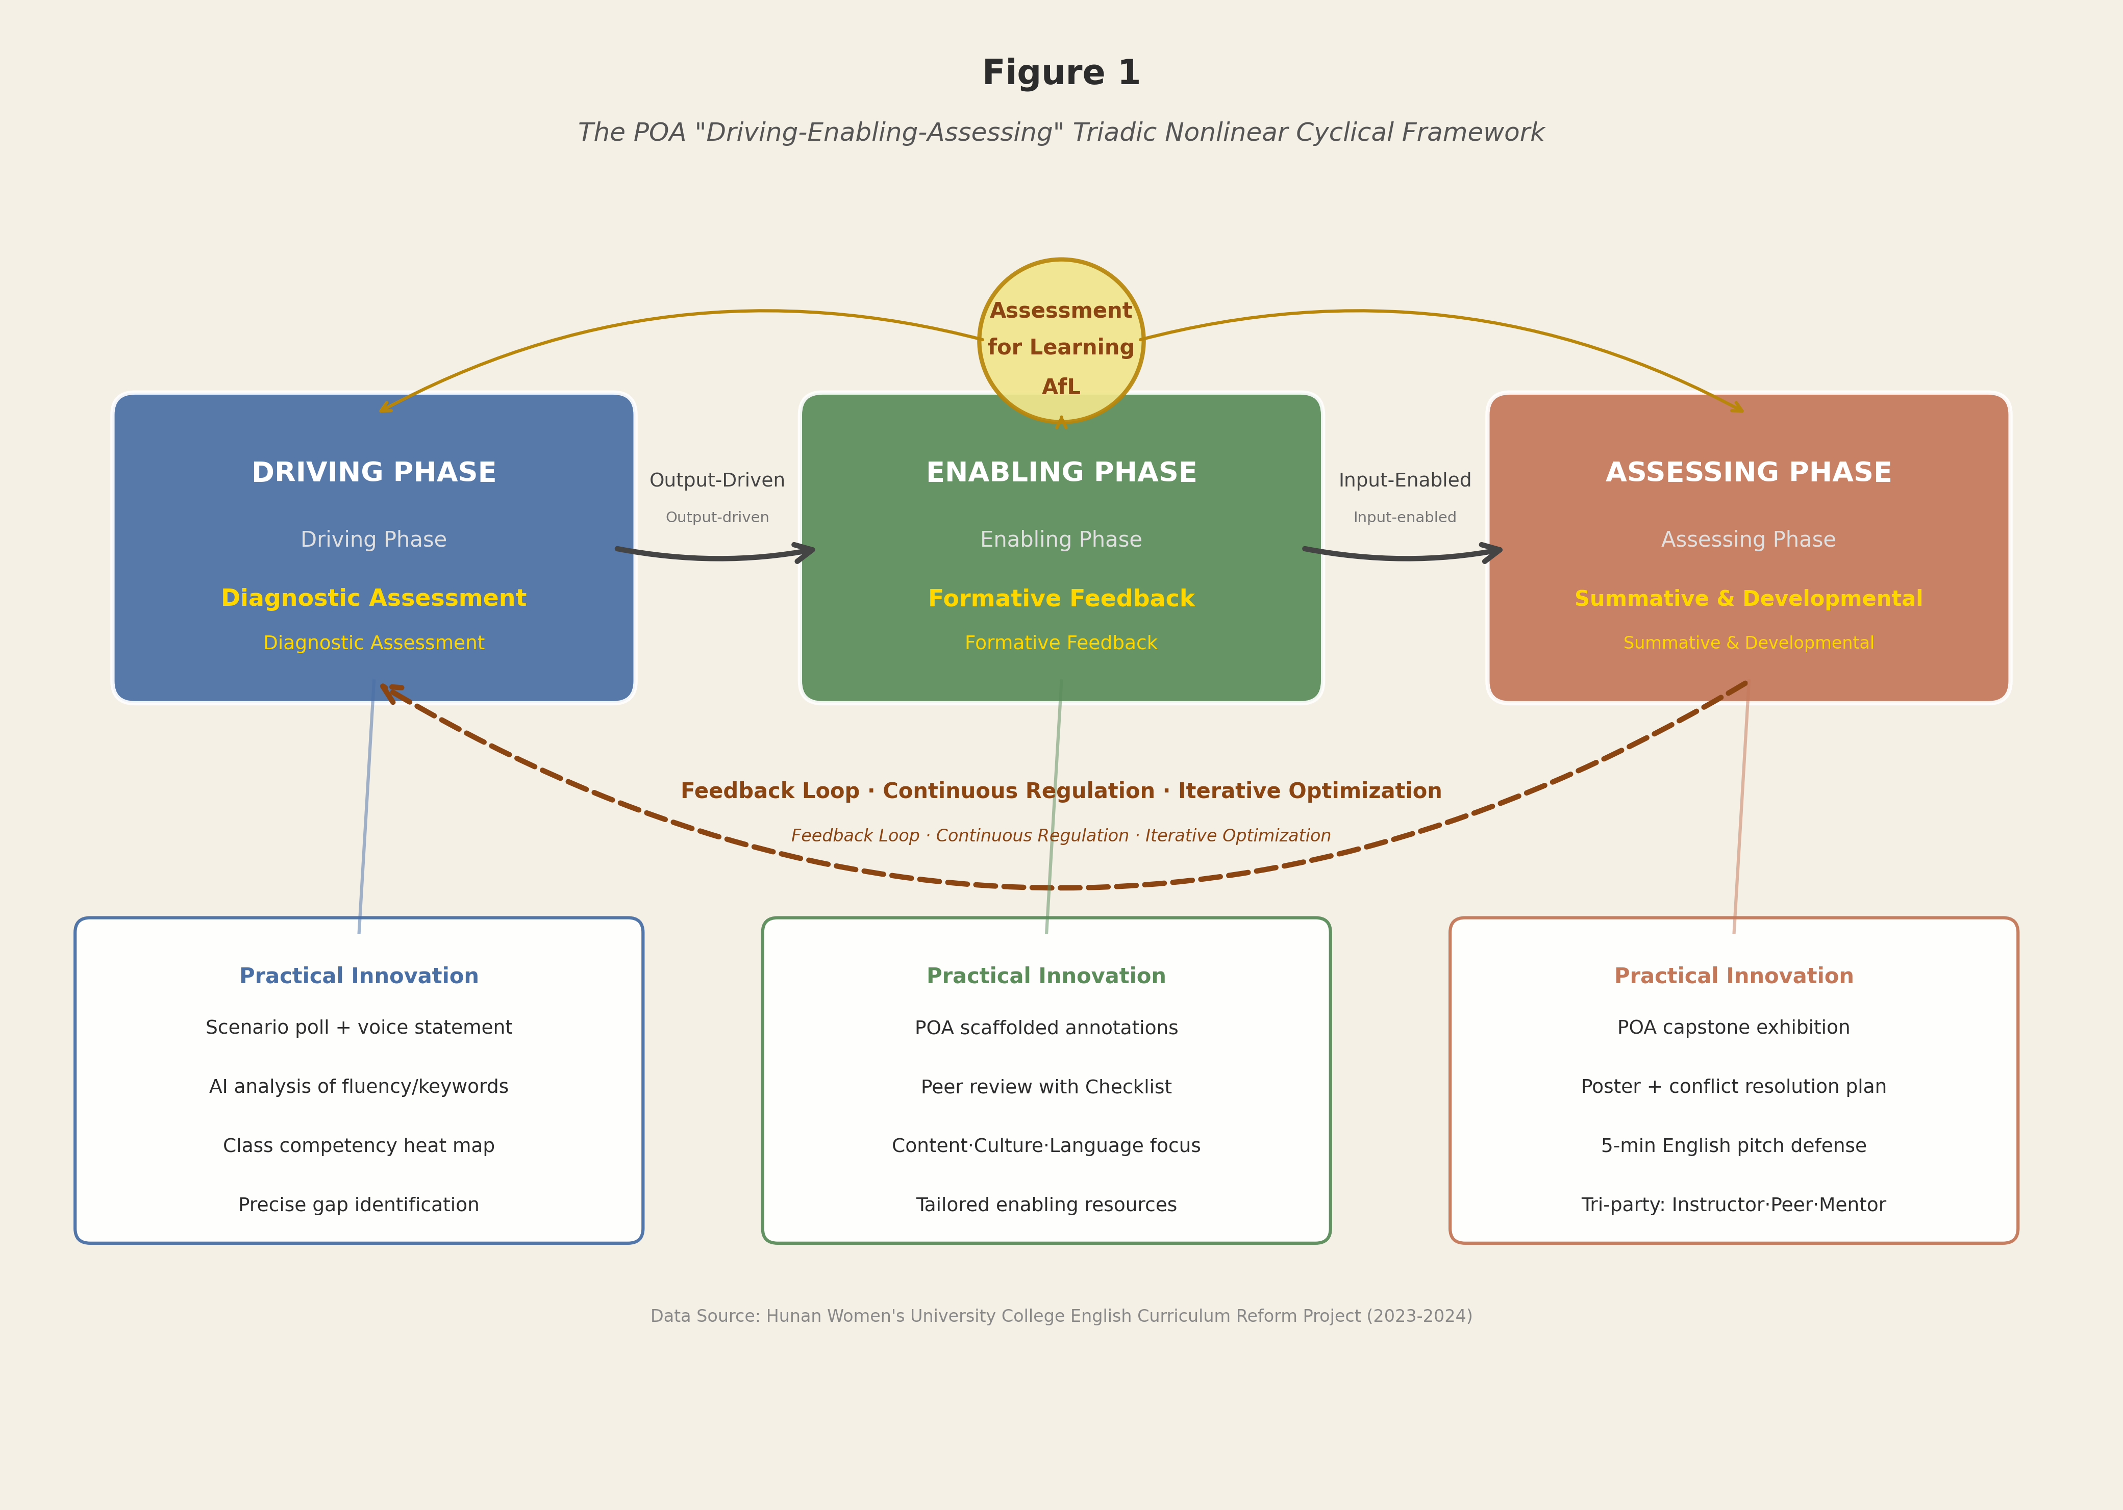
Figure 1.The POA “Driving-Enabling-Assessing” Triadic Nonlinear Cyclical Framework.

In the Driving phase, diagnostic assessment is implemented through U-School scenarios (e.g., a “career-choice dilemma” poll combined with three-minute voice statements analyzed by AI for fluency and keyword density), generating a class-wide competency heat map that precisely identifies gaps to be addressed. In the Enabling phase, formative feedback follows AI scoring on Pigai.org with POA-aligned scaffolded annotations; peer review employs a Production Task Checklist assessing content logic, cultural stance, and linguistic appropriateness. In the Assessing phase, the 20% “performance/comprehensive assessment” functions not as a free-choice assignment but as a POA capstone exhibition: volunteer posters require an attached “cross-cultural conflict anticipation and resolution plan”; business proposals undergo a five-minute English pitch evaluated jointly by instructor, peers, and industry mentors, ensuring authenticity and learning-application integration.

3. Four-dimensional construction of a POA-guided formative assessment system
Building upon the above theoretical framework, this study implements a Goal-Task-Evidence-Feedback four-dimensional formative assessment system in College English A (I) and College English A (II), where every assessment instance constitutes a miniature POA cycle.

3.1. Goal dimension ^{[6]}: Rigorous mapping between course objectives and observable indicators
Strictly adhering to the syllabus’s stipulation that course objectives support graduate attributes, abstract goals are operationalized into observable, measurable indicators. For example, Course Objective 2 (critical thinking) maps to indicators such as “identify implicit cultural stances in textual analysis” and “compare Chinese and Western market research methodologies and propose localization-adapted recommendations.” Course Objective 4 (autonomous learning) maps to indicators such as “record three or more strategy adjustments in U-School learning journals” and “demonstrate two or more rounds of substantive revision in Pigai.org essay drafts based on feedback.” This ensures alignment with POA’s learner-centeredness, eliminating vague or unmeasurable criteria ^{[7]}.

3.2. Task dimension: Output-driven innovation in assessment carriers
All formative tasks are reconceived as sub-tasks or competence modules of the unit’s culminating output, rejecting isolated, decontextualized exercises. Illustrative cases include: Volunteer Project Unit. The formative chain proceeds from a U-School “cross-cultural volunteer motivation survey report” (Driving), through group brainstorming audio recordings (Enabling), to a poster draft plus cultural risk mitigation plan (performance assessment), culminating in an English pitch defense (comprehensive assessment) ^{[8]}.
Advertising Unit. The formative chain proceeds from a Pigai.org “English introduction to Chinese tea culture” draft (diagnostic), through a U-School “advertising rhetoric matching exercise” (enabling), to peer review of “cultural symbol deployment effectiveness” (feedback), culminating in final ad copy plus cultural interpretation video (output).
Such design embeds value-oriented education organically, making assessment both a conduit for value transmission and a crucible for competence development.

3.3. Evidence dimension: Multimodal, data-rich learning portfolios
Moving beyond numeric scores, a three-tiered evidentiary ecosystem is constructed. Digital footprints: U-School logs learning pathways (e.g., repeated viewing of “comparison-and-contrast writing” micro-lectures signals need for targeted enabling); Chaoxing captures discourse quality in forums (e.g., depth of cultural stance articulation in discussion posts). Portfolio artifacts: Pigai.org archives full revision histories of essays; platforms store multimodal outputs, PPTs, videos, posters, from group projects. Reflective journals: Students submit mandatory POA Reflection Journals per unit, addressing: “Where did I stall in my output task?” “Which enabling activity proved most effective?” and “How did I adjust my learning strategies?” This triangulated evidence base furnishes dynamic, process-oriented, individualized data for objective attainment analysis, transforming “objective attainment” from a statistical abstraction into a narrative of growth ^{[9]}.

3.4. Feedback dimension: Immediate, precise, actionable closed-loop regulation
To fulfill POA’s AfL mandate, feedback must embody three essential qualities. Immediacy: U-School exercises yield instant feedback; Pigai.org AI scoring responds within seconds; instructors provide POA-scaffolded annotations on key drafts (e.g., initial proposals) within 48 hours ^{[10]}. Precision: Feedback targets specific POA-defined gaps. Instead of generic comments like “unclear structure,” instructors annotate: “Apply the ‘Problem-Solution-Effect’ framework (pushed via U-School) in Paragraph 2 to analyze the concrete impact of the gig economy on local youth employment” ^{[11]}. Actionability: Every feedback item includes a concrete next-step directive: e.g., “Watch the ‘Intercultural Responsive Strategies’ micro-lecture (12:30-15:45) and apply the phrase ‘I appreciate your perspective, and from a Chinese context...’ in your next forum post.” This transforms assessment from a verdict into a blueprint, realizing Wen’s assertion that “assessment is an organic component of teaching, not its terminus” ^{[12]}.

4. Empirical validation: Demonstrated pedagogical efficacy of the reform
(1) Implemented across eight classes (N = 326) in the 2023-2024 academic year, including Chinese Language Education and Cross-Border E-Commerce majors, under the Hunan Provincial Educational Reform Project, the POA-guided formative assessment system yielded statistically significant gains, verified via U-School/Pigai.org backend analytics, student surveys (N = 312), and instructor reflective journals.
(2) Enhanced language production quality. Pigai.org data shows a 37.2% improvement in the reasonableness of cross-cultural conflict resolution statements in volunteer project reports; a 41.5% rise in natural integration of Chinese cultural elements in advertising copy. Oral output saw a 2.8-fold increase in use of critical-connective phrases (however, in contrast, from a cultural perspective), confirming the efficacy of POA’s Enabling phase ^{[13]}.
(3) Deepened higher-order competencies and value identification. In the “Gig Economy” unit, 92.3% of students engaged in dialectical analysis linking China’s flexible employment policies (vs. 58.1% pre-reform), demonstrating concurrent achievement of critical thinking and sound professional ethics. Student reflection journals showed a 3.5-fold increase in frequency of keywords like “cultural confidence” and “telling China’s stories well” ^{[14]}.
(4) Sustained evolution of autonomous learning ecology. U-School journal submission rate reached 98.7%, with 85.4% containing concrete strategy-adjustment records (e.g., “switched to mind-mapping for ad logic”). Agreement with “Assessment helps me clarify my learning direction” rose to 96.2% (vs. 63.8% pre-reform) ^{[15]}.
These findings confirm: When formative assessment is deeply empowered by POA theory, it ceases to be ornamental “window dressing” and becomes the core engine propelling students’ transformation, from knowledge consumers to meaning creators.

5. Toward a new ecology of “assessment-as-teaching”
This study, grounded in the lived classroom reality of College English A (I) and College English A (II) at Hunan Women’s University, affirms that POA theory offers an irreplaceable blueprint, not only for conceptual reframing but also for granular, scalable implementation of formative assessment reform in university English education. Its fundamental insight is profound: Effective formative assessment is never a spectatorial record of learning; it is a participatory co-construction, guided by POA’s architectural logic, where teachers leverage assessment as a lever to activate learning, students use it as a mirror to calibrate growth, and digital technology serves as the nervous system connecting pedagogy and practice ^{[10]}.
Future directions include three principal avenues. First, intelligent upgrading: Developing POA-specific algorithms capable of automatically detecting POA-critical deficits, e.g., “absence of cultural stance,” “fractured logical chains”, in student writing. Second, ecological extension: Integrating assessment data with the university’s Academic Early Warning System, triggering personalized mentoring for students persistently below POA-defined milestone benchmarks. Third, social co-governance: Inviting industry mentors to co-evaluate performance assessments, subjecting university English output to authentic societal demand, thereby closing the loop between curriculum and career ^{[12]}.
When assessment is no longer perceived as the epilogue of teaching, but as its overture and pulse, college English instruction will achieve its historic transition: from teaching English to educating through English. This study thus signifies more than methodological innovation; it represents a philosophical return to an educational paradigm whose ultimate telos is the holistic development of the learner.

Disclosure statement
The authors declare no conflict of interest.

References
[1] Ministry of Education of the People’s Republic of China, 2020, Guidelines for College English Teaching (2020 Edition). Higher Education Press, Beijing.
[2] Wen QF, 2015, The Production-Oriented Approach: Explorations in Theory Innovation for Foreign Language Education in China [in Chinese]. Foreign Language Teaching and Research Press, Shanghai.
[3] Sun YZ, 2021, Over to You (I) and Over to You (II). Foreign Language Teaching and Research Press, Shanghai.
[4] Wen QF, 2018, The Production-Oriented Approach in EFL Teaching in China: Rationale, Conceptual Framework and Pedagogical Principles. Language Teaching, 51(3): 339–353.
[5] Wen QF, Sun SG, 2020, Production-Oriented Approach: Theory and Practice of Foreign Language Teaching Reform in Chinese Universities [in Chinese]. Foreign Language Teaching and Research Press, Shanghai.
[6] Qiu L, Sun SG, Wen QF, 2020, Exemplifying Design Criteria for the Enabling Stage of the Production-Oriented Approach. Foreign Language Education in China, 3(2): 19–26.
[7] Carless D, 2022, Excellence Through Engagement and Empowerment: Feedback Literacy for Assessment for Learning. Assessment and Evaluation in Higher Education, 47(3): 365–377.
[8] Zhang WZ, Jack R, 2019, Constructing a Formative Assessment System for College English in the Big Data Era [in Chinese]. Foreign Language World, (2): 41–49.
[9] Black P, Wiliam D, 1998, Inside the Black Box: Raising Standards Through Classroom Assessment. Phi Delta Kappan, 80(2): 139–148.
[10] Hattie J, Timperley H, 2007, The Power of Feedback. Review of Educational Research, 77(1): 81–112.
[11] Hyland K, 2015, Feedback on Second Language Students’ Writing. Language Teaching, 48(1): 93–110.
[12] Carless D, 2022, Excellence Through Engagement and Empowerment: Feedback Literacy for Assessment for Learning. Assessment and Evaluation in Higher Education, 47(3): 365–377.
[13] Black P, Wiliam D, 2009, Developing the Theory of Formative Assessment. Educational Assessment, Evaluation and Accountability, 21(1): 5–31.
[14] Carless D, Boud D, 2018, The Development of Student Feedback Literacy: Enabling Uptake of Feedback. Assessment & Evaluation in Higher Education, 43(8): 1315–1325.
[15] Nicol D, Macfarlane-Dick D, 2006, Formative Assessment and Self-Regulated Learning: A Model and Seven Principles of Good Feedback Practice. Studies in Higher Education, 31(2): 199–218.

Publisher’s note
Bio-Byword Scientific Publishing remains neutral with regard to jurisdictional claims in published maps and institutional affiliations.

