Research Approaches on the Development and Implementation of Tourism Value for Edles Silk
Li Zheng, Yunyun Ma, Yuhuan Quan
Shache County Secondary Vocational and Technical School， Kashgar 844700, Xinjiang, China

Copyright: © 2026 Author(s). This is an open-access article distributed under the terms of the Creative Commons Attribution License (CC BY 4.0), permitting distribution and reproduction in any medium, provided the original work is cited.

Abstract: Edelweiss silk is a national intangible cultural heritage and a cultural relic of the Silk Road, embodying the local folk customs and traditional aesthetics of Kashgar. Leveraging the Belt and Road Initiative and the transformation of the cultural tourism market, silk craftsmanship has developed in tandem with local tourism, becoming a key driver for revitalizing intangible cultural heritage, enhancing industrial efficiency, and promoting rural revitalization ^{[1]}. This article integrates literature review, field research, case studies, and quantitative analysis, focusing on the six elements of tourism to identify the resource advantages and existing shortcomings of Edelweiss's cultural-tourism integration, and proposes a development strategy centered on cultural heritage preservation, supported by industrial quality improvement, and linked through experiential innovation. The study demonstrates that improving the entire industry chain, developing immersive cultural tourism projects, leveraging digital empowerment, and strengthening talent teams can balance cultural preservation with tourism revenue generation, providing a reference model for the integration of intangible cultural heritage and cultural tourism in border regions ^{[2]}.
Keywords: Edles silk; Kashgar tourism; Integration of culture and tourism; Revitalization of intangible cultural heritage; Industrial upgrading

Online publication:

1. Introduction
1.1. Research background
Kashgar is situated at the heart of the ancient Silk Road, boasting abundant cultural and tourism resources. The old city's architectural style, folk culture, and intangible cultural heritage crafts form the core advantages of its cultural and tourism development ^{[3]}. The Edelweiss silk weaving and dyeing technique was inscribed on the national list of intangible cultural heritage in 2008. With its unique tie-dyeing process, distinctive color aesthetics, and auspicious cultural connotations, it has become a highly representative regional cultural symbol of Kashgar ^{[4]}. Driven by various distinctive cultural and tourism events, Edelweiss silk has made appearances on international fashion stages such as Shanghai and Paris, successfully transcending the limitations of traditional clothing and becoming an important vehicle for integrating regional culture with modern trends ^{[5]}. As domestic cultural and tourism consumption enters a phase of deep immersion experiences, this intangible cultural heritage craft has gained significant popularity among young tourists and has become a popular cultural experience activity in Xinjiang ^{[6]}. Kashgar has vigorously developed intangible cultural heritage and folk tourism, with annual sales at local intangible cultural heritage markets exceeding 50 million yuan, and Edelweiss silk-based cultural and tourism products have become a crucial contributor to local economic growth ^{[7]}. However, the industry still faces challenges such as incomplete industrial chains, product homogenization, and a shortage of innovative talent. How to achieve high-quality coordinated development between cultural preservation and the tourism sector remains an urgent challenge to address ^{[8]}.

1.2. Research significance
Refine the research framework for integrating intangible cultural heritage with tourism, establish an analytical model encompassing “cultural resources – industrial transformation – tourism experience,“ enhance quantitative studies on silk-related intangible cultural heritage in border ethnic regions, and provide theoretical references for revitalizing similar projects ^{[9]}; explore the development potential of Edelweiss silk tourism, propose actionable integration pathways, support the quality improvement and upgrading of Kashgar‘s tourism industry, promote local employment, income growth, and rural revitalization, and strengthen the sense of community among the Chinese nation ^{[10]}.

1.3. Research methods
(1) Literature Review Method: This study employed a literature review approach to systematically examine literature on Edelweiss silk across three dimensions—subject matter, sources, and publication years—with a focus on its patterns, designs, and applications in intangible cultural heritage. It analyzed the distribution of publications in databases such as Peking University Core and CSSCI, tracked recent research trends, and reviewed Kashgar's tourism development plans and the Edelweiss Silk Industry Report ^{[11]}.
(2) Field investigation method: Through on-site visits and online questionnaire surveys at seven key locations—including the Intangible Cultural Heritage Market in Kashgar Ancient City, the Aidesilis Workshop in Shache County, Zepu County, and Jiya Township in Hotan—three intangible cultural heritage inheritors, ten tourism professionals, and 30 tourists were interviewed via both online and offline approaches to collect relevant data ^{[12]}.
(3) Case Study Method: This study selects seven representative regions—Shache, Jiya Township in Hotan, the Ancient City of Kashgar, Zebu, Huiyuan Town in Yili, Kuqa, and Urumqi—as comparative samples, covering diverse development models including industrial bases, cultural tourism sites, rural folk customs, and urban cultural innovation ^{[13]}.
(4) Data Analysis Method: Quantitative analysis of integration effectiveness is conducted by utilizing official data published on various websites, combined with corporate operational reports and e-commerce sales data ^{[14]}.

2. Analysis of the current integration of Kashgar Aidesil silk industry and tourism
2.1. Literature review and analysis
2.1.1. Analysis of the distribution of major research topics
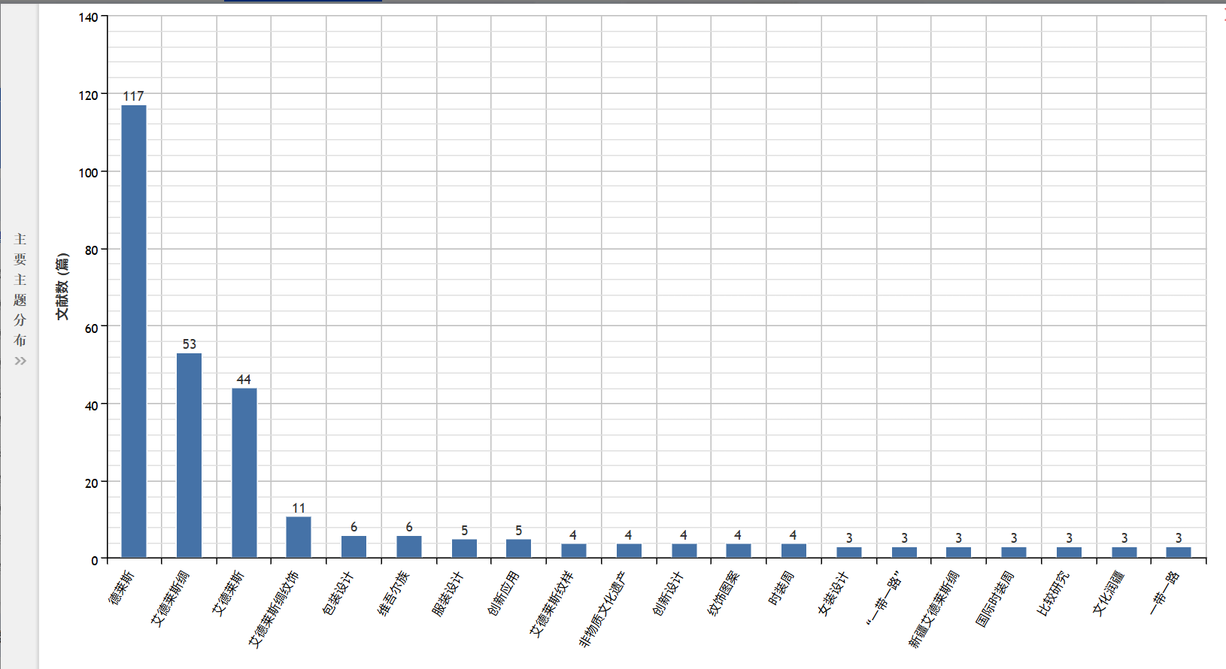
Figure 1. Distribution map of main themes in Edel’s literature research.

From the perspective of research topic distribution (Figure 1), studies related to Edelweiss exhibit a stratified pattern. Current research primarily focuses on ontological analysis, with literature on the Edelweiss silk itself being the most abundant and forming the foundational body of research. Decorative pattern studies serve as a crucial link between ontological and applied research, while studies in areas such as packaging, apparel design, intangible cultural heritage preservation, and innovative applications have steadily emerged, reflecting the ongoing evolution of contemporary revitalization efforts. Overall, this field has established a progressive framework spanning basic research to innovative applications; however, applied research remains fragmented and lacks systematic organization, necessitating interdisciplinary integration for deeper development.

2.1.2. Analysis of major research sources
From the perspective of literature source distribution (Figure 2), research on Edelays exhibits a distinct hierarchical pattern. Domestic core journals serve as the primary publication platform, with 27 articles in Peking University Core Journals, 18 in WJCI, 10 in CSCD, and 9 in CSSCI, forming the core research foundation and demonstrating an interdisciplinary research base. In contrast, the number of high-impact international publications such as AMI and EI remains relatively low, reflecting limited international dissemination, weak integration of engineering technologies, and the need for enhanced cross-disciplinary application and global influence in this field.

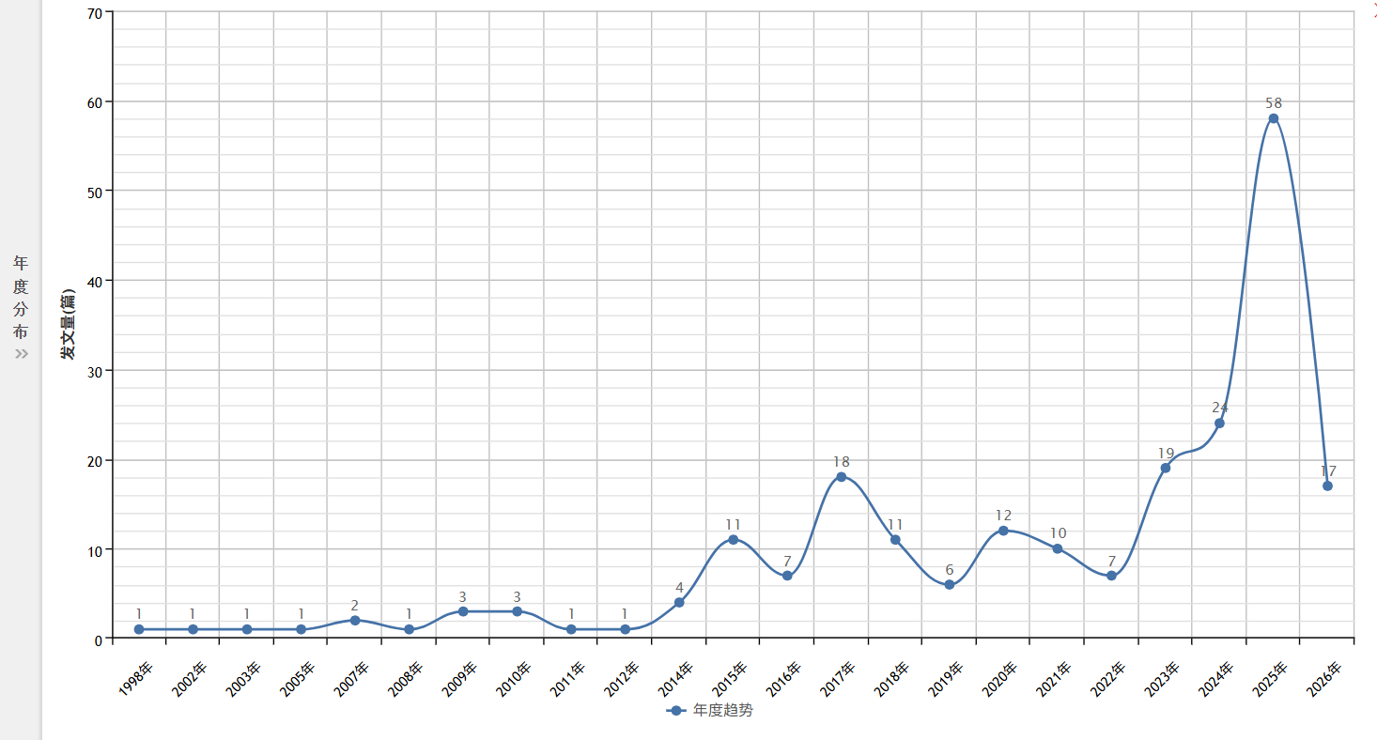
Figure 2. Statistical chart of source categories in Edles‘ literature research.

2.1.3. Annual research analysis
Research publications on Aidesi exhibit distinct phased growth patterns (Figure 3). From 1998 to 2013, the field remained in its nascent stage with extremely low publication volumes and no established academic framework. After 2014, output steadily increased with fluctuations, reaching its first peak in 2017 driven by intangible cultural heritage protection policies. Between 2018 and 2022, research activity stabilized at a moderate level. Starting in 2023, interest surged dramatically, with publications continuing to rise from 2023 to 2025 and hitting an all-time high in 2025. Supported by national strategies such as cultural-tourism integration and intangible cultural heritage revitalization, modern value studies of Aidesi have become a prominent academic focus, and existing data from 2026 indicate sustained growth in research momentum.

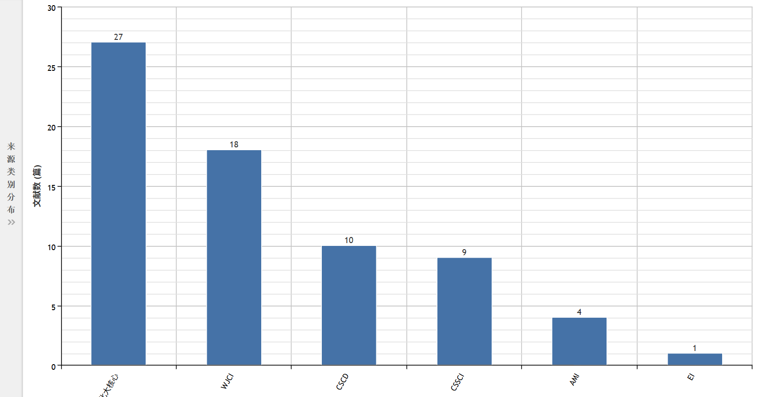
Figure 3. Trend chart of publication volume in Edles-related studies.

2.2. Analysis of the current integration of Edles silk and tourism
2.2.1. Combining foundational and core strengths
(1) The uniqueness of cultural resources is particularly prominent.
Edelise Silk selects high-quality silkworm silk as its core raw material, employing natural plant dyes throughout the coloring process combined with the unique traditional tie-dyeing technique. The classic decorative patterns on the fabric surface, such as the Thar pattern and pomegranate motif, draw inspiration from the natural landscapes and folk customs of Xinjiang. The color scheme inherits and aligns with the traditional Chinese five-color aesthetic philosophy, creating a unique and irreplaceable regional cultural IP ^{[15]}. This traditional weaving technique is inclusive and serves as a vivid embodiment of the diverse cultural exchanges along the ancient Silk Road. Moreover, Edelise Silk's intangible cultural heritage resources can complement local distinctive assets like the cultural tourism resources of Kashgar Ancient City and the art culture of the Twelve Muqam, forming a rich and multidimensional Xinjiang cultural tourism resource system.
(2) The industrial scale has begun to take shape.
Kashgar has established a relatively comprehensive Edelweiss silk production system, with core production areas demonstrating stable output capacity and significant economic returns, as detailed in Table 1.

Table 1. Core data statistics of the Kashgar Edelweiss silk industry
Data Source | Indicator Category | Core Data
Industrial Data of Jiya Township, Hotan | Annual Production Scale | 50.83 ten thousand pieces
Industrial Data of Jiya Township, Hotan | Annual Output Value | 200 million yuan
Industrial Data of Jiya Township, Hotan | Annual Profit | More than 40 million yuan
Industrial Data of Jiya Township, Hotan | Business Entities | 798 family workshops
Industrial Data of Jiya Township, Hotan | Indirect Beneficiaries | More than 1000 people
Jiang Kexin (2025) | E-commerce Proportion | 35%
A Certain Atlas Workshop in Kashgar | Annual Reception Per Workshop | 90 thousand person-times
A Certain Atlas Workshop in Kashgar | Annual Sales Per Workshop | 4.6 million yuan

(3) Policy support combined with market demand drives integrated industrial development.
Leveraging favorable policies such as the Belt and Road cooperation initiatives and the preservation of intangible cultural heritage, Edelweiss Silk's integration of culture and tourism enjoys solid policy support. Currently, young consumers increasingly prefer immersive folk cultural tourism experiences, and the continuously expanding consumer demand continues to open up sales channels for Edelweiss's distinctive tourism products. Based on local resource characteristics, Kashgar has developed a growth strategy of “deeply exploring cultural heritage through policy implementation and revitalizing resources to connect with the market,“ successfully transforming local intangible cultural heritage resources into core cultural tourism attractions.
(4) Diverse innovations have been successfully implemented, with tangible industrial commercialization outcomes.
The implementation of digital production equipment has addressed the traditional limitations in manual weaving capacity for Edelweiss silk. Taking the Shanghai Silk Cooperation Project as an example, it overcame the previous production constraint of only 3 to 4 meters per day achieved by single workers. Many emerging inheritors of intangible cultural heritage have refined product designs based on modern aesthetics; their self-developed Edelweiss-inspired cheongsams achieve stable monthly shipments exceeding 100 pieces, while total annual sales of all cultural and creative products surpass 30,000 units, with individual items reaching peak daily revenues of over ¥230,000. New products enhanced through improvements to traditional patterns and color schemes have gained strong market recognition.

2.2.2. Major existing issues (Quantitative analysis)
The current integration of culture and tourism still faces five major shortcomings, which can be analyzed from the following five dimensions; quantitative data are presented in Table 2.

Table 2. Quantitative analysis of existing issues in the integration of culture and tourism
Problem Dimension | Quantitative Performance | Impact Level
Industrial Chain Collaboration | About 10% capacity loss due to raw material shortage | Severe
Product Homogenization | Traditional products account for more than 70% | Relatively High
Experience Depth | Immersive experience projects account for less than 30% | Medium
Talent Structure | Compound talents only account for 5% of practitioners | Severe
Cultural Communication | Coverage rate of complete interpretation of cultural connotation is less than 40% | Relatively High

In summary, the integrated development of Edles silk culture and tourism faces challenges such as a fragmented industrial chain, product homogeneity, insufficient experiential depth, a lack of interdisciplinary talent and digital marketing capabilities, and fragmented cultural dissemination, all of which hinder the transformation of its cultural value into tourism appeal.

3. Practical approaches for the deep integration of Edles silk products with tourism in Kashgar
3.1. Establishment of a comprehensive industrial chain collaboration system
This study centers on full-industry-chain collaboration, strengthening the development foundation across three dimensions: industrial closed-loop systems, cultural-tourism integration, and brand cultivation. On the industrial front, it adopts a “leading enterprise + cooperative + family workshop“ model, integrating over 10 standardized sericulture bases to achieve a 15%-20% cost reduction, introduce digital equipment to increase production capacity tenfold, and establish a comprehensive traceability system leveraging blockchain technology. On the cultural-tourism front, it creates thematic consumption scenarios encompassing all key elements and develops a unified cultural visual identity. Regarding branding, the initiative aims to cultivate 10–15 local original brands, build three major product portfolios, and maintain a profit margin of over 60% for premium products.

3.2. Development of multi-level cultural and tourism experience products
To enhance market appeal, this study establishes a multi-tiered intangible cultural heritage (ICH) tourism experience system. First, it introduces the “Mobile Rainbow“ full-industry-chain traceability tour, offering an immersive experience lasting 3–6 hours with an estimated annual visitor capacity of 50,000 and projected direct revenue of 4–7.5 million yuan. Second, it innovates immersive cultural scenarios by leveraging VR technology to recreate Silk Road trade settings and enriching cultural experiences through diverse activities. Third, it upgrades the ICH marketplace by hosting over 40 inheritors' studios and establishing online-offline sales channels, aiming for annual sales exceeding 80 million yuan.

3.3. Digital empowerment as a pathway for innovative development
This study leverages digital technology as the core driver to expand development channels across three dimensions. At the technological innovation level, it promotes AI-driven pattern design and digital printing technologies, establishes a traditional pattern database, reduces product customization cycles from 3–5 days to 1–2 days, with personalized orders accounting for over 30% of total orders; in digital marketing, it builds an official cultural platform, creates more than 10 vertical influencer accounts, achieves annual exposure exceeding 50 million across all platforms, and develops digital collectibles to target younger audiences; in smart tourism, it deploys intelligent tour guidance systems that utilize big data for precise product recommendations, thereby enhancing tourist conversion rates.

3.4. Strengthen talent cultivation and cultural dissemination to ensure sustainable development
The integrated development of Edilesi Silk Cultural Tourism is structured with two-phase objectives: Within the first two years, prioritize consolidating over 10 standardized sericulture bases, launching five full-process immersive experience projects, cultivating 200 cultural tourism professionals annually, establishing 10–15 local original brands, achieving a 30% share of personalized custom orders, and maintaining annual sales at the core intangible cultural heritage market above 80 million yuan. The three-year medium-to-long-term goal includes reaching annual industry-wide sales exceeding 150 million yuan, creating 1,000 new jobs cumulatively, attracting over 50,000 visitors annually to experience programs, building a tiered inheritance system for intangible cultural heritage bearers, sustaining high-end product profit margins above 60%, achieving annual new media exposure exceeding 50 million across all platforms, and realizing comprehensive, scaled, branded, and high-quality development.

4. Practical analysis of multiple cases on the integration of cultural tourism with Xinjiang Edelweiss Silk
4.1. Overview of typical case studies
To enhance the comprehensiveness and credibility of the study, this paper selects seven representative regions—Shache, Jiya Township in Hotan, the Ancient City of Kashgar, Zebu, Huiyuan Town in Yili, Kuqa, and Urumqi—as comparative cases, covering diverse development models including industrial bases, cultural tourism sites, rural folk traditions, and urban cultural innovation. The practical measures implemented, their outcomes, and existing challenges in each region are summarized below.
Table 3. Comparative analysis of practical approaches across different case sites
Practice Region | Key Initiatives | Key Outcomes | Development Gaps
Shache County | Digital capacity upgrading, new Chinese-style product innovation, integration of intangible cultural heritage (ICH) workshops with old town cultural tourism scenarios, and cultivation of young inheritors | Significant growth in production capacity and orders, income increase for over 20,000 business entities, and outstanding cultural tourism passenger flow | Weak new media marketing, insufficient coverage of young consumer groups
Jiya Township, Hotan | Standardization and scenic-oriented transformation of production plants, enrichment of cultural and creative product categories, and cultivation of young practitioners | Steady growth in production capacity and orders, cultural tourism revenue generation, and effective promotion of employment and income increase for farmers | Lack of high-end design empowerment, low added value of product brands
Kashgar Ancient City | Building an ICH exhibition, cultural and creative sales, and immersive performance system based on the ancient city scenarios | High market popularity of cultural and creative products, high exposure among young groups, and significant advantages in cultural tourism drainage | Severe homogenization of experience projects, lack of in-depth craftsmanship experience content
Zepu County | Creating ICH costume-themed cultural tourism activities based on natural scenic spots and characteristic festivals. | Significant order growth of new-style products, high online communication popularity, and income increase for regional business formats | Strong seasonal dependence of development, insufficient income generation capacity of normalized operation
Huiyuan Town, Ili | Building ICH-themed homestay clusters, developing rural folk experience and cultural and creative sales business formats | Awarded the national-level rural tourism demonstration title, effectively increasing farmers' operating income. | Scattered business format layout, lagging construction of branding and online operation
Kuqa City | Integrating Qiuci culture to innovate ICH products, building characteristic workshops, and linking global cultural tourism resources | Created a differentiated Silk Road ICH IP, and stably received cultural tourism passenger flow | Immature market-oriented operation, shortage of young innovative talent reserves
Urumqi | Cooperating with young designers to innovate products, and expanding the national market through exhibitions and e-commerce | Significant increase in online sales volume and product unit price, won multiple cultural and creative honors. | High production costs, difficulty in achieving large-scale mass production

4.2. Commonalities and distinctive features across multiple cases
From the practices across Xinjiang, the integration of Aidesi silk with cultural tourism has consistently followed a clear roadmap: pursuing a path of “industrial upgrading + product innovation + cultural tourism implementation,“ transforming traditional crafts into new forms of cultural tourism. Shache excels in its complete industrial chain, with substantial benefits for the public driven by scaled development; Hotan focuses on standardized production, laying a solid industrial foundation; Kashgar Ancient City and Urumqi excel in traffic generation and brand modernization; Zepu and Yili leverage natural and rural resources to incorporate immersive experiences into daily life; while Kuqa delves deeply into Kucha culture, creating unique intangible cultural heritage IPs, forming a diversified and complementary landscape.

4.3. Comprehensive insights and common issues
Comparing these cases reveals that the key to sustainable development of intangible cultural heritage tourism lies in preserving cultural authenticity, leveraging industrial upgrading, product innovation, and diverse application scenarios to transform resources into growth drivers effectively. However, across Xinjiang, the industry faces several common challenges: inadequate new media marketing efforts targeting young audiences have failed to engage this demographic fully; products remain highly homogeneous with limited premium pricing for high-end brands; development primarily relies on visitor traffic from scenic spots and festivals, coupled with weak capacity for sustained operations; and a shortage of versatile professionals skilled in both cultural creativity and operational management further hinders deeper integration of culture and tourism.

5. Conclusion and prospects
5.1. Research findings
By establishing a comprehensive industrial chain collaboration system, developing multi-level experiential products, leveraging digital technologies to empower innovation, and strengthening talent development and cultural dissemination, the full potential of cultural and economic value can be unleashed, driving Kashgar's tourism sector toward a transition from resource-driven to culture-driven growth. Data indicates that deep integration of culture and tourism can increase the added value of intangible cultural heritage tourism resources by 40%–60%. It is projected that within the next three years, annual sales related to Kashgar's Aidesil silk tourism will exceed 150 million yuan, creating over 1,000 new jobs and becoming a key driver for rural revitalization.

5.2. Future outlook
In the future, we can further deepen integrated models such as “intangible cultural heritage + educational tours,“ “intangible cultural heritage + digital economy,“ and “intangible cultural heritage + cross-border tourism.“ By leveraging new technologies like artificial intelligence, blockchain, and VR, we can continuously enhance production efficiency, cultural dissemination effectiveness, and tourism experience quality, thereby establishing replicable and scalable integration models for intangible cultural heritage and tourism. Ultimately, these models will be incorporated into the national cultural narrative system, serving as vivid vehicles for telling China's stories well and strengthening the sense of community among the Chinese nation.

Disclosure statement
The authors declare no conflict of interest.

References
[1] Xinjiang Daily, 2025, Edelweiss Silk Weaves a New Vision, August 29, 20225.
[2] National Party Media Information Public Platform, 2025, “Protection + Inheritance”: Intangible Cultural Heritage Gains New Vitality in Kashgar, June 18, 2025.
[3] Sohu.com, 2025, 2025 Kashgar In-depth Travel Guide: Exploring Xinjiang – Immersive Experience First, visited on December 10, 2025, https://www.sohu.com/a/942274129_122528929/
[4] The Paper, 2025, Shanghai and Kashiwa United | Edles’ “Dual Revival”, visited on December 10, 2025, https://m.thepaper.cn/newsDetail/forward/1078965456789234
[5] Kashgar Prefecture Administrative Office, 2025, Xinjiang’s New Narrative of Cultural and Tourism Integration – Carrying Local Attractions in Your Bag, visited on December 10, 2025, http://www.kashgar.gov.cn/zwxx/lyfw/202511/t20251121_1896525.html
[6] Hotan Regional Integrated Media Center, 2025, Our 14th Five-Year Plan | The Youthful Face of Hotan’s Intangible Cultural Heritage, visited on Dcember 13, 2025, http://www.ht.gov.cn/xw/ttxw/202512/t20251212_2789631.html
[7] Jintai Information, 2025, People’s Daily on Xinjiang | Aidesi Weaves New Colors, visited on December 30, 2025, https://m.gmw.cn/paper/20251228/1245789.html
[8] Sohu.com, 2026, How Can Millennia-Old Culture Be Monetized? Instead of Selling Antiques, Shache Has Launched an Innovative Experience-Based Approach That’s Truly Remarkable, visited on January 5, 2026, https://www.sohu.com/a/951236789_1236987
[9] AMiner, 2025, Research on the Development and Protection of Tourism Products Based on Intangible Cultural Heritage—A Case Study of Xinjiang Aidesil Silk, visited on September 1, 2025, https://www.aminer.cn/pub/6598745632145789
[10] China Intangible Cultural Heritage Network, 2025, Research on Innovation and Development Strategies for the Aidesil Industry in Xinjiang under the Background of “Belt and Road”, visited on October 20, 2025, https://www.ihchina.cn/research/202510/t20251016_5896.html
[11] Jiang K, 2025, The E-commerce Application of Intangible Cultural Heritage: Living Transmission and Commercial Innovation Through the Case Study of Edelweiss Silk. E-commerce Review, 14(12): 766–773.
[12] Li J, 2025, Research on the Innovative Design and Application of Xinjiang’s Earthenware Cultural Symbols from the Perspective of Cultural-Tourism Integration: A Case Study of Kashgar Region. Journal of Shihezi University (Philosophy and Social Sciences Edition), 39(3): 89–96.
[13] Zhang M, 2021, Research on Edles’ Color Aesthetics and Fashion Revitalization Design. Textile Guide, (8): 82–84.
[14] Xu H, Shan X, Liu H, 2007, A Living Fossil of Multicultural Integration Along the Silk Road: Edelweiss Silk. Journal of Xinjiang University (Natural Sciences Edition), 24(3): 365–368.
[15] Liu Y, 2018, Research on the Innovation and Development Strategy of Xinjiang Aidesil Industry under the Background of Belt and Road. Cultural Industry Research, (1): 86–97.

Publisher’s note
Bio-Byword Scientific Publishing remains neutral with regard to jurisdictional claims in published maps and institutional affiliations.

