Research on the Integrated Path and Practical Exploration of Ideological and Political Education in Vocational Education: A Case Study of Zhejiang Institute of Communications
Lei Lyu, Qi Feng
Zhejiang Institute of Communications, Hangzhou 311112, Zhejiang, China

Copyright: © 2026 Author(s). This is an open-access article distributed under the terms of the Creative Commons Attribution License (CC BY 4.0), permitting distribution and reproduction in any medium, provided the original work is cited.

Abstract: In the new era, vocational education shoulders the vital mission of cultivating socialist builders and successors with all-round development of morality, intelligence, physical fitness, aesthetics, and labor skills. Ideological and political (I&P) education serves as the fundamental guarantee for vocational education to stay true to its educational mission and strengthen connotative development. Taking Zhejiang Institute of Communications as the research object and based on the strategic background of building a powerful transportation country in the new era, this paper focuses on the core proposition of deep integration between vocational education and I&P education. It systematically analyzes the college’s I&P education model featuring “ideological guidance, industry empowerment, cultural immersion and practical education” from four dimensions: educational connotation, practical paths, guarantee mechanisms and achievement transformation. The study shows that establishing a vocational education system integrating “transportation characteristics and red genes” and building a cultural education brand of “Five Actions Fulfill Five Educations” (cultivate morality, intelligence, physical health, aesthetics and labor through practice), as well as innovating a trinity education field covering “classroom-practice-online”, can effectively realize coordinated development of vocational education and I&P education. It provides practical references for vocational colleges to implement the fundamental task of fostering virtue through education in the new era.
Keywords: Vocational education; Ideological and political education; Powerful transportation country; Integrated path

Online publication:

1. Introduction
The Report to the 20th National Congress of the Communist Party of China clearly proposed to “integrate vocational education with general education and integrate industry with education as well as science and education, and optimize the type positioning of vocational education”, charting the course for high-quality development of vocational education in the new era ^{[1]}. The Fourth Plenary Session of the 20th Central Committee put forward core requirements for vocational education, including serving national strategies, deepening industry-education integration, and cultivating high-quality technical and skilled talents ^{[2]}. As the main platform for training technical and skilled personnel, vocational education should not only impart professional knowledge and practical abilities, but also strengthen ideological and political guidance, cultivate students’ patriotism, craftsman spirit and sense of social responsibility, so as to cultivate builders with firm political stances and fulfill the mission of educating people for the Party. As the core driving force of university education, ideological and political work plays an irreplaceable role in integrating educational resources, pooling educational synergy and standardizing educational directions.
Transportation is a basic, leading and strategic industry as well as an important service sector of the national economy, acting as the pathfinder and foundation for Chinese modernization ^{[3]}. As an important birthplace and practice ground of the President of the CPC Thought on Socialism with Chinese Characteristics for a New Era, Zhejiang has achieved landmark results in building a powerful transportation country, including integrated development of Ningbo Zhoushan Port, full coverage of well-built rural roads, and completion of a comprehensive transportation network with six vertical and six horizontal corridors ^{[4–5]}. As an important carrier for cultivating industrial talents, transportation vocational colleges provide core talent support and internal driving force for high-quality transportation development. It has become an urgent task to integrate I&P education into the whole process of vocational education and transform the great achievements and spiritual wealth of the transportation industry into vivid materials for I&P education. Based on the practical exploration of Zhejiang Institute of Communications, this paper deeply analyzes the integration logic and realization paths of I&P education in vocational education, and offers replicable and promotable experience for similar colleges.
Some vocational colleges in Zhejiang have carried out educational practices combining industrial characteristics. Zhejiang Police Vocational College developed a “Five-in-One” practical model centered on safety prevention, giving full play to the fighting role of I&P education in industry-education integration, faculty development, student management, training infrastructure, and social services ^{[6]}. Zhejiang Finance Vocational and Technical College proposed that I&P education should focus on fostering virtue through education and regard training of “dual leaders” as a key measure for professional development ^{[7]}. Zhejiang University of Mechanical and Electrical Engineering implemented an integration project of I&P education and majors to boost high-quality development in the era of the “Double High-level Plan” by enhancing leadership, support, and contribution capacity ^{[8]}. Jinhua Polytechnic built a one-stop student community demonstration brand relying on I&P classrooms and explored one-stop student services via the “Four Guidance Project” ^{[9]}.

2. Core connotation and integration logic of vocational education under ideological and political education
2.1. Educating for the party and the country as the core connotation of vocational education
Essentially, I&P education in vocational education transforms the Party’s political and organizational advantages into educational strengths. It equips students with the Party’s innovative theories, nurtures their minds with industrial practical achievements, and shapes their souls with red cultural genes, realizing the organic integration of consolidating Party building, prioritizing education, empowering industries, and all-round development, and ultimately achieving the goal of educating for the Party and the country.
Its core connotation is reflected in three dimensions. First, the dimension of political guidance: we adhere to the socialist orientation of running schools, implement the fundamental task of fostering virtue through education throughout the whole process of vocational education, and cultivate technical and skilled personnel who uphold the leadership of the Communist Party of China and meet the needs of national development. Second, the dimension of industry integration: based on industrial characteristics, we deeply integrate the industry’s development history, major achievements, and spiritual inheritance with ideological and political work, so that professional education and ideological and political education can advance in tandem. Third, the dimension of practical education: taking ideological and political activities as the carrier, we guide students to strengthen their ideals and convictions and hone solid capabilities through the construction of on-campus and off-campus practical bases, volunteer services, social surveys, and other forms of practice.

2.2. Establishment of integration logic: Value guidance – resource integration – cultural inheritance
Logic of Value Guidance: Party building provides fundamental political guarantee for vocational education. The type positioning of vocational education closely links it with industrial development and industrial upgrading. Through clarifying educational orientation and strengthening value guidance, I&P work ensures vocational education always serves national strategies and industrial demands, avoiding the one-sided tendency of valuing skills over morality.
Logic of Resource Integration: I&P education pools diversified resources for vocational education. It effectively integrates resources from governments, industries, enterprises, and society to build a school-local-enterprise collaborative education mechanism, providing practical venues, teaching staff, and technical support, and enriching the forms and contents of I&P education.
Logic of Cultural Inheritance: I&P education injects red cultural genes into vocational education. By organically integrating red culture, industrial culture, and campus culture and constructing red education bases and cultural inheritance activities, vocational characteristic campus culture can be cultivated to realize educating people through culture and morality.

3. Practical paths of ideological and political education in vocational education
Based on Zhejiang’s transportation industrial characteristics, Zhejiang Institute of Communications has built an all-round, multi-level and three-dimensional I&P education system centered on the construction of a powerful transportation country (Figure 1). The model addresses three core questions: what to integrate, how to integrate, and where to integrate.
What to integrate: Develop high-quality comprehensive ideological courses themed on building a powerful transportation country, carrying out serial activities including “writing about transportation, traveling transportation routes, building ports and constructing transportation networks.”
How to integrate: Build a cultural education system of “Five Actions Fulfill Five Educations” — cultivate morality, intelligence, physical health, aesthetics and labor through practice.
Where to integrate: Integrate I&P education into main teaching positions, ideological practice activities and online campus platforms to realize integrated online and offline education.

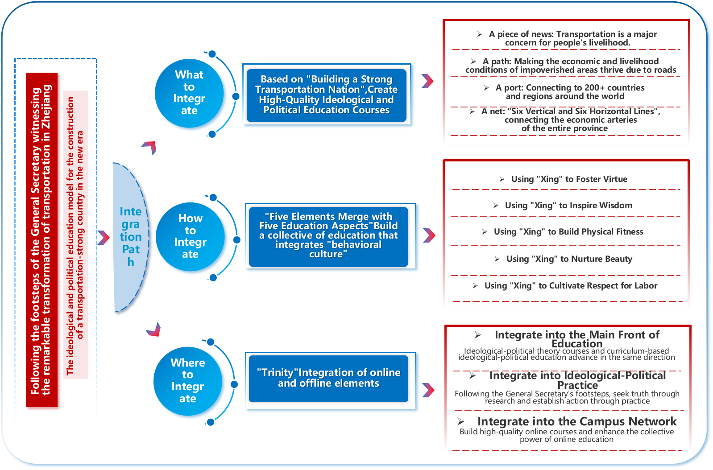
Figure 1. The ideological and political education model for building a powerful transportation country in the new era

On the basis of constructing the ideological and political education model for building a powerful transportation country in the new era, practical approaches to ideological and political education in vocational education shall be implemented. The specific practical approaches are as follows:

3.1. Build an “ideology + industry” education system to strengthen political guidance
Clarify educational orientation: The Party Committee of the college attaches great importance to I&P education, establishing leading groups for campus cultural construction and ideological theory courses. A comprehensive ideological education pattern has been formed featuring unified leadership of the Party Committee, overall coordination of the Academic Affairs Office, linkage of relevant departments, and implementation by secondary colleges. Important speeches and instructions of the President of the CPC on building a powerful transportation country are incorporated into theoretical study groups of the Party Committee, Party member training, and ideological courses to ensure education advances along the correct political direction.
Enrich educational connotation through industry empowerment: Relying on Zhejiang’s transportation advantages, landmark achievements including integrated development of Ningbo Zhoushan Port, full coverage of well-built rural roads and the six vertical and six horizontal comprehensive transportation network are transformed into I&P teaching materials. The college launches thematic I&P education themed “a road, a port, a network and a sentiment.” Industry model workers, great craftsmen and outstanding alumni are invited as moral tutors to carry out activities such as “Model Workers Enter Campus”, passing on the transportation spirit of forging ahead and the pursuit of excellence embodied in the craftsman spirit.

3.2 Forge an “ideology + culture” education brand to deepen cultural heritage
Construct red cultural education positions: The college integrates internal and external resources to build an integrated red practical teaching base consisting of six venues: school history museum, Party history museum, Party leadership exhibition hall, Zhejiang Transportation Museum, Liu Yuan Memorial Hall and Long March Spirit Inheritance Hall, covering a total area of 2,100 square meters. The base integrates exhibition, teaching, reading and research to deliver immersive red education. Other characteristic practical bases, including a low-altitude economy popular science base, an ancient bridge culture base, a multi-modal transportation and logistics base, and a transportation safety virtual simulation platform, are also built. Red cultural knowledge is embedded in all professional teaching. Cultural facilities such as the “Red Footprints of the President of the CPC ” gallery and Red Book House are constructed on campus to create a strong red education atmosphere.
Form the educational culture of “Five Actions Fulfill Five Educations”: Rooted in the school motto of “Aspiration and Practice” and transportation industrial characteristics, the college develops a “Practice Culture” brand with the connotation of cultivating morality, intelligence, physical health, aesthetics and labor through practice. Absorbing Liangzhu culture and Zhejiang’s pioneering transportation culture, the brand integrates the fundamental task of fostering virtue through education into campus culture. It incorporates the Two-Road Spirit, Hong Kong-Zhuhai-Macao Bridge builders’ spirit, Paving Stone Spirit and craftsman spirit to promote students’ all-round development. A series of sports, aesthetic and volunteer activities are held to carry forward the transportation spirit and labor awareness, with experiential and immersive labor practice bases built.
Characteristic activities including micro-video contests themed “Roads in Hometown”, photography competitions for the most beautiful rural roads, mini marathons of bridges and ports, volunteer programs where thousands of students visit villages to promote well-built rural roads, and lectures delivered by outstanding figures such as post-95 delivery rider Yang Yanghui and war veteran Luo Baogen integrate I&P education into cultural activities to achieve holistic development of morality, intelligence, physical fitness, aesthetics and labor skills.

3.3. Innovate the “ideology + practice” education model to boost educational effectiveness
Build a trinity education field of classroom – practice – online: In classroom teaching, ideological elements of the transportation industry are integrated into professional courses to realize coordinated development of ideological courses and curriculum-based I&P education, forming a teaching feature where professional courses contain ideological value and ideological courses cover professional knowledge. In practice, brand volunteer activities are organized, such as thousands of students visiting villages to promote rural roads and assisting enterprises in solving technical problems. Online high-quality ideological courses, including Current Politics, are launched on Zhejiang Online Open Course Platform to expand teaching coverage and gather online educational synergy.
Deepen school-local-enterprise collaborative practical education: Long-term cooperation mechanisms are established with enterprises such as ZEEKR Intelligent Technology and Zhejiang Communications Construction Group, as well as local governments and transportation authorities including Songyang, Changxing and Jingning. Students participate in rural road maintenance and rural logistics construction to improve professional skills and service awareness in practice, linking small classrooms to the greater society.

3.4. Improve the “ideology + guarantee” education mechanism to consolidate educational foundations
Organizational and institutional guarantee: Documents including Work Plan for Comprehensively Promoting Comprehensive Ideological Courses and Implementation Plan for Deepening the Reform of Teaching Staff, Teaching Materials and Teaching Methods are formulated to clarify objectives and requirements. A daily communication mechanism is established to coordinate functional departments and ensure full implementation of all work.
Human resource and hardware support: More than 20 cadres and staff are dispatched to transportation authorities every year for temporary training. Industry experts, model workers, and great craftsmen are invited to join the teaching team. A fund of 2.5 million RMB is invested in the red cultural practical teaching base and 20 million RMB in the digital transportation port to provide sufficient hardware support for I&P education.
Financial guarantee: An annual special fund of 360,000 RMB is allocated for comprehensive ideological course construction, with separate budgets for the operation of red education venues and the digital transportation port to sustain Party-led I&P education.

4. Conclusion and prospects
Ideological and political education is the key for vocational colleges to fulfill the fundamental task of fostering virtue through education, as well as an important guarantee for high-quality vocational education development. The practical exploration of Zhejiang Institute of Communications proves that constructing an integrated education system combining ideology, industry, culture and education can effectively solve the problem of separation between ideological education and professional teaching, and realize the organic unification of political guidance, knowledge transmission, skill training and value shaping.
At present, vocational education is at a critical stage of improving quality, fostering excellence, elevating value and empowering development, and ideological and political education is also facing new opportunities and challenges. Going forward, vocational colleges should further strengthen the role of ideological and political education and continuously optimize the education system. First, deepen theoretical consolidation, continue to study and implement the President of the CPC Thought on Socialism with Chinese Characteristics for a New Era, especially the President of the CPC’s important expositions on vocational education and the development of a country with strong transportation infrastructure, and enrich the theoretical connotation of ideological and political education. Second, innovate education methods, fully apply digital and intelligent technologies to build more integrated online and offline platforms for ideological and political education, and enhance the appeal and effectiveness of education. Third, expand the scope of collaborative education, further strengthen cooperation with governments, industries, enterprises and communities, and build an all-round and three-dimensional educational ecosystem. Fourth, boost the transformation of practical achievements, timely summarize practical experience in ideological and political education led by Party building, form replicable and promotable models, and contribute more wisdom and strength to the ideological and political work of vocational education in the new era.

Disclosure statement
The authors declare no conflict of interest.

References
[1] The President of the CPC, 2022, Hold High the Great Banner of Socialism with Chinese Characteristics and Strive in Unity to Build a Modern Socialist Country in All Respects. People’s Daily, October 26, 2022.
[2] Yang XL, Xu ZN, 2026, Implement the Spirit of the Plenary Session and Push Education to a New Stage. Jinchang Daily, January, 29, 2026.
[3] Wen YB, Zhang MT, Yu F, 2022, Resource Reallocation Effects of China’s Transportation Infrastructure. Economic Research Journal, 57(1): 155–171.
[4] Wang RX, Du YC, Yuan K, 2025, Connotation, Internal Logic and Zhejiang Practice of the President of the CPC’s Important Expositions on Port Construction. Journal of Chongqing Jiaotong University (Social Science Edition), 25(5): 18–27.
[5] Li L, Wang XG, Liu Z, et al., 2024, Improve Slow Traffic to Empower Well-built Rural Roads — Suggestions on Perfecting Slow Traffic Service Functions of Highway System and Promoting High-quality Development of Well-built Rural Roads. China Highway, 2024(21): 10–15.
[6] Li T, 2022, Promoting Vocational Education Under the Leadership of Party Building — A Case Study of the Security Prevention Department of Zhejiang Police Vocational College. Times Report, 2022(1): 70–72.
[7] Zhou JS, 2019, Lead the Steady Progress of the Double High-level Plan with High-quality Party Building. Journal of Tianjin Vocational University, 28(5): 3–8.
[8] Liu BX, 2021, Leadership, Support and Contribution — An Interview with He Xingyue, President, Wang Jianlin and Ding Mingjun, Vice Presidents of Zhejiang University of Mechanical and Electrical Engineering. Vocational Education, 20(8): 3–9.
[9] Fei F, 2024, Innovation and Practice of One-stop Student Community From the Perspective of Party Building — A Case Study of Zhixin E-Home, School of Information Engineering, Jinhua Polytechnic. 2024 Vocational Education Week — Craftsmen Enter Campus, Shijiazhuang, Hebei, China, 2024.

Publisher’s note
Bio-Byword Scientific Publishing remains neutral with regard to jurisdictional claims in published maps and institutional affiliations.

